# Abstract

This database management system course project’s goal was to implement a working website that had a database running in the background. The general problem we thought of was the need for character tracking in mediums such as film, TV, and animation. Thus the ultimate goal of the database is to create a resource where the user easily see relationships between characters and track relevant things.

For design, we have three main users: SuperFan, admins, and industry professionals. SuperFan are the main audience and come here to look up other users, browse the database, and create custom lists from the database. Admins are administrators and can edit the public database. Industry professionals can simply be a writer or the voice actor for a character, this is to help build the community. A use case analysis was also performed, which can be found in the appendix.

The ER diagram presented shows our data base design from an entity relationship model. Several assumptions are listed off in the actual report for the actual construction. We have separate relations for characters in TV and Movies, as you can see in our relational schema.

As for user interaction, an example one is searching for a media title. Users can do so by entering a specific title, year, studio, etc. and the results that match will appear. The interface follows a minimalistic design and several shots of the User Interface in action can be seen below.

# Intro

If you’re a big movie or TV show fan, at times you may be interested the characters and how their traits change over the course of the runtime. However popular websites such as IMDB do not have this kind of feature, they only provide a basic synopsis and plot summary. Diehard fans or people who are keen to analyzing film would be forced to go to various websites to get detailed information, this can get quite tedious. In comes SUPERFAN, a database used to keep track of detailed information such as characters, their motivations, TV shows, movies etc. Essentially a lot of basic information found on IMDB would be available but on top of that we allow for more details of a TV show or film to be tracked essentially broadening the scope of our users. The goal of our database is to create a resource where user can get more in depth character detail.

# Project Design Section

Our system has three main users: typical front end users with no admin control (SuperFan), front end administrators (Which are still SuperFan but with admin privileges). Then professionals who are SuperFan but who have an industry connection or role to a media with a verified account. These three users are all able to interact with our interface and browse through movies and television shows, however there are different level of privileges for each that allow them to do different things. We did a use case analysis of the SuperFan user to generate general ideas. Please refer to Appendix A for the use case analysis.

The first user of our website is our SuperFan user, or the typical user in layman terms. This user has no administrative privileges but they would be the main user of the database, and they are the largest primary user. Please refer to Appendix A for the Use Case Analysis, in there is Figure 1 which is a use case diagram for the primary user. The user can create an account, edit media, sign in, sign up, browse, create a collection such as adding to their Favorites, copy a collection, and look up and follow another user. Following a user entails getting updates on another individual’s collections and being able to see if they add to their own collections such as Favorites or “To-Watch.” This allows for the regular user to perhaps get new ideas of what is good to watch from other people they decide to follow.

Secondly is the admin SuperFan user. This user has administrative privileges and can add/edit media objects within the database, in addition to the user actions above. Essentially, the admin user is a SuperFan user but with enhanced privileges. The admin SuperFan user can add objects: shows; actors; industry people; movies, and edit the details of said objects. By adding objects, they can add television shows and movies to the database. They have control over the content of the website and what is displayed. For example, if a new show X has recently come out, the administrator can add X to the database so that all users can find information on it. The administrator can also modify any content in the database for if there are any changes that need to be made for a movie or television show.

The third user for our system is an industry professional. This person could be an actor, animator, voice actor, director, employee for a collaboration studio that worked on a movie, etc., in real life. Regarding the SuperFan database, they are just an industry professional that is verified. They can act like a regular SuperFan user but they have a few enhanced abilities, such as scheduling or posting a Q&A session. They can add quotes or insights to projects they work on. This user is considered for this system to add official information from a verified individual who has worked on a movie or television show. They have special privileges that allow for them to host question and answer forums where other users can ask questions about the movie/TV show they have worked on. Adding quotes or insights to projects they work is added to the database as well and appear on the corresponding movie or television show as extra information for users to see.

Screenshots are included below to see the functionality of SUPERFAN and how these user transactions will look on our website.

# ER DIAGRAM

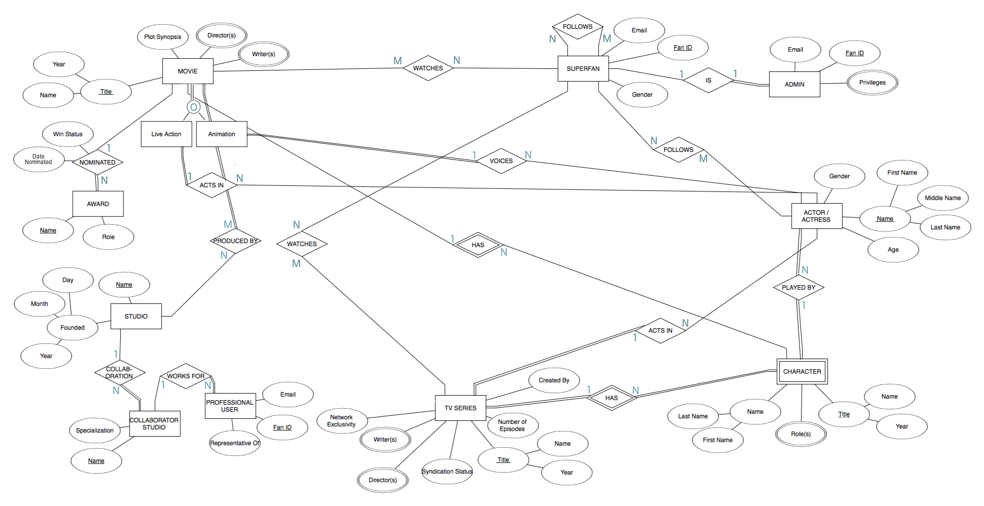Above is our ER Diagram for SUPERFAN. The following assumptions were made:

* A movie or TV show does not necessarily need to be watched by a SuperFan
* Not all actor/actresses either act in or voices in a movie
* Similar for TV shows, not all actor/actresses act in a TV show
* All characters must be played by an actor/actress and an actor/actress must play a character
* A character can be played by multiple actor/actresses (for example, a character in different adaptations or a character played by different people for different ages.)
* Movie can be specialized into a live action or animation movie and the two can overlap because there are some movies that are both (for example, “Enchanted” is a live movie with animation involved.)
* Character is a weak entity because it is dependent on the TV show or Movie and a character named John versus a character named John in a movie is uniquely identified by the title (name and year) of the movie or TV show

A few changes made to the ER diagram include changing the AWARD entity to only have the attributes: Name and Role and the relationship “NOMINATED” to have the following attribute “Win Status” because it is not guaranteed that a movie wins something. We also made the participation partial on the MOVIE side because not all movies are nominated for an award. We also added the PROFESSIONAL USER entity to consider another user of our system. In addition to the SuperFan and Admin, we wanted to include a professional user who acts as a representative of a COLLABORATION STUDIO so they can use our system to host things like Q&A’s, post official quotes, etc. for a movie.

# RELATIONAL SCHEMA

The biggest decision made during the process of converting our ER diagram to a relational schema was having separate relations for TV characters and Movie characters. In our ER diagram, character is its own entity but in our relational, we have it as TV character and Movie character. The reason for this being we needed to differentiate between the characters and if the title of where they belong to is a movie or television (since TV SERIES and MOVIE both have the “HAS” relationship with characters.

Overall, we have many similar relations which are just differentiated by the fact if what’s being stored in the database is a movie or television show. Both objects have the same relationship with characters and the SuperFan and actors/actresses, therefore the relations look similar but need different relations to separate between movie and television titles.

# database management system

An interaction implemented for any user of our system (SuperFan, admin, professional user, or just the casual user) is the SEARCH function. This is open for anyone to use on our website to search through our database. This means that a user can go to the TV or MOVIE page and browse and search through the different shows/movies using keywords. Users can search by entering a specific title, year, studio, etc. and the results that match will appear. For example, if a user was looking for information about the Shrek movies, they could type into the search bar: “Shrek” and the Shrek movies in the database will appear with its corresponding info. The SQL statement for this transaction is:

$sql = "SELECT Id, created, episodenum, synstat, network, director, writer, name

FROM series

WHERE name = '$series_name'";

Another interaction implemented for our system is the ADD function. This is for the administrators signed up on our site. They have the power to add to the database – meaning they are the ones to add new TV shows and movies for viewing.

$sql = "INSERT INTO movie (release, synopsis, title)

VALUES('$_POST[release]','$_POST[synopsis]','$_POST[title]')";

# user interface

For our user interface, we decided to go with a minimalistic and clean design that is easy to navigate. We used a template found online, sourced in our code, for the webpage formatting panels and the toolbar on the side. We went for a website with few words but self-explanatory icons that describe what they do without the clutter of text. Once a user opens our website, they are greeted with a log-in/sign-up panel. They can decide to do that or continue scrolling to view information on movies and television shows. There is also a navigation bar on the side that will allow a user to quickly take a shortcut to the panel they desire. On the bar are ways to get to the log-in panel, the movies page, the television page, and the about section.

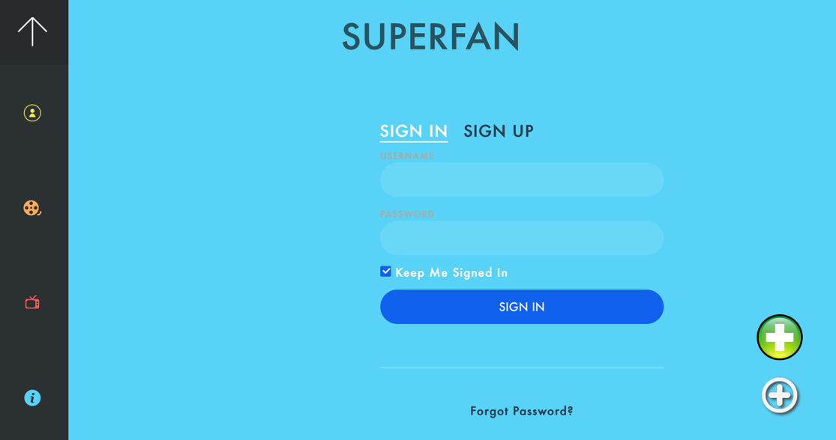

For each movie and television show panel are the categories that movies/shows are classified under. This was designed to organize all the different types of entertainment for easier navigation for the user and make finding what they are looking for a quicker process.

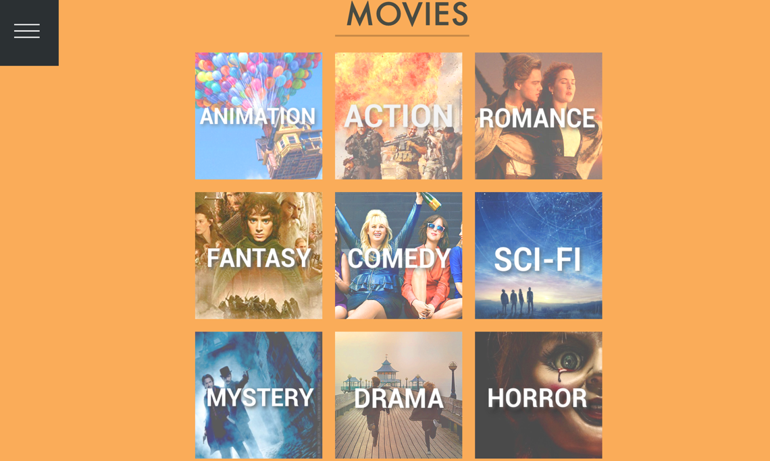

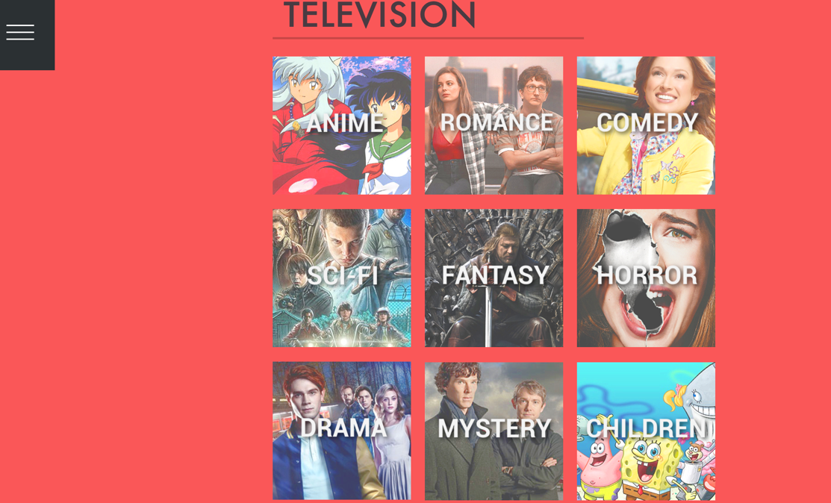

If a user were to click a specific category for either a movie or TV show, it would open and list all the shows/movies listed under that category. Highlighting over an image will give the title of the series. The back button will also take the user back to either the movie or TV page, depending on what they were looking at in the first place.

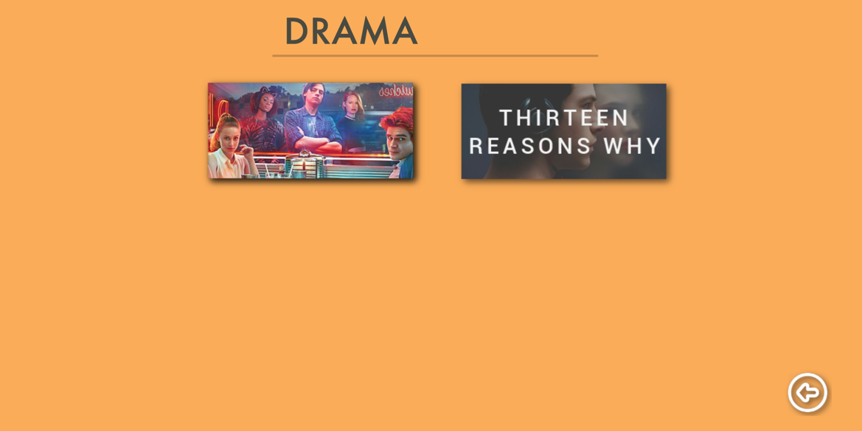

The about page gives a short description of our website and the creator names.



Other features of our website include adding to the database of entertainment, which only administrators can do. They do this by clicking the plus button on the bottom-right corner of the homepage. If a non-admin tries adding, an error screen will pop-up. An example of adding a TV show is below. Pressing submit will re-direct the user back to the main television show section where they can find the show they added.

