For our user interface, we decided to go with a minimalistic and clean design that is easy to navigate. We used a template found online, sourced in our code, for the webpage formatting panels and the toolbar on the side. We went for a website with few words but self-explanatory icons that describe what they do without the clutter of text. Once a user opens our website, they are greeted with a log-in/sign-up panel. They can decide to do that or continue scrolling to view information on movies and television shows. There is also a navigation bar on the side that will allow a user to quickly take a shortcut to the panel they desire. On the bar are ways to get to the log-in panel, the movies page, the television page, and the about section.

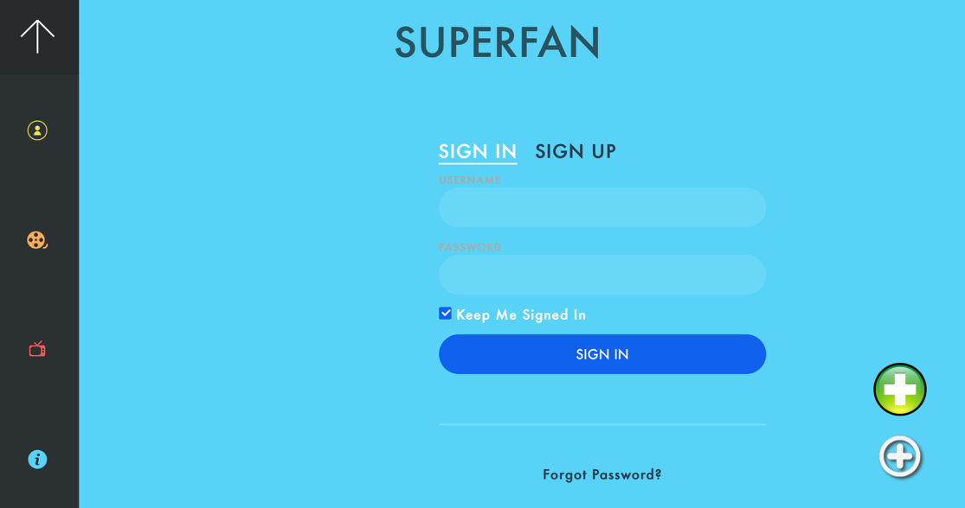

For each movie and television show panel are the categories that movies/shows are classified under. This was designed to organize all the different types of entertainment for easier navigation for the user and make finding what they are looking for a quicker process.

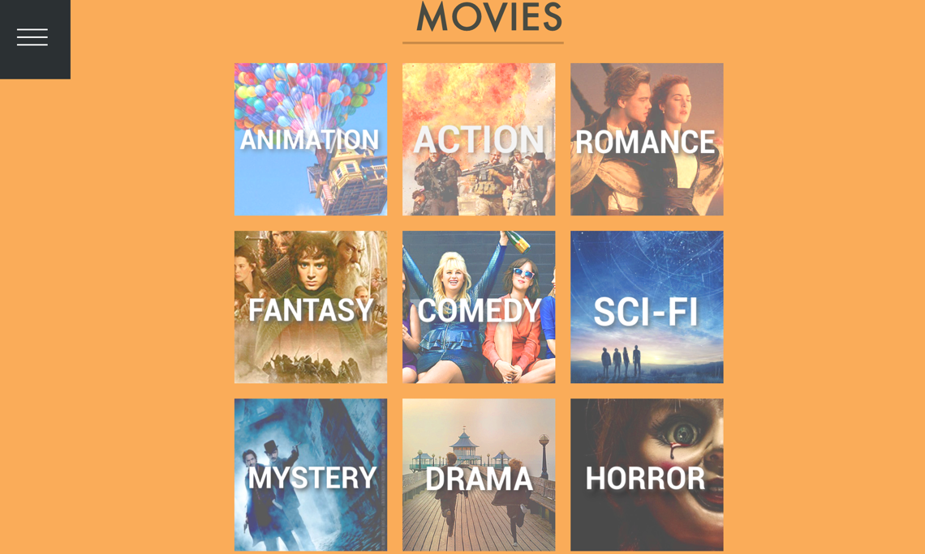

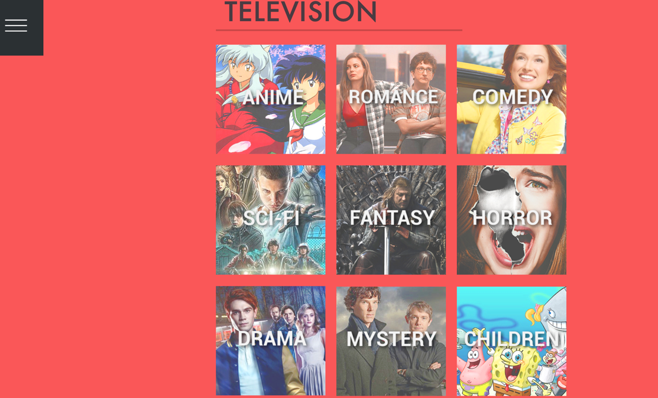

If a user were to click a specific category for either a movie or TV show, it would open and list all the shows/movies listed under that category. Highlighting over an image will give the title of the series. The back button will also take the user back to either the movie or TV page, depending on what they were looking at in the first place.

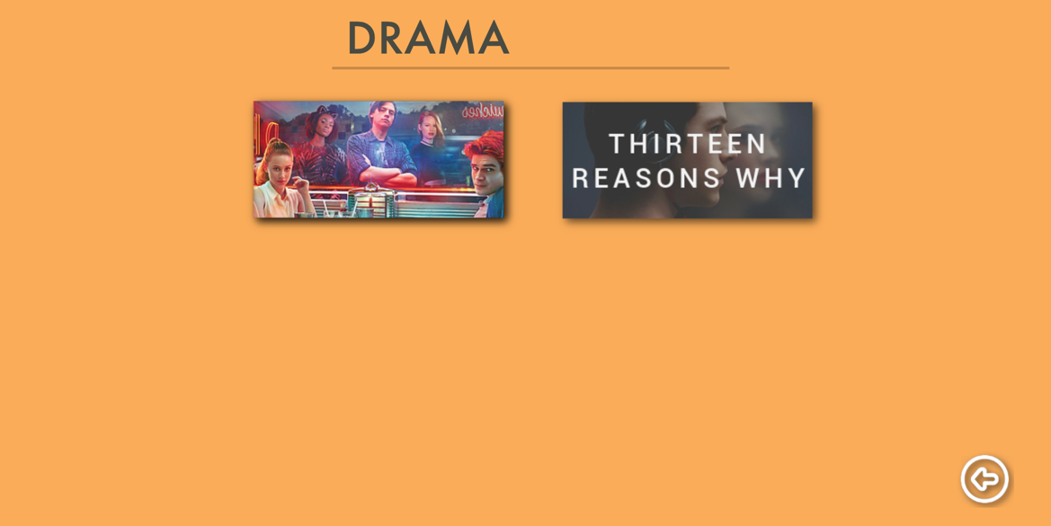

The about page gives a short description of our website and the creator names.



Other features of our website include adding to the database of entertainment, which only administrators can do. They do this by clicking the plus button on the bottom-right corner of the homepage. If a non-admin tries adding, an error screen will pop-up. An example of adding a TV show is below. Pressing submit will re-direct the user back to the main television show section where they can find the show they added.

