# CHAPTER 3

**METHODOLOGY, SYSTEM ANALYSIS AND DESIGN**

**3.1 The Research Approach**

This Chapter gives a brief description of the methodology that will be used to develop the proposed system. The main methodology involves feasibility study, system analysis and design, developing and implementing A E Learning System. The methodology is very important to ensure that the new system would give benefits to the school.

. **3.1.1 Analysis of Existing System**

The current system in Adeleke University, Ede does not make use of any E learning system, the mode of learning has always been the classrooms alone method During the course of the analysis, the following problems were discovered:

1. Inefficient of completing the syllabus of a given session
2. Misplacing of student’s script due to tedious papers collation
3. It is tedious in collating/grades students C.A
4. Financial constraints in terms of printing large number of pages or voluminous due to high cost in printing.

## **3.3 BENEFITS OF PROPOSED SYSTEM OVER EXISTING SYSTEMS**

The Web-based E learning System has many benefits.

* It creates a platform where students and lectures can interact thereby fostering knowledge sharing.
* Speedy communications.
* Elimination of paper work as lecturers can assess the students via net.
* Organization chain management simplified

**3.4 Design of the Proposed System**

In this section, the design of the proposed E learning System will be discussed in detail.

**3.4.1 Database Design**

The database system that will be used to store the information for this system is MySQL. This is a freely available open source relational database management system that uses structured query language.

Below are required tables used in the database.

* Administrator
* Lecturer
* Student Biodata.

## **3.5 DATABASE DESIGN**

1. **Forum (Interaction) ER Diagram**



FIGURE 1.0 FORUM ER DIAGRAM

**Registration ER Diagram**

FIGURE 1.1 REGISTRATION ER DIAGRAM

(c )**Assessment ER Diagram**

FIGURE 1.2 ASESSMENT ER DIAGRAM

3.6 FRAMEWORK OF THE SYSTEM

j0195384**ADMIN LECTURER**

-----------------------------------**STUDENT**

---------------------------- Presentation layer-----------------------------------------

**E-LEARNING SITE**

**PHP**

----------------------------------------------------**Logic Layer**-------------------------------------

**DATABASE**

**SERVER**

**---------------------------------------------------Back Layer--------------------------------------**

**3.4 Design of Assignment Submission and Grading System:**

Part of the E learning system also includes Assignment Submission and Grading System,In this section, the design of the proposed Assignment Submission and Grading System will be discussed in detail.

The rest of this section describes the components and modules of the proposed system in terms of software UML diagrams.

Admin Login

Tutor Login

Begin

Home

Student Login

Add/Edit Course

Add/Edit Tutor

View/Edit Exam

Add/Edit Student

Settings

Session / Semester / Department

Set & Grade

Assignment

Group Student

Add / Edit

Classroom

View/Edit

Assignment Result

Upload/Delete Article

View

Exam Result

View

Attendance

View/Submit Assignment

Course Registration

View Article

View Grade

Write

Exam

Change Password

View

Profile

**Figure 3.1;** A block diagram showing the components of the software and their various linkages

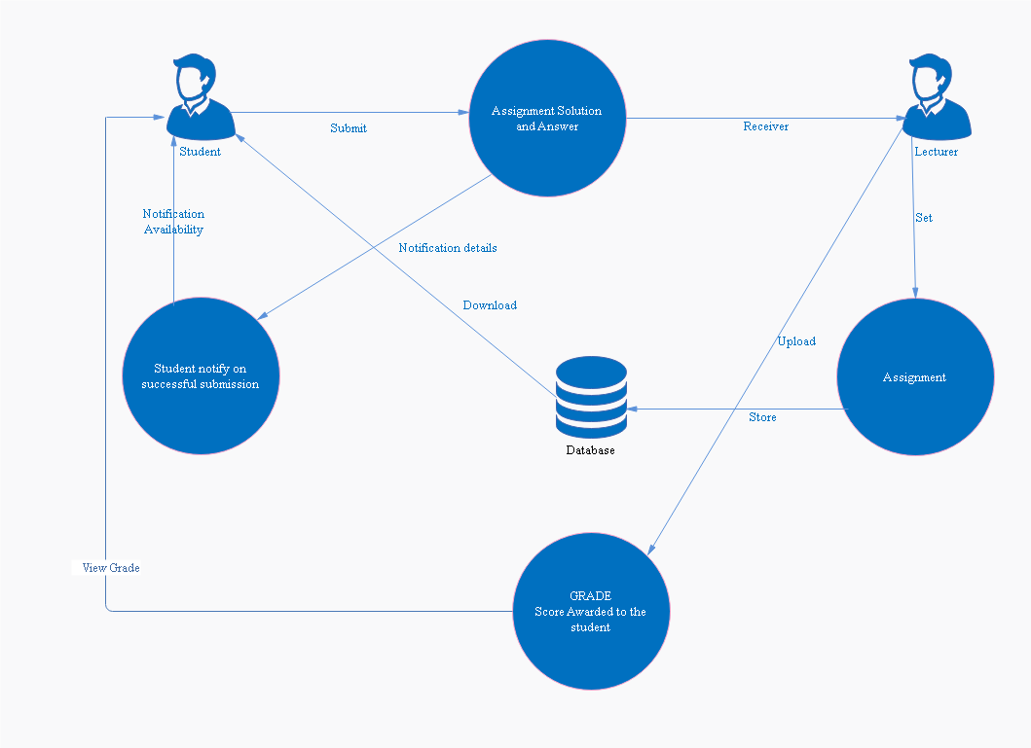

**Figure 3.2;** Data Flow Diagram of the ASG System

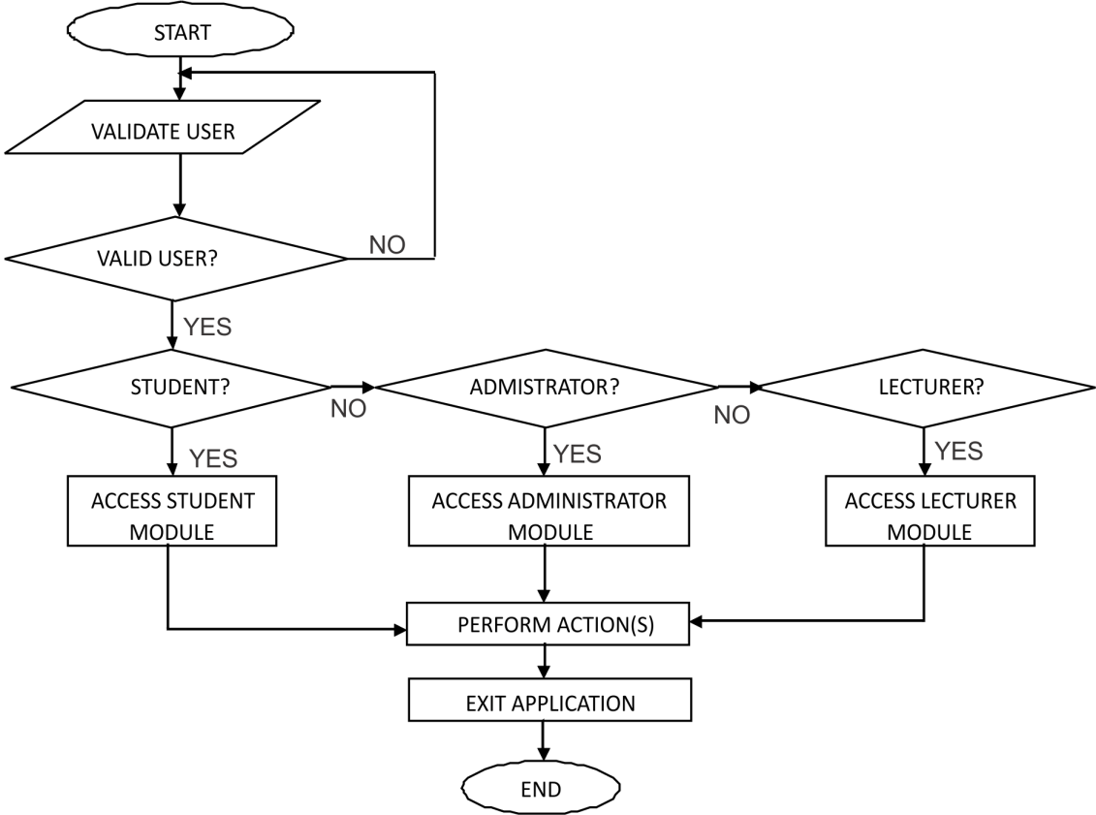

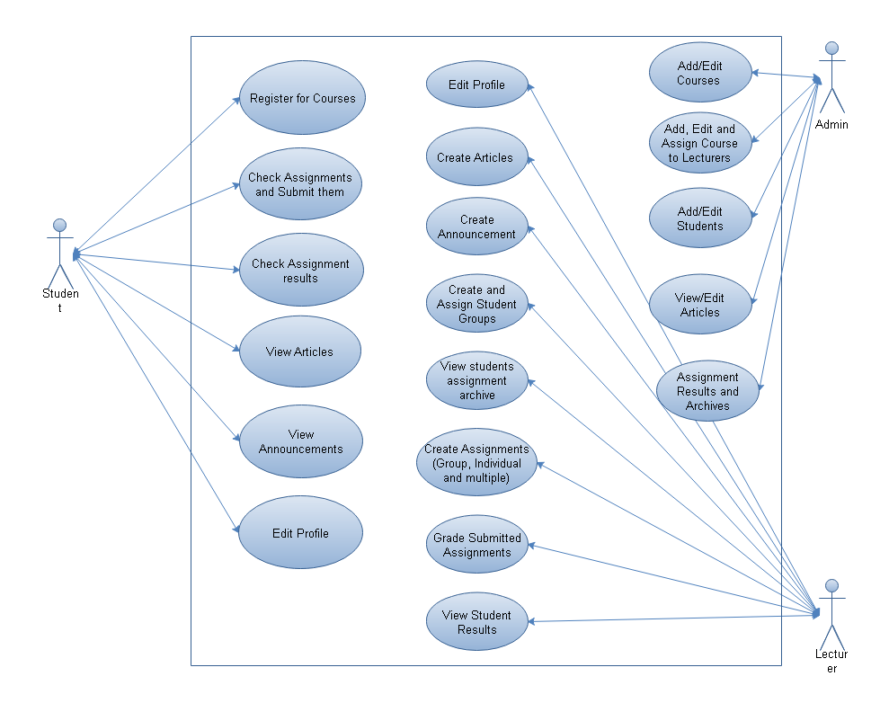**Figure 3.3;** Flowchart Diagram

**Figure 3.4;** Use Case Diagram for Admin, Lecturer and Student

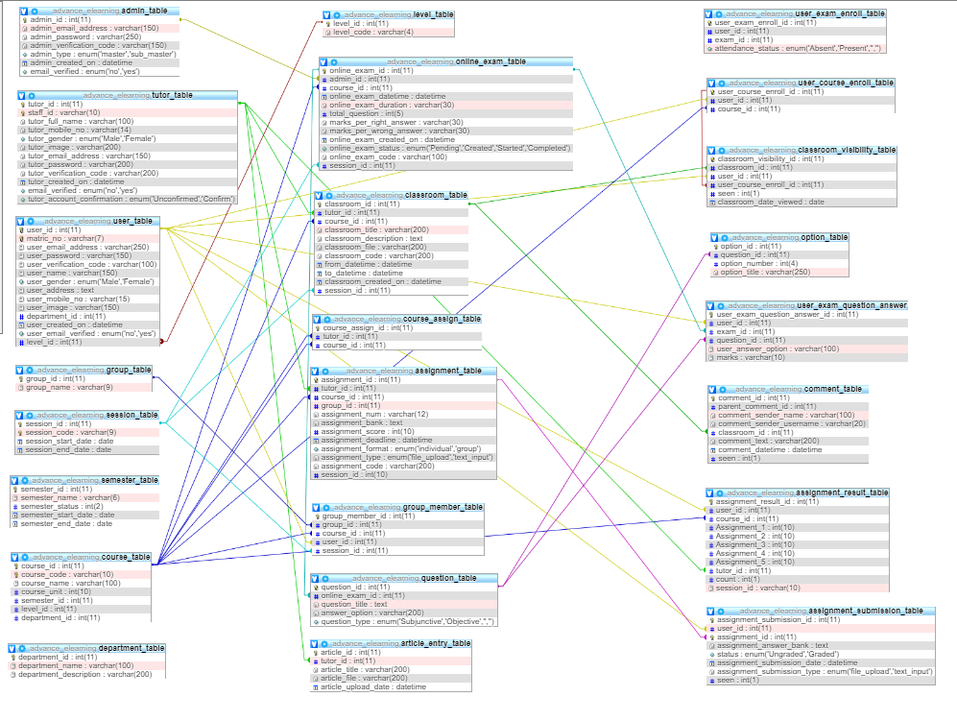

**Figure 3.5;** Entity Relationship Diagram

**3.5 Choice of Programming Language**

The system is constructed based on PHP as a server programming language. The motives of PHP technology is basically developing of an internet platform. Secondly, it is easy to use and understand, Javascript/jQuery serve as a client server and it is also used to validate user input before finally sending to server side for storage, MYSQL as the database management system (DBMS), XAMPP as the testing server, HTML5 and CSS3/Bootstrap for the front-end.

**3.5 Definition of Terms**

PHP: PHP is a general-purpose server-side scripting language originally designed for web development to produce dynamic web pages.

MySQL: MySQL is the world’s most relational database management system (RDBMS) that runs as server providing multi-user access to a number of databases. The SQL phrase stands for Structured Query Language.

HTML: Hypertext Markup Language (HTML) is the main markup language for web pages. HTML elements are the basic building-blocks of web pages.

JAVASCRIPT (JS): is a scripting language, primarily used on the Web. It is used to enhance HTML pages and is commonly found embedded in HTML code. **JavaScript** is an interpreted language. jQuery is also part of Javascript library at of numerous library.

USE CASE DIAGRAM: use case diagrams overview the usage requirements for a system. They are useful for presentations to management and/or project stakeholders, but for actual development you will find that [use cases](http://agilemodeling.com/artifacts/systemUseCase.htm) provide significantly more value because they describe "the meat" of the actual requirements.

FLOW CHART DIAGRAM: A flowchart is a diagram that depicts a process, system or computer algorithm. They are widely used in multiple fields to document, study, plan, improve and communicate often complex processes in clear, easy-to-understand diagrams.

DATAFLOW DIAGRAM: Data flow diagrams are used to graphically represent the flow of data in a business information system. DFD describes the processes that are involved in a system to transfer data from the input to the file storage and reports generation.

ENTITY RELATIONSHIP DIAGRAM: An entity relationship diagram (ERD), also known as an entity relationship model, is a graphical representation of an information system that depicts the relationships among people, objects, places, concepts or events within that system. An ERD is a [data modeling](https://searchdatamanagement.techtarget.com/definition/data-modeling) technique that can help define business processes and be used as the foundation for a [relational database](https://searchdatamanagement.techtarget.com/definition/relational-database)