PalmPay App - User Guide

How to Send Money to Other Banks

Version 1.0 | Nigeria

Overview
This guide walks you through the process of sending money from your PalmPay wallet to an account at any bank in Nigeria. Follow each step carefully to ensure a successful transfer.

Before You Begin Make sure you have:
• The PalmPay app installed and set up on your mobile device
• Your 6-digit login passcode
• Your transaction PIN
• The recipient's 10-digit bank account number and bank name
• Sufficient balance in your PalmPay wallet

Step-by-Step Instructions
Step 1: Open the PalmPay App
Locate and tap the PalmPay app icon on your mobile device to launch it.
Step 2: Log In to Your Account
When prompted, enter your 6-digit passcode to securely log in.
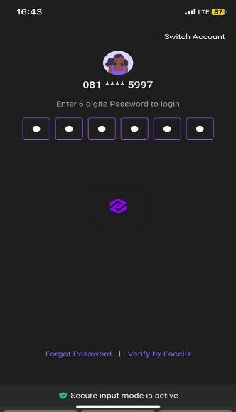
Step 3: Access Your Dashboard
After a successful login, your dashboard will appear displaying a welcome message and your current wallet balance.

Step 4: Tap "To Bank" on the Dashboard
Locate and tap the "To Bank" option displayed beneath your available balance on the dashboard.
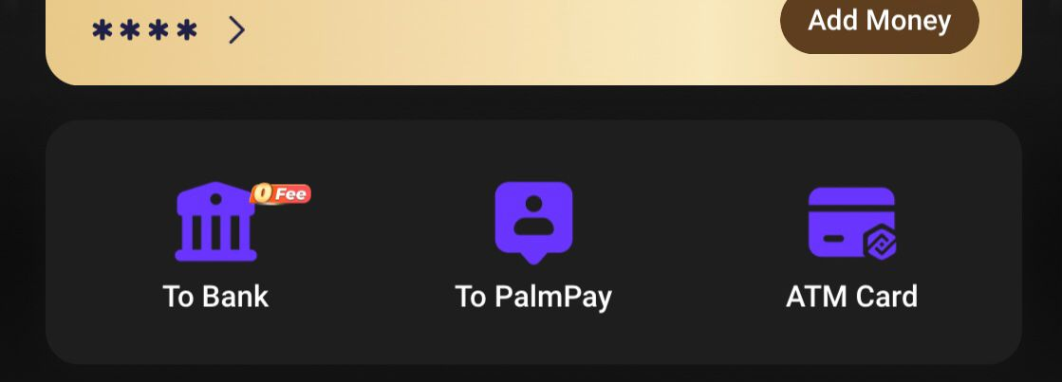
Step 5: Select "To Other Banks"
On the Transfer to Bank page, tap the "To Other Banks" tab to initiate an inter-bank transfer.
Step 6: Enter the Recipient's Account Number
In the field labelled "10-digit Account Number," type the recipient's full bank account number.
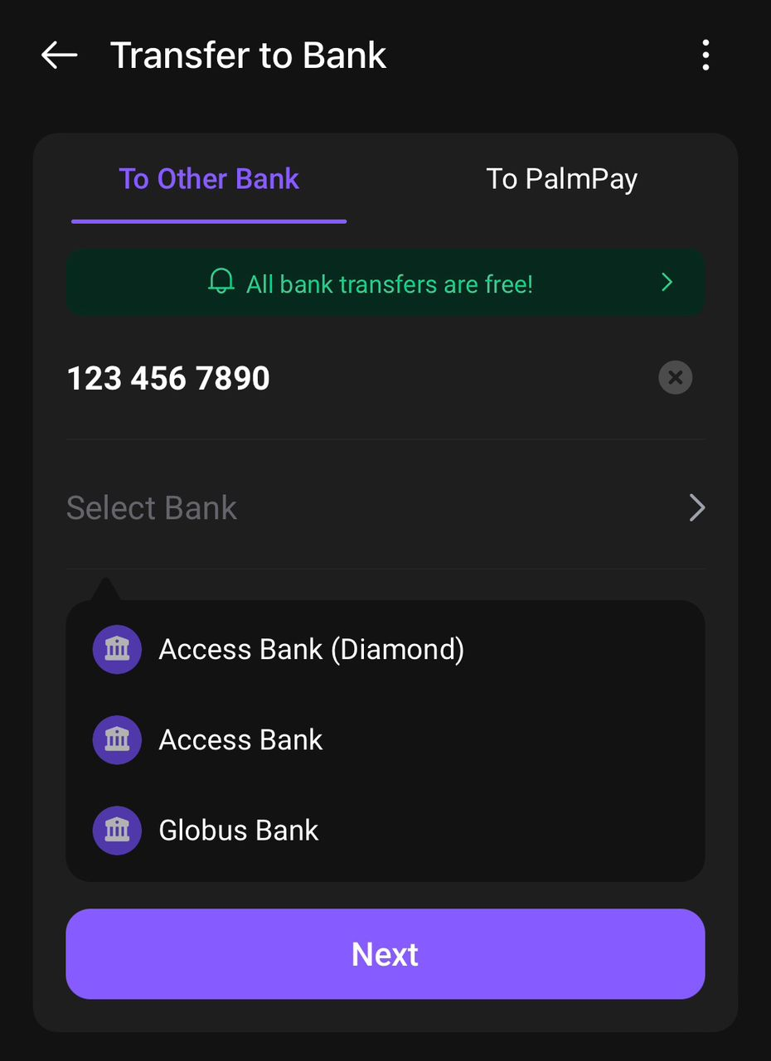
Step 7: Select the Recipient's Bank
Tap "Select Bank," then use the search bar to find and select the recipient's bank from the list.
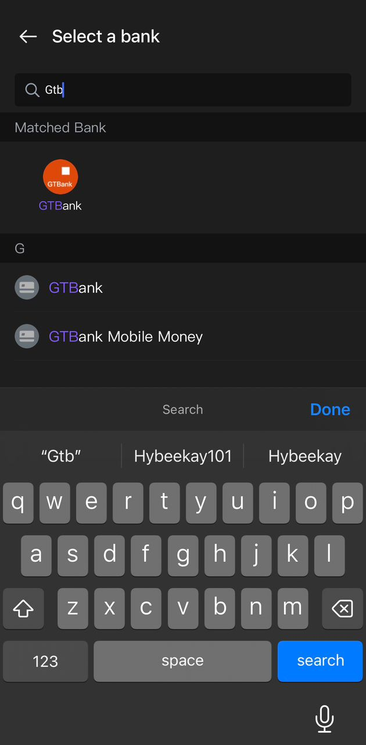
Step 8: Verify the Account Name
The system will automatically retrieve and display the account name linked to the number you entered. Carefully confirm the name is correct before proceeding.
Note: Do not continue if the displayed name does not match the intended recipient. Contact your recipient to confirm their details.
Once verified, tap "Next."
Step 9: Review Transfer Details and Confirm
A summary of the transfer will be displayed. Review all the details carefully, then tap "Confirm."
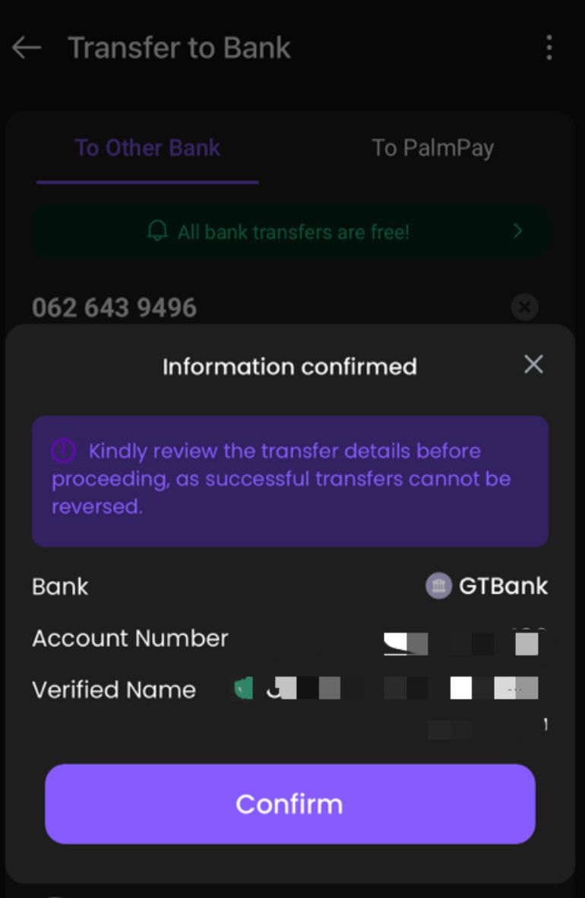
Step 10: Enter the Transfer Amount
Type the amount you wish to send.
Note: You may add an optional note (e.g., payment purpose or reference) to help both parties identify the transaction.
Step 11: Final Review and Payment Authorisation
Review the transaction details one final time. When satisfied, tap "Confirm to Pay," then enter your transaction PIN to authorise the transfer.
Step 12: Transfer Confirmation
A "Transfer Successful" message will appear on your screen, confirming the transaction has been completed.


Troubleshooting
Issue | Recommended Action
Account name not retrieved | Check that the 10-digit account number is correct. Ensure you have a stable internet connection, then try again.
Incorrect account name displayed | Do not proceed. Ask your recipient to verify their account number and bank before retrying.
Insufficient balance error | Top up your PalmPay wallet before initiating the transfer.
Wrong PIN entered | Re-enter your correct transaction PIN. After multiple failed attempts, your account may be temporarily locked.
Transfer not received by recipient | Allow up to 30 minutes for inter-bank processing. If unresolved, contact PalmPay support.

Contact Support
If you continue to experience issues, reach out to PalmPay customer support through any of the following channels:
• In-app Help Centre: Tap Menu → Help & Support
• Email: support@palmpay-inc.com
• Phone: 0700 PALMPAY (0700 725 6729)

