**High Level Design**

**Algorithm Trading APP.**

**CMD:**

an application for a specific user for communicate with the trading client server of introduction to Software Engineering.

The user will choose an action that he wants to do that required a response from the server.

All the action required an authentication of the user with a token.

Some actions require to set parameters.

the actions are:

buy commodities

sell commodities

cancel request

query about status (of user, market, history or commodities)

the user gets a response from the server if the action that he asked is done or failed.

If the action failed, he gets message “Fail” with an explanation why.

In addition, if user’s requests frequency is more than 20 requests per 10 seconds the user will ban for 2 minutes.

**GUI**:

GUI were added for easier use for the users

He include all the options that the user can do on the Algorithm Trading Market.

In addition, it can to put the system on condition of "automat pilot" it is call AMA and this do things lonely in a sophisticated way with strategy.

Recently was added few option like see a statistic graphs about his changes or his details of his user, its enable him to get information to PDF file and save him where he will want.

One thing that was added is history that remind all his action of sell/buy/cancel and show it in table on the view.

All requests are accompanied by an authentication token was encrypted in method of using in nonce and now the server was hardly and safely.

The information of all users that all action of buy\sell was saved on SQL Data Base.

**GUI – Presentation and Explaining:**

**Window 2 - AMA Window**

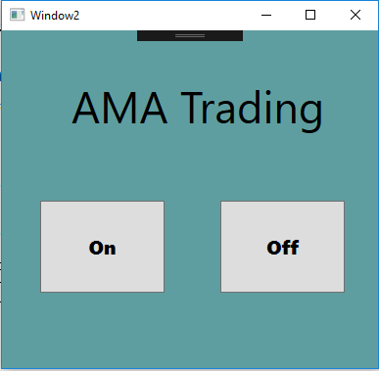

On- click on this will start the run of AMA.

Off-click on this will stop the run of AMA.

This button makes a sale operation

This button makes a purchase

Main Window:

This button let info about specific item

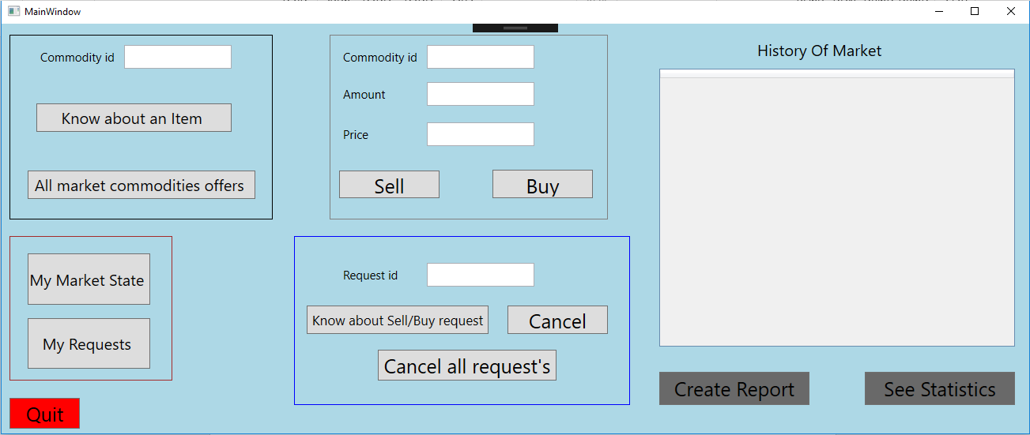

This button let info about all ask and bid prices

This button let Status of your market

See Statistic and Graphs about Market

Close the Application

This button let info about all your request's

This button let info about request

This button Cancel all Requests

Create Report in PDF file with info about the Market

This is the history of buy/ sell/ cancel actions.

This button Cancel request

**Window Graph –**

This window present statistic graphs and information about our commodities and requests.

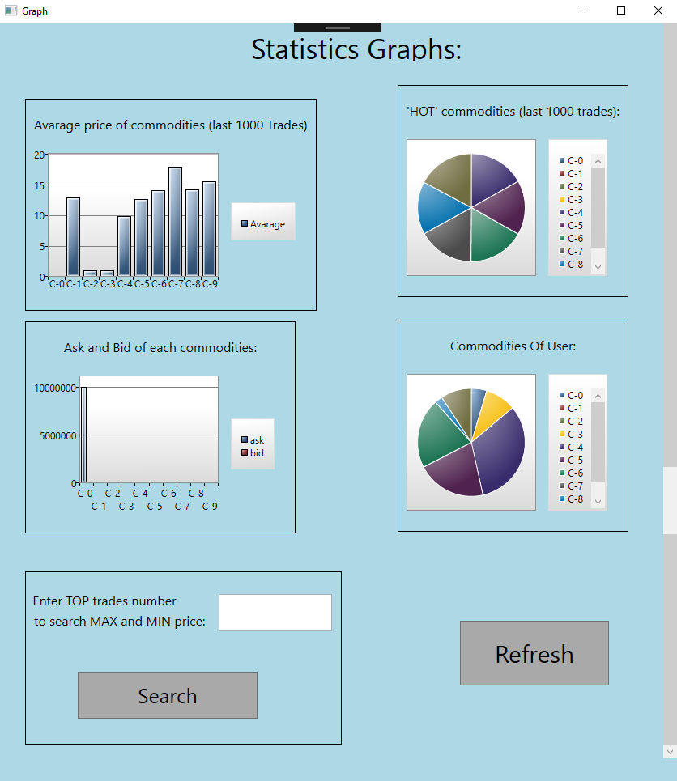

This button take the 'number' that the user enter and search in data base on last 'number's

The Min AND Max

This button refresh the page

*© 2017 orel, nati and or DOEs ALL RIGHTS RESERVED*

**Unique Features**

**Gui-** an amazing gui which presented good looking software for the user.

Influence on the user to buy and sell more commodities.

Gives a nice touch glance for our the company and better grade in Milestone 3.

**Refresh button**- updates the visual data in the gui.

**Quit button**- exit all the program include all its windows.

**Graphs**- unique graphs for many different perspective about the market and user transactions. The user can upgrade its skills of trading by it.

i.e. maximum and minimum price for all the commodities.

**Pdf** – create a pdf file that include the information about the market and user for the time it's been create.

**History**- your history is being saved to your computer, the reliable on the data base is been decreased.

*© 2017 orel, nati and or DOEs ALL RIGHTS RESERVED*

**Low Level Design**

this ise172 project includes 4 projects:

***all the projects are connected to a log4net package that been reported about the progress of the software.

**Presentation Layer**

Start class:

The purpose is a CMD communication.

choosing from the request options that presents:

buy- “1”

sell- “2”

query buy/sell- “3”

query user- “4”

query market- ”5”

cancel buy/sell- ”6”

market User Request –"7"

query all market- "8"

and after adding the information that the function need for it.

Try catch is been using for data analysis for a wrong input.

A Message box is been show the user and when the input throws an exception and is been catch.

**GUI**

Wpf Project

This project includes 3 windows.

Window2 is the main window,

This window has 2 buttons for starting and stopping the AMA Trading.

When this window is closed a User Access Window is been open.

Main window – the User Access Window for manual trading in ISE172 market client.

Tester – window of Statistic and Graphs

Window 2 – AMA window -starting window

*© 2017 orel, nati and or DOEs ALL RIGHTS RESERVED*

**Bussiness Layer**

This layer includes the logical part of the project.

For sending a request to the server , we would making an matching object for the request :

AMA

**BuyRequest**

fields: string type, int commodity, int amount, int amount, int price

sendBuyRequest()

**SellRequest**

fields: string type, int commodity, int amount, int amount, int price sendBuyRequest(int price, int commodity, int amount)

**MarketItemQuery**

Fields: object auth, string type, int commodity, int amount, int price

Print () : void

ToString A() : string

SendQueryBuySellRequest() : MarketItemQuery

**MarketUserData**

fields: Dictionary commodities<string,int>, float funds, List<int> requests

Print ()

ToString A()

SendQueryUserRequest() :

QueryUser

**MarketCommidtyOffer**

Print ()

ToString A()

SendQueryMarketRequest()

QueryMarket

**CancelBuySellRequest**

SendCancelBuyRequest (int id) : bool

**MarkertUserRequest**

SendQueryUserRequests ()

QueryUserRequests

**AllMarketCommodityOffer**

Fields: List<ComInfo> lci

SendQueryAllMarketRequests () : List<ComInfo>

Ask() : int

Bid() : int

QueryAllMarket

Program – main class

**HistoryItem** – class that include the data that will enter to file of history with all the information.

**Report**- class that create PDF file with information in the computer of the user

*CreateReport* ()

**Token** – create a token for all the requests

CreateToken ()

GetUrl ()

GetPrivatKey ()

GetUserName ()

GetNonce ()

**ComInfo** – the data structure that include MarketCommodityOffer, and into this has a Info and Id.

The function “send____Request()” creates the queries that the functions in the DL needs and fills the necessary fields for making the token for the authentication of the user.

Query object-which will send to the server.

Token-user and password.

**Data Access Layer**

**SqlData** //managing the connection with the sql data base

*Connect*() //open connection to data base

*Close* () //close connection to data base

*SendCommand*(string command) : SqlDataReader //gets a command to be sent

to the data base

*HotCommodities*() : double[] //return a 2d array with commodity number and

amount of transactions in each commodity

*AvarageOnly*(int last) : double[] //return a 2d array with commodity number and

average price per 'last' transactions

**Program** // main class

**SimpleHTTPClient** //client communication for sending requests

*SendPostRequest*<..>(..) : string //communicate with the server and get a string type response.

*SendPostRequest*<T1>(..) : T1– communicate with the server and get a return

type as asked in this function .

**Utills**

SimpleCtyptoLibrary

*createToken*() – creates a token using user and password

*© 2017 orel, nati and or DOEs ALL RIGHTS RESERVED*

**UnitTestProject**

UnitTest1

This Layer responsible for check that the function of AMA and history and ensure they did their job as necessary.

*© 2017 orel, nati and or DOEs ALL RIGHTS RESERVED*