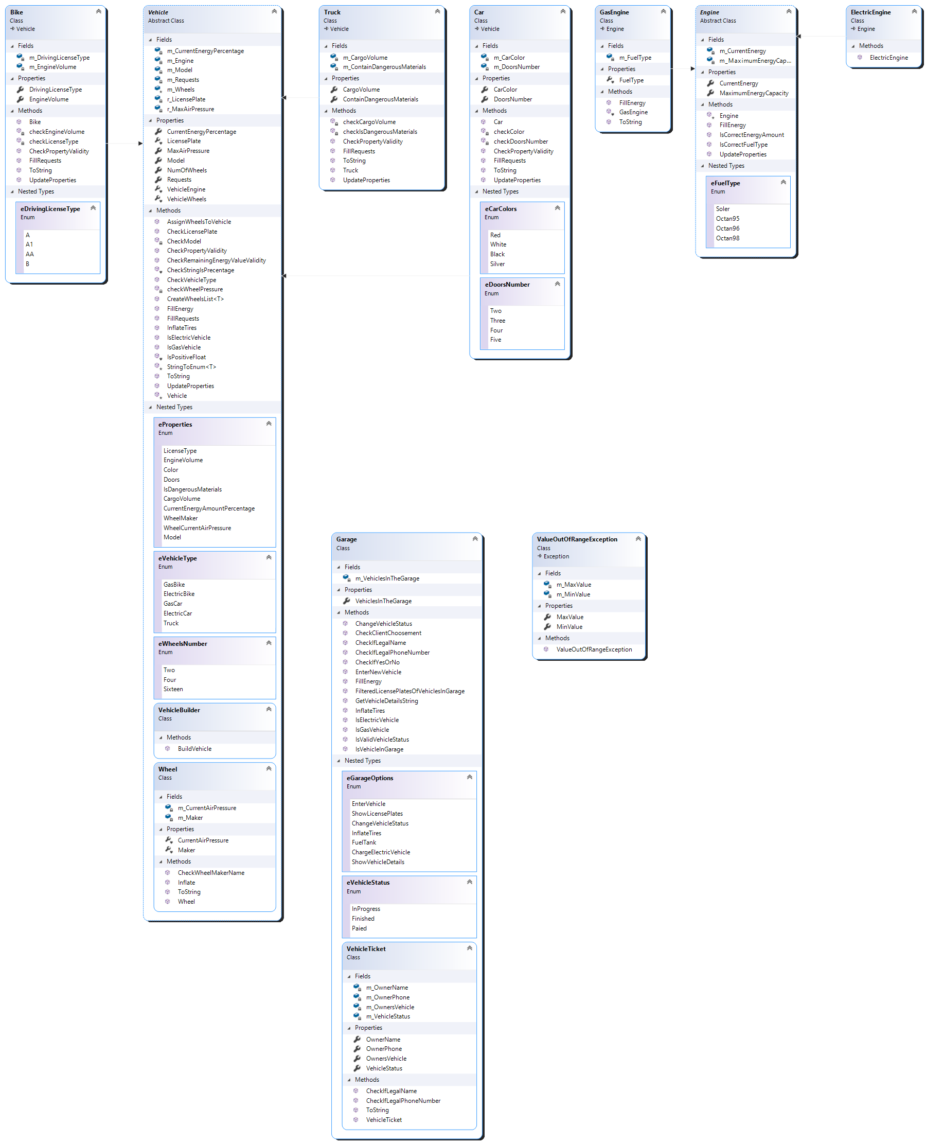

**Description**:

**Class Vehicle** contain the basic properties and methods of the variety vehicles

include:

Enum eProperties- the properties of vehicle

Enum eVehicleType-the different types of vehicles.

Enum eWheelNumber- the different options of wheels number in the different vehicles.

Class VehicleBuilder- build the base of the vehicle.

**Class Bike**- derived from Class Vehicle and contain the properties and methods of Bike.

**Include**:

Enum eLicenseType- the options of license for bike.

Class Truck- derived from Class Vehicle and contain the properties and methods of Truck.

Class Car- derived from Class Vehicle and contain the properties and methods of Car.

Include:

Enum eCarColor-the different options for car color.

Enum eDoorNum- the different options for number of doors.

Class Engine- contain the basic methods of the different engines

Include:

Enum eFuelType- the different fuel types.

Class ElectricEngine- derived from Class Engine and contain methods and properties of electric vehicles.

Class GasEngine- derived from Class Engine and contain methods and properties of gas vehicles.

Class OutOfRangeExeption- derived from Class Exeption, an exeption that tell about out of limits.

Class Garage- contain the garage operation system and the properties.

Include:

Enum eGarageOptions- the different operations that garage can do.

Enum eVehicleStatus-the different statuses of vehicle in garage.

Class VehicleTicket- contain the information about the owner and the vehicle .