Foreclosure Example: From Training Call to SOP
This reference shows how a real training call transcript was turned into a structured SOP. Use it as a model for how to extract workflows from transcripts and format them as playbooks or SOPs.

The Source: What We Started With
A 40-minute training call where Ty (team lead) walked Marwan (new team member) through the daily process of pulling foreclosure notices from a public records site, qualifying each record, and adding good ones to Sift. The transcript was messy — full of tangents, troubleshooting, and back-and-forth — but the core process was clear.

What We Extracted
From the transcript, we identified:
• 10 main steps in the daily workflow
• 5 key decision points where you keep or skip a record
• 3 tools used (Public Notice site, Zillow, Sift)
• 7 pro tips from the trainer's experience
• 1 complete walkthrough of a real record

The Finished SOP
Below is the SOP that was produced from that transcript. Notice how the messy, conversational training call became clean, scannable documentation with a process map, decision trees, and a worked example.

How to Pull Foreclosure Records Daily
SOP

Purpose & Overview
This process pulls fresh foreclosure notices from your county's public records site every day. You qualify each record, skip the junk, and add good ones to Sift so the team can market to them.
Purpose: Get first-to-market foreclosure leads into Sift every day.
How: Pull notices from public records, qualify each one, and upload the good ones.

Process Map
Here's the workflow at a glance. The overview shows the major phases, then each phase has its own detail chart below.

Overview: The 4 Phases

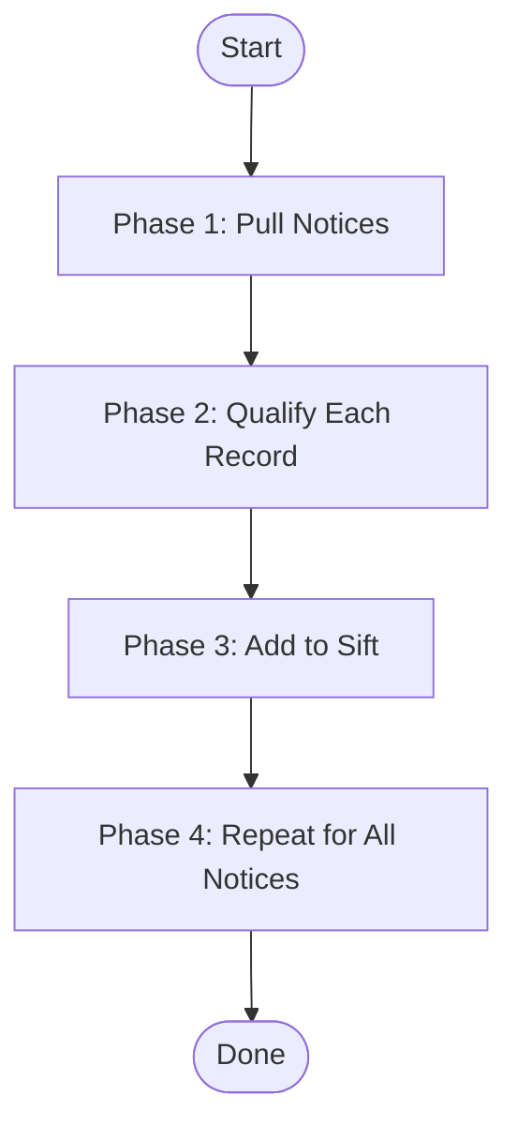

Phase 1 Detail: Pull Notices

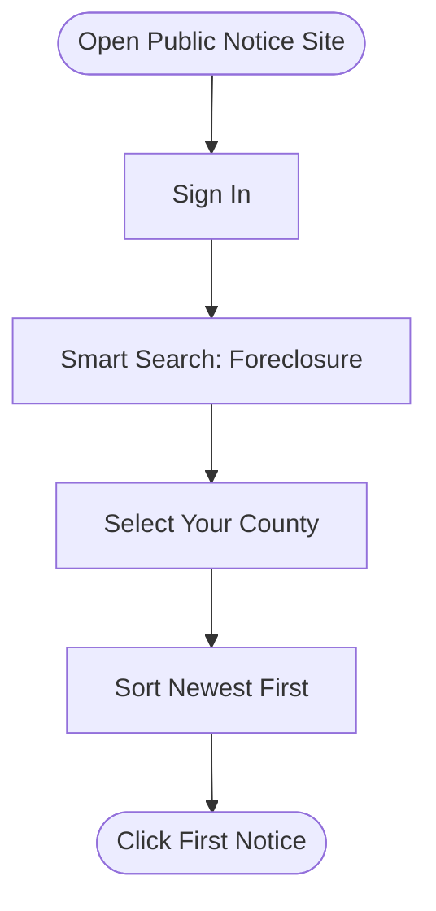

Phase 2 Detail: Qualify Each Record

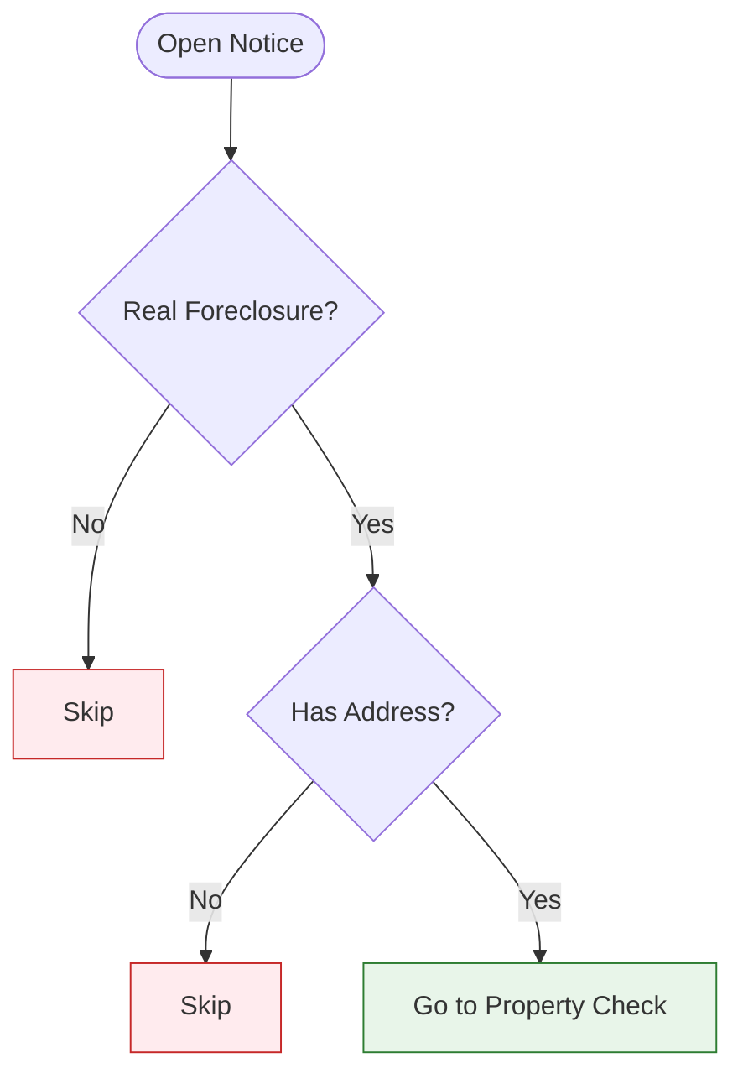

Phase 2 Detail: Property Type Check

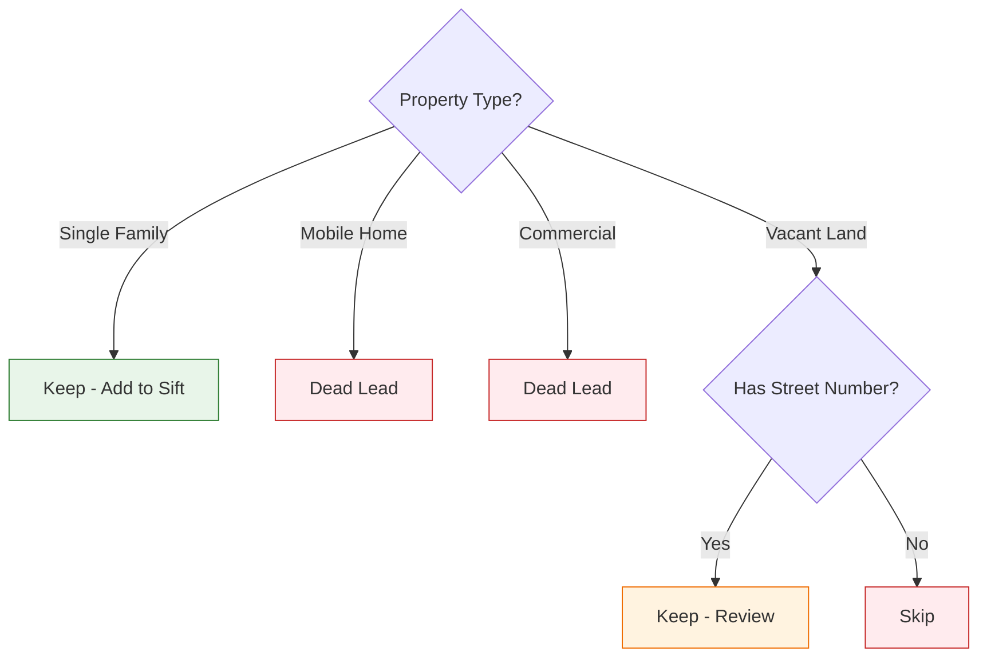

What You Need

Tools & Access

Tool | What It's For | How to Get It
Public Notice Site (e.g., TM Public Notice) | Pulling foreclosure notices daily | Sign up at the site. Use Smart Search.
Zillow | Quick property lookup to check type and value | Free — just go to zillow.com
Sift | CRM where you store and manage leads | Your team admin gives you access

Setup
1. Public Notice Account: Sign in. You'll see a "Welcome" banner at the top. Go to Viewed Search Criteria.
2. Sift Access: Make sure you can create records and upload files.
3. Zillow: No setup needed. Just have it open in another tab.

Steps

Step 1: Open the Public Notice Site and Search Foreclosures
Goal: Pull today's batch of foreclosure notices for your county.
Go to the public notice site and sign in. Hit Smart Search at the top. Go to Viewed Search Criteria and select Foreclosure. Pick your county (for example, Knox County). Set it to pull the trailing year of data, sorted from newest to oldest.
Actions:
1. Sign in to the public notice site
2. Click Smart Search at the top
3. Select Foreclosure as the search type
4. Pick your county
5. Sort results newest to oldest
6. Set results per page to 50 (speeds things up)

SCREENSHOT: Public Notice Search Screen

Capture: The Smart Search page with Foreclosure selected and county filter applied
Purpose: Shows the reader exactly which filters to set

Pro Tip: Do this every day, ideally in the morning. You want to catch new notices as soon as they're posted. This is how you stay first to market.

Step 2: Open Each Notice and Check If It's a Real Foreclosure
Goal: Filter out non-foreclosure notices that get mixed into the results.
Click on the first notice in the list. It'll open a detail view. Read through it quickly. A lot of the time, what looks like a foreclosure is actually something else — a property tax notice, a non-resident notice, or a government filing.
Actions:
1. Click on the first notice
2. Complete the captcha if one pops up
3. Read the notice quickly
4. Look for the word "foreclosure" or "address" or "property" in the text

Decision Gate:
• IF the notice mentions a property address and foreclosure -> Keep it. Go to Step 3.
• IF it's not clearly a foreclosure (no property mentioned, just legal language) -> Skip it. Click back and go to the next notice.
• IF you're unsure -> Copy the text into ChatGPT and ask: "Is this a foreclosure notice? What's the property address?"

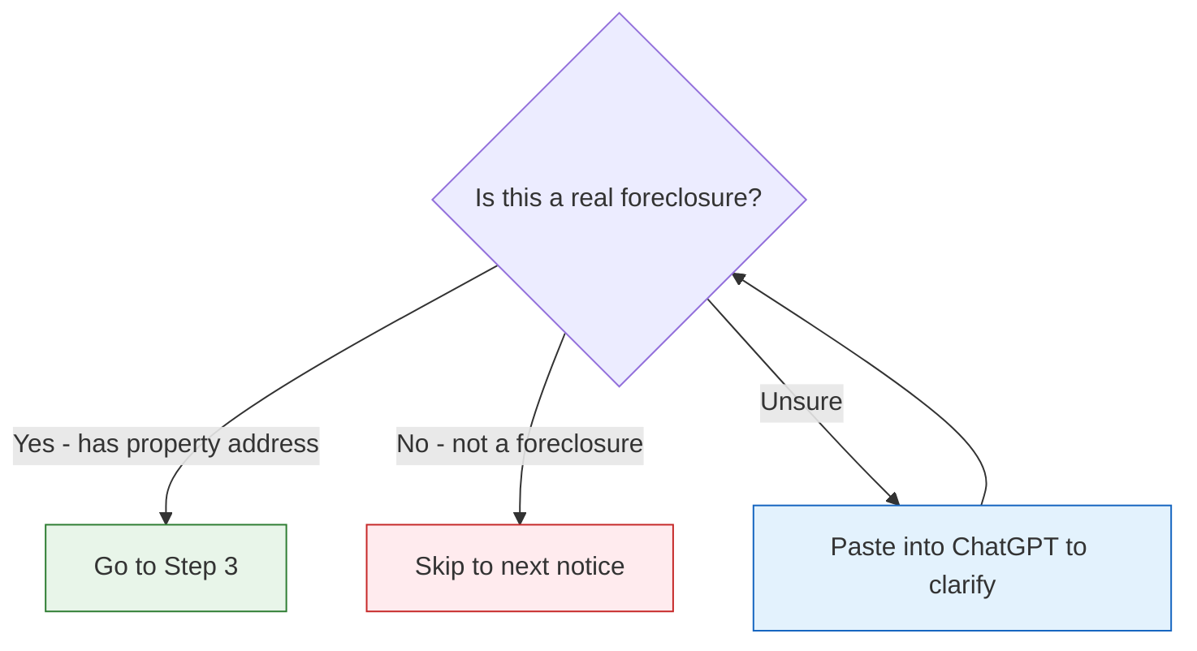

Pro Tip: Anytime the notice is a "non-resident notice," it's almost never a real foreclosure. You can usually skip these. But double-check a few to be safe.

Step 3: Look Up the Property on Zillow
Goal: Figure out what kind of property it is and if it's worth pursuing.
Take the property address from the notice and search it on Zillow. Hit the lightning bolt or just type it in. You're looking for three things: property type, approximate value, and whether it looks like a real house.
Actions:
1. Copy the property address from the notice
2. Open Zillow in another tab
3. Paste the address and search
4. Check the property type and estimated value

Decision Gate:
• IF it's a single-family home under $600K -> Keep it. Go to Step 4.
• IF it's a mobile home -> Dead lead. Mark and skip.
• IF it's commercial (car lot, strip mall, etc.) -> Dead lead. Mark and skip.
• IF it's vacant land with no street number -> Skip — not worth it.
• IF Zillow can't find the address -> The address might be slightly off. Try adjusting it. If still nothing, keep it and manually verify later.

SCREENSHOT: Zillow Property Lookup

Capture: A Zillow search result showing property type and estimated value
Purpose: Shows what information to look for

Pro Tip: Anytime the assessed value shows something like $2,800, be skeptical. That's usually vacant land assessed at almost nothing, not a house. Check the map view to confirm.

Step 4: Add the Property to Sift
Goal: Get this lead into your CRM so the team can market to it.
Go to Sift. Click Records and then Add a New Property. Sometimes Sift will auto-find the property when you start typing the address. If it does, great. If not, you'll need to add it manually.
Actions:
1. Go to Sift -> Records -> Add New Property
2. Type the property address
3. If Sift finds it -> Click to add it
4. If Sift says "property already in records" -> Skip it (someone already added it)
5. If Sift can't find it -> Add manually using Ctrl+Shift+V to paste as plain text

SCREENSHOT: Sift Add Property Screen

Capture: The Add New Property dialog in Sift
Purpose: Shows where to type the address and what buttons to click

Pro Tip: If the manual add button doesn't work at first, make sure you hit it at the end of the address entry. It's a quirk of the system.

Step 5: Fill in the Record Details
Goal: Make sure the record has all the info the team needs.
Once the property is added, fill in the key fields. The system will auto-enrich most of it, but you need to add the date and the source.
Actions:
1. Set the city and zip code (Sift auto-fills most of this)
2. Add the Date Added (today's date, format: MM/DD/YY)
3. Leave other fields blank — Sift will enrich them automatically
4. Add a note: "Foreclosure — [County Name] — pulled [date]"

Step 6: Repeat for Every Notice
Goal: Work through the full list of new notices for the day.
Go back to the search results and click the next notice. Follow the same process: check if it's real, look up on Zillow, add to Sift if it qualifies. Keep going until you've gone through all the new notices since your last pull.
Daily Cadence:
• Do this every day
• Process all new notices since your last session
• Typical volume: 10-50 notices per county per day (many will be skips)
• Expected keepers: roughly 20-30% of total notices

Worked Example: Walking Through a Real Record
Starting point: A new foreclosure notice for Knox County, Tennessee.
Step 1 applied: Opened the public notice site, searched Knox County foreclosures, sorted newest first. Found a notice posted today.
Step 2 applied: Clicked on the notice. Read through it. It mentions "foreclosure sale" and lists a property: "All Tassel Pike, Knoxville, Tennessee 37918." This is a real foreclosure with an address.
Step 3 applied: Searched "All Tassel Pike, Knoxville TN 37918" on Zillow. It's a single-family home. Estimated value: $185,000. Under the $600K cap. Looks like a normal house on a residential street.
Decision: Keep it. Single-family, reasonable value, has a real address.
Step 4 applied: Went to Sift -> Records -> Add New Property. Typed the address. Sift found a match and auto-populated the property details.
Step 5 applied: Added the date (10/13/25). Added a note: "Foreclosure — Knox County — pulled 10/13/25."
End result: The property is now in Sift as a foreclosure lead, tagged with the county and date. Ready for the team to skip trace and start marketing.

Quality Check

Checklist
1. [ ] Pulled all new notices since last session
2. [ ] Checked each notice to confirm it's a real foreclosure
3. [ ] Looked up each property on Zillow to verify type and value
4. [ ] Added all qualifying properties to Sift
5. [ ] Filled in date and source note for each record
6. [ ] Skipped mobile homes, commercial, and vacant land without addresses

Common Problems

Problem | Cause | Fix
Notice isn't a foreclosure | Public records mix in other notice types | Read for the word "foreclosure" or "property address"
Zillow can't find the address | Address in the notice is slightly different | Try variations (street name without direction, nearby city names)
Sift says property already exists | Someone else already added it | Skip it — no need to duplicate
Captcha keeps popping up | The site throttles automated-looking behavior | Solve it and slow down a bit

Quick Reference

Steps at a Glance

Step | What to Do | What You Should See
1 | Search foreclosures on public notice site | List of notices sorted newest first
2 | Open each notice, check if it's real | Property address visible in the notice
3 | Look up property on Zillow | Property type and value displayed
4 | Add qualifying properties to Sift | Property appears in your records
5 | Fill in date and source | Record has complete info
6 | Repeat for all new notices | Empty inbox — all processed

Keep vs. Skip Quick Guide

Property Type | Value | Action
Single-family home | Under $600K | Keep
Single-family home | Over $600K | Review — may not have wholesale buyers
Mobile home | Any | Skip — dead lead
Commercial | Any | Skip — dead lead
Vacant land | Has street number | Review — keep if value is over $50K
Vacant land | No street number | Skip
Any | Assessed at ~$2,800 | Skip — almost always vacant land

