Lead Management
TRAINING MANUAL
Remedi Home Solutions LLC
March 2026

Welcome to Remedi Home Solutions

Company Vision
To become the most elite real estate investment company across Florida by providing unparalleled solutions to homeowners and Remedi Home Solutions investment partners.
Develop an organization with a focus on authentic leaders who are compassionate about helping others and providing honest solutions to the communities we help.

Core Values
- Authenticity
- Compassion
- Honesty
- Wisdom
- Diligence
- Community

Full Service Real Estate 101

What is Full Service Real Estate?
A full-service real estate investment company handles the entire lifecycle of a transaction. There are six major steps to every deal, and as a Lead Manager, you are responsible for the first three: finding the lead, qualifying the lead, and setting the appointment for Acquisitions.

Where Do Leads Come From?
Two of our best sources for wholesale deals are Direct Mail (which generates inbound calls) and Outbound Prospecting (cold calling, text, etc.).
At any given time, there are a certain number of private homeowners looking to quickly liquidate their property. We use several methods to market to these sellers.
- Direct Mail leads are funneled directly into our Lead Management System (DataSift/REISift). You are responsible for following up and gauging interest.
- Outbound Calling leads are also funneled directly into DataSift. These leads are already vetted with interest, so you will be responsible for qualifying the lead as Cold, Warm, or Hot.

How to Qualify a Lead
A lead is qualified not by when they want to close on a property, but by when they are willing to go under an agreement with us to purchase their property (or otherwise solve their situation).
The core items you are looking to understand from a seller:
- What is their timeline to sell?
- What are their price expectations?
- What is the reasoning behind looking to sell?
- What is the condition of the property?
- What happens after they sell? Are they moving? Do they need another property first?
Based on your conversation, you determine the lead temperature and assign the appropriate follow-up task. If the individual is ready for an offer, you assign the appropriate task for a Make Offer and send them to Acquisitions.
For more examples, listen to the seller calls in the WAR Community Classroom.
WAR Community Classroom

The Lead Manager Role
Our goal is to train you to be the best all-around lead manager you can be. The Lead Manager is the first human touchpoint in the sales cycle at Remedi Home Solutions. Your job is to take every lead that enters the business and move it through a structured qualification process until it either becomes an appointment for the Acquisitions Specialist or exits the pipeline.
You are not making offers or closing deals. You are gathering intelligence on the seller’s situation, maintaining consistent follow-up, and making sure no lead ever sits without a next action. You are the bridge between marketing (which generates the leads) and Acquisitions (which makes offers and closes deals).
The core goal of every interaction: end with either an appointment set for the Acquisitions Specialist or a confirmed follow-up task with a date. No third option.

Responsibilities
Daily
- Answer inbound calls from Direct Mail, Website, and Lead Follow-ups
- Call new leads, qualify them, and set follow-ups or appointments
- Track and update KPIs using Tally Count (transfer to Google Sheet end of day)
- Update Lead Summary Document with new lead statuses
Weekly
- Run QC audit filters to make sure nothing is being missed
- Present Lead Summary Overview at team meeting
Monthly / Quarterly
- End of month lead debrief
- End of quarter lead debrief

The System — DataSift Default Build
You will work inside DataSift (REISift), which comes pre-configured with a complete framework for managing leads. This is called the default build. It was developed through direct collaboration with six- and seven-figure real estate investors and refined through hundreds of hours of implementation.
The default build is a starting framework, not a rigid system. Your job is to learn it, operate within it, and over time identify ways to improve it. Be very careful about creating new statuses, tasks, or phases just because you feel like you need them. The system was designed to focus you on what matters. Expanding without understanding impact will create clutter and break automations.

What Comes Pre-Built
- SiftLine Boards — Kanban-style boards for visualizing your pipeline (Lead Management, Acquisitions, Transactions, Wholesale, Flips, Rentals).
- Property Statuses — New Lead, No Contact New Lead, Cold, Warm, Hot, Ghosting Lead, Dead Lead, Not Interested, Under Contract, Closed.
- Task Presets — Pre-configured tasks for each pipeline stage (Call New Lead, No Contact New Lead, Nurture New Lead, Cold/Warm/Hot Follow-Up, Make Offer, etc.).
- Filter Presets — Saved filters organized into folders: My Tasks, Lead Management, Acquisitions, and Transactions.
- Sequences — Automations that fire when statuses change or cards move on the board. They add tasks, change statuses, move cards, and clear old tasks automatically.

How Sequences Work
Sequences follow a trigger → condition → action pattern. When you move a record to the Cold Lead phase on SiftLine, a sequence fires that changes the status to Cold, clears existing tasks, and adds a Cold Follow-Up task due in 45 days. When you complete that task, the sequence loops it. No record ever sits without a next action.
Important: A sequence cannot be triggered by an action from another sequence. If Sequence 1 adds a tag, Sequence 2 cannot be triggered by that tag. Combine the actions into one sequence instead.

STABM — Check Every Record, Every Time
Every time you open or leave a record, run STABM:
S | Status — Is the property status correct for where this record is in the pipeline?
T | Task — Is the right task on the record? Only one task? Correct frequency?
A | Assignee — Is the record assigned to the correct team member?
B | Board — Is the record on the correct SiftLine board and phase? Does it match the status?
M | Messages — Are the notes up to date? Did you log your call notes?

STABM is not just a QC audit step. It is a proactive habit on every record you touch. If you do this on the way in and out, you are doing quality control in real-time.

The Lead Flow
Every lead moves through three phases: New Lead, Unqualified, and Qualified. Within each phase, the record has a specific status, task, and follow-up frequency. Leads are always in motion — they promote or demote based on engagement and never sit static.

Lead Flow Diagram
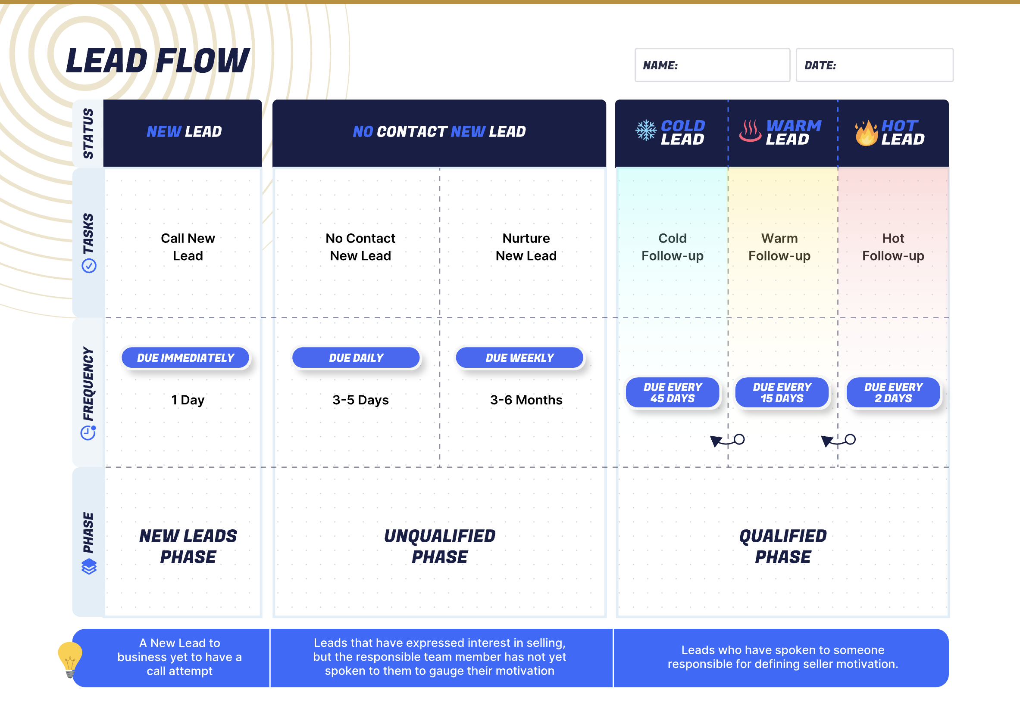

Phase 1: New Lead
A brand-new lead has entered the business. It could come from direct mail, a cold caller, a Carrot website submission, or a pay-per-lead source. The lead manager calls the lead the same day it comes in. By end of day, the New Lead column on SiftLine should be empty.
Task: Call New Lead | Due: Immediately | Duration: 1 day

Phase 2: Unqualified
The lead didn’t answer on the first attempt. There are two stages:
- No Contact New Lead — Daily follow-up for 3–5 days. Call, double-tap, text, leave voicemails. How long you stay here depends on the property quality.
- Nurture New Lead — Weekly follow-up for up to 3–6 months. The lead didn’t pick up during the daily phase, so you reduce frequency. Total touches across the unqualified phase: roughly 31 before moving to Ghosting.

Phase 3: Qualified
You’ve spoken to the seller and qualified them. Based on the conversation, assign a temperature:
- Cold — Follow-up every 45 days. Wants to sell but not urgent. Timeline 180+ days. About 75% of your pipeline.
- Warm — Follow-up every 15 days. Moderate motivation. Timeline 30–180 days. About 15% of your pipeline.
- Hot — Follow-up every 2 days. Actively communicating, wants to sell. About 5% of your pipeline. A hot lead is about tempo and priority, not just motivation level.

Temperature Movement
Leads promote or demote based on engagement:
- Promotion: Cold → Warm → Hot → Send to Acquisitions
- Demotion: Hot → Warm → Cold → Ghosting (after 12–18 months of cycling)

Terminal Statuses
These are the exit points from the active pipeline:
- Dead Lead — Clearly never going to be a deal. No task added.
- Not Interested — Seller confirmed they don’t want to sell after objection handling. Requires an actual conversation. No task added.
- Lost Deal — Property listed or sold to someone else. No task added.
- Ghosting — Stopped communicating. No active task, but receives drip campaign nurture (see Drip Campaigns section). Not permanent — if they respond, they re-enter the pipeline.

The Handoff to Acquisitions
When a qualified lead is ready for an offer, move the record to the Send to Acquisitions phase on SiftLine. This triggers a sequence that creates a Make Offer task and moves the card to the Acquisitions board. If the lead comes back, it goes to Sent Back to LM and re-enters your workflow.

Complete Pipeline Flow — Expanded View
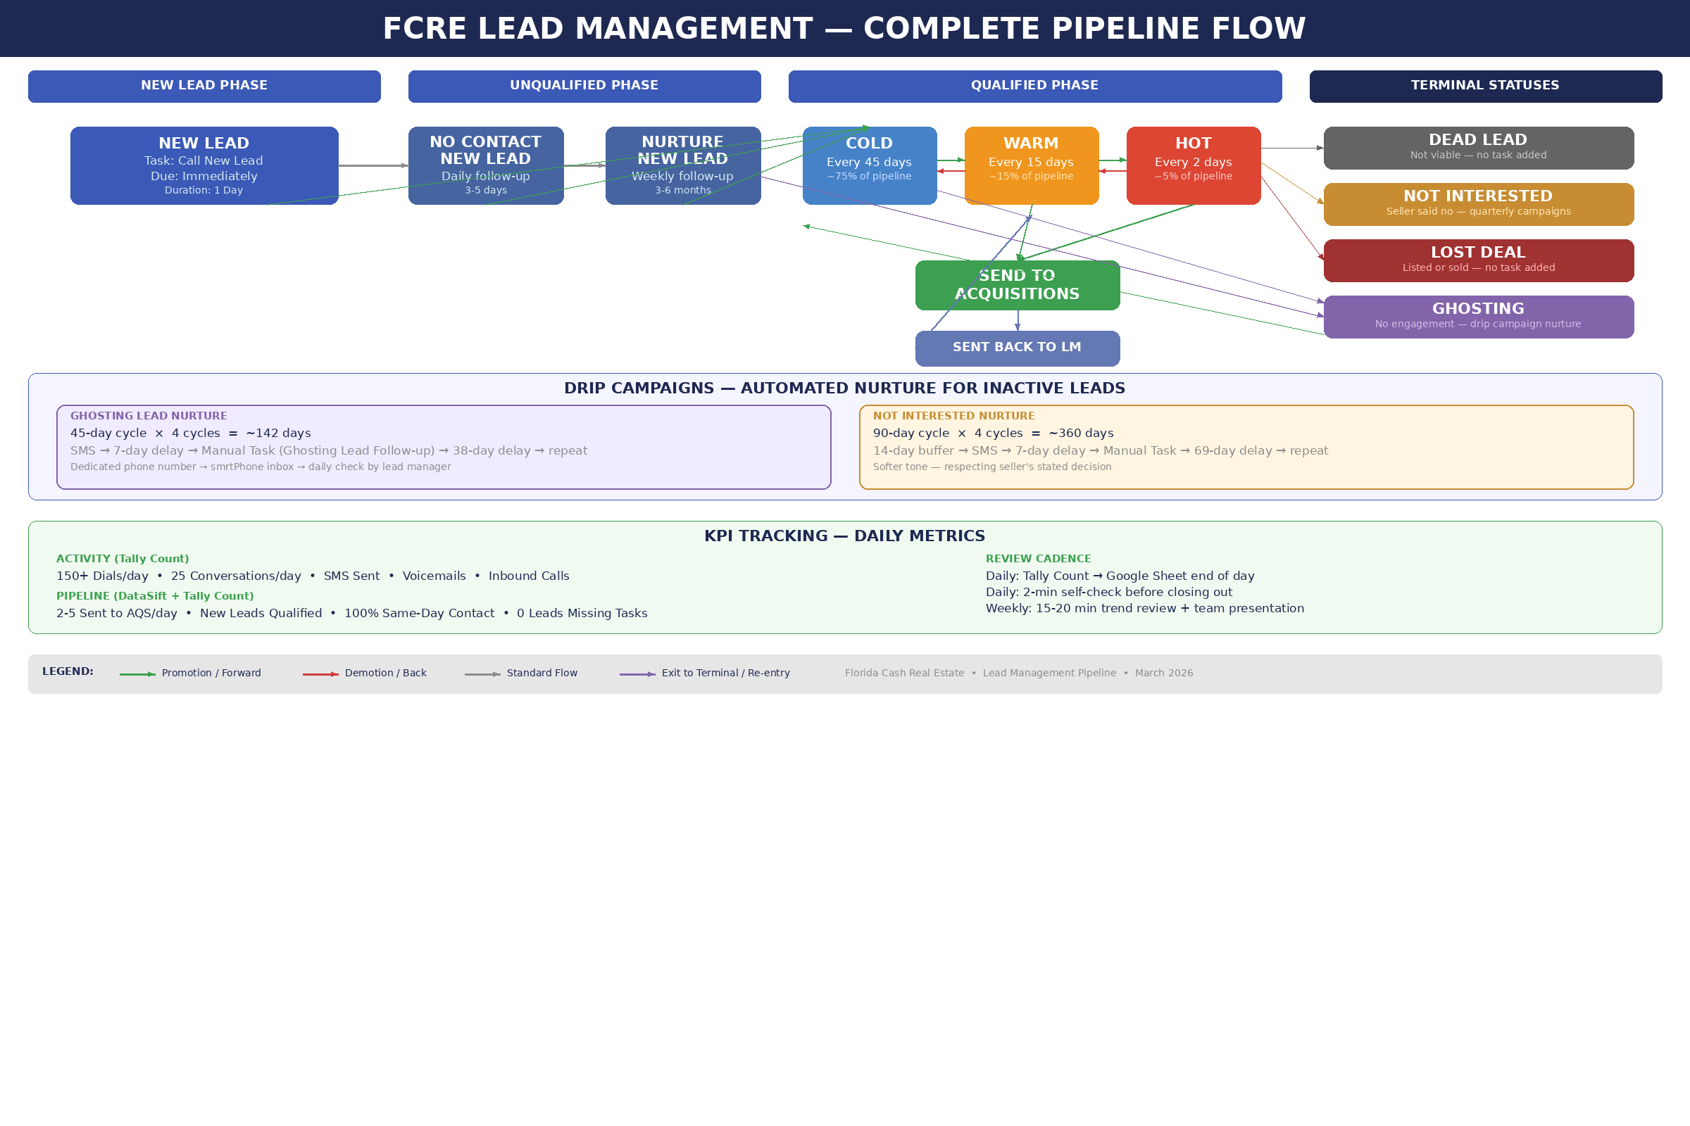
This diagram shows the full pipeline including active phases, temperature movement, terminal statuses, drip campaign nurture, and KPI tracking.

Your Day — Daily Workflow
One rule overrides everything: Any new inbound call or newly submitted lead takes immediate priority over whatever you are currently working on. Inbounds always come first.

Daily Priority Order
Work through these in order using the filter presets on the Records page under the Lead Management folder. For each filter, always check Overdue first, then switch to Due Today.
1. Clear the Queue
Before touching any filter presets, clear your overnight backlog:
- Check for missed phone calls on your personal line — prioritize voicemails first
- Respond to any missed text messages
- Check inbound Direct Mail leads under smrtPhone “Inbound Leads” inbox
- Check inbound PPL leads via smrtPhone “PPL Inbounds” inbox and your PPL provider
- Check inbound Your Website leads via smrtPhone “Online Inbounds” inbox and carrot.com
Note: Some lead sources (Carrot, PPL) may not auto-push to DataSift. Check both the smrtPhone inbox and the source website.
2. Call New Lead Tasks (Preset 0)
Brand-new leads that need a first call attempt. Complete these the same day they come in. By end of day, the New Lead phase on SiftLine should be empty.
3. Unqualified Lead Tasks (Preset 1)
No Contact New Lead (daily follow-up) and Nurture New Lead (weekly follow-up). Call, double-tap, text, leave voicemails.
4. Qualified Follow-Ups (Preset 2)
Your qualified leads — Cold, Warm, and Hot. Work through overdue first, then due today. If you scheduled a specific callback time with a seller, create a Google Calendar event so you don’t miss it.
5. Leads Missing Tasks (Preset 3)
Daily safety net. A lead without a task is invisible to your workflow — it will never surface in your daily filters. Every lead should have a task. No task = no follow-up = dead lead.
6. Sent Back to LM (Preset 5)
Leads that were sent to Acquisitions but came back for additional follow-up. Review, re-qualify, and put back into the appropriate temperature.

Throughout the Day
- New inbounds always take priority over whatever you’re working on
- Update KPIs using Tally Count as you work — don’t batch at end of day
- Log call notes on every record immediately after the call
- STABM every record you touch
- Update custom fields during or immediately after every seller conversation

End of Day
- Check for missed phone calls, voicemails, or texts
- Confirm the New Lead phase on SiftLine is empty
- Confirm all tasks due today have been completed or rescheduled
- Transfer Tally Count numbers to the Remedi Home Solutions KPIs Google Sheet

Custom Fields — The Intake Call
When you get a seller on the phone, it’s not enough to assign a temperature and set a follow-up. You are responsible for capturing detailed information into seven custom field folders in DataSift. These fields are the singular source of truth for the entire company. When Acquisitions pulls a record, when Tyler walks into an appointment, when the underwriting team runs a report — they all start with what’s in these fields. If it’s not in the custom fields, it doesn’t exist.

The Seven Folders
Review these folders inside DataSift and use them as your guide during every qualifying conversation:
- Qualifying Questions — Timeline, motivation, asking price, flexibility
- Property Condition — General — Overall condition, vacancy, interior/exterior notes
- CapEx Assessment — Roof, HVAC, water heater, plumbing, electrical, junk removal
- Property Debts & Encumbrances — Mortgage, taxes, liens, HOA, probate, foreclosure
- Title & Ownership — Decision-maker confirmation, heirs, trusts, attorneys
- Deal Intelligence — Price source, willingness, preferred terms, negotiation intel
- Appointment & Next Steps — Appointment details, property access, what Acquisitions needs

Intake Call Flow
When qualifying a seller, work through the folders in this order:
- Open — Establish rapport. Confirm the address and who you’re speaking with.
- Title & Ownership (Folder 5) — Confirm they are the decision-maker before going further.
- Qualifying Questions (Folder 1) — Timeline, motivation, asking price, flexibility.
- Property Condition (Folder 2) — General condition, vacancy.
- CapEx Assessment (Folder 3) — Ask directly: Has the roof been replaced? Is the AC working? Any plumbing or electrical issues?
- Property Debts (Folder 4) — Mortgage, taxes, liens, HOA, probate.
- Deal Intelligence (Folder 6) — Price source, willingness.
- Appointment & Next Steps (Folder 7) — Set appointment or confirm follow-up.
You may not get through all seven folders on a single call — that’s fine. Capture what you can and fill in more on subsequent conversations. But always start with Title (confirm decision-maker) and Qualifying Questions (understand their situation).
Why CapEx matters: Every “Unknown” in the CapEx fields forces a Full Gut rehab scenario ($50/sqft) and an inspection contingency flag on the underwriting report. Better intake = better underwriting = better offers = more deals closed.

Quality Control
QC is a daily discipline, not an occasional audit. The most important QC happens in real-time through STABM. If you STABM every record on the way in and out, you prevent most issues from accumulating. The QC filters described below are the safety net — they catch anything that slipped through.

Daily: Leads Missing Tasks (Preset 3)
Check this filter every day. A lead without a task is invisible. The only records without tasks should be Dead Leads, Not Interested, Lost Deals, and Ghosting leads.

Weekly: Four Audit Filters
Run these from the Records page. For each filter, cycle through every phase on the Lead Management board.
- Boards, Tasks, Check — Records with overdue or mismatched tasks.
- Boards, No Tasks, Check — Records on a board phase with zero tasks. These are invisible to your workflow.
- Boards with Two or More Tasks — Double tasks from sequences or manual adds. Keep the most recent correct one, delete the rest.
- Boards Missing Correct Number — Records without a working phone number. These will fail in dial sessions and drip campaigns.

The Most Common Problem: Status vs. Phase Mismatch
This happens when someone changes the status manually instead of moving the card on the SiftLine board. When you move a card, the sequence fires and updates everything. When you just change the status, the board phase stays the same and the record is mismatched. Always move cards on the board — let the sequences do their job.

KPI Tracking
KPIs tell you whether you’re doing the right things at the right volume. We track KPIs manually — with a tally counter and a Google Sheet — on purpose. There is no way to get closer to perfect than doing it yourself in real time. The CRM is useful for cross-checking, but the Google Sheet is our source of truth for daily activity metrics.

What Gets Tracked
Your Tally Count categories should be identical to the columns in the Lead Management tab of the Remedi Home Solutions KPIs Google Sheet. One-to-one copy, no translation needed.
Activity Metrics
- Dials Made, SMS Sent, Voicemails, Inbound Calls, SMS Inbound, Qualified Lead Follow-Ups
Pipeline Metrics
- New Leads (Prospects), New Leads Qualified, Conversations, Not Interested, Ghosting, Dead Leads, Sold, Sent to AQS

Benchmarks
KPI | Benchmark | Notes
Dials Made (daily) | 150 minimum | This is the floor, not the target
Conversations (daily) | 25 | Actual two-way conversations
Sent to AQS (daily) | 2–5 | The money metric. Zero for multiple days = something is broken.
Same-Day New Lead Contact | 100% | Every new lead gets a call the same business day
Leads Missing Tasks | 0 | Should be zero every single day

The Daily Tracking Process
- Open Tally Count at the start of your shift.
- Tally every action as it happens — dials, conversations, texts, voicemails, inbound calls.
- After every conversation, update your tally counter immediately. Don’t wait until the end of a calling block.
- End of day: transfer Tally Count numbers to the Remedi Home Solutions KPIs Google Sheet → Lead Management tab.
Do not batch KPI entry at the end of the week. Daily entry keeps the data accurate.

The Leads Summary
In addition to daily KPIs, you maintain the Leads Summary tab — a record-level view of each lead’s journey through the pipeline. The cold caller starts each row when they generate a new lead (address, source, date). You fill in the rest as the lead progresses: date qualified, temperature, date not interested, date dead, etc.
The Lead Management tab tells you how much effort went in. The Leads Summary tells you what happened with the actual leads over time — conversion timelines and seller motivation patterns.

Drip Campaigns
Drip campaigns automate follow-up on leads that no longer need manual effort. The primary use case is Ghosting and Not Interested leads — where you still want periodic contact but don’t want to burn calling hours on manual tasks.

Prerequisites
- SMS integration: smrtPhone, Twilio, or Plivo (Kixie, Smarter Contact, and Launch Control are not supported)
- Account timezone set under Settings → Profile (texts send 8 AM – 9 PM)
- Correct/primary phone numbers on records (records without them will fail)

Ghosting Lead Nurture
45-day cycle × 4 cycles = ~142 days of automated nurture. Each cycle: SMS → 7-day delay → Manual Task (Ghosting Lead Follow-up preset) → 38-day delay → next cycle.
Use a dedicated phone number for this drip. Route all responses through smrtPhone to a “Ghosting Leads” inbox/folder. Check this folder daily as part of your morning queue clear.

Not Interested Nurture
90-day cycle × 4 cycles = ~360 days. Starts with a 14-day buffer before the first text — the seller just said no, don’t text them the next day. Softer messaging tone.

Critical Design Rules
- Drip actions run on autopilot — the lead manager does not approve each text. Have a plan for removal.
- Sequence-based removal is essential — when a lead re-enters the active pipeline (New Lead, Cold, Warm, Hot, Send to AQS), the receiving sequence must remove the drip campaign.
- Watch for task conflicts — don’t add drip-generated tasks to records that already have sequence-generated task loops. This is why drips are best for Ghosting and Not Interested, which don’t have active loops.

Quick Tip Trainings — Loom Videos
These are recorded walkthroughs for processing leads from specific sources. Watch these during your onboarding and reference them whenever you’re processing a new lead type for the first time.

Your Website Lead Processing
After Talking to New PPC/SEO/Carrot Lead Process
Watch on Loom
After Talking to New PPC/SEO/Carrot Lead Process (Part 2)
Watch on Loom
Processing a New Your Website Lead with Property Typo
Watch on Loom

PPL Lead Processing
Processing New PPL Lead — 280 Bracewell St
Watch on Loom
Processing New PPL Lead — 37 Olde Cypress
Watch on Loom
Processing New PPL Lead — 3155 Pinewoods Dr
Watch on Loom

Keys to Success
- Every call should end with an appointment or a confirmed follow-up with a task. There is no third option.
- Comping is the enemy of revenue. There’s selling time and admin time. Master the art of having a general idea of property value so you can understand seller needs without getting bogged down in analysis during calling hours.
- Stay organized. Know who you need to speak with and when. Tasks must be updated constantly in DataSift. Every lead should have a task unless it’s Dead or already has an Appointment set for Acquisitions.
- Call back every lead the same business day it comes in. If a call comes in after 5 PM, you may call the next business day — but motivated lead managers will call back a hot after-hours lead.
- Always take phone calls with DataSift open whenever possible.
- Keep all promises to your prospects. Call them back when you said you would.
- Stay on top of your tasks. Label them High, Medium, Low Priority every day. If you can’t complete all of them, finish high and medium first and reschedule low.
- Commit to continual learning and refining your craft.

Remedi Home Solutions LLC • Lead Management Training Manual • March 2026

