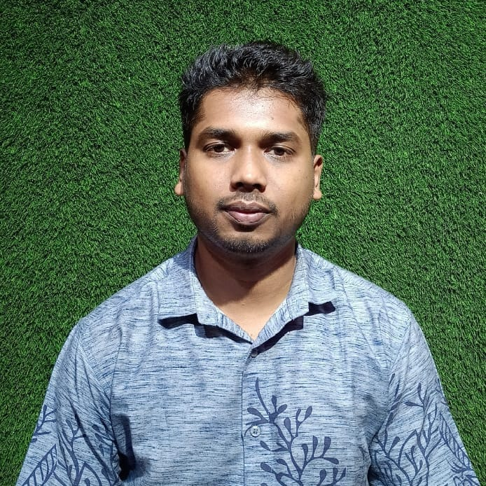
RESUME
OF
Pial Lawrance Costa
CAFÉ ARIYAL KHA
RESTAURANT & PARTY CENTER
Cell: +8801892679582
E-mail: pialcosta2010@gmail.com

Personal Information
Full Name : Pial Lawrance Costa
Date of Birth : May 7, 2001
Father’s Name : Mr. Pabitra Costa
Mother’s Name : Mrs. Kalpana Costa
Passport No. : A03580111
Issuing Date : 09 May ,2022
Validity Date : 08 May, 2027
Religion : Christian (R.C)
Nationality : Bangladeshi (By birth)
Permanent address : Dokhin Rajnagar ,Kaligang, Rangamatia-1720,Gazipur
Vill: Rangamatia
P.O: Rangamatia, P.S: Kaliganj
Dist: Gazipur-1720, Bangladesh.
Mailing address : Dokhin Rajnagar,Rangamatia,Kaligang,Gazipur
Marital Status : Unmarried.
Hobby : Gardening

Professional Experiences

1.) Previous employer: From 1st January 2021… to 27th March,2021.
Worked in Boximco Limited as a Store Keeper.
2) Previous employer: From 1st April,2021…to 20th September,2021
Worked in Hotel71 as Cook
2.) Previous employer: From 10 October,2021… to 20th March, 2022
Worked in Long Beach as Cook

I declare that all the above mentioned Statement is correct and true.

Skills

Ø Responsible to receive all goods,
Ø Good relations with all staff & Customers.

Educational Qualification:

NAME OF EXAM | GROUP | SCHOOL & COLLEGE | YEAR
S.S.C | Business Studies | Bandura Holy Cross School & College | 2018
H.S.C | Business Studies | Bandura Holy Cross School & College | 2021
B.B.S | Commerce | Kaliganj Sromik College, Kaligang,Gazipur. | Still Running

Language
*English, Hindi & Bangla.

Extra-Curricular Activities
*I had been Serve as Coaching Organization named "St. John Vianney Catholic School "
(Center for education, cultural, sports, science and economic
Development).

You’re faithfully

Pial Lawrance costa
Cell: +8801892-679582

Page-2/2

