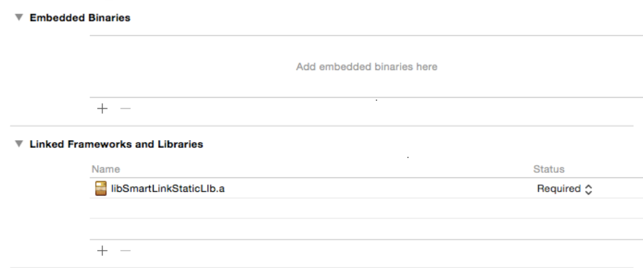
必须用IOS设备来运行(Must use the read IOS device to run the APP)

示例代码：
在自己的工程文件内调入， Import the the following header file in project
#import <SmartlinkLib/SmartlinkLib.h>
-(void)viewDidLoad{
smtlk = HFSmartLink shareInstence];//获取单例 Get instance
smtlk.isConfigOneDevice = true;//设置为多设备配置还是单个配置 Set the single or multiple device config
/*your code*/
}
/*
设置开始的按键 Set the start button
isconnecting 表⽰示是否正在进⾏行配置
*/
- (IBAction)connectPress:(id)sender {
NSString * pswdStr = self.pswd.text;
self.progress.progress = 0.0;
if(!isconnecting){
[smtlk startWithKey:pswdStr processblock:^(NSInteger process) {
self.progress.progress = process/18.0;
} successBlock:^(HFSmartLinkDeviceInfo *dev) {
[self showAlertWithMsg:[NSString stringWithFormat:@"%@:%@",dev.mac,dev.ip] title:@"OK"];
} failBlock:^(NSString *failmsg) {
[self showAlertWithMsg:failmsg title:@"error"];
} endBlock:^(NSDictionary *deviceDic) {
isconnecting = false;
[self.connectBtn setTitle:@"connect" forState:UIControlStateNormal];
}];
isconnecting = true;
[self.connectBtn setTitle:@"connecting" forState:UIControlStateNormal];
}else{
[smtlk stopWithBlock:^(NSString *stopMsg, BOOL isOk) {
if(isOk){
isconnecting = false;
[self.connectBtn setTitle:@"connect" forState:UIControlStateNormal];
[self showAlertWithMsg:stopMsg title:@"OK"];
}else{
[self showAlertWithMsg:stopMsg title:@"error"];
}
}];
}
}
--------------------------------------------------------------------------------------------------
接口注释 Interface Comment
/**
* 设置进度Block Set process block
*
* @param process 0〜～18 的整数 process 0~18 value
*/
typedef void(^SmartLinkProcessBlock)(NSInteger process);
/**
* 设置成功以后的Block Set smartlink success block
*
* @param dev
*/
typedef void(^SmartLinkSuccessBlock)(HFSmartLinkDeviceInfo *dev);
/**
* 设置失败的信息 Set smartlink fail information
*
* @param failmsg 失败信息
*/
typedef void(^SmartLinkFailBlock)(NSString * failmsg);
/**
* 用户手动停掉的block Set smartlink stop block
*
* @param stopMsg 停止的信息 Stop information
* @param isOk 是否停止成功 Is stop ok
*/
typedef void(^SmartLinkStopBlock)(NSString *stopMsg,BOOL isOk);
/**
* 关闭服务的Block Close smartlink service block
*
* @param closeMsg 关闭的信息
* @param isOK 是否关闭成功
*/
typedef void(^SmartLinkCloseBlock)(NSString * closeMsg,BOOL isOK);
/**
* 发现设备的block Find smartlink config OK device block
*
* @param deviceDic 发现的设备 Deice information
*/
typedef void(^SmartLinkEndblock)(NSDictionary * deviceDic);

@interface HFSmartLink : NSObject
/**
* 是否配置单个设备，或者多个设备 默认false Config single or multiple device, false by default
*/
@property (nonatomic) BOOL isConfigOneDevice;
/**
*配置信息发送完成以后，等待搜索设备的时间 second 默认15
*Wait times for sending the smartlink UDP broadcase data. Default is 15 seconds.
*/
@property (nonatomic) NSInteger waitTimers;

/**
* 获取smartlink 的单例 Get smartlink instance
*
* @return 返回smartlink的单例
*/
+(instancetype)shareInstence;

/**
* for smartlink V7.0
* 开始配置 block不能为nil Start config. block should be be nil
*
* @param ssid 路由器SSID Router SSID
* @param key 路由器密码 Router password
* @param v3x false -- 组播+V8(新协议), true – 组播 + V3(老协议)，对于LPB100和LPB120系列模块，请使用true，对于HF-LPB130系列模块，请使用false。
* @param pblock 进度block process block
* @param sblock 成功block success block
* @param fblock 失败block fail block
* @param eblock 结束block end block
*/
-(void)startWithSSID:(NSString*)ssid Key:(NSString*)key withV3x:(BOOL)v3x processblock:(SmartLinkProcessBlock)pblock successBlock:(SmartLinkSuccessBlock)sblock failBlock:(SmartLinkFailBlock)fblock endBlock:(SmartLinkEndblock)eblock;
/**
* 停止配置 Stop config
*
* @param block 停止配置的block
*/
-(void)stopWithBlock:(SmartLinkStopBlock)block;

