GUI Parameter Tuning Guide
Current GUI — parameter-by-parameter tuning
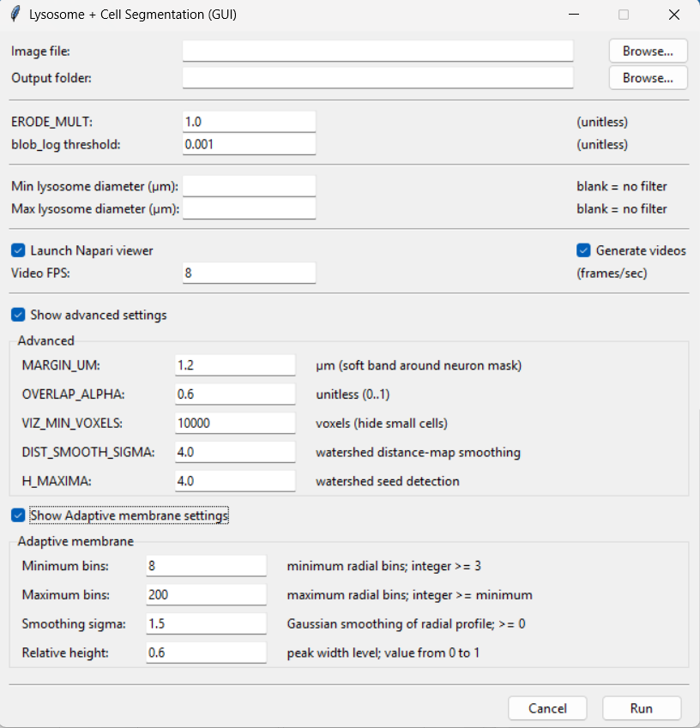
Figure 1. Current GUI with both Advanced and Adaptive membrane sections expanded.
Best starting rule Run the defaults first on a representative image. Change one parameter at a time and compare the Napari overlays/masks. The current GUI has separate checkboxes for Advanced settings and Adaptive membrane settings.

1. Current GUI organization
Control | Default | Purpose | When to adjust
Input | — | Image file + Output folder | Choose source data and destination.
Basic | — | ERODE_MULT + blob_log threshold | Cell-mask erosion and lysosome sensitivity.
Diameter filter | blank | Min/Max lysosome diameter | Optional filtered subset.
Output | on / 8 FPS | Napari + videos | Interactive QC and video generation.
Advanced | visible when checked | MARGIN_UM, OVERLAP_ALPHA, VIZ_MIN_VOXELS, DIST_SMOOTH_SIGMA, H_MAXIMA | Cell association, display filtering and watershed behavior.
Adaptive membrane | visible when checked | Minimum bins, Maximum bins, Smoothing sigma, Relative height | Radial membrane-profile sampling and peak-width interpretation.

2. Basic detection controls

ERODE_MULT — default 1.0
The implementation uses this as an adjustment to the automatically estimated erosion radius. Larger values produce stronger erosion. Increase carefully when masks are too thick or remain connected by narrow bridges; decrease when thin real structures disappear.

blob_log threshold — default 0.001
This is the primary lysosome detection-sensitivity control. Lower values generally produce more candidates, including weaker spots; higher values are more selective. Tune this before changing membrane-profile parameters.

Min / Max lysosome diameter — default blank
Blank means no filter on that side. Use these fields to restrict the diameter-filtered subset. The minimum cannot exceed the maximum and negative values are not valid.

3. Advanced settings
Control | Default | Purpose | When to adjust
MARGIN_UM | 1.2 µm | Width of the soft band around the cell mask. | Higher accepts more near-edge association; lower is stricter.
OVERLAP_ALPHA | 0.6 | Required overlap fraction for association. | Toward 1 = stricter; toward 0 = more permissive.
VIZ_MIN_VOXELS | 10000 | Visualization-size threshold. | Higher hides more small fragments; lower shows more.
DIST_SMOOTH_SIGMA | 4.0 | Distance-map smoothing before watershed seed detection. | Higher removes local peaks; lower preserves more peaks.
H_MAXIMA | 4.0 | Strength threshold for watershed maxima/seeds. | Higher = fewer seeds/less splitting; lower = more seeds/more splitting.

Pairing tip DIST_SMOOTH_SIGMA and H_MAXIMA both control watershed splitting. For more splitting, reduce one or both gradually. For over-segmentation, increase them gradually.

4. Adaptive membrane settings
This section now has its own Show Adaptive membrane settings checkbox. The parameters control the radial intensity profile used to estimate the membrane band.
Control | Default | Purpose | When to adjust
Minimum bins | 8 | Minimum radial profile resolution. | Increase if automatic binning is too coarse; integer ≥ 3.
Maximum bins | 200 | Upper cap on radial profile resolution. | Lower if profiles become too detailed/noisy; must be ≥ minimum.
Smoothing sigma | 1.5 | Gaussian smoothing before peak interpretation. | Higher stabilizes noisy profiles but can blur narrow features.
Relative height | 0.6 | Vertical level used for peak-width/membrane-thickness measurement. | Shape/width control, not a detection threshold; valid 0–1.

5. Symptom-based tuning
Control | Default | Purpose | When to adjust
Too many false lysosomes | — | Increase blob_log threshold. | If mainly tiny, also use a minimum diameter for the filtered subset.
Real lysosomes missing | — | Decrease blob_log threshold. | Change gradually.
Cells split into too many pieces | — | Increase DIST_SMOOTH_SIGMA and/or H_MAXIMA. | Inspect multiple cells.
Touching cells not separated | — | Decrease DIST_SMOOTH_SIGMA and/or H_MAXIMA. | Avoid large jumps.
Boundary lysosomes rejected | — | Increase MARGIN_UM and/or decrease OVERLAP_ALPHA. | Confirm against raw channels.
Outside lysosomes accepted | — | Decrease MARGIN_UM and/or increase OVERLAP_ALPHA. | Check cell edges.
Membrane profile noisy | — | Increase Smoothing sigma; consider lower Maximum bins. | Tune only after segmentation is credible.
Membrane band too broad/narrow | — | Review Relative height and smoothing. | Compare directly with raw Channel-2 signal.

6. Recommended tuning order
- Run defaults and save a baseline.
- Tune blob_log threshold first for lysosome sensitivity.
- Tune ERODE_MULT and watershed controls for cell segmentation.
- Tune MARGIN_UM and OVERLAP_ALPHA for inside/outside association.
- Only then tune Adaptive membrane settings if the membrane band needs correction.
- Validate the final settings on several images and record the values.

7. Valid-input reminders
Control | Default | Purpose | When to adjust
OVERLAP_ALPHA | 0–1 | Fraction | Must remain between 0 and 1.
Minimum bins | ≥ 3 | Integer | At least 3.
Maximum bins | ≥ Minimum bins | Integer | Cannot be below Minimum bins.
Smoothing sigma | ≥ 0 | Number | Non-negative.
Relative height | 0–1 | Number | Must remain between 0 and 1.
Min/Max diameter | blank or ≥ 0 | µm | Minimum cannot exceed maximum.
Video FPS | 8 default | integer | Playback speed only.

