Lysosome + Cell Segmentation (GUI)
Simple User Manual — Current GUI
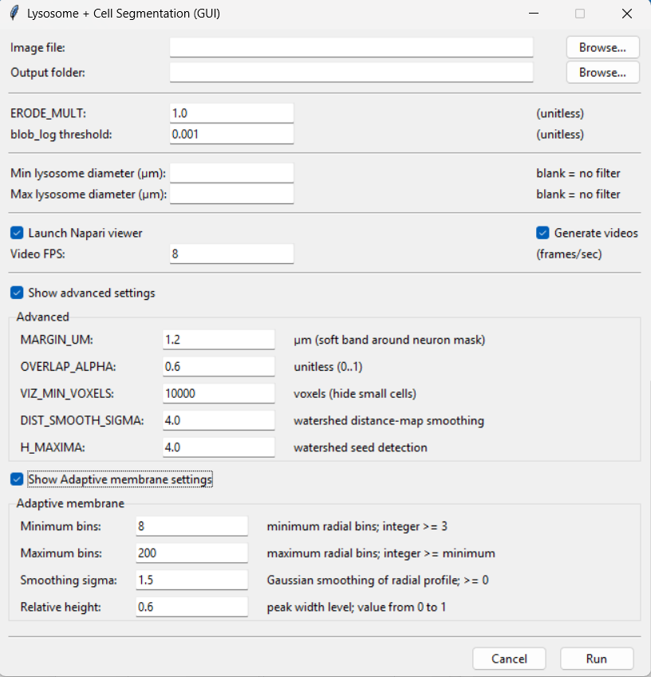
Figure 1. Current GUI with both Advanced and Adaptive membrane sections expanded.
Quick start 1) Choose Image file. 2) Choose Output folder. 3) Keep defaults for the first run. 4) Leave Napari enabled for QC. 5) Click Run. Change one parameter at a time only when a specific problem is visible.

1. What is new in the current GUI
The current window separates the technical controls into two independently collapsible groups: Show advanced settings and Show Adaptive membrane settings. Both are visible in Figure 1. The Adaptive membrane controls are no longer simply presented as part of the Advanced block.

2. Input and output controls
Control | Default | Purpose | When to adjust
Image file | empty | Microscopy image to analyze (.tif/.tiff/.czi). | Required. Use Browse.
Output folder | empty / selected | Destination for tables, TIFFs, videos and other results. | Choose a dedicated results location.
Launch Napari viewer | checked | Opens the interactive viewer after processing. | Keep on for QC; disable for unattended runs.
Generate videos | checked | Creates video outputs. | Disable when videos are unnecessary.
Video FPS | 8 | Playback speed of exported videos. | Raise for faster playback; lower for slower playback.

3. Basic lysosome controls
Control | Default | Purpose | When to adjust
ERODE_MULT | 1.0 | Adjusts erosion used while refining the Channel-2/cell mask. | Increase if masks remain too thick/connected; decrease if real thin structure is lost.
blob_log threshold | 0.001 | Main sensitivity control for blob/lysosome detection. | Lower to detect weaker/more spots; raise to be more selective.
Min lysosome diameter (µm) | blank | Optional lower diameter filter. | Use to exclude very small detections.
Max lysosome diameter (µm) | blank | Optional upper diameter filter. | Use to exclude large/merged detections.

4. Show advanced settings
Checking Show advanced settings reveals the Advanced group. Unchecking it hides the controls without changing the stored values.
Control | Default | Purpose | When to adjust
MARGIN_UM | 1.2 µm | Soft physical band around the neuron/cell mask used in association logic. | Increase for valid near-edge lysosomes; decrease if outside signal is being included.
OVERLAP_ALPHA | 0.6 | Overlap fraction used for cell association (0–1). | Raise for stricter assignment; lower for more permissive assignment.
VIZ_MIN_VOXELS | 10000 | Minimum object size for selected visualization layers. | Raise to hide tiny fragments; lower to show smaller real regions.
DIST_SMOOTH_SIGMA | 4.0 | Smooths the watershed distance map. | Raise to reduce over-fragmentation; lower when touching cells need more separation.
H_MAXIMA | 4.0 | Controls which distance-map peaks become watershed seeds. | Raise for fewer seeds; lower for more splitting.

5. Show Adaptive membrane settings
The current GUI has a separate Show Adaptive membrane settings checkbox. When checked, the Adaptive membrane group appears beneath the Advanced group.
Control | Default | Purpose | When to adjust
Minimum bins | 8 | Minimum radial bins used for the membrane intensity profile. | Usually keep at 8; must be an integer ≥ 3.
Maximum bins | 200 | Maximum radial bins allowed. | Must be ≥ Minimum bins; lower to cap profile detail.
Smoothing sigma | 1.5 | Gaussian smoothing of the radial profile. | Increase if the profile is noisy; decrease if narrow real features are blurred.
Relative height | 0.6 | Peak-width level used when estimating membrane thickness. | Tune cautiously if the membrane band is consistently too broad or narrow; valid range 0–1.

6. Run and Cancel
Run validates the entries and starts the analysis. Cancel closes the GUI without processing. Invalid values should be corrected before the analysis begins.

7. Recommended first-run workflow
- Select the image and output folder.
- Keep ERODE_MULT = 1.0 and blob_log threshold = 0.001 for the baseline run.
- Leave diameter fields blank unless a size filter is intentionally required.
- Keep Launch Napari viewer checked so the segmentation and detections can be inspected.
- Keep Advanced and Adaptive membrane values at their defaults initially.
- After reviewing the result, change only the parameter connected to the visible problem.

8. Quick troubleshooting
Control | Default | Purpose | When to adjust
Too many lysosomes | — | Increase blob_log threshold slightly. | Also consider Min diameter if false detections are tiny.
Too few lysosomes | — | Decrease blob_log threshold gradually. | Compare several cells/slices.
One cell split too much | — | Increase H_MAXIMA and/or DIST_SMOOTH_SIGMA. | Use small changes.
Touching cells stay merged | — | Decrease H_MAXIMA and/or DIST_SMOOTH_SIGMA. | Check the mask after each change.
Membrane profile noisy | — | Increase Adaptive membrane Smoothing sigma. | Consider reducing Maximum bins if excessively detailed.

9. Before clicking Run
☐ Correct microscopy image selected
☐ Correct output folder selected
☐ Diameter filter blank unless intentionally used
☐ Napari enabled if interactive QC is wanted
☐ Advanced values checked if you changed them
☐ Adaptive membrane values checked if you changed them

