Napari Interface and Layer Guide
Microscopy cell and lysosome workflow - current interface
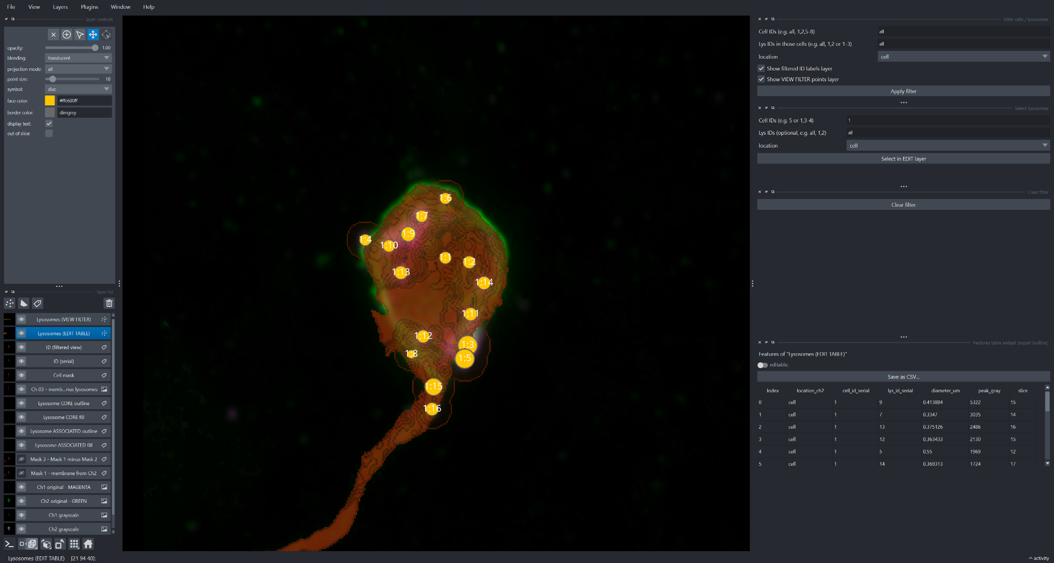
Figure 1. Current napari workspace, including the two additional derived mask layers: Mask 3 - Mask 1 minus Mask 2 and Mask 1 - membrane from Ch2.

1. Quick orientation to the current napari window
- Upper-left: layer display controls for the selected Points layer.
- Lower-left: the complete layer stack, including the two additional mask layers.
- Center: fluorescence, segmentation, masks, and cell:lysosome annotations are composited on the canvas.
- Upper-right: Filter cells / lysosomes.
- Middle-right: Select lysosomes in the editable layer.
- Lower-right: feature table for Lysosomes (EDIT TABLE), with editable toggle and Save as CSV.

2. Layers in the current project
Layer | Type | Role | How to use it
Lysosomes (VIEW FILTER) | Points | Filtered display subset of lysosome points. | Use after Apply filter for focused viewing.
Lysosomes (EDIT TABLE) | Points | Working/editable lysosome point set. | Use for selection, review, and intentional metadata editing.
ID (filtered view) | Points/text | ID labels for the filtered subset. | Show with VIEW FILTER.
ID (serial) | Points/text | Full serial ID annotation set. | Use for full-field identity context.
Cell mask | Labels | Segmented cell region(s). | Use with reduced opacity to check cell boundaries.
Ch 03 - membrane minus lysosomes | Derived image | Processed membrane/context signal with lysosome-related regions removed or excluded by the workflow. | Compare with original channels and mask layers for spatial QC.
Lysosome CORE outline | Outline | Boundary of core lysosome regions. | Preferred for boundary QC.
Lysosome CORE fill | Labels | Filled core lysosome segmentation. | Use with partial opacity.
Lysosome ASSOCIATED outline | Outline | Boundary of associated/peripheral lysosome regions. | Compare directly with CORE outline.
Lysosome ASSOCIATED fill | Labels | Filled associated/peripheral lysosome regions. | Compare with CORE fill and underlying signal.
Mask 3 - Mask 1 minus Mask 2 | Derived mask | Difference mask produced by subtracting Mask 2 from Mask 1. | Use to inspect the portion retained in Mask 1 after removal of the Mask-2 region; compare with Ch 03 and the original channels.
Mask 1 - membrane from Ch2 | Derived mask | Membrane mask derived from Channel 2. | Use as the direct segmentation/QC representation of the Channel-2 membrane; compare against Ch2 original - GREEN and Ch2 grayscale.
Ch1 original - MAGENTA | Image | Original Channel 1 displayed in magenta. | Primary Channel-1 color reference.
Ch2 original - GREEN | Image | Original Channel 2 displayed in green. | Primary Channel-2 color reference.
Ch1 grayscale | Image | Grayscale display of Channel 1. | Useful for intensity/morphology without color mixing.
Ch2 grayscale | Image | Grayscale display of Channel 2. | Useful for Channel-2 membrane/intensity inspection.

3. The two additional mask layers

Mask 1 - membrane from Ch2
This layer represents the membrane mask derived from Channel 2. Its main purpose in napari is quality control: turn on Ch2 original - GREEN or Ch2 grayscale underneath it and check whether the mask follows the visible Channel-2 membrane signal. Use partial opacity when needed so both the segmentation and raw fluorescence remain visible.
QC questions: Does the mask follow the true cell membrane? Does it extend into background? Are real membrane regions missing? Does it preserve thin extensions of the cell?

Mask 3 - Mask 1 minus Mask 2
This is a derived difference mask. The layer name indicates that it contains the region remaining after Mask 2 is removed from Mask 1. In practical QC, it lets you see which part of the Mask-1 membrane region remains after the second mask has been excluded.
Use it together with Mask 1, the lysosome CORE/ASSOCIATED layers, Ch 03 - membrane minus lysosomes, and the original fluorescence. Toggling these layers on and off is the safest way to understand exactly which spatial regions are being retained or removed.

4. Recommended display order
- Bottom: Ch1 original - MAGENTA and Ch2 original - GREEN, or their grayscale versions.
- Above the raw images: Cell mask and Mask 1 - membrane from Ch2 with partial opacity.
- Above Mask 1: Mask 3 - Mask 1 minus Mask 2 and other derived contextual layers such as Ch 03.
- Above the masks: Lysosome CORE and ASSOCIATED fills/outlines.
- Top: Lysosome point layers and ID text layers.

5. Filter cells / lysosomes
Control | Use
Cell IDs | Enter all, individual IDs, comma-separated IDs, or ranges.
Lys IDs in those cells | Optionally restrict lysosomes within selected cells.
location | Choose the location/classification scope.
Show filtered ID labels layer | Toggle ID (filtered view).
Show VIEW FILTER points layer | Toggle Lysosomes (VIEW FILTER).
Apply filter | Apply the requested visual subset.

6. Select lysosomes and EDIT TABLE
The selection widget identifies matching records in Lysosomes (EDIT TABLE). Filtering controls what is displayed; selection controls which editable records are selected.
Feature column | Meaning
location_ch2 | Channel-2 location/classification.
cell_id_serial | Serial cell identifier.
lys_id_serial | Serial lysosome identifier.
diameter_um | Lysosome diameter in micrometers.
peak_gray | Peak grayscale/intensity-related measurement.
slice | Associated image-slice index.

7. Updated QC workflow including the mask layers
- Start with Ch1 original - MAGENTA and Ch2 original - GREEN.
- Check Cell mask against the original fluorescence.
- Turn on Mask 1 - membrane from Ch2 and compare it directly with Channel 2.
- Toggle Mask 3 - Mask 1 minus Mask 2 to inspect the region remaining after the Mask-2 exclusion.
- Compare Mask 3 with Ch 03 - membrane minus lysosomes to understand the derived membrane/residual region.
- Inspect Lysosome CORE outline and fill.
- Inspect Lysosome ASSOCIATED outline and fill.
- Use ID (serial) to confirm cell:lysosome identities.
- Filter to a manageable subset when needed.
- Cross-check cell_id_serial and lys_id_serial in the EDIT TABLE.
- Select/edit only when necessary and re-check the masks and original channels afterward.
- Save as CSV after validation and Clear filter before a new query.

8. Quick reference
Goal | Layer(s) to use | What to check
Original Channel 1 | Ch1 original - MAGENTA / Ch1 grayscale | Raw lysosome-related intensity and morphology.
Original Channel 2 | Ch2 original - GREEN / Ch2 grayscale | Raw membrane/cell-related intensity.
Cell segmentation | Cell mask | Cell boundary against fluorescence.
Channel-2 membrane segmentation | Mask 1 - membrane from Ch2 | Agreement between membrane mask and raw Ch2.
Difference region | Mask 3 - Mask 1 minus Mask 2 | What remains from Mask 1 after Mask 2 is removed.
Derived membrane residual | Ch 03 - membrane minus lysosomes | Relationship between residual membrane signal and lysosome regions.
Lysosome core | CORE outline / fill | Core boundary and measured region.
Associated lysosome region | ASSOCIATED outline / fill | Expanded/peripheral region relative to CORE.
IDs | ID serial / filtered view | Correct cell:lysosome identity.
Measurements | Lysosomes (EDIT TABLE) | IDs, location, diameter, peak intensity and slice.

