DEPARTMENT OF SOFTWARE ENGINEERING

OBJECT ORIENTED PROGRAMMING (OOP)
FINAL PROJECT
Submitted By
Abdul Wahab (F-301025)
Wardah Fatima (F-301056)
Tayyaba Fatima Zafar (f-301014)
Class: BSE-3
Semester: 3
Instructor Name
Engr. Saiqa Anjum
Submission Date: 12 January 2022
Project Submission
Subject: OBJECT ORIENTED PROGRAMMING
Course: SE-03
Instructor: Saiqa Anjum

QUESTION:
Make an information system.

ABSTRACT
This is a Postal Service Information System. The Postal Service's mission is to provide the nation with reliable, affordable, universal mail service. We’ve designed this system to ease the process of collecting, processing, storing and distributing information. This system can be used in various education departments and can distribute the copies of the system among the management and staff members for the required information of their customer.

INTRODUCTION
Difficulty in speedy and efficient information processing is crucial to our socially and highly developed technology. Computer can help the intolerable burden of handling the ever-increasing amount of information with government department, public services and business concerns expected to contain because of their ability to analyze information. This may also to some extent lead to problems occurring due to information explosion.
Post Office works in every walk of our life. Through the automation of this system one can easily generate the information about the customer available and also about the old records. For this efficient software the first and the foremost thing is that all the requirements should be known before hand and the developer should devote its effort for the completion of that requirement which are demanded by the customer should be fulfilled.

PROBLEM STATEMENT
Records of mails are made manually simply by noting it in the records book. However, this method is not suitable and outdated as it creates problem later. The possibility of losing track of records and the inability to receive mail from the correct person is very high. Besides that, it is slower to hand over mail to receiver as it consumes quite some time to call each staff individually to pick up their mail and post items.
With the development of this system, finding of records and confirmation of parcel receive can be made easily.
MOTIVATION
The post office provides an important public service. To our country's founders, the Postal Service's social and civic purpose—connecting people to each other and fostering a well-informed citizenry—were as or more important than its economic benefits.

LITERATURE REVIEW
- Accessibility of an urban postal service system with a limited number of postal service counters installed.
- The MCLP has become one of the most extensively investigated location models due to its applicability to a wide range of practical problems
- p-median problem (PMP) was used to determine the optimal locations of switching centers in a telecommunications network.
- The use of simulation has become an attractive tool to evaluate a model’s output in several problems, e.g., factory flow optimization, production planning, service accessibility, and intermodal transportation under uncertainty.

METHODOLOGY
- To solve the problems of traditional mathematical methods
- Proposed a variable dependent method for the service system design problem
- Use of file handling concept for the storage of data and creating a database
- Database of Account officer, Clerks, Postman and customer
- Database of Orders, Addresses etc.
- Shifting the display panel and making the menu as user friendly as we can
BLOCK DIAGRAM:
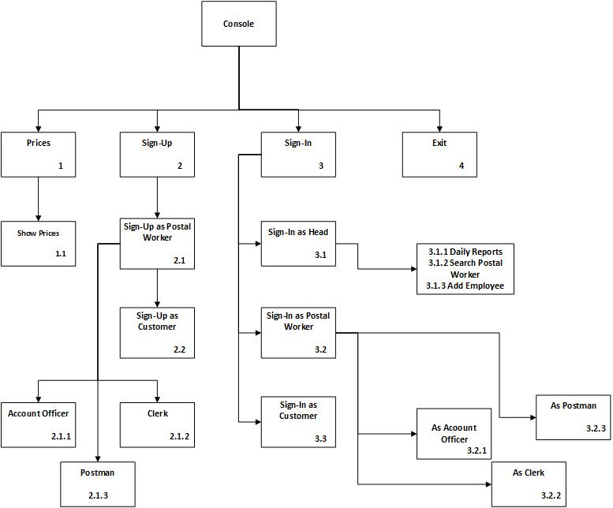

USE CASE:
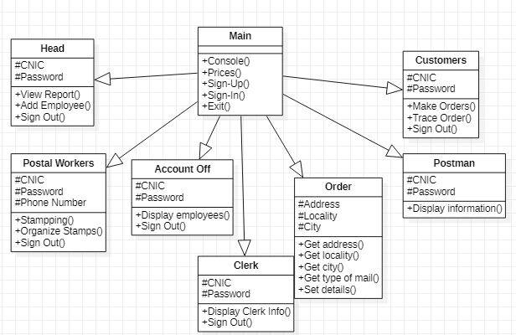
FAILURE
- Multiple user contradiction
- No order tracking
- File handling of orders won’t pick the records
- Records maintenance of admin function is replaced rather than sorting

FUTURE WORK
We can add some features to the existing system:
- Transaction receipt
- Order tracking

PROGRAM:
/*
Group Project
Wardah Fatima (f-301056)
Tayyaba Fatima Zafar (f-301014)
Abdul Wahab (f-301025)
*/

#include "Head.cpp"
#include "PostalWorkers.cpp"
#include "Clerk.cpp"
#include "AccountOfficer.cpp"
#include "Postman.cpp"
#include "Customers.cpp"
#include "Order.cpp"

using namespace std;

void console();
void options1();
void prices();
void controller();

int main()
{
controller();
}

void console()
{
cout << "\n\t\t **************************************** \n";
cout << "\n\t\t WELCOME TO PAKISTAN-POST COURIER SERVICE \n";
cout << "\n\t\t **************************************** \n";
}

void options1()
{
cout << "\n";
cout << "\t 1. Prices";
cout << "\t 2. Sign Up";
cout << "\t 3. Sign In";
cout << "\t 4. Exit";
}

void prices()
{
cout << "\n PRICE TABLE OF REGULAR MAIL SERVICE";
cout << "\n";
cout << "\n Weight upto Weight upto Additional";
cout << "\n 250 grams 500 grams 500 grams";
cout << "\n";
cout << "\n Local Rs. 25 Rs. 40 Rs. 10";
cout << "\n";
cout << "\n Inter-City Rs. 60 Rs. 100 Rs. 20";

cout << "\n PRICE TABLE OF URGENT MAIL SERVICE";
cout << "\n";
cout << "\n Weight upto Weight upto Additional";
cout << "\n 250 grams 500 grams 500 grams";
cout << "\n";
cout << "\n Local Rs. 50 Rs. 65 Rs. 25";
cout << "\n";
cout << "\n Inter-City Rs. 85 Rs. 130 Rs. 45";

cout << "\n\n";

cout << "\n PRICE TABLE OF PARCEL DELIVERY SERVICE";
cout << "\n";
cout << "\n Category Rate";
cout << "\n";
cout << "\n Upto 1 Kg Rs. 100";
cout << "\n Upto 3 Kg Rs. 175";
cout << "\n Upto 5 Kg Rs. 250";
cout << "\n Upto 10 Kg Rs. 375";
cout << "\n Upto 15 Kg Rs. 500";
cout << "\n Upto 20 Kg Rs. 625";
cout << "\n Upto 25 Kg Rs. 750";
cout << "\n Upto 30 Kg Rs. 875";

cout << "\n\n";

cout << "\n Back to Home";
}

void controller()
{
Head H;
PostalWorkers *P;
Clerk CL;
AccountOfficer AO;
Postman PM;
Customers C;
Order OR;

fstream file;

int to, s1, s2, s3, s4, s5;
char opt;
bool flag;
string cn, na, nu, pa;

while(1)
{
console();
options1();

opt = getch();

system("CLS");

switch(opt)
{
case '1':
console();
prices();

opt = getch();

system("CLS");
break;

case '2':
console();
options1();

cout << "\n";
cout << "\n\t\t\t\t ^";
cout << "\n\t\t\t\t |";
cout << "\n\t\t\t\t |";
cout << "\n\t\t\t\t |--- 1. As Postal Worker";
cout << "\n\t\t\t\t |";
cout << "\n\t\t\t\t |--- 2. As Customer";

opt = getch();

system("CLS");

switch (opt)
{
case '1':
console();
options1();

cout << "\n";
cout << "\n\t\t\t\t ^";
cout << "\n\t\t\t\t | --- 1. Account Officer";
cout << "\n\t\t\t\t | /";
cout << "\n\t\t\t\t |--- 1. As Postal Worker ----- --- 2. Clerk";
cout << "\n\t\t\t\t | \\";
cout << "\n\t\t\t\t |--- 2. As Customer --- 3. Postman";

opt = getch();

system("CLS");

switch(opt)
{
case '1':
P = &AO;
P->SignUp();

opt = getch();

system("CLS");
break;

case '2':
P = &CL;
P->SignUp();

opt = getch();

system("CLS");
break;

case '3':
P = &PM;
P->SignUp();

opt = getch();

system("CLS");
break;

default:

break;
}
break;

case '2':
C.SignUp();

opt = getch();

system("CLS");
break;

default:

break;
}
break;

case '3':
console();
options1();

cout << "\n";
cout << "\n\t\t\t\t\t\t ^";
cout << "\n\t\t\t\t\t\t |";
cout << "\n\t\t\t\t\t\t |--- 1. As Head";
cout << "\n\t\t\t\t\t\t |";
cout << "\n\t\t\t\t\t\t |--- 2. As Postal Workers";
cout << "\n\t\t\t\t\t\t |";
cout << "\n\t\t\t\t\t\t |--- 3. As Customers";

opt = getch();

system("CLS");

switch (opt)
{
case '1':
H.SignIn();

opt = getch();

system("CLS");

do
{
flag = true;
console();

cout << "\n";
cout << "\n 1. Daily Report";
cout << "\n 2. Search Postal Workers";
cout << "\n 3. Add Employees";
cout << "\n 4. Sign Out";

opt = getch();

system("CLS");

switch(opt)
{
case '1':
cout << "\n\t ***************** \n";
cout << "\n\t YOUR DAILY REPORT \n";
cout << "\n\t ***************** \n";

file.open("Payment.txt");

file >> to >> s1 >> s2 >> s3 >> s4 >> s5;

file.close();

cout << "\n\n Total Earnings : " << to;
cout << "\n";
cout << "\n Stamps sold of each category";
cout << "\n";
cout << "\n Rs.100 Rs.50 Rs.20 Rs.10 Rs.5";
cout << "\n";
cout << "\n " << s1 << " " << s2 << " " << s3 << " " << s4 << " " << s5;

cout << "\n\n Back to Main";

opt = getch();

system("CLS");
break;

case '2':
console();

cout << "\n";
cout << "\n 1. Daily Report";
cout << "\n 2. Search Postal Workers";
cout << "\n\t 1. Account Officer";
cout << "\n\t 2. Clerk";
cout << "\n\t 3. Postman";
cout << "\n";
cout << "\n 3. Add Employees";
cout << "\n 4. Sign Out";

opt = getch();

system("CLS");

switch(opt)
{
case '1':
cout << "\n Following is all the information of Account Officers";

file.open("AccountOfficer.txt");

while(!file.eof())
{
file >> cn >> na >> nu >> pa;

cout << "\n\n";
cout << "\n CNIC : " << cn;
cout << "\n Name : " << na;
cout << "\n Number : " << nu;
}

file.close();

opt = getch();

system("CLS");
break;

case '2':
cout << "\n Following is all the information of Clerks";

file.open("Clerk.txt");

while(!file.eof())
{
file >> cn >> na >> nu >> pa;

cout << "\n\n";
cout << "\n CNIC : " << cn;
cout << "\n Name : " << na;
cout << "\n Number : " << nu;
}

file.close();

opt = getch();

system("CLS");
break;

case '3':
cout << "\n Following is all the information of Postmans";

file.open("Postman.txt");

while(!file.eof())
{
file >> cn >> na >> nu >> pa;

cout << "\n\n";
cout << "\n CNIC : " << cn;
cout << "\n Name : " << na;
cout << "\n Number : " << nu;
}

file.close();

opt = getch();

system("CLS");
break;

default:

break;
}
break;

case '3':
console();

cout << "\n";
cout << "\n 1. Daily Report";
cout << "\n 2. Search Postal Workers";
cout << "\n 3. Add Employees";
cout << "\n\t 1. Account Officer";
cout << "\n\t 2. Clerk";
cout << "\n\t 3. Postman";
cout << "\n";
cout << "\n 4. Sign Out";

opt = getch();

system("CLS");

switch(opt)
{
case '1':
P = &AO;
P->SignUp();

opt = getch();

system("CLS");
break;

case '2':
P = &CL;
P->SignUp();

opt = getch();

system("CLS");
break;

case '3':
P = &PM;
P->SignUp();

opt = getch();

system("CLS");
break;

default:

break;
}
break;

case '4':
cout << "\n\n Head has been signed out successfully!!";
cout << "\n\n Back to Home";

opt = getch();

system("CLS");

flag = false;
break;

default:

break;
}
}
while(flag == true);
break;

case '2':
console();
options1();

cout << "\n";
cout << "\n\t\t\t\t\t\t ^";
cout << "\n\t\t\t\t\t\t |";
cout << "\n\t\t\t\t\t\t |--- 1. As Head --- 1. Account Officer";
cout << "\n\t\t\t\t\t\t | /";
cout << "\n\t\t\t\t\t\t |--- 2. As Postal Worker ----- --- 2. Clerk";
cout << "\n\t\t\t\t\t\t | \\";
cout << "\n\t\t\t\t\t\t |--- 3. As Customer --- 3. Postman";

opt = getch();

system("CLS");

switch (opt)
{
case '1':
AO.SignIn();

opt = getch();

system("CLS");

do
{
flag = true;
console();

cout << "\n";
cout << "\n 1. Manage Accounts";
cout << "\n 2. Sign Out";

opt = getch();

system("CLS");

switch(opt)
{
case '1':
cout << "\n\n All accounts have been managed successfully!!";
cout << "\n\n Back to Main";

opt = getch();

system("CLS");
break;

case '2':
cout << "\n\n Account officer has been signed out successfully!!";
cout << "\n\n Back to Home";

opt = getch();

system("CLS");

flag = false;
break;

default:

break;
}
}
while(flag == true);
break;

case '2':
CL.SignIn();

opt = getch();

system("CLS");

do
{
flag = true;
console();

cout << "\n";
cout << "\n 1. Stamp Orders";
cout << "\n 2. Sign Out";

opt = getch();

system("CLS");

switch(opt)
{
case '1':
cout << "\n\n All orders have been stamped successfully!!";
cout << "\n\n Back to Main";

opt = getch();

system("CLS");
break;

case '2':
cout << "\n\n Clerk has been signed out successfully!!";
cout << "\n\n Back to Home";

opt = getch();

system("CLS");

flag = false;
break;

default:

break;
}
}
while(flag == true);
break;

case '3':
PM.SignIn();

opt = getch();

system("CLS");

do
{
flag = true;
console();

cout << "\n";
cout << "\n 1. Distribute Orders";
cout << "\n 2. Sign Out";

opt = getch();

system("CLS");

switch(opt)
{
case '1':
cout << "\n\n All orders have been distributed successfully!!";
cout << "\n\n Back to Main";

opt = getch();

system("CLS");
break;

case '2':
cout << "\n\n Postman has been signed out successfully!!";
cout << "\n\n Back to Home";

opt = getch();

system("CLS");

flag = false;
break;

default:

break;
}
}
while(flag == true);
break;

default:

break;
}
break;

case '3':
C.SignIn();

opt = getch();

system("CLS");

do
{
flag = true;
console();

cout << "\n";
cout << "\n 1. Place Order";
cout << "\n 2. Trace Order";
cout << "\n 3. Sign Out";

opt = getch();

system("CLS");

switch(opt)
{
case '1':
console();

cout << "\n";
cout << "\n 1. Place Order";
cout << "\n\t 1. Order of Parcel";
cout << "\n\t 2. Order of Mail";
cout << "\n";
cout << "\n 2. Trace Order";
cout << "\n 3. Sign Out";

opt = getch();

system("CLS");

switch(opt)
{
case '1':
OR.setParcelDetails(C.getCnic());

opt = getch();

system("CLS");
break;

case '2':

break;

default:

break;
}
break;

case '2':
console();

cout << "\n";
cout << "\n 1. Place Order";
cout << "\n 2. Trace Order";
cout << "\n\t 1. Tracing Parcel";
cout << "\n\t 2. Tracing Mail";
cout << "\n";
cout << "\n 3. Sign Out";

opt = getch();

system("CLS");

switch(opt)
{
case '1':
OR.traceParcelDetails(C.getCnic());

opt = getch();

system("CLS");
break;

case '2':

break;

default:

break;
}
break;

case '3':
cout << "\n\n Customer has been signed out successfully!!";
cout << "\n\n Back to Home";

opt = getch();

system("CLS");

flag = false;
break;

default:

break;
}
}
while(flag == true);

break;

default:

break;
}
break;

case '5':
exit(0);
break;

default:
exit(0);
break;
}
}
}

OUTPUT:

Main Screen

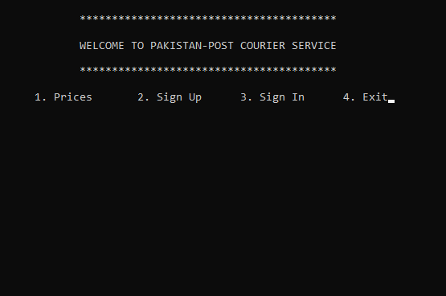

For Prices

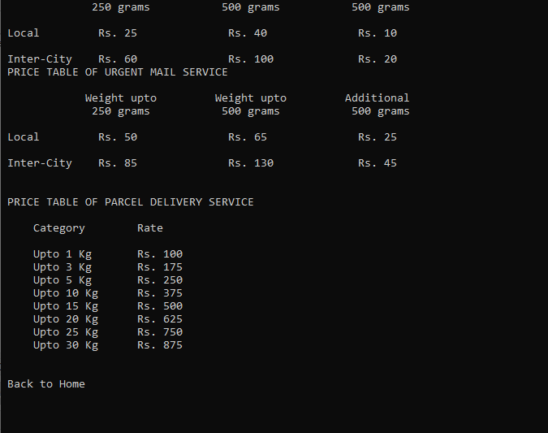

For Sign-up (as a customer)

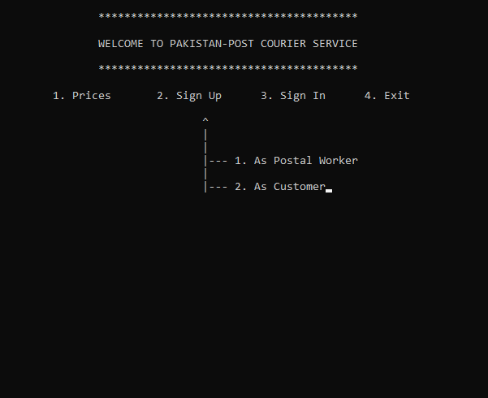

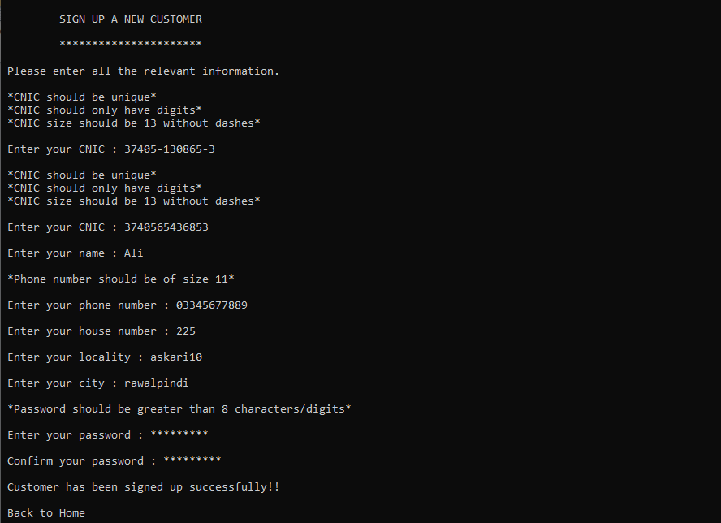

For Sign-in (as head)

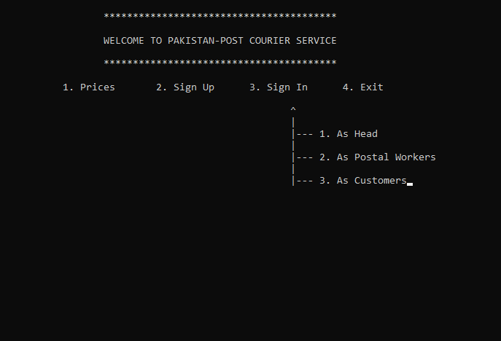

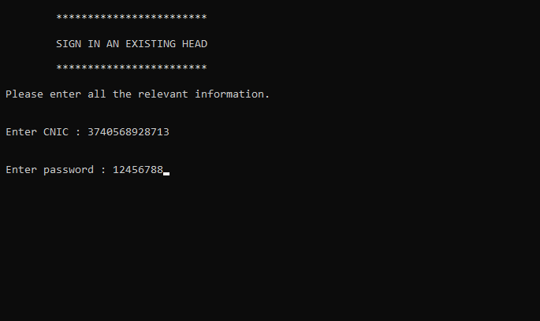

For exit press 4

