1. API endpoint http://simplebankapi.azurewebsites.net/
2. Starter Code \CWS.SimpleBank\js\app
3. There are few modules, but the only one you need to work on is “customer” module
4. Default route is pointing to customer module.

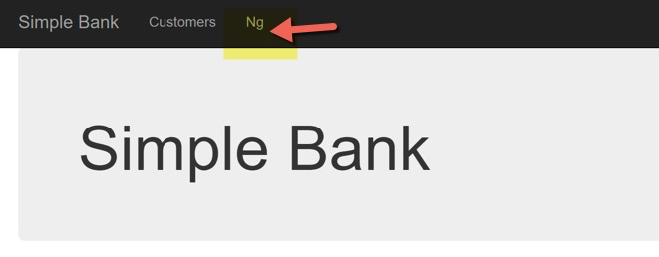

1. After clicking on the link, you will see a list of customers

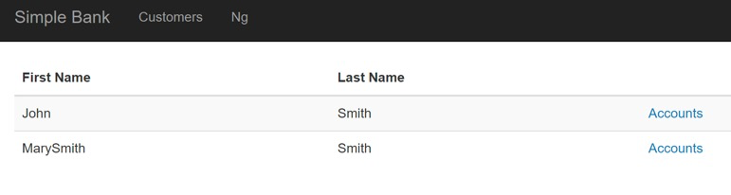

1. Display Account List by calling
   1. /api/CustomerAccounts/<customerNumber>
   2. This will return account array.

[

{

"accountNumber": 8,

"typeCode": "C"

},

{

"accountNumber": 9,

"typeCode": "L"

},

]

1. To get account details call /api/CustomerAccounts/<customerNumber>?accountType=<accountType>
2. This will return an array of accounts for requested type. Make this call for all types that customer has
3. Get all available account types by
   1. api/accounttypes
4. For account types that customer does not have display “Apply for <account type description> account ” button or link
5. Create new Route/Controller/Template – “account-create”
6. Send account type to “account-create” and display type description.