Telemetry Anomaly Detection Report
Generated: 2026-03-11 17:31. This version includes embedded plots/graphs.

1. Objective
Build and evaluate a baseline anomaly detection pipeline for IoT telemetry using Z-score and Isolation Forest on NAB and SKAB datasets.

2. Pipeline Summary
- Data loading: NAB realAWSCloudwatch and SKAB anomaly-free/valve scenarios.
- Preprocessing: timestamp alignment, forward fill, optional smoothing, scaling.
- Feature engineering: rolling statistics and delta-based features.
- Models: Robust Z-score and Isolation Forest.
- Calibration: threshold percentile tuning (99.0, 99.5, 99.9).
- Evaluation: precision, recall, F1, confusion matrix and anomaly score plots.

3. Aggregate Visual Results
Figure 1: NAB per-series F1 comparison.
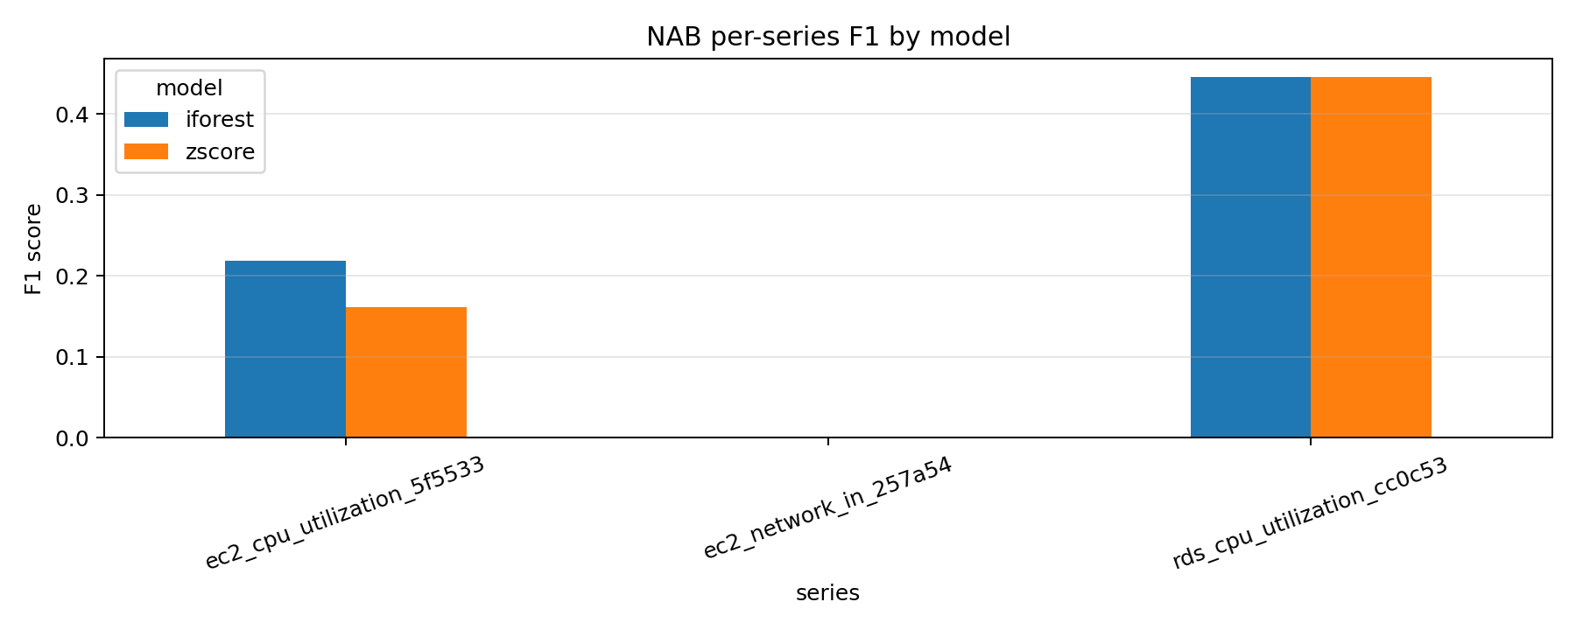
Figure 2: Effect of threshold percentile on F1 for NAB and SKAB.
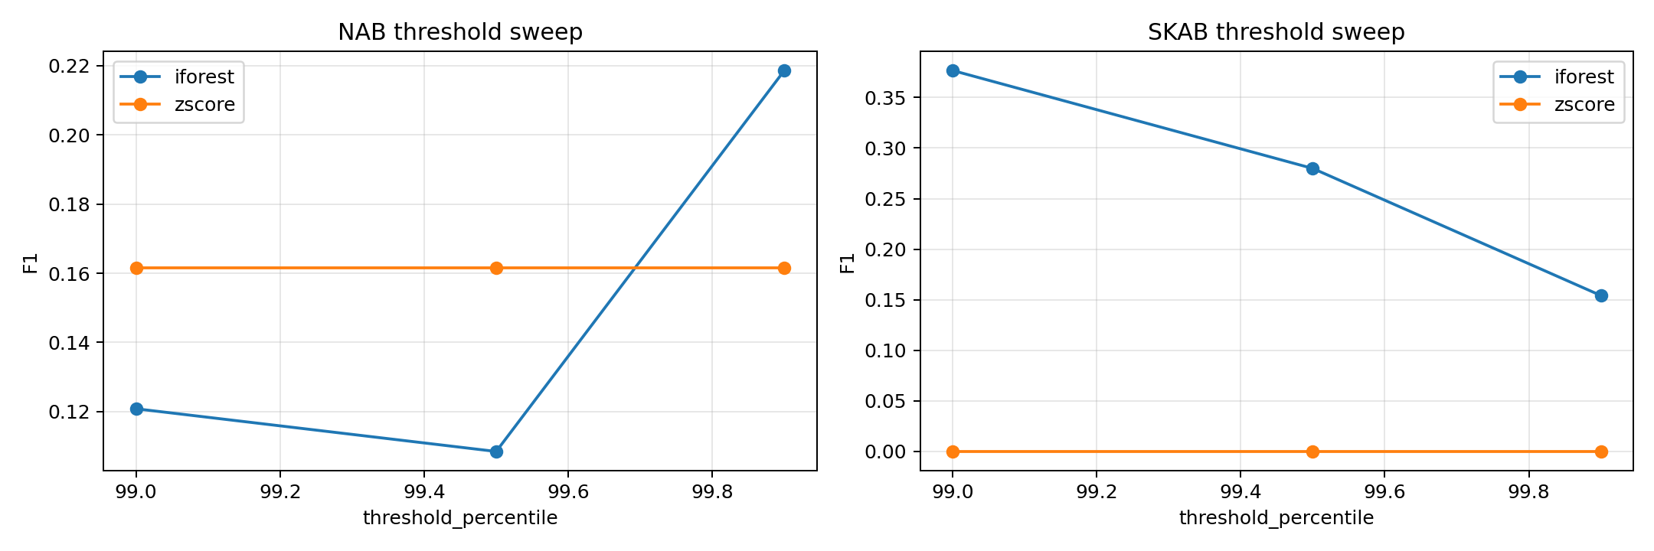

4. NAB Per-Series Metrics Table
Dataset | Series | Model | F1 | Precision | Recall
nab | ec2_cpu_utilization_5f5533 | iforest | 0.2186 | 0.1495 | 0.4067
nab | ec2_cpu_utilization_5f5533 | zscore | 0.1615 | 0.0917 | 0.6733
nab | ec2_network_in_257a54 | iforest | 0.0000 | 0.0000 | 0.0000
nab | ec2_network_in_257a54 | zscore | 0.0000 | 0.0000 | 0.0000
nab | rds_cpu_utilization_cc0c53 | iforest | 0.4461 | 0.3172 | 0.7512
nab | rds_cpu_utilization_cc0c53 | zscore | 0.4461 | 0.3172 | 0.7512

5. Best Thresholds From Sweep
Dataset | Variant | Model | Best Threshold | F1 | Precision | Recall
nab | ec2_cpu_utilization_5f5533 | iforest | 99.9 | 0.2186 | 0.1495 | 0.4067
nab | ec2_cpu_utilization_5f5533 | zscore | 99.0 | 0.1615 | 0.0917 | 0.6733
skab | anomalyfree_vs_valve1_1 | iforest | 99.0 | 0.3767 | 0.4900 | 0.3060
skab | anomalyfree_vs_valve1_1 | zscore | 99.0 | 0.0000 | 0.0000 | 0.0000

6. Detailed Plots
Figure 3: NAB confusion matrices (Z-score, Isolation Forest).
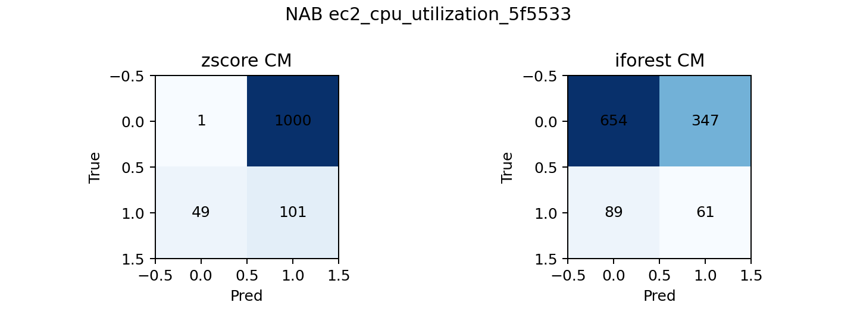
Figure 4: NAB Isolation Forest anomaly score timeline.
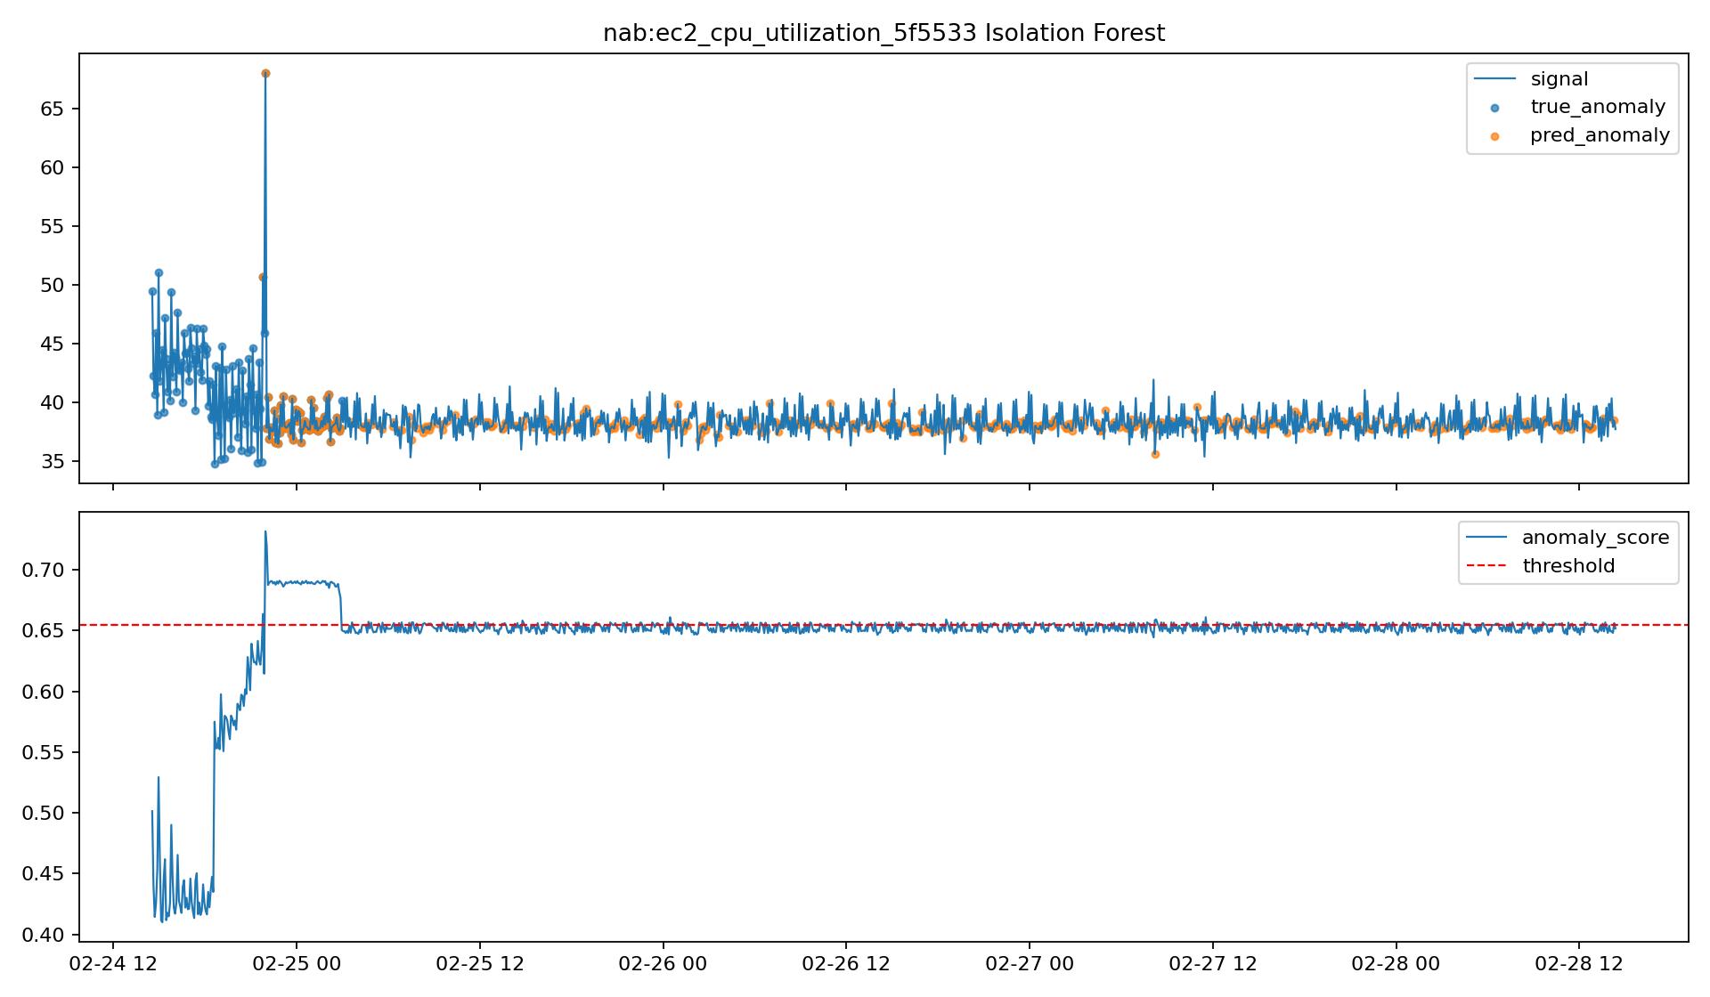
Figure 5: SKAB confusion matrices (Z-score, Isolation Forest).
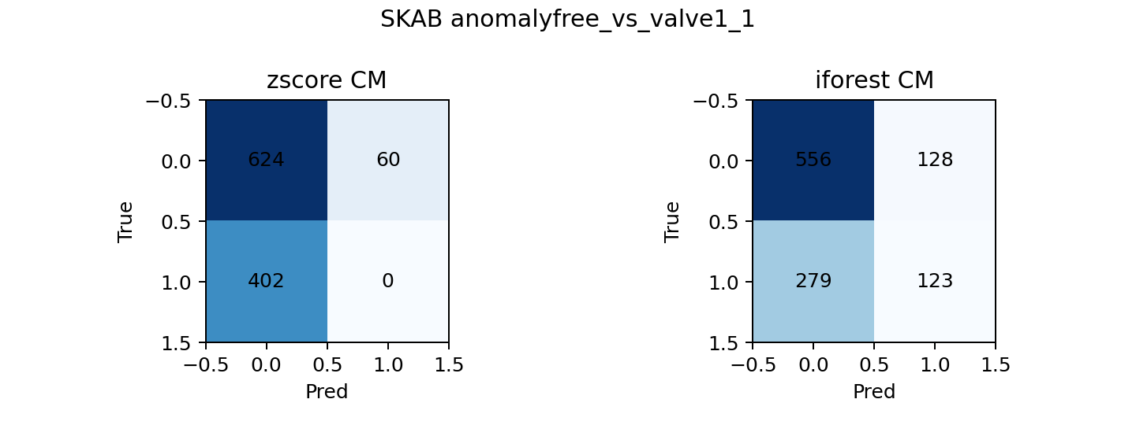
Figure 6: SKAB Isolation Forest anomaly score timeline.
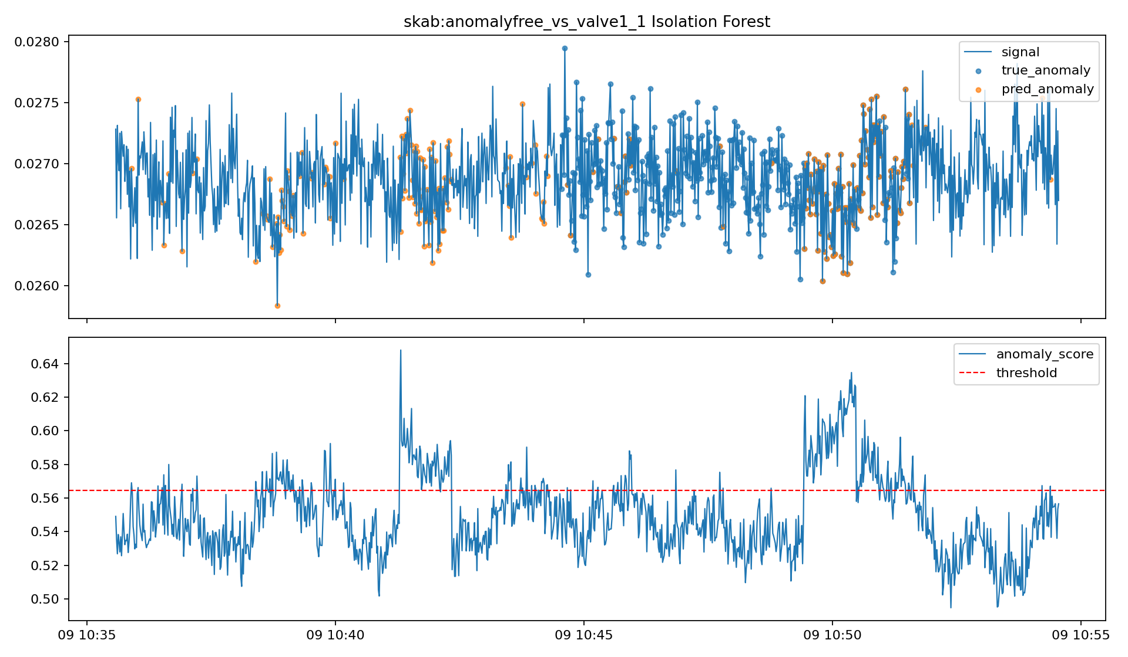

7. Key Findings
- Isolation Forest improved after threshold tuning (NAB best near 99.9, SKAB best near 99.0).
- Z-score was more sensitive on NAB but failed on SKAB with current features.
- NAB ec2_network_in_257a54 remains challenging and requires feature/parameter refinement.

8. Next Steps
- Tune feature windows and add frequency-domain features for difficult series.
- Add advanced models (LSTM/CNN autoencoders) and compare with baselines.
- Use the notebook for figure generation and integrate the final selected figures into submission.

