Telemetry Anomaly Detection - Enhanced Report (Baseline + Advanced)
Generated: 2026-03-11 19:42

1. Scope
This report extends baseline analysis (Z-score, Isolation Forest) with advanced models (LSTM Autoencoder, CNN Autoencoder) and compares all models on NAB and SKAB.

2. Models Evaluated
- zscore
- iforest
- lstm_ae
- cnn_ae

3. Aggregate Visual Comparison
Figure 1. Point-level F1 for all models.
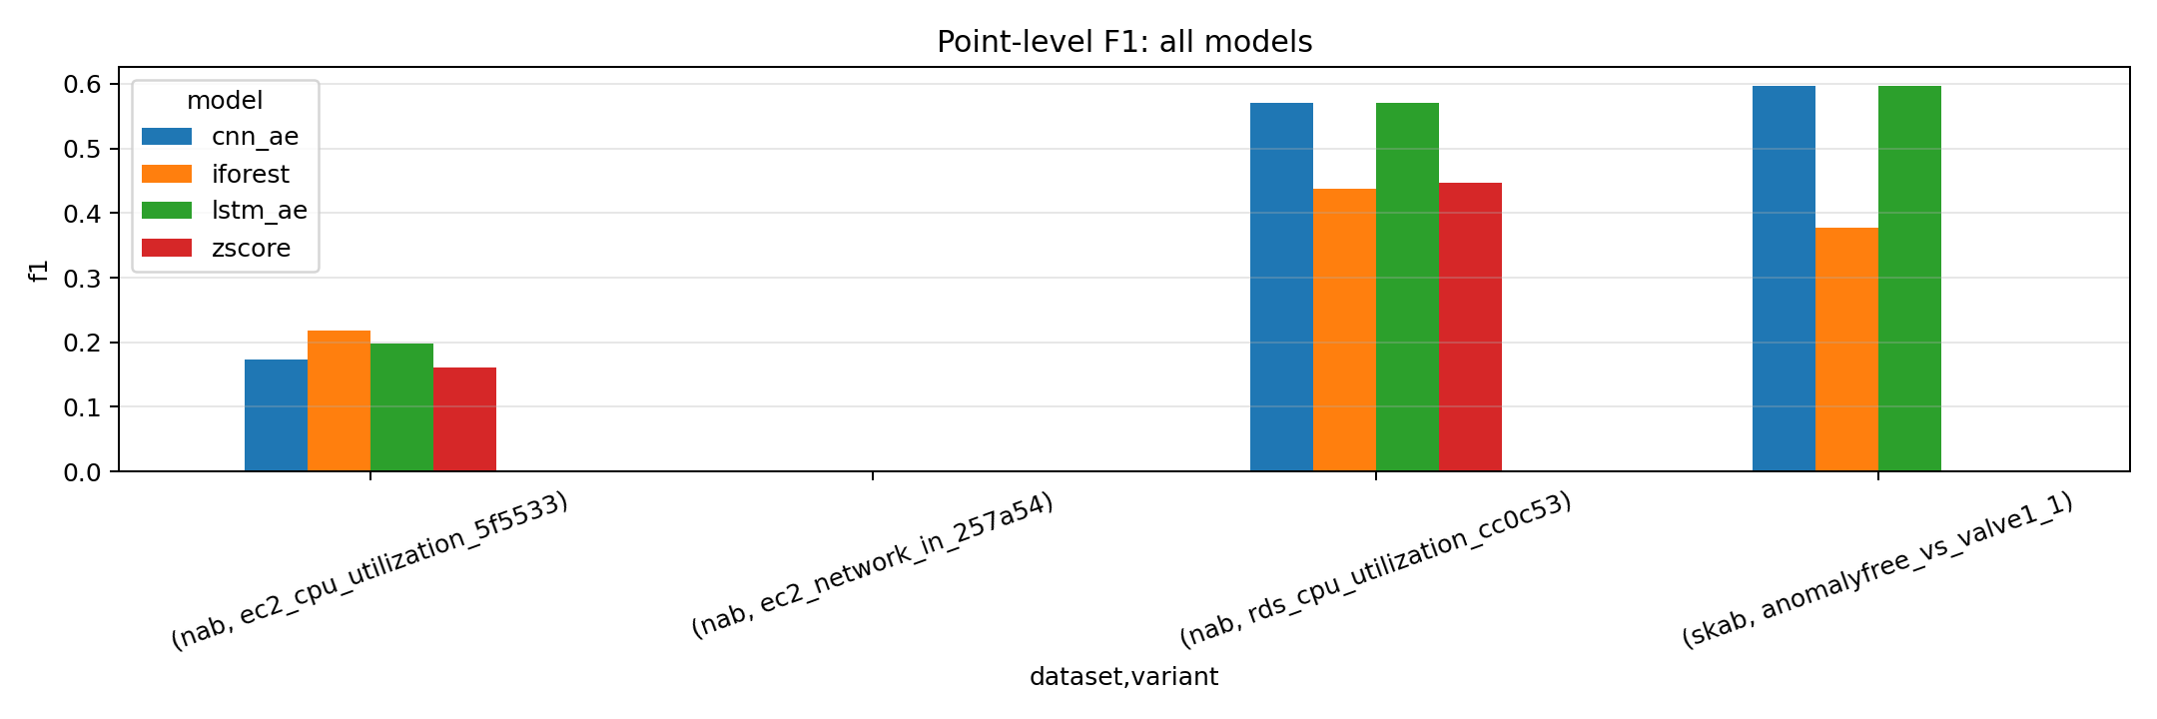
Figure 2. Event-level F1 for all models.
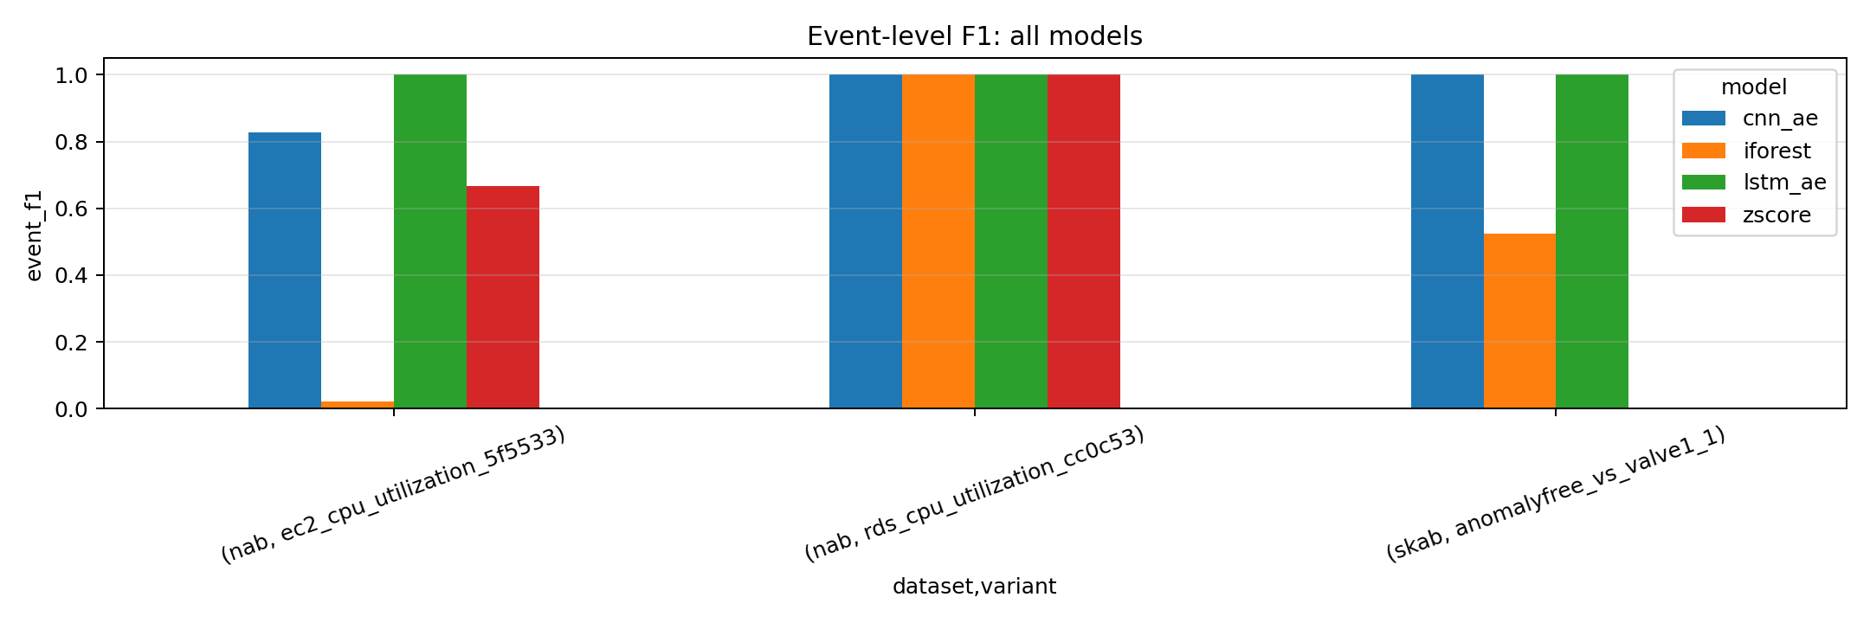
Figure 3. PR-AUC for all models.
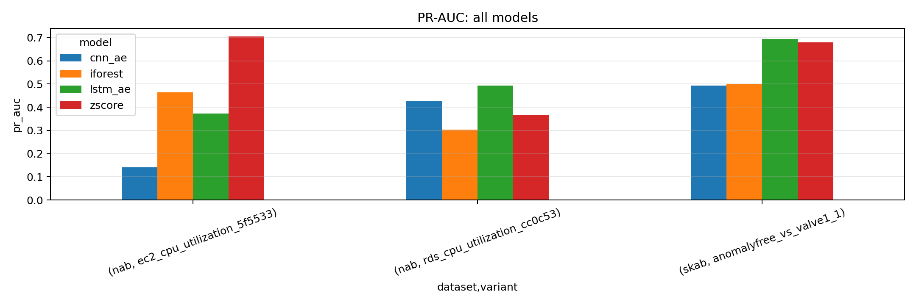

4. Detailed Metrics Table
Dataset | Variant | Model | F1 | Precision | Recall | Event F1 | PR-AUC | ROC-AUC
nab | ec2_cpu_utilization_5f5533 | cnn_ae | 0.1737 | 0.1042 | 0.5215 | 0.8276 | 0.1411 | 0.2412
nab | ec2_cpu_utilization_5f5533 | iforest | 0.2186 | 0.1495 | 0.4067 | 0.0206 | 0.4634 | 0.4089
nab | ec2_cpu_utilization_5f5533 | lstm_ae | 0.1973 | 0.1180 | 0.6029 | 1.0000 | 0.3733 | 0.3365
nab | ec2_cpu_utilization_5f5533 | zscore | 0.1615 | 0.0917 | 0.6733 | 0.6667 | 0.7045 | 0.6707
nab | ec2_network_in_257a54 | cnn_ae | 0.0000 | 0.0000 | 0.0000 | NA | NA | NA
nab | ec2_network_in_257a54 | iforest | 0.0000 | 0.0000 | 0.0000 | NA | NA | NA
nab | ec2_network_in_257a54 | lstm_ae | 0.0000 | 0.0000 | 0.0000 | NA | NA | NA
nab | ec2_network_in_257a54 | zscore | 0.0000 | 0.0000 | 0.0000 | NA | NA | NA
nab | rds_cpu_utilization_cc0c53 | cnn_ae | 0.5707 | 0.4412 | 0.8077 | 1.0000 | 0.4283 | 0.4327
nab | rds_cpu_utilization_cc0c53 | iforest | 0.4368 | 0.3114 | 0.7313 | 1.0000 | 0.3036 | 0.3962
nab | rds_cpu_utilization_cc0c53 | lstm_ae | 0.5707 | 0.4412 | 0.8077 | 1.0000 | 0.4934 | 0.4640
nab | rds_cpu_utilization_cc0c53 | zscore | 0.4461 | 0.3172 | 0.7512 | 1.0000 | 0.3662 | 0.4943
skab | anomalyfree_vs_valve1_1 | cnn_ae | 0.5960 | 0.4245 | 1.0000 | 1.0000 | 0.4930 | 0.6491
skab | anomalyfree_vs_valve1_1 | iforest | 0.3767 | 0.4900 | 0.3060 | 0.5238 | 0.4998 | 0.5987
skab | anomalyfree_vs_valve1_1 | lstm_ae | 0.5960 | 0.4245 | 1.0000 | 1.0000 | 0.6946 | 0.7435
skab | anomalyfree_vs_valve1_1 | zscore | 0.0000 | 0.0000 | 0.0000 | 0.0000 | 0.6805 | 0.8942

5. Best Model per Variant
Dataset | Variant | Best Model (F1) | F1 | Precision | Recall
nab | ec2_cpu_utilization_5f5533 | iforest | 0.2186 | 0.1495 | 0.4067
nab | ec2_network_in_257a54 | cnn_ae | 0.0000 | 0.0000 | 0.0000
nab | rds_cpu_utilization_cc0c53 | cnn_ae | 0.5707 | 0.4412 | 0.8077
skab | anomalyfree_vs_valve1_1 | cnn_ae | 0.5960 | 0.4245 | 1.0000

6. Selected Detailed Plots
Figure: reports/skab/anomalyfree_vs_valve1_1/lstm_ae_plot.png
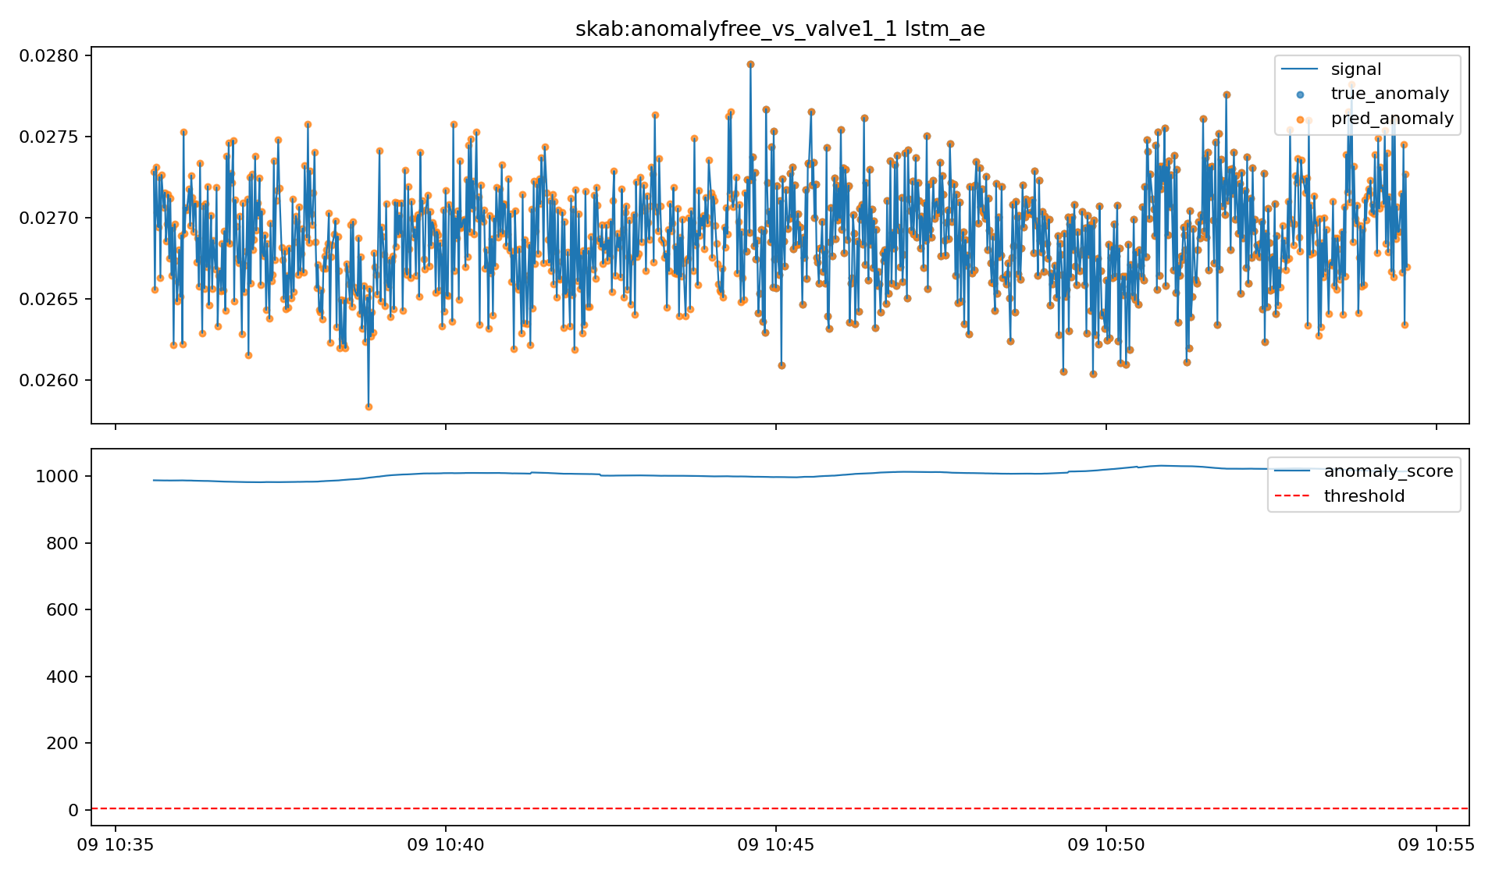
Figure: reports/skab/anomalyfree_vs_valve1_1/cnn_ae_plot.png
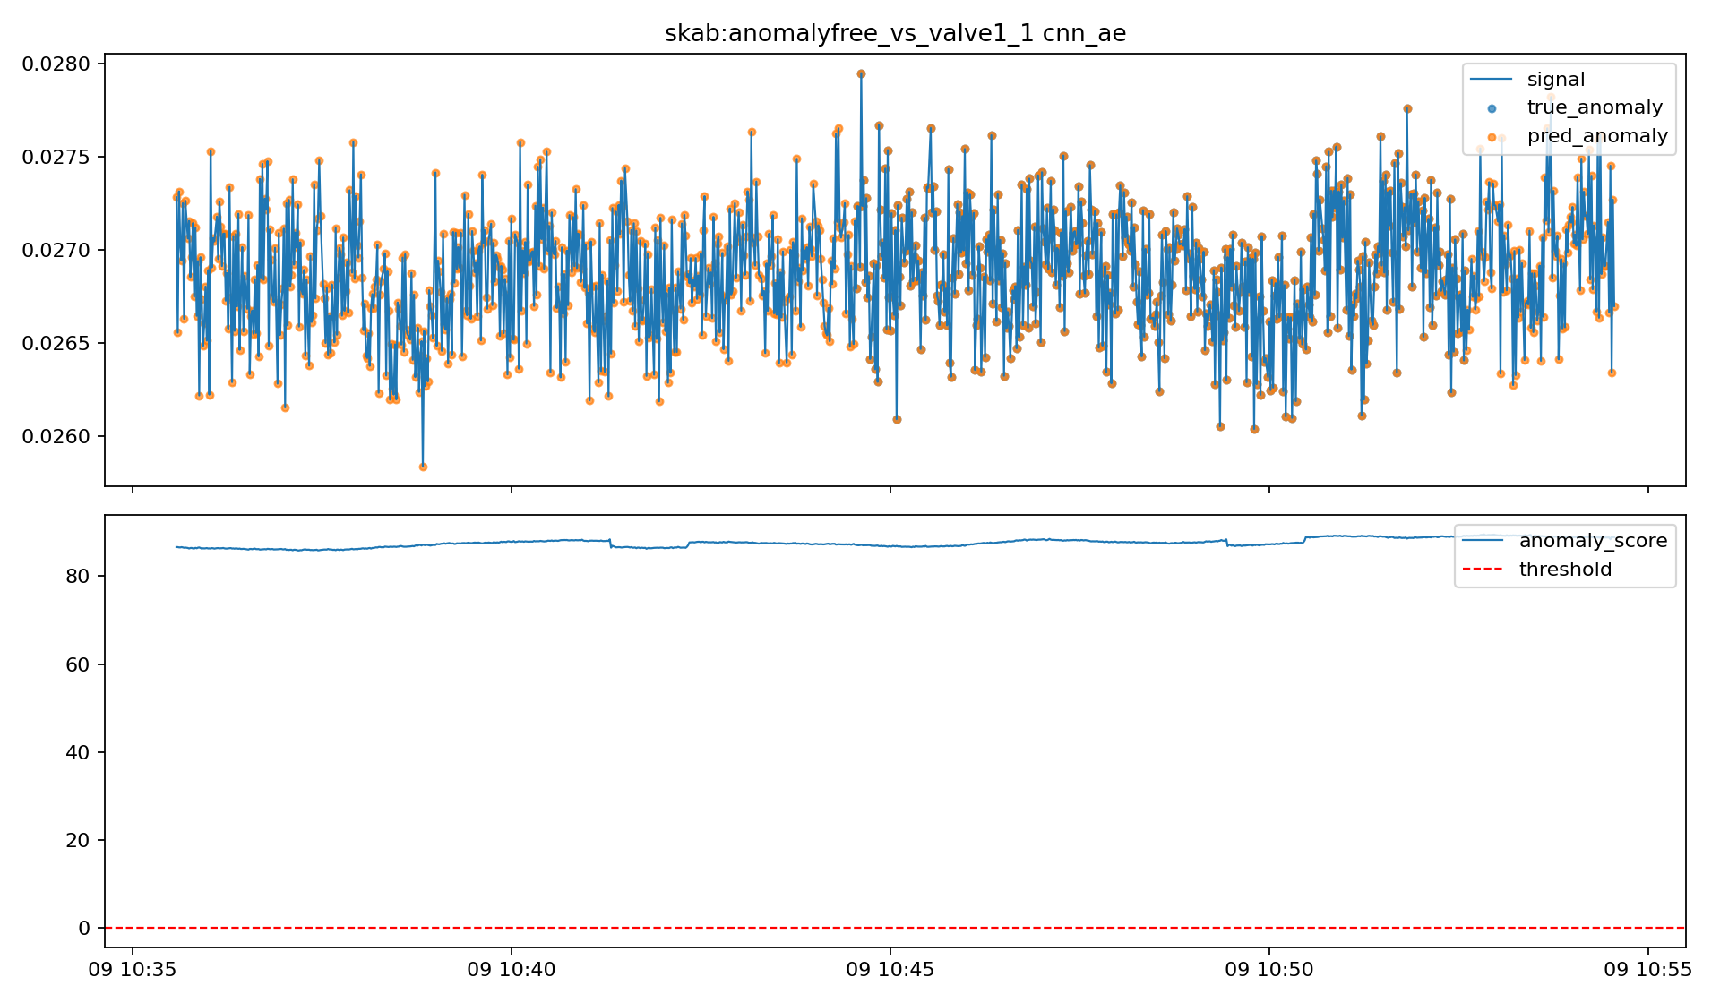
Figure: reports/skab/anomalyfree_vs_valve1_1/lstm_ae_confusion_matrix.png
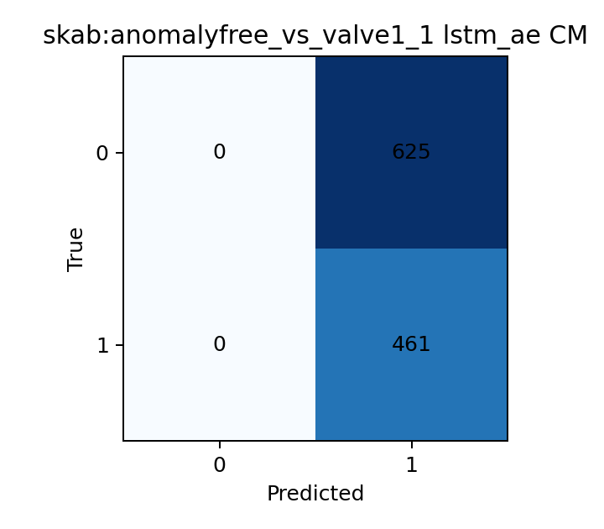
Figure: reports/nab/rds_cpu_utilization_cc0c53/lstm_ae_plot.png
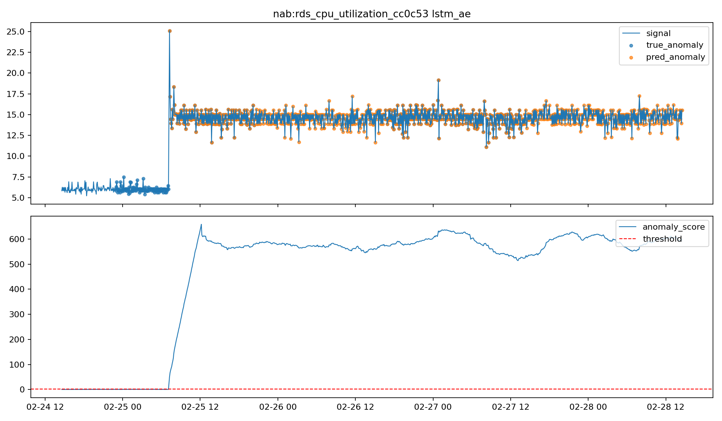

7. Interpretation
- Advanced models improved point-level F1 on some variants (notably SKAB and NAB rds_cpu_utilization_cc0c53).
- For hard variants (e.g., ec2_network_in_257a54), all models remain weak and need feature/calibration refinement.
- Event-level metrics can differ from point-level metrics; both should be reported in final evaluation.
- Streaming thresholds for advanced models still require tuning to reduce over-alerting in production-like scenarios.

8. Reproducibility
Use scripts/train_offline.py and scripts/evaluate_offline.py for offline pipelines; use scripts/infer_stream_pi.py for streaming simulation. See notebooks/enhanced_results_all_models.ipynb for result analysis.

