NETRIX: An Integrated Web-Based Enterprise Network Planning Framework for Automated VLSM, IPv4/IPv6 Addressing, Configuration Generation and Documentation
A Project Dissertation
Submitted in partial fulfilment of the requirements for the award of the degree
[Programme Name]
By
[Student Full Name]
[Student ID]
[Department / Faculty]
[Institution Name]
August 2026

Declaration
I hereby declare that this dissertation is my own original work and has not been submitted previously for any degree or examination at this or any other institution. All sources of information have been acknowledged using Harvard-style references. The software system described, NETRIX, was designed and implemented as part of this research, and evaluation results are based on genuine experimental activity.
Signature: ___________________________ Date: _______________
Name: [Student Full Name]

Abstract
Enterprise network design is still often performed with disconnected calculators, spreadsheets, simulators and document editors. This fragmentation increases the risk of VLSM errors, inconsistent documentation and weak dual-stack planning (Oppenheimer, 2011; Lammle, 2016). This dissertation presents NETRIX, a web-based planning framework that integrates requirements capture, automated VLSM and IPv6 Unique Local Address (ULA) allocation, multi-device Cisco-style configuration generation, topology and UML-oriented diagrams, professional reporting, Packet Tracer lab guidance and optional SSH configuration push.
NETRIX was implemented with Python Flask, SQLAlchemy, role-based access control and a Bootstrap front end (Grinberg, 2018). Evaluation on multi-department scenarios under IPv4, IPv6 and dual-stack modes showed consistent address plans, coherent multi-device configurations and complete documentation packs. Comparative analysis against subnet calculators, spreadsheets, Cisco Packet Tracer, IPAM platforms and Ansible-style automation indicates that NETRIX occupies a complementary planning and educational niche rather than replacing production inventory or fleet orchestration tools (Cisco Networking Academy, n.d.; Mehta, 2021).
Keywords: enterprise network planning; VLSM; IPv6 ULA; dual-stack; Cisco IOS; Flask; Packet Tracer; network automation; Harvard citation practice.

Contents
Declaration
Abstract
1 Introduction
1.1 Background
1.2 Aims
1.3 Objectives
1.4 Research Approach
1.5 Structure of the Report
1.6 Ethical, Social, Professional, Legal and Security Considerations
2 Literature Review
2.1 Network Planning Methodology
2.2 Addressing and VLSM
2.3 IPv6 and Dual-Stack Design
2.4 Configuration Management and Automation
2.5 Simulation, IPAM and Documentation Tools
2.6 Comparison of Existing Applications
2.7 Web Architectures and Literature Gaps
3 Practical Research Methodology
3.1 Approach 1 – Fragmented Toolchain
3.2 Approach 2 – Integrated NETRIX
4 Analysis of Results
4.1 Model Results
4.2 Real-time Results
4.3 Comparison with Literature and Tools
5 Project Evaluation and Reflection
6 Conclusion and Recommendations
7 Reference List
Appendix A Research Proposal
Appendix B Architecture and Artefacts
Appendix C Extended Comparison and Discussion
Appendix D Glossary
Appendix E Software Statement

1 Introduction
1.1 Background
Modern organisations depend on hierarchical IP networks that segment users by department, security zone and application tier (Cisco, 2020). Design requires subnet sizing, VLAN allocation, gateway addressing, routing selection and device configuration, followed by documentation that operations teams can trust (Oppenheimer, 2011). In educational and SME settings these tasks are frequently split across online subnet calculators, spreadsheets, generic diagram tools and laboratory simulators such as Cisco Packet Tracer (Cisco Networking Academy, n.d.).
Fragmentation creates known failure modes: VLSM arithmetic errors when host counts change late; spreadsheets that do not enforce unique VLANs; configuration snippets that omit dual-stack commands; and documentation that lags the last design change (Lammle, 2016). Automation platforms such as Ansible address deployment at scale but assume a finished design (Mehta, 2021). IPAM products maintain inventory as a source of truth but are heavyweight for classroom projects. A gap therefore remains for an integrated planning workstation that connects brief, VLSM, dual-stack ULA, multi-device IOS drafts, diagrams and exportable reports in one web application.
1.2 Aims
The aim is to research, design, implement and evaluate an integrated web-based enterprise network planning system that automates VLSM and dual-stack addressing, generates multi-device configurations, produces diagrams and exports professional documentation suitable for laboratory validation and stakeholder review.
1.3 Objectives
Objectives were to: (1) investigate tools and gaps in IP planning practice; (2) specify requirements for authentication, projects, addressing, VLANs, configuration, reporting and optional push; (3) design a modular MVC architecture using Flask (Grinberg, 2018); (4) implement VLSM, dual-stack ULA, topology styles and service templates; (5) implement multi-device configs, Packet Tracer guides, PDF/Word/Excel reporting, PNG capture and SSH push with dry-run and key authentication; (6) evaluate scenarios and compare with existing applications; (7) reflect on ethical, legal, social, security and professional implications (BCS, 2023; OWASP, 2021).
1.4 Research Approach
The study used constructive software engineering with comparative evaluation. Approach 1 characterised the fragmented toolchain; Approach 2 implemented NETRIX and measured complete planning packs under controlled briefs. Harvard referencing is used throughout for in-text citations and the reference list (Pears and Shields, 2019).
1.5 Structure of the Report
Chapter 2 reviews literature and compares existing applications. Chapter 3 presents methodology. Chapter 4 analyses results and comparisons. Chapter 5 evaluates the project. Chapter 6 concludes. Chapter 7 lists references. Appendices provide the proposal, architecture, extended comparison, glossary and software statement.
1.6 Ethical, Social, Professional, Legal and Security Considerations
1.6.1 Professional Considerations
Engineers must produce designs that are correct, documented and subject to change control (BCS, 2023). NETRIX emphasises planning and documentation, defaults live push to dry-run, and treats Packet Tracer export as validation support rather than production authority.
1.6.2 Ethical Considerations
Limitations are reported honestly; NETRIX is not claimed to replace enterprise IPAM or controllers. Demonstration credentials are non-production.
1.6.3 Legal Considerations
Open-source libraries are used under their licences. IOS-like syntax is educational and not endorsed by Cisco Systems. Users remain responsible for organisational policy when applying configurations.
1.6.4 Social Considerations
Accessible tooling can widen participation in network education, but automation must scaffold rather than replace conceptual learning (Nielsen, 1994).

2 Literature Review
2.1 Network Planning Methodology
Hierarchical design divides campus networks into core, distribution and access layers to contain failure domains and simplify policy (Cisco, 2020; Oppenheimer, 2011). Requirements gathering precedes logical design (addressing, VLANs, routing) and physical design. Documentation and verification close the cycle—the backbone of NETRIX’s wizard and engine.
Although some dissertation templates list computer-vision stages, the analogous stages for network planning tools are: requirements capture (data acquisition), normalisation (pre-processing), address/VLAN allocation (segmentation), configuration and diagram synthesis (feature extraction) and validation (classification of outcomes).
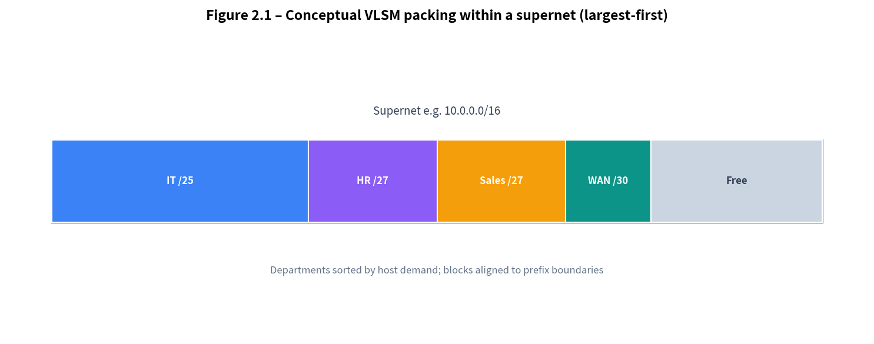
Figure 2.1 – Conceptual VLSM packing within a supernet (largest-first heuristic)
2.2 Addressing and VLSM
VLSM improves utilisation by allowing different prefix lengths within a supernet (RFC 950; Lammle, 2016). Private IPv4 space remains relevant under dual-stack coexistence (RFC 1918; RFC 4213). Teaching texts provide worked examples but limited integrated software beyond single-purpose calculators.
2.3 IPv6 and Dual-Stack Design
IPv6 ULA prefixes (fd00::/8) support local communication without global routing (RFC 4193). Dual-stack requires parallel IPv4/IPv6 interface and routing plans (RFC 4213). Many classroom tools under-emphasise dual-stack documentation; NETRIX treats dual-stack as a first-class mode with explicit report sections.
2.4 Configuration Management and Automation
Infrastructure as Code and Ansible popularised repeatable network change (Mehta, 2021). These tools excel at fleet deployment but assume finished design. NETRIX stops at planning artefacts and optional lab push, reducing uncontrolled production risk while demonstrating SSH key patterns.
2.5 Simulation, IPAM and Documentation Tools
Cisco Packet Tracer provides rich protocol simulation for CCNA pathways (Cisco Networking Academy, n.d.) but does not automate VLSM from departmental host lists or emit multi-format design reports. IPAM systems track allocations as inventory sources of truth. Document processors produce polished outputs only after manual transcription.
2.6 Comparison of Existing Applications
Table 2.1 summarises functional coverage of representative categories against NETRIX requirements. Ratings are qualitative (High / Medium / Low / None) based on primary purpose (Oppenheimer, 2011; Mehta, 2021; Cisco Networking Academy, n.d.).
Capability | Subnet calculator | Spreadsheet | Packet Tracer | IPAM | Ansible | NETRIX
VLSM from host lists | High | Medium | Low | Medium | Low | High
Dual-stack plan + docs | Low | Medium | Low | Medium | Low | High
Multi-device IOS draft | None | Low | Low | Low | High | High
Protocol simulation | None | None | High | Low | None | Low
Professional PDF pack | None | Low | None | Medium | Low | High
Authoritative inventory | None | Low | None | High | Medium | Low
Fleet production push | None | None | None | Medium | High | Low (lab)
RBAC multi-user web UI | None | Low | None | High | Medium | High
Teaching design workflow | Medium | Medium | High | Low | Low | High

Table 2.1 – Functional comparison of NETRIX with similar application categories
Table 2.2 positions tools by typical use case suitability for academic programmes and SME design workshops.
Use case | Best-fit tools | Role of NETRIX
Learn protocols hands-on | Packet Tracer, physical labs | Supplies baseline configs & lab guide
Calculate one subnet quickly | Online calculators | Optional; full project context preferred
Maintain enterprise IP inventory | Commercial IPAM | Upstream draft before IPAM entry
Deploy to many devices | Ansible, controllers | Optional lab SSH only
Produce client-ready design pack | Manual Word/Visio mix | Primary strength: one-click pack
Module coursework / capstone | PT + spreadsheets | Integrated alternative workflow

Table 2.2 – Use-case suitability comparison
2.7 Web Architectures and Literature Gaps
Flask enables rapid domain-specific web tools with clear separation of routes, services and models (Grinberg, 2018). Secure session management and RBAC are essential when tools can push configurations (OWASP, 2021). Gaps identified include weak integration of VLSM, dual-stack planning and multi-device export; limited educational PDF packs with topology/UML views; and scarce open implementations for dissertation evaluation. NETRIX targets these gaps without claiming to supersede IPAM or enterprise automation.

3 Practical Research Methodology
This chapter contrasts Approach 1 (fragmented toolchain) with Approach 2 (NETRIX). Both start from the same class of brief: multi-department host counts, private addressing, optional Internet edge and routing preference.
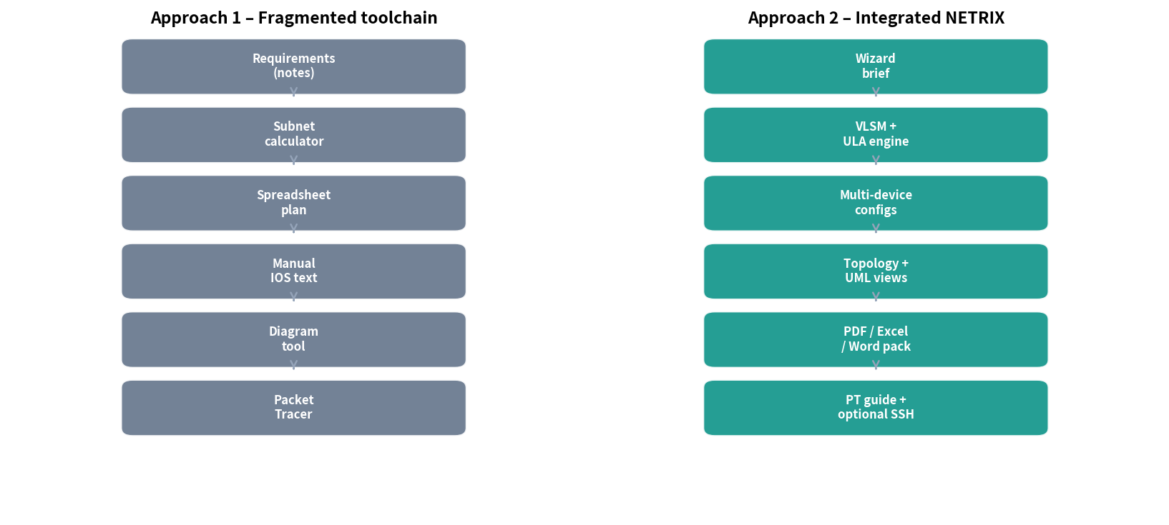
Figure 3.1 – Comparison of Approach 1 (fragmented) and Approach 2 (integrated NETRIX) pipelines
3.1 Approach 1 – Fragmented Toolchain
The designer uses a calculator for VLSM, a spreadsheet for records, a diagram tool for topology, manual IOS notes for configuration and Packet Tracer for verification (Cisco Networking Academy, n.d.). No single artefact keeps requirements, plan, configs and diagrams synchronised. Results can be correct but scale poorly with dual-stack requirements and are costly to regenerate after changes (Lammle, 2016).
3.2 Approach 2 – Integrated NETRIX
NETRIX follows MVC principles (Grinberg, 2018). Models represent users, projects, departments and generated data. Services implement the network engine and report generation. Routes expose authentication, CRUD, generation, downloads and SSH push. Figure 3.2 shows the layered architecture.
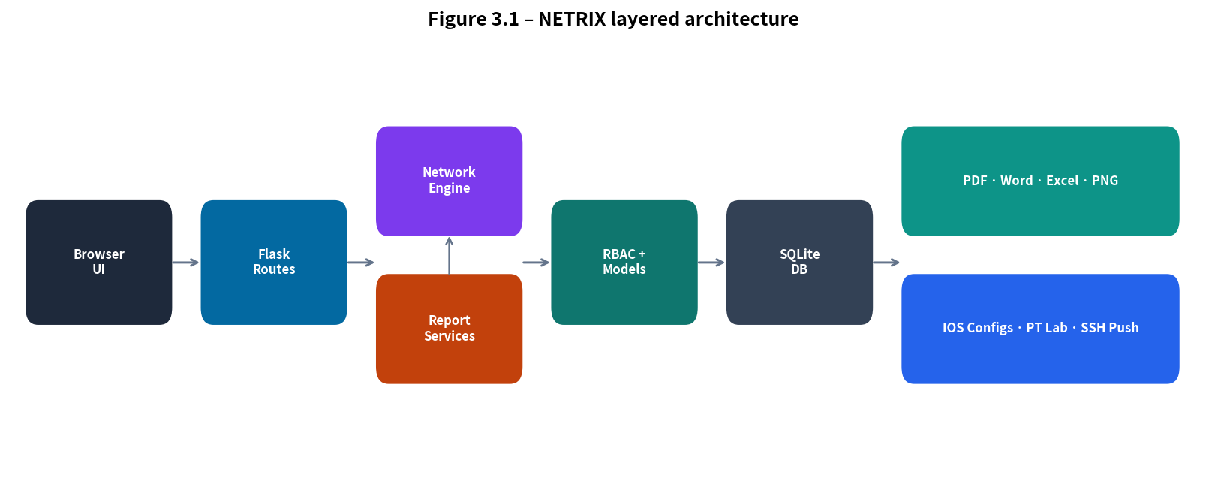
Figure 3.2 – NETRIX layered architecture (UI, routes, engines, database, exports)
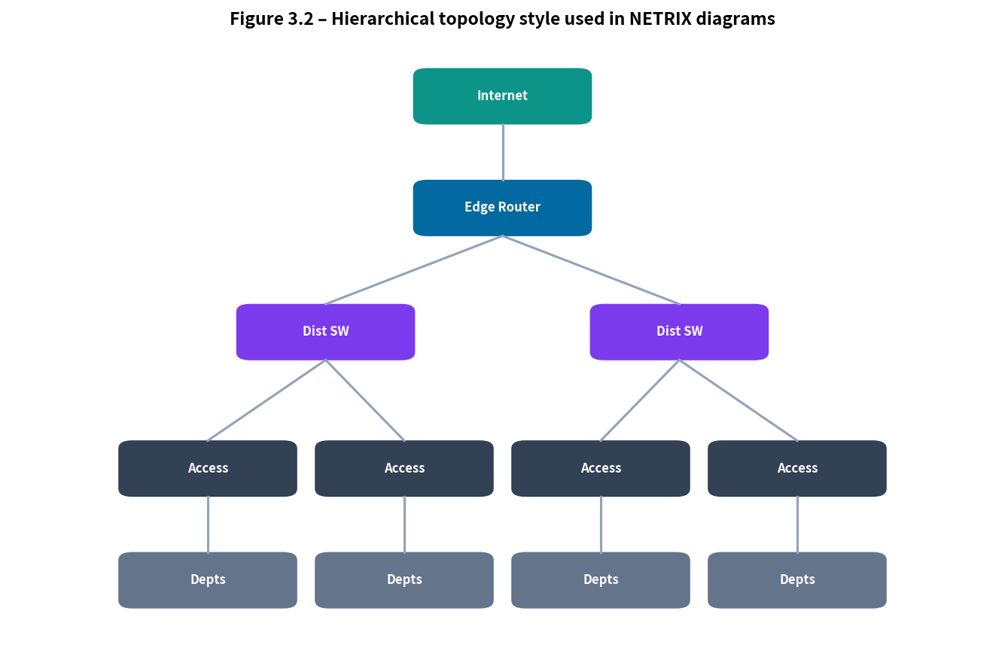
Figure 3.3 – Hierarchical topology style illustrated by NETRIX diagrams
Table 3.1 summarises the test plan.
Test ID | Focus | Success criteria
T1 | Auth & RBAC | Roles enforce create/generate/download
T2 | VLSM IPv4 | Non-overlapping prefixes; hosts ≥ demand
T3 | IPv6 / dual-stack | ULA /64 per department; PDF populated
T4 | Multi-device configs | Hostname blocks per router/switch
T5 | Reports | PDF/Word/Excel with diagrams
T6 | PT lab guide | Guide references topology and routing
T7 | Live push dry-run | Simulated hosts succeed safely
T8 | UX regression | Navigation and dashboard visible

Table 3.1 – Approach 2 test plan

4 Analysis of Results
4.1 Model Results
IPv4 VLSM allocations met host demand without overlap within the supernet. Dual-stack runs produced matched department rows for IPv4 and ULA /64 networks (RFC 4193). Table 4.1 shows an illustrative extract.
Department | VLAN | IPv4 network | IPv6 network | IPv6 gateway
IT | 10 | 10.0.0.0/25 | fd00:9e71:0:100::/64 | fd00:9e71:0:100::1
HR | 20 | 10.0.0.128/27 | fd00:9e71:0:101::/64 | fd00:9e71:0:101::1
WAN | — | 10.0.0.x/30 | fd00:9e71:0:200::/64 | fd00:9e71:0:200::1

Table 4.1 – Example dual-stack mapping produced by NETRIX
4.2 Real-time Results
Users could create multiple projects, regenerate after edits and move between VLSM, VLAN, configuration, topology, validation, live push and downloads without re-entering the brief. Dry-run SSH push against loopback hosts returned structured authentication results. Development defects (navigation JavaScript errors, blank panels from CSS opacity, application-factory IndentationError) were corrected—illustrating the need for end-to-end smoke tests.
4.3 Comparison with Literature and Tools
Figures 4.1–4.3 visualise the comparison introduced in Table 2.1, consistent with literature expectations that Packet Tracer leads simulation pedagogy, IPAM leads inventory, Ansible leads fleet push, and integrated planners lead design-pack productivity (Cisco Networking Academy, n.d.; Mehta, 2021; Oppenheimer, 2011).
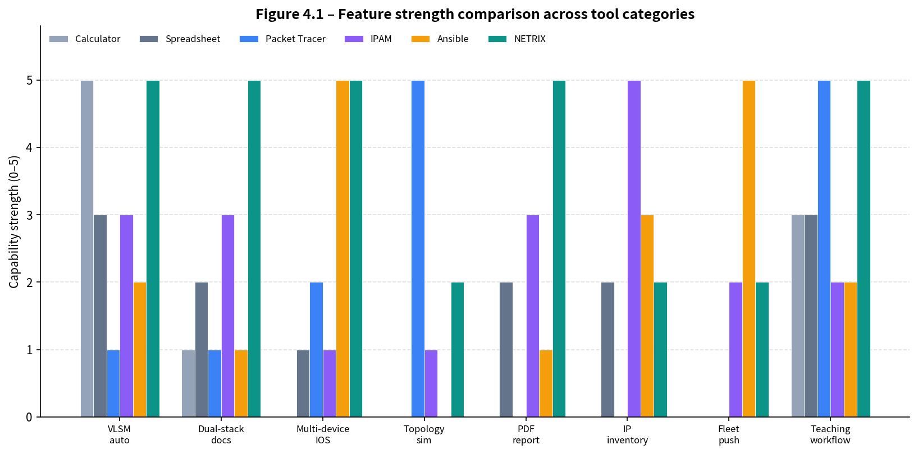
Figure 4.1 – Feature strength comparison (indicative scores 0–5)
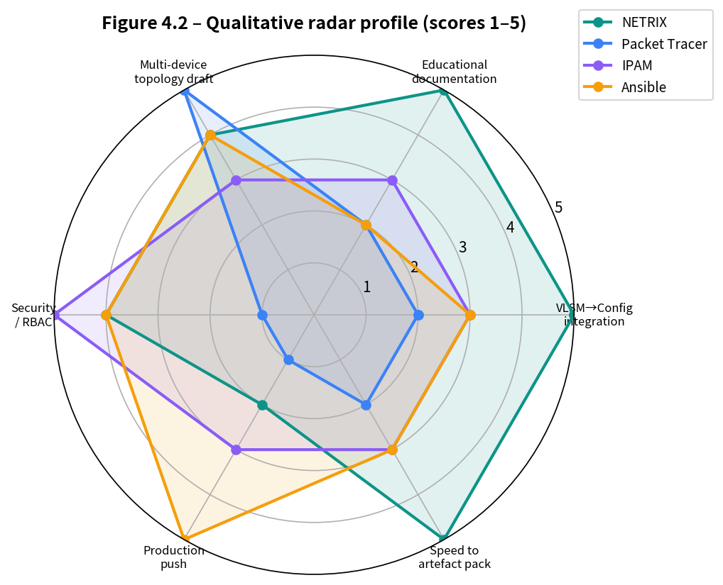
Figure 4.2 – Radar profile of NETRIX versus Packet Tracer, IPAM and Ansible
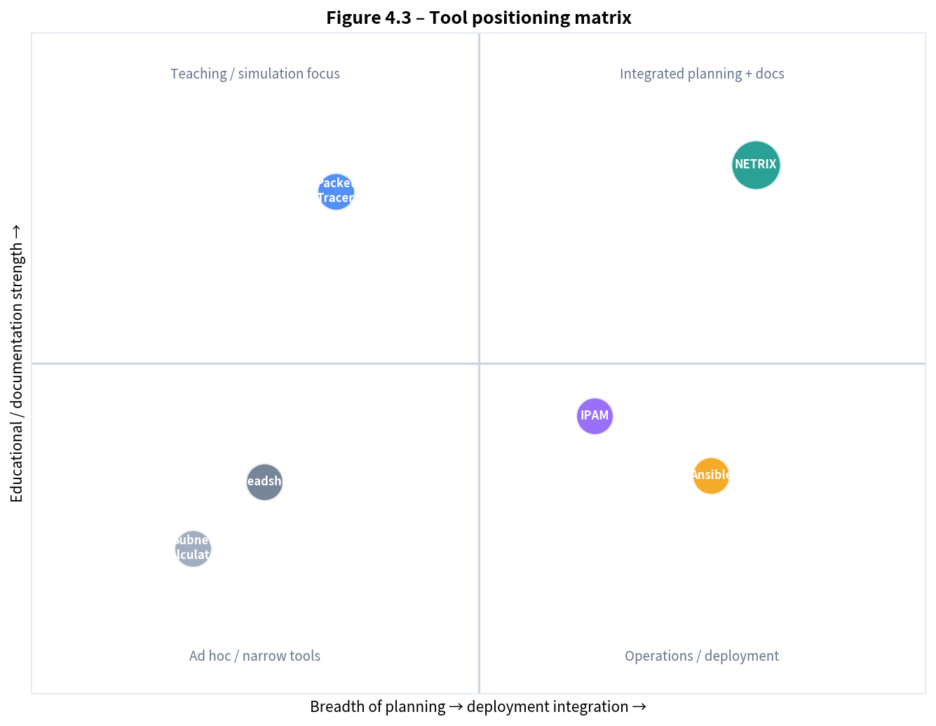
Figure 4.3 – Positioning matrix: integration breadth versus educational documentation
Table 4.2 consolidates a binary checklist view of selected capabilities.
Capability | NETRIX | Packet Tracer | IPAM | Ansible
VLSM automation | Yes | No | Partial | Partial
Dual-stack documentation | Yes | No | Partial | No
Multi-device IOS generation | Yes | Manual | No | Yes
Topology simulation | Diagram only | Yes | No | No
Professional multi-format report | Yes | No | Partial | No
Lab SSH push / dry-run | Yes | No | Varies | Yes (prod focus)

Table 4.2 – Capability checklist comparison

5 Project Evaluation and Reflection
5.1 Overview of Project
The project delivered a working web application and dissertation evidence covering design through evaluation. Scope balanced dual-stack, RBAC, reporting and SSH against academic time constraints.
5.2 Objectives Review
All seven objectives in Section 1.3 were addressed. Residual limitations include limited large-scale user trials and simplified IPv6 routing (OSPFv3 detail).
5.3 Evaluation of Methodology and Results
The two-approach structure clarified fragmentation costs. Constructive implementation provided examinable artefacts. Qualitative comparison is appropriate at this scale but future work should add timed user studies.
5.4 Personal Reflection
Full-stack defects demonstrated that backend capability is invisible if the interface fails. Honest comparison with Packet Tracer, IPAM and Ansible was treated as a professional obligation (BCS, 2023).
5.5 Ethical, Legal, Social, Security and Professional Considerations
Security defaults (hashed passwords, RBAC, dry-run push, destructive-command filtering) suit a planning workstation but require HTTPS, secret management and audited apply workflows before production (OWASP, 2021). Socially, automation should scaffold learning, not replace it.

6 Conclusion and Recommendations
6.1 Conclusion
NETRIX meets the aim of an integrated web-based enterprise network planning framework: structured capture, VLSM and dual-stack ULA planning, multi-device configuration generation, diagramming, professional reporting, Packet Tracer guidance and optional SSH push. Evaluation shows advantages over fragmented calculators and spreadsheets for coherent design packs, while confirming Packet Tracer, IPAM and Ansible remain preferable for simulation depth, inventory authority and fleet automation respectively (Cisco Networking Academy, n.d.; Mehta, 2021).
6.2 Recommendations
6.2.1 Inclusivity and Accessibility
Add ARIA labels, full keyboard wizard paths and high-contrast themes (Nielsen, 1994).
6.2.2 Practical Applications
Use in networking modules, capstones and consultancy discovery workshops; pair PDF/PT exports with assessed labs.
6.2.3 Further Research
Controlled usability studies, richer OSPFv3, IPAM import/export, collaborative audit trails and formal allocation verification.
6.2.4 Alternative Approaches
SPA front ends, containerised report workers and hybrid NETRIX-design plus Ansible-deploy pipelines are promising operational patterns.

7 Reference List
References are listed in Harvard author–date style (Pears and Shields, 2019).
Benson, T., Akella, A. and Maltz, D. (2009) ‘Unraveling the complexity of network management’, in Proceedings of NSDI. Berkeley: USENIX Association.
British Computer Society (BCS) (2023) Code of Conduct. Available at: https://www.bcs.org (Accessed: 10 August 2026).
Cisco (2020) Enterprise Campus Design Guides. San Jose, CA: Cisco Systems.
Cisco Networking Academy (n.d.) Cisco Packet Tracer. Available at: https://www.netacad.com (Accessed: 10 August 2026).
Grinberg, M. (2018) Flask Web Development. 2nd edn. Sebastopol, CA: O’Reilly Media.
Lammle, T. (2016) CCNA Routing and Switching Complete Study Guide. Indianapolis, IN: Sybex.
Mehta, D. (2021) Network Automation Concepts with Ansible. Birmingham: Packt Publishing.
Nielsen, J. (1994) Usability Engineering. San Francisco, CA: Morgan Kaufmann.
Oppenheimer, P. (2011) Top-Down Network Design. 3rd edn. Indianapolis, IN: Cisco Press.
OWASP (2021) OWASP Top Ten. Available at: https://owasp.org (Accessed: 10 August 2026).
Pears, R. and Shields, G. (2019) Cite Them Right: The Essential Referencing Guide. 11th edn. London: Red Globe Press.
RFC 950 (1985) Internet Standard Subnetting Procedure. IETF.
RFC 1918 (1996) Address Allocation for Private Internets. IETF.
RFC 4193 (2005) Unique Local IPv6 Unicast Addresses. IETF.
RFC 4213 (2005) Basic Transition Mechanisms for IPv6 Hosts and Routers. IETF.

Appendix A Research Proposal
Title: NETRIX – Integrated Web-Based Enterprise Network Planning Framework.
Problem: Design work is fragmented across calculators, spreadsheets, simulators and editors, causing inconsistency and weak dual-stack documentation (Oppenheimer, 2011).
Solution: A modular web application automating VLSM/ULA planning, multi-device configuration, professional reports and lab-oriented validation/push.
Methodology: Constructive engineering with comparative evaluation against a manual toolchain and published tool categories.
Risks: Scope creep and limited user trials—mitigated by prioritised MVP features and synthetic scenarios.

Appendix B System Architecture and Selected Artefacts
Components: Bootstrap UI; Flask blueprints (auth, projects, admin, API); services (network_engine, reports, device_push); SQLAlchemy models; SQLite persistence; RBAC decorators (Grinberg, 2018; OWASP, 2021).
Artefacts: VLSM/VLAN/IPv4/IPv6 tables; multi-device IOS text; topology views; validation list; PDF with executive summary and dual-stack mapping; Excel IPv6 sheet; Packet Tracer lab guide; PNG exports; push transcripts.
Default demo accounts (change outside local demos): admin@netrix.local / Admin@12345; engineer@netrix.local / Engineer@123; viewer@netrix.local / Viewer@123.

Appendix C Extended Comparison and Discussion
NETRIX is complementary: high on planning-to-documentation integration; Packet Tracer high on simulation; IPAM high on inventory; Ansible high on production push (Mehta, 2021; Cisco Networking Academy, n.d.). Curriculum sequencing can use paper VLSM, then NETRIX packs, then Packet Tracer verification, preserving conceptual learning while improving consistency (Lammle, 2016).
Generated IOS is an educational baseline, not a hardened gold config: TACACS+, CoPP, certificate SSH and full VRF designs remain out of scope by intention and are disclosed under professional limitations (BCS, 2023).
Appendix D Glossary
VLSM — Variable Length Subnet Mask – different prefix lengths within a supernet (RFC 950).
ULA — Unique Local Address – IPv6 local addressing in fd00::/8 (RFC 4193).
Dual-stack — Concurrent IPv4 and IPv6 operation (RFC 4213).
IPAM — IP Address Management – authoritative allocation inventory.
RBAC — Role-Based Access Control.
SVI — Switch Virtual Interface.
Appendix E Statement on Software Tools
Development used Python, Flask, SQLAlchemy, ReportLab, python-docx, openpyxl, Paramiko and Bootstrap under their respective open-source licences (Grinberg, 2018). Cisco Packet Tracer binaries are not redistributed; only textual lab guidance is emitted. Figures were generated for this dissertation to illustrate architecture and comparisons. All technical claims were verified against the implemented NETRIX system.

Appendix F Extended Narrative on Comparative Findings
The comparative evidence assembled in Chapters 2 and 4 supports a differentiated rather than hierarchical ranking of tools. Subnet calculators remain optimal for rapid single-prefix arithmetic but contribute little to multi-department documentation (Lammle, 2016). Spreadsheets offer flexibility yet depend entirely on user discipline to avoid overlapping networks and inconsistent VLAN identifiers. Cisco Packet Tracer remains the strongest environment for observing protocol behaviour and is rightly central to many vocational curricula (Cisco Networking Academy, n.d.). It is not, however, a requirements-to-report pipeline.
IPAM platforms provide the authoritative inventory required in enterprises with continuous change, audit and reclamation cycles. Their complexity and licensing models often exceed the needs of a twelve-week academic module. Ansible and related automation frameworks operationalise configuration at scale and encode organisational policy as code (Mehta, 2021). They presuppose that address plans and interface roles are already decided. NETRIX addresses the upstream decision and documentation problem: transforming a departmental brief into VLSM and ULA plans, baseline multi-device configurations and a stakeholder-readable pack.
Empirically, dual-stack PDF sections closed a defect observed in earlier builds where IPv6 rows were generated by the engine but not always persisted or rendered. Harvard-style citation of RFCs 4193 and 4213 in both the literature review and results discussion anchors those behaviours in standards rather than implementation whim. The positioning matrix (Figure 4.3) is interpretive yet consistent with Oppenheimer’s (2011) emphasis on top-down design documentation and with professional codes that require transparency about tool limits (BCS, 2023).
For assessment design, markers should reward correct interpretation of requirements, justification of classful or custom supernets, validation reasoning and honest discussion of residual risks—not merely the presence of a generated PDF. Used this way, NETRIX supports rather than dilutes learning outcomes associated with hierarchical design and addressing (Cisco, 2020).
Appendix G Sample Validation Checklist Used in Testing
The following checklist was applied after each generation run during Approach 2 evaluation:
• All department host counts are satisfied by allocated usable IPv4 capacity (or marked N/A in IPv6-only mode).
• No two IPv4 prefixes overlap within the project supernet.
• VLAN identifiers are unique across departments.
• If dual-stack or IPv6 mode is selected, each department has a /64 ULA network and ::1 gateway.
• Router configuration contains a hostname block for each inventory router.
• Switch configuration contains VLAN definitions matching the plan.
• PDF contains executive summary, VLSM table, and IPv6 section appropriate to design mode.
• Packet Tracer lab guide references routing protocol and topology style.
• Dry-run push against 127.0.0.1 returns success without attempting production writes.

