Spotzy
Functional Specifications
P2P Parking Marketplace — MVP

Version 2.0
March 2026

Table of Contents
1. Context & Market 2
1.1 Parking in Brussels 2
1.2 The Gap 2
1.3 Solution Overview 2
2. Personas & Glossary 4
2.1 Persona Overview 4
2.2 Persona Descriptions 4
Host 4
Spotter 4
Block Spotter (post-MVP) 4
Spot Manager (post-MVP) 4
3. Proposed Functionalities 6
3.1 Subscription — Host 6
3.2 Subscription — Spotter 6
3.3 Search 6
3.4 Booking 6
3.5 Change & Cancellation 6
3.6 Follow-up & Communication 7
3.7 Reviews 7
3.8 Disputes 7
4. User Stories 8
4.1 Host Stories 8
4.2 Spotter Stories 9
4.3 Block Spotter Stories (post-MVP) 10
4.4 Spot Manager Stories (post-MVP) 11
5. Customer Journeys 13
5.1 Host Journey 13
5.2 Spotter Journey 13
5.3 Block Spotter Journey (post-MVP) 14
5.4 Cross-Journey Observations 15
6. Use Cases — Host 16
UC-H01 — Create Parking Listing 16
UC-H02 — Define Availability Schedule 16
UC-H03 — Set Rental Duration Rules 17
UC-H04 — Publish Listing 17
BR-H04 — AI Validation Rules for Listing Photos 18
UC-H05 — Manage Real-Time Availability 19
UC-H06 — Receive and Confirm Booking 19
UC-H07 — Reclaim Parking Space 20
UC-H08 — Receive Booking Alerts 20
UC-H09 — Chat with Spotter 21
UC-H10 — Rate a Spotter 22
UC-H11 — Open a Dispute 23
UC-H12 — Set Up Banking for Payouts 23
7. Use Cases — Spotter 25
UC-S01 — Search for a Parking Spot on the Map 25
UC-S02 — Filter Search Results 26
UC-S03 — Save Preferences and Frequent Destinations 26
UC-S04 — Book and Pay for a Parking Spot 27
UC-S05 — Modify a Booking 28
UC-S06 — Cancel a Booking 29
UC-S07 — Rate a Host and Spot 29
UC-S08 — Open a Dispute 30
8. Use Cases — Spot Manager (post-MVP) 32
UC-SM01 — Create a Spot Pool 32
UC-SM02 — Swap a Pool Spot Assignment 33
UC-SM03 — Manage Portfolio Dashboard 34
Data Model Impact 34
9. Release Scope — MVP vs v1.1 35

1. Context & Market

1.1 Parking in Brussels
Brussels faces a structural parking challenge that is only intensifying. Roughly 500,000 parking spaces exist across the Brussels-Capital Region's 19 municipalities — but supply is actively shrinking as the city pursues its Good Move mobility strategy, which aims to remove 65,000 street-level spaces by 2030 while creating only 20,000 new off-street resident spots as replacement.

Data point | Figure | Source
Total parking spaces (region-wide) | ~500,000 | Brussels Parking Observatory, 2019
Street spaces targeted for removal | 65,000 by 2030 | Good Move regional transport plan
New off-street resident spaces planned | 20,000 | Good Move regional transport plan
Data portal | MobiGIS / Brussels Open Datastore | parking.brussels

1.2 The Gap
Despite this pressure on public parking, a significant amount of privately owned parking capacity sits idle:
- Many private garage owners do not rent out their space due to safety concerns, lack of time, or simply not knowing how to find a renter.
- Other owners use their garage regularly but leave it empty for extended periods — evenings, weekends, holidays, work trips.
- Hotels and Airbnb hosts lose bookings from guests who explicitly require off-street parking.
- Event organisers and public institutions struggle to accommodate visitor parking at scale.

Spotzy unlocks this latent capacity by connecting the owners of idle parking spaces directly with the drivers who need them — through a simple, trusted, peer-to-peer platform.

1.3 Solution Overview
Spotzy is an online P2P parking marketplace. Parking space owners (Hosts and Spot Managers) list their spaces with availability and pricing. Drivers (Spotters) find, book and pay for a space. Organisations needing multiple spaces (Block Spotters) can reserve a batch in one operation.

A reclaim mechanism protects Hosts who may need their space back unexpectedly, while ensuring Spotters are never left without notice:
- Host may reclaim the spot with a defined notice period (e.g. 2 hours).
- Host can reclaim only outside active bookings.
- Host can define reclaim windows (e.g. 22:00–06:00 only).

2. Personas & Glossary

2.1 Persona Overview
Persona | Role | In a nutshell
Host | Individual parking owner | Has one spot to spare, earns on the side
Spot Manager | Portfolio / multi-spot owner | Manages multiple spots as an asset — post-MVP
Spotter | Individual driver | Spots a spot — finds and books parking
Block Spotter | Bulk group booker | Books a block of spots for guests or visitors — post-MVP

Concept | Definition
Spot | A single parking space listed on Spotzy — a real physical place where a car fits
Spot Pool | A pool of interchangeable spots listed as one by a Spot Manager — Spotters book a type, not a specific bay
Pool Spot | An individual bay within a Spot Pool — managed internally; swappable without disrupting bookings
Spot-Block | A group of Spots reserved together by a Block Spotter

2.2 Persona Descriptions

Host
A Host is someone who owns a parking spot and rents it out on Spotzy — turning an empty space into extra income. They don't just have a spot, they host it. Like an Airbnb host opens their home to guests, a Spot-Host opens their garage to Spotters. 🏠

Spotter
A Spotter is someone who uses Spotzy to find and book a parking spot. Just like you book a hotel room on Booking.com, a Spotter books a parking spot on Spotzy — from someone who has one to spare. And yes, there's a little wink in the name — a Spotter spots a spot. You're not just parking, you're on the hunt, scanning the map, zeroing in on the perfect space. 🎯

Block Spotter (post-MVP)
A Block Spotter is a hotel, Airbnb host or event organiser who needs to reserve a whole block of spots at once — not just one, but enough for all their guests or visitors. Think of it as booking a parking lot, not a parking spot. One booking, many spots, zero headache. 🏨

Spot Manager (post-MVP)
A Spot Manager is a Host who owns or manages multiple parking spots and lists them on Spotzy as part of a portfolio. Just like a Host opens their garage to Spotters, a Spot Manager opens their entire lot — and manages all their spots from a single dashboard. A Spot Manager can group identical spots into a Spot Pool — a single listing representing a pool of interchangeable bays. When a Spotter books from a Spot Pool, they book the type of spot, not a specific bay. 🅿️🅿️🅿️

3. Proposed Functionalities

3.1 Subscription — Host
Feature | Detail
Address info | Mandatory — used to geolocate the listing
Personal description | Optional — shown on Host profile
Banking info | Mandatory before publishing — Stripe Connect
Spot description | Mandatory — type, access instructions, dimensions

3.2 Subscription — Spotter
Feature | Detail
Address info | Home address for preference matching
Personal description | Shown to Hosts
Verification | Phone number OTP verification
Payment methods | Stripe — credit/debit card
Describe car(s) | Make, model, plate — used for access and booking

3.3 Search
Feature | Detail | MVP
GIS map search | Mapbox — primary discovery surface; zooms to destination on location filter | Yes
List view | Alternative to map — sortable, filterable results list | Yes
Filters | Price, availability, type, covered, accessible, EV | Yes
Conversational filter | Natural language search input | No
Profiling / suggestions | Background preference learning — suggested spots on home screen | Yes

3.4 Booking
Feature | Detail
Select car | Spotter selects which registered vehicle to use
Confirm booking | Summary review before payment
Confirm payment | Stripe Elements — card or saved card
Instant booking | No host approval required — confirmed immediately

3.5 Change & Cancellation
Feature | Detail
Change start time | Modify booking start time (min 2h before original start)
Change end time | Extend or reduce — subject to host availability and min duration
Cancellation | >48h: 100% refund / 24–48h: 50% / <24h: no refund

3.6 Follow-up & Communication
Feature | Detail | MVP
Messaging | Booking-scoped chat thread (text + images; no emojis) | Yes
Alerts | SMS + email on booking created / modified / cancelled | Yes
Smart lock interface | Seam / RemoteLock integration for automated access | No

3.7 Reviews
Dimension | Criteria
Host rating (by Spotter) | Safety/security · State · Convenience · Location
Spotter rating (by Host) | Communication · Respect of rules · State
Free text | Optional description — max 500 characters
Visibility | Published after both parties rate, or after 7 days

3.8 Disputes
Feature | Detail
AI-assisted chat | Structured question flow — gathers evidence, summarises, confirms
Human escalation | Automatic if AI detects complexity or user requests agent
Phone support | Available for escalated disputes
Evidence | Photos, description, booking context

4. User Stories

4.1 Host Stories

MVP scope only. Post-MVP stories are marked accordingly.

As a host I want to rent out my parking lot so that I can make extra bucks.
- Renting for short and medium term (>3 months)

As a host I want to rent out my parking lot so that it's still used when not occupied by regular users.
- Facility to provide availability schedule

As a host I want to rent out my parking lot for a short time so that it can be reclaimed easily.
- Possibility to set time limit

As a host I want to register my parking spot with address, description, photos and availability so that Spotters can find and book it easily.
- Description + 2 photos — mandatory
- Define change/cancellation rules

As a host I want to set my spot as eligible for Block Spotters or not so that I remain in control of who can reserve my parking.
- Not MVP — checkbox

As a host I want to receive a suggested price based on demand forecasts so that I can maximise my revenue without having to research the market myself.
- Not MVP

As a host I want to receive alerts when a booking is made, modified or cancelled so that I am always informed about the status of my spot.
- SMS + email

As a host I want to communicate with Spotters via chat so that I can clarify access instructions or resolve issues before arrival.
- Basic chat — text + images; no emojis

As a host I want to integrate my smart lock with the platform so that access to my parking spot can be granted and revoked automatically.
- Not MVP

As a host I want to rate the Spotter after a booking so that the community stays trustworthy and respectful.
- 3 sections: Communication · Respect of rules · State
- Optional description

As a host I want to open a dispute with platform support so that I am protected in case of damage or rule violations.
- AI chat prompt gathers details → escalates to agent if necessary

As a host I want to enter my banking information so that I can receive payouts automatically.
- Stripe Connect

As a host I want to reclaim my parking space so that I still have availability for my car in case of an unexpected need.
- Reclaim rules defined during listing setup

4.2 Spotter Stories

As a Spotter I want to find a parking spot so that I have freedom to move without worrying about my car.
- Accessibility assessment indicator

As a Spotter (event goer) I want to find a spot close to the event so that I can get on time to the event.
- Walking distance displayed

As a Spotter (event goer) I want to find a privately owned spot so that I don't need to worry about local parking rules.

As a Spotter (event goer) I want to find a secure spot so that I have peace of mind.
- Security indicator — not MVP

As a Spotter I want to park at a covered spot so that my car is more secure and not exposed to weather conditions.
- Display indicator whether spot is covered

As a Spotter I want to search for parking spots on a map so that I can visually identify the most convenient location relative to my destination.
- Mapbox

As a Spotter I want to filter spots by availability, price, type and features so that I only see results that match my needs.

As a Spotter I want to use a conversational search so that I can describe what I need in natural language without filling in complex filters.
- Not MVP

As a Spotter I want to save my preferences and frequent destinations so that the platform can proactively suggest relevant spots.
- Automated in background

As a Spotter I want to pay securely through the platform so that I don't need to exchange money directly with the host.
- Stripe

As a Spotter I want to receive access instructions and smart lock credentials automatically upon booking confirmation so that I can access the spot without manual coordination with the host.
- Not MVP

As a Spotter I want to rate the host and the spot after my stay so that other Spotters can make informed decisions.
- 4 sections: Safety/security · State · Convenience · Location

As a Spotter I want to open a dispute if something is wrong so that I can get support and a resolution from the platform.
- AI chat prompt gathers details → escalates to agent if necessary

As a Spotter I want to see the local parking zones to understand whether I need to book a spot so that I can optimise my bookings.
- Not MVP — MobiGIS integration

As a Spotter I want to change the parking period for my booking so that I can adapt to unexpected changes.
- Change start time / change end time

As a Spotter I want to cancel my booking so that I can free the spot and recuperate the cost partially or entirely.
- Cancellation rules apply

4.3 Block Spotter Stories (post-MVP)

As a hotel/Airbnb host I want to rent a spot so that I can offer it to customers.

As an event organizer I want to direct event goers to the platform so that visitors have easy and payable parking access.

As a Block Spotter I want to reserve multiple parking spots in a single booking so that I can accommodate all my guests or visitors at once.

As a Block Spotter I want to search for hosts who have opted in to bulk spot reservations so that I don't waste time on spots that are not available for group booking.

As a Block Spotter I want to receive a consolidated invoice for all reserved spots so that accounting and expense reporting is straightforward.

As a Block Spotter I want to manage and redistribute spot access among my guests so that each visitor receives their own parking assignment.

As a Block Spotter I want to receive alerts if a reserved spot becomes unavailable so that I can arrange an alternative in time.

4.4 Spot Manager Stories (post-MVP)

As a Spot Manager I want to manage all my spots from a single dashboard so that I have a clear overview of occupancy, earnings and availability across my portfolio.

As a Spot Manager I want to enter multiple identical spots in one operation so that I don't waste time creating the same listing over and over.
- Group spots as a Spot Pool
- Define shared characteristics once (type, dimensions, EV, price)
- Enter number of bays — system creates Pool Spots internally

As a Spot Manager I want to group interchangeable spots into a Spot Pool listing so that Spotters book a type of spot rather than a specific bay, giving me flexibility to manage my pool.
- All Pool Spots must share: type, dimensions, EV charging, price, location
- Non-homogeneous spots must be listed as separate Spot Pools or individual listings

As a Spot Manager I want to swap the assigned Pool Spot for a Spotter silently so that I can accommodate unexpected availability changes without cancelling or disrupting the booking.
- Booking ID, dates, price unchanged
- Only access instructions update
- Spotter receives a silent notification with updated access instructions
- Swap is logged for audit

As a Spot Manager I want to see a consolidated earnings report across all my spots so that I can track performance across my portfolio.

As a Spot Manager I want to set availability at portfolio level as well as per individual Pool Spot so that I can block the whole pool for maintenance without editing each spot separately.

As a Spot Manager I want a Spot Pool to be automatically matched with Block Spotters looking for multiple spots so that I can fill my pool efficiently.
- Post-MVP

5. Customer Journeys

5.1 Host Journey
The host starts with mild curiosity, quickly gains confidence during the listing setup, and peaks at first payout. The friction points are the initial registration form (banking info) and any dispute scenario, which is why the AI triage chat is key.

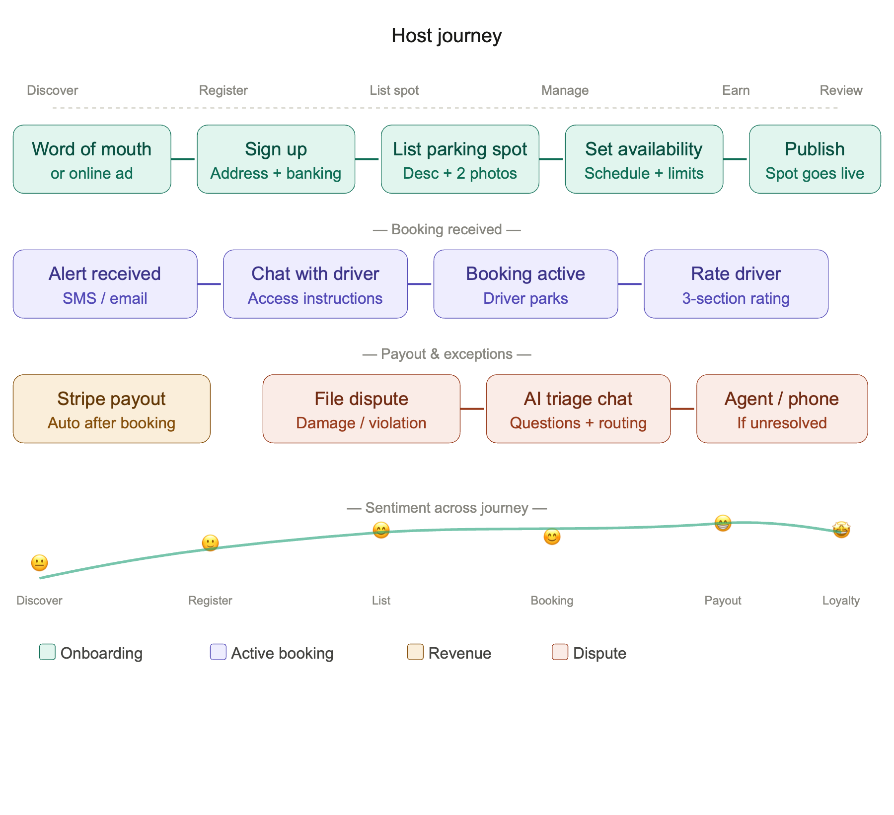

5.2 Spotter Journey
The Spotter starts anxious (no parking, event pressure), and the platform's job is to reverse that curve fast. A clean map search and rapid booking are the critical moments. Access to the spot without friction is the peak satisfaction moment.

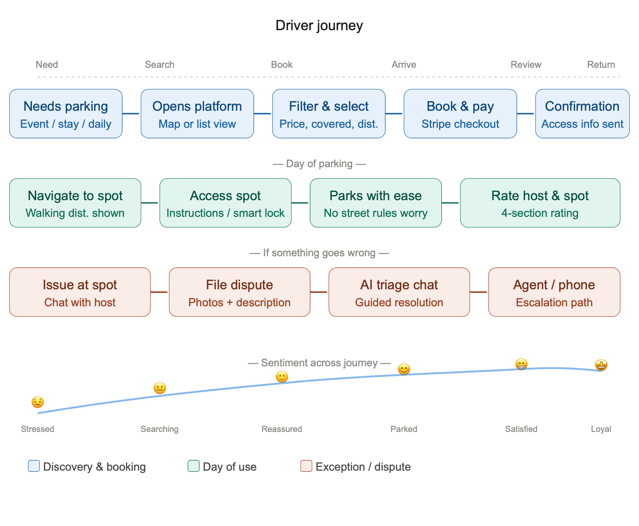

5.3 Block Spotter Journey (post-MVP)
The key differentiator here is the 'one booking → many guests' flow. The Block Spotter's emotional peak comes not at the payment step, but when all guests are smoothly parked without manual coordination. The consolidated invoice is a secondary but important moment for hotel and event accounting teams.

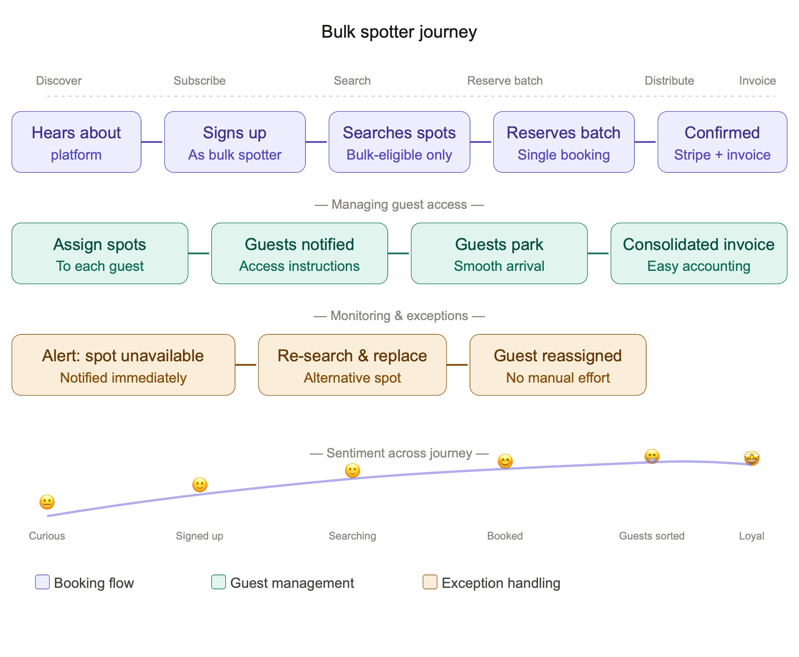

5.4 Cross-Journey Observations
- The dispute flow is identical across all three personas — AI triage first, human agent as fallback — which simplifies development.
- The sentiment curve starts lowest for Spotters (parking stress is the trigger), making first-impression speed critical — the map must load fast and show relevant results immediately.
- Block Spotters have the highest B2B relationship potential — likely to repeat-book for every event or guest cycle, making them the highest LTV segment despite lower frequency per individual booking.

6. Use Cases — Host

Bird's-Eye: Host Publishes Flexible Parking Rental Offering Goal: Enable a host to rent out their parking space for both short-term and medium-term durations, defining availability windows and reclaiming the space when needed — all in order to generate extra income while retaining control. Key capabilities: Create listing · Set availability schedule · Define duration and reclaim rules · Publish listing · Manage real-time availability · Receive and process bookings · Rate Spotter · Handle disputes · Receive payouts.

UC-H01 — Create Parking Listing
UC-H01 | Create Parking Listing
Goal | Host creates a valid, publishable parking listing
Primary Actor | Host
Precondition | Host is registered and has completed banking setup
Trigger | Host selects 'Add a spot'

Main Flow
- Host enters address of the parking spot.
- System validates the address and checks for duplicates.
- Host enters a description of the spot (access instructions, dimensions, type).
- Host uploads minimum 2 photos (mandatory).
- Host selects spot type (covered / uncovered / garage / driveway).
- System previews the listing.
- Host confirms and saves as draft.

Alternate Flow — Address not found: At step 2, if the address cannot be validated, the system prompts the host to pin the location manually on the map.
Alternate Flow — Fewer than 2 photos: At step 4, the system blocks progression and prompts the host to upload the missing photo(s).
Postcondition: Listing saved as draft, ready for availability setup (UC-H02).

UC-H02 — Define Availability Schedule
UC-H02 | Define Availability Schedule
Goal | Host defines when their spot is available for booking
Primary Actor | Host
Precondition | Draft listing exists (UC-H01 completed)
Trigger | Host opens availability settings on their listing

Main Flow
- Host selects recurring availability (e.g. weekdays 8am–6pm).
- Host optionally adds one-off availability windows (e.g. a specific weekend).
- Host optionally blocks specific dates or periods (e.g. holidays, personal use).
- System validates that at least one availability window exists.
- System displays a visual calendar preview of the availability.
- Host confirms and saves.

Alternate Flow — Conflicting windows: At step 3, if a blocked period overlaps an available window, the system warns the host and asks them to resolve the conflict before saving.
Postcondition: Availability schedule is attached to the listing; spot will only be bookable within defined windows.

UC-H03 — Set Rental Duration Rules
UC-H03 | Set Rental Duration Rules
Goal | Host defines the minimum and maximum rental durations and reclaim rules
Primary Actor | Host
Precondition | Draft listing exists (UC-H01 completed)
Trigger | Host opens duration settings on their listing

Main Flow
- Host selects rental type(s): short term (hours/days) and/or medium term (weeks/up to 3 months).
- Host sets minimum booking duration (e.g. 1 hour, 1 day).
- Host sets maximum booking duration (e.g. 7 days, 3 months).
- Host optionally sets a reclaim notice period (e.g. 48h notice to reclaim).
- System validates that min duration is less than max duration.
- Host confirms and saves.

Alternate Flow — Only medium term selected: Short term booking options are hidden from Spotters on the listing.
Postcondition: Duration rules are saved and enforced during booking validation.

UC-H04 — Publish Listing
UC-H04 | Publish Listing
Goal | Host makes their listing live and discoverable to Spotters
Primary Actor | Host
Precondition | UC-H01, UC-H02 and UC-H03 completed; all mandatory fields filled
Trigger | Host selects 'Publish'

Main Flow
- System runs a completeness check (address, description, 2 photos, availability, duration rules).
- System runs a content moderation check on photos and description (AI validation — see BR-H04).
- System confirms listing is valid and ready.
- Host clicks 'Go live'.
- System publishes the listing and makes it searchable on the map and list view.
- System sends a confirmation notification to the host (email + SMS).

Alternate Flow — Completeness check fails: System highlights missing fields and blocks publishing until resolved.
Alternate Flow — Content moderation flag: System notifies host and requests correction before publishing.
Postcondition: Listing is live, visible to Spotters, and bookable within defined availability and duration rules.

BR-H04 — AI Validation Rules for Listing Photos
BR-H04 | AI Validation Rules
Applies to | UC-H04 — Publish Listing, step 2
Enforcement | Automated, triggered on every publish and re-publish action
Fallback | Manual review by platform agent if AI confidence score is below threshold

BR-H04-01 — Photo must show a parking space
The AI model must verify that each submitted photo visibly depicts a parking space. Accepted evidence includes: a garage interior, a driveway, parking markings on the ground, a carport, or a clearly identifiable space where a vehicle can be stationed.

Outcome | Condition | System Action
Pass | Photo clearly shows a parking space with sufficient confidence | Proceed to BR-H04-02
Review | Confidence score below threshold (ambiguous angle, poor lighting) | Flag for manual agent review before publishing
Fail | Photo does not depict a parking space | Block publishing; notify host with rejection reason and guidance to resubmit

BR-H04-02 — Parking space must appear tidy and clean
The AI model must assess whether the space is reasonably tidy and free of obstructions. It should not contain excessive clutter, large debris, visible damage, or items that would prevent a vehicle from using it.

Outcome | Condition | System Action
Pass | Space appears clear, usable and reasonably clean | Proceed to publishing
Review | Space has minor clutter or ambiguous content | Flag for manual agent review before publishing
Fail | Space is visibly obstructed, heavily cluttered or unusable | Block publishing; notify host with rejection reason and prompt to tidy and resubmit

BR-H04-03 — Resubmission rules
- Host may resubmit corrected photos at any time after a rejection.
- Each resubmission triggers a new AI validation pass.
- After 3 consecutive failures, the system escalates to a manual platform agent review.
- The host is not penalised for failed attempts made in good faith.

BR-H04-04 — Transparency
- The system must always provide a human-readable rejection reason with actionable guidance.
- The system must never reject a listing silently.
- AI rejection reasons are logged and available for audit by platform agents.

UC-H05 — Manage Real-Time Availability
UC-H05 | Manage Real-Time Availability
Goal | Host updates availability after publishing — blocking or opening windows in real time
Primary Actor | Host
Precondition | Listing is published
Trigger | Host needs to block or open availability

Main Flow
- Host opens their listing calendar.
- Host selects a date or period to block or open.
- System checks whether existing confirmed bookings conflict with the change.
- No conflict found — system updates availability immediately.
- Listing reflects updated availability to Spotters in real time.

Alternate Flow — Conflict with existing booking: System warns the host, displays the affected booking, and prevents the change until the booking has ended or been resolved.
Postcondition: Availability is updated in real time; no double bookings possible.

UC-H06 — Receive and Confirm Booking
UC-H06 | Receive and Confirm Booking
Goal | Host is notified of a new booking and the system processes it automatically
Primary Actor | Host (notified), System (acts)
Precondition | Listing is live; Spotter has completed a booking
Trigger | Spotter completes a booking on the host's spot

Main Flow
- System validates the booking against current availability and duration rules.
- System processes payment via Stripe.
- System blocks the booked period in the host's availability calendar.
- System sends booking confirmation to host via SMS and email.
- System sends access instructions prompt to host to share via chat if not pre-filled.
- Host reviews booking details in their dashboard.

Alternate Flow — Spot no longer available: System cancels the booking, notifies the Spotter, and releases the payment.
Postcondition: Booking is confirmed; calendar is blocked; host is notified; payment is held pending completion.

UC-H07 — Reclaim Parking Space
UC-H07 | Reclaim Parking Space
Goal | Host reclaims their spot at the end of a booking or within defined reclaim rules
Primary Actor | Host
Precondition | Active booking exists; reclaim rules were set in UC-H03
Trigger | Booking end date reached, or host initiates early reclaim within allowed rules

Main Flow
- System detects booking end time approaching (24h before).
- System notifies Spotter that the booking is ending soon.
- Booking period ends — system marks spot as available again.
- System releases payment to host via Stripe.
- System prompts both host and Spotter to leave a review.

Alternate Flow — Host initiates early reclaim: If the reclaim notice period has been respected, the system notifies the Spotter, calculates a pro-rata refund, processes it, and releases the spot.
Alternate Flow — Reclaim notice period not respected: System blocks the reclaim and informs the host of the earliest possible reclaim date.
Postcondition: Spot is returned to available status; payment is settled; both parties are invited to review.

UC-H08 — Receive Booking Alerts
UC-H08 | Receive Booking Alerts
Goal | Host is notified in real time whenever a booking is made, modified or cancelled
Primary Actor | Host
Precondition | Listing is published; host has verified phone number and email
Trigger | A booking event occurs (creation, modification or cancellation)

Main Flow
- System detects a booking event on the host's listing.
- System composes a notification message summarising the event.
- System sends notification via SMS to the host's registered phone number.
- System sends notification via email to the host's registered email address.
- Host receives both notifications within 60 seconds of the event.

Event | SMS Content | Email Content
New booking | Spot name, Spotter name, dates, total amount | Full booking summary, access to dashboard
Modification | What changed (dates / duration), by whom | Before/after comparison, link to booking
Cancellation | Who cancelled, refund status if applicable | Full cancellation summary, updated calendar

Alternate Flow — SMS delivery failure: System retries once after 2 minutes and logs the failure. Email remains the fallback.
Postcondition: Host is informed of all booking status changes via both channels; no silent booking changes occur.

UC-H09 — Chat with Spotter
UC-H09 | Chat with Spotter
Goal | Host communicates with a Spotter to share access instructions or resolve pre-arrival issues
Primary Actor | Host
Precondition | A confirmed booking exists between host and Spotter
Trigger | Host or Spotter initiates a message in the booking chat thread

Main Flow
- System creates a dedicated chat thread per booking upon booking confirmation.
- Host opens the chat thread from their booking dashboard.
- Host types and sends a text message.
- System delivers the message to the Spotter in real time.
- Spotter replies; host receives the reply with a push notification and email notification.
- Host can attach and send images (e.g. photo of entrance, access code panel, gate).
- System stores the full chat history for the duration of the booking plus 30 days after.

Feature | Status
Text messages | Enabled
Images | Enabled
Emojis | Disabled
Links | Enabled
File attachments (PDF etc.) | Disabled (MVP)
Video | Disabled (MVP)

Alternate Flow — No active booking: System blocks the message and displays a notice that chat is only available for confirmed bookings.
Postcondition: Host and Spotter have a shared, logged communication thread tied to the booking; access instructions are on record.

UC-H10 — Rate a Spotter
UC-H10 | Rate a Spotter
Goal | Host submits a structured rating for a Spotter after a completed booking
Primary Actor | Host
Precondition | Booking has reached its end date and is marked as completed
Trigger | System prompts host to leave a rating, or host navigates to the completed booking

Main Flow
- System sends a rating prompt to the host via email and SMS within 1 hour of booking completion.
- Host opens the rating form for the completed booking.
- Host rates the Spotter across 3 sections (1–5 stars each): Communication · Respect of rules · State.
- Host optionally adds a free-text description (max 500 characters).
- Host submits the rating.
- System saves the rating and updates the Spotter's public profile score.
- System notifies the Spotter that a review has been received.

Rule | Detail
Deadline | Host has 7 days after booking completion to submit a rating
Editability | Rating cannot be edited once submitted
Visibility | Rating is visible on the Spotter's profile after both parties have rated, or after 7 days
Anonymity | Rating content is public; individual scores per section visible to the rated Spotter only

Postcondition: Spotter's community trust score is updated; rating is visible on their profile.

UC-H11 — Open a Dispute
UC-H11 | Open a Dispute
Goal | Host files a complaint about damage or rule violation and receives guided support toward resolution
Primary Actor | Host
Precondition | A booking exists (active or recently completed, within 48 hours of end)
Trigger | Host selects 'Report an issue' from a booking

Main Flow
- Host selects 'Report an issue' on a booking from their dashboard.
- System opens the AI-assisted dispute chat.
- AI prompt greets the host and asks them to describe the issue in their own words.
- AI asks structured follow-up questions: nature of issue, when it occurred, whether host has photo evidence.
- Host uploads photos if applicable.
- AI summarises the gathered information and asks the host to confirm accuracy.
- Host confirms — system logs the dispute with full context and assigns a reference number.
- System notifies the Spotter that a dispute has been opened.
- System gives the Spotter 24 hours to respond via the dispute chat thread.

Alternate Flow — AI escalation to human agent: At any point in steps 3–6, if the AI detects complexity, a safety concern, or the host explicitly requests a human, the system transfers to an agent queue with full transcript attached. First response guaranteed within 4 business hours.
Alternate Flow — Spotter does not respond within 24 hours: System automatically escalates to a platform agent.
Postcondition: Dispute is logged with a reference number; both parties are notified; resolution is reached via AI guidance or escalated to a human agent.

UC-H12 — Set Up Banking for Payouts
UC-H12 | Set Up Banking for Payouts
Goal | Host registers their banking details so that earned income is paid out automatically via Stripe
Primary Actor | Host
Precondition | Host has a registered Spotzy account
Trigger | Host accesses payout settings, or is prompted during listing creation

Main Flow
- Host navigates to payout settings.
- System redirects host to the Stripe Connect onboarding flow (hosted by Stripe).
- Host enters: full legal name, IBAN / bank account number, address for verification.
- Stripe performs identity and bank account verification.
- Stripe confirms successful setup and returns the host to Spotzy.
- System marks the host's account as payout-enabled.
- System confirms that payouts will be processed automatically after each completed booking.

Rule | Detail
Payout timing | Triggered automatically upon booking completion
Processing time | 2–5 business days depending on the host's bank
Currency | Local currency as supported by Stripe
Minimum payout | Subject to Stripe minimums (platform to confirm)
Failed payout | System notifies host and retries after 48 hours

Alternate Flow — Stripe verification fails: Host is notified to correct their details and retry. Listing can be created but cannot be published until payout setup is complete.
Postcondition: Host's Stripe Connect account is active; payouts are processed automatically after every completed booking.

7. Use Cases — Spotter

Bird's-Eye UC-D01: Discover and Select the Ideal Parking Spot Enable Spotters to easily find, compare, and select a parking spot that best fits their needs, preferences, and destination. Covers map search, filtering, indicators, preference profiling and (post-MVP) conversational search.

Bird's-Eye UC-D02: Book, Modify, and Manage a Parking Reservation Enable Spotters to book a spot, adjust the booking if plans change, or cancel with clear cost recovery rules. Covers booking flow, payment, modification and cancellation.

Bird's-Eye UC-D03: Post-Stay Interaction — Ratings, Issues & Support Enable Spotters to provide feedback on their parking experience and request support when something goes wrong. Covers ratings, dispute handling and support escalation.

UC-S01 — Search for a Parking Spot on the Map
UC-S01 | Search for a Parking Spot on the Map
Goal | Spotter finds available parking spots visually on a map relative to their destination
Primary Actor | Spotter
Precondition | Spotter is registered and logged in; Mapbox map is loaded
Trigger | Spotter opens the search screen and enters a destination

Main Flow
- Spotter enters a destination address or point of interest in the search bar.
- System geocodes the destination and centres the Mapbox map on that location.
- System displays available spots as pins on the map within a default radius.
- Each pin shows a summary card on tap: price, spot type, covered indicator, walking distance from destination.
- Spotter browses the map, zooms and pans to explore spots in the area.
- Spotter selects a spot pin to view the full listing detail.
- System displays full listing: photos, description, availability, price, host rating, walking distance, covered/uncovered indicator, accessibility info.
- Spotter proceeds to booking (UC-S04).

Business Rules
Walking distance: Calculated via Mapbox routing. Shown in metres under 500m, and in minutes walking time above 500m. Option: display connecting public transport possibilities.
Covered indicator: Roof icon displayed if the spot is covered. Sourced from host's listing setup.
Accessibility: Indicator displayed if host has flagged step-free access, wide bay, or proximity to lift.

Alternate Flow — No spots found: System automatically expands the search radius and notifies the Spotter.
Alternate Flow — Destination not found: System prompts the Spotter to adjust their search term or pin their destination manually on the map.
Postcondition: Spotter has a clear visual overview of available spots near their destination and can proceed to filtering or booking.

UC-S02 — Filter Search Results
UC-S02 | Filter Search Results
Goal | Spotter narrows down search results to spots that match their specific needs
Primary Actor | Spotter
Precondition | Map search is active with at least one result displayed (UC-S01)
Trigger | Spotter opens the filter panel

Main Flow
- Spotter opens the filter panel from the search screen.
- System presents filter options: Availability (date range, start/end time, duration) · Price (max per hour/day/month) · Spot type (garage/driveway/carport/open space) · Features (covered, accessible, privately owned, EV charging).
- Spotter selects one or more filters and applies them.
- System refreshes the map and list view in real time.
- System displays a count of results matching the active filters.
- Spotter can reset individual filters or clear all filters at any time.

Privately owned filter rule: When active, excludes public and commercial parking operators — shows only P2P listings from individual hosts.
Alternate Flow — No results match filters: System displays 'No results' message and suggests which filter(s) to relax.
Postcondition: Map and list view show only spots matching the Spotter's criteria.

UC-S03 — Save Preferences and Frequent Destinations
UC-S03 | Save Preferences and Frequent Destinations
Goal | System learns the Spotter's habits and proactively proposes relevant spots
Primary Actor | System (automated), Spotter (passive)
Precondition | Spotter is registered and has completed at least one booking
Trigger | Automated — runs in the background after each search and booking event

Main Flow
- System silently records each destination searched, filters applied and spot booked.
- System identifies recurring patterns over time.
- System builds a Spotter preference profile (stored privately, not visible to hosts).
- On next search, system pre-populates filters based on learned preferences.
- System surfaces a 'Suggested for you' section on the home screen.
- If a previously booked spot is available for an upcoming period matching past behaviour, system sends a proactive alert.

Privacy rule: The preference profile is used exclusively for personalisation within the platform. It is never shared with hosts or third parties. The Spotter can view and reset their preference data at any time from account settings.
Postcondition: Spotter experiences a progressively more personalised search with less manual effort over time.

UC-S04 — Book and Pay for a Parking Spot
UC-S04 | Book and Pay for a Parking Spot
Goal | Spotter securely books and pays for a parking spot through the platform
Primary Actor | Spotter
Precondition | Spotter has selected a spot (UC-S01 or UC-S02); registered payment method via Stripe
Trigger | Spotter selects 'Book this spot' on a listing

Main Flow
- Spotter selects start date/time and end date/time for the booking.
- System validates the requested period against the host's availability schedule and duration rules.
- System calculates the total price and displays a booking summary (spot, dates, total cost, cancellation policy).
- Spotter confirms the booking details.
- System initiates Stripe payment authorisation.
- Stripe processes the payment and returns a confirmation.
- System confirms the booking and blocks the period in the host's calendar.
- System sends booking confirmation to the Spotter via email and SMS.
- System notifies the host of the new booking (UC-H08).

Rule | Detail
Payment method | Stripe — credit/debit card
Charge timing | Payment authorised at booking; captured upon booking start
Escrow | Funds held by Stripe until booking completion
Receipt | Automatic email receipt issued by Stripe

Alternate Flow — Selected period no longer available: System displays 'Unavailable' message and returns the Spotter to search results.
Alternate Flow — Payment failure: System notifies the Spotter; the booking is not confirmed; the calendar period is released.
Postcondition: Booking is confirmed and paid; spot is reserved for the Spotter; both parties are notified.

UC-S05 — Modify a Booking
UC-S05 | Modify a Booking
Goal | Spotter adjusts the start or end time of an existing booking to accommodate unexpected changes
Primary Actor | Spotter
Precondition | Booking is confirmed and has not yet started, or is active (for end time extension only)
Trigger | Spotter selects 'Modify booking' from their booking dashboard

Main Flow — Change start time
- Spotter selects 'Change start time' on a confirmed upcoming booking.
- System displays available earlier and later start times within the host's availability window.
- Spotter selects a new start time.
- System recalculates the total price based on the new duration.
- If the new duration is longer — system charges the price difference via Stripe.
- If the new duration is shorter — system issues a partial refund via Stripe.
- System confirms the modification and updates the booking and calendar.
- System notifies the host via SMS and email.

Main Flow — Change end time
- Spotter selects 'Change end time' on a confirmed or active booking.
- System checks host availability immediately after the current end time.
- Extension is available — Spotter selects a new end time.
- System charges the additional period via Stripe.
- System confirms the modification and updates the booking and calendar.
- System notifies the host via SMS and email.

Rule | Detail
Start time change deadline | Must be requested at least 2 hours before original start time
End time extension | Only possible if host's calendar is free after current end time
End time reduction | Allowed subject to minimum booking duration; partial refund applies per cancellation policy
Modification fee | None (MVP)

Alternate Flow — Extension not available: System notifies the Spotter and suggests nearby available spots.
Postcondition: Booking is updated with new times; payment difference is settled; host is notified.

UC-S06 — Cancel a Booking
UC-S06 | Cancel a Booking
Goal | Spotter cancels a booking and receives a refund according to the cancellation policy
Primary Actor | Spotter
Precondition | Booking is confirmed
Trigger | Spotter selects 'Cancel booking' from their booking dashboard

Main Flow
- Spotter selects 'Cancel booking' on a confirmed booking.
- System displays the applicable cancellation policy and the refund amount the Spotter will receive.
- Spotter confirms the cancellation.
- System cancels the booking and releases the period in the host's calendar.
- System processes the refund via Stripe according to the cancellation policy.
- System notifies the host via SMS and email.
- System sends a cancellation confirmation to the Spotter with refund amount and expected processing time.

Time before booking start | Refund to Spotter
More than 48 hours | 100% refund
Between 24 and 48 hours | 50% refund
Less than 24 hours | No refund
Booking already started | No refund

Alternate Flow — Host cancels: Spotter receives 100% refund regardless of timing. Host cancellation is logged and may affect host's reliability score.
Postcondition: Booking is cancelled; calendar is freed; refund is processed per policy; both parties are notified.

UC-S07 — Rate a Host and Spot
UC-S07 | Rate a Host and Spot
Goal | Spotter submits a structured rating for the host and the spot after a completed booking
Primary Actor | Spotter
Precondition | Booking is marked as completed
Trigger | System prompts Spotter to leave a rating, or Spotter navigates to the completed booking

Main Flow
- System sends a rating prompt to the Spotter via email and SMS within 1 hour of booking completion.
- Spotter opens the rating form for the completed booking.
- Spotter rates the host and spot across 4 sections (1–5 stars each): Safety/security · State · Convenience · Location.
- Spotter optionally adds a free-text description (max 500 characters).
- Spotter submits the rating.
- System saves the rating and updates the host's and listing's public score.
- System notifies the host that a review has been received.

Rule | Detail
Deadline | Spotter has 7 days after booking completion to submit a rating
Editability | Rating cannot be edited once submitted
Visibility | Published after both parties have rated, or after 7 days whichever comes first
Minimum submission | At least 2 of the 4 sections must be rated to submit

Postcondition: Host and listing scores are updated; rating contributes to community trust signals.

UC-S08 — Open a Dispute
UC-S08 | Open a Dispute
Goal | Spotter files a complaint about an issue with a spot or host and receives guided support toward resolution
Primary Actor | Spotter
Precondition | A booking exists (active or completed within 48 hours)
Trigger | Spotter selects 'Report an issue' from a booking

Main Flow
- Spotter selects 'Report an issue' on a booking from their dashboard.
- System opens the AI-assisted dispute chat.
- AI greets the Spotter and asks them to describe the issue in their own words.
- AI asks structured follow-up questions: nature of issue (spot not as described / access problem / safety concern / host unresponsive / other), when it occurred, whether the Spotter has photo evidence.
- Spotter uploads photos if applicable.
- AI summarises the gathered information and asks the Spotter to confirm accuracy.
- Spotter confirms — system logs the dispute and assigns a reference number.
- System notifies the host that a dispute has been opened.
- System gives the host 24 hours to respond via the dispute chat thread.

Alternate Flow — AI escalation to human agent: If the AI detects complexity, a safety concern, or the Spotter explicitly requests a human, the system transfers to an agent queue. First response guaranteed within 4 business hours.
Alternate Flow — Host does not respond within 24 hours: System automatically escalates to a platform agent and notifies the Spotter.
Alternate Flow — Dispute relates to a refund: AI flags it as a financial dispute and escalates directly to a human agent with Stripe transaction details attached.
Postcondition: Dispute is logged with a reference number; both parties are notified; resolution is reached via AI guidance or escalated to a human agent.

8. Use Cases — Spot Manager (post-MVP)

All use cases in this section are post-MVP. They are documented here for planning purposes and will be built once the core Host/Spotter loop is validated in production.

UC-SM01 — Create a Spot Pool
UC-SM01 | Create a Spot Pool
Goal | Spot Manager creates a single listing representing a pool of interchangeable parking spots
Primary Actor | Spot Manager
Precondition | Spot Manager is registered with a verified account and banking setup
Trigger | Spot Manager selects 'Add a Spot Pool' from their portfolio dashboard

Main Flow
- Spot Manager enters the shared location address of the pool (building, lot, or facility).
- Spot Manager defines the shared characteristics: type (covered/outside/garage), dimensions (standard/large), EV charging (yes/no), and price per hour/day/month.
- Spot Manager uploads a minimum of 2 photos representing the type of spot (mandatory).
- Spot Manager enters the number of individual Pool Spots in the pool (e.g. 10).
- System generates individual Pool Spot records internally (Bay-1 through Bay-10), each linked to the Spot Pool listing.
- Spot Manager optionally assigns a label and specific access instructions to each Pool Spot (e.g. 'Bay 3 — enter via side entrance, code 4521').
- System previews the Spot Pool listing as it will appear to Spotters.
- Spot Manager confirms and saves as draft.
- Spot Manager proceeds to availability setup (UC-H02 applies at pool level) and publishes (UC-H04).

Characteristic | Must match within a Spot Pool
Spot type | Yes — covered / outside / garage
Dimensions | Yes — standard / large
EV charging | Yes — yes / no
Price | Yes — same price per time unit
Location (building / lot) | Yes — same physical address
Floor / level | No — may differ; noted per Pool Spot

Alternate Flow — Non-homogeneous spots: System warns that non-homogeneous spots cannot be grouped in a single Spot Pool and prompts creation of separate listings per type.
Alternate Flow — Single spot entered: System prompts whether host intended a regular single listing (UC-H01) and offers to switch.
Postcondition: Spot Pool listing is saved as draft with N Pool Spot records linked internally; the listing is ready for availability setup and publication.

UC-SM02 — Swap a Pool Spot Assignment
UC-SM02 | Swap a Pool Spot Assignment
Goal | Spot Manager reassigns a Spotter from one Pool Spot to another within the same Spot Pool without cancelling or disrupting the booking
Primary Actor | Spot Manager
Precondition | An active or upcoming booking exists on the Spot Pool; at least one alternative Pool Spot is available for the same period
Trigger | Spot Manager selects 'Swap Pool Spot' on an active booking, or a Pool Spot is marked as unavailable while a booking is active on it

Main Flow
- Spot Manager opens the booking from their portfolio dashboard.
- Spot Manager selects 'Swap Pool Spot' and chooses an available replacement Pool Spot from the pool.
- System validates that the replacement Pool Spot is free for the full booking period.
- System updates the booking record — booking ID, dates, price and Spotter details remain unchanged.
- System updates the access instructions visible to the Spotter with the replacement Pool Spot's specific instructions.
- System sends a silent notification to the Spotter: updated access instructions only.
- System logs the swap event against the booking for audit purposes.

Rule | Detail
Booking unchanged | Booking ID, price, dates and Spotter identity are never modified by a swap
Spotter notification | Always sent — silent in tone, access-instruction focused
Swap limit | No limit on number of swaps per booking; each swap is logged
Swap timing | Allowed at any point before or during the booking
No available replacement | System blocks the swap and alerts the Spot Manager
Spotter action required | None — the Spotter receives updated instructions only

Alternate Flow — No replacement available: System blocks the swap and suggests the Spot Manager either extends availability on another Pool Spot or contacts the Spotter via chat.
Alternate Flow — Automatic swap trigger: If a Pool Spot is blocked while a confirmed booking is active on it, the system automatically attempts to find a free replacement. If found, the swap is performed automatically and the Spot Manager is notified. If none found, the Spot Manager is alerted to resolve manually.
Postcondition: Spotter is assigned to the replacement Pool Spot; access instructions are updated; booking continuity is preserved; swap is logged.

UC-SM03 — Manage Portfolio Dashboard
UC-SM03 | Manage Portfolio Dashboard
Goal | Spot Manager monitors occupancy, availability and earnings across all spots and Spot Pools from a single view
Primary Actor | Spot Manager
Precondition | Spot Manager has at least one published listing or Spot Pool
Trigger | Spot Manager opens their portfolio dashboard

Main Flow
- System displays a portfolio summary: total spots under management, current occupancy rate, total earnings this month and all-time, number of active and upcoming bookings.
- System displays a listing-level breakdown — each listing and Spot Pool shown as a row with occupancy, active bookings, and monthly earnings.
- Spot Manager can drill into any Spot Pool to see individual Pool Spot status (available / booked / blocked).
- Spot Manager can block availability at pool level (affects all Pool Spots) or at individual Pool Spot level.
- Spot Manager can navigate to any individual booking from the dashboard.
- Spot Manager can view a consolidated earnings report filterable by listing, spot type, and date range.

Postcondition: Spot Manager has a real-time view of their entire portfolio and can act on any spot or booking directly from the dashboard.

Data Model Impact
Entity | Description
SpotPool | A listing record representing a pool — stores shared characteristics, photo references, price, availability rules, and pool size
PoolSpot | Each individual bay within the pool — stores label, floor/level, and specific access instructions; linked to SpotPool by poolId
Booking | Extended with a poolSpotId field (nullable) — null until a specific bay is assigned at booking time; updated on swap without changing the booking itself

9. Release Scope — MVP vs v1.1

MVP validates the core P2P loop — a Host lists a spot, a Spotter finds and books it, payment flows, both rate each other.

v1.1 builds on proven traction to unlock the professional and institutional layer — Spot Managers with Spot Pools, Block Spotters reserving batches, smart lock automation, and AI-assisted pricing. These features require either real platform data, a critical mass of users, or hardware/third-party dependencies that are premature to build before the core loop is validated.

Feature | MVP | v1.1
Host listing creation and publication | Yes
AI photo validation (Rekognition) | Yes
Spotter map search (Mapbox) | Yes
Availability-based filtering | Yes
Instant booking and Stripe payment | Yes
Booking modification (start/end time) | Yes
Cancellation with refund policy | Yes
SMS + email notifications | Yes
Host-Spotter chat (text + images) | Yes
Host and Spotter ratings | Yes
AI-assisted dispute flow | Yes
Stripe Connect payout to host | Yes
Spotter preference learning (background) | Yes
Smart lock integration (Seam / RemoteLock) |  | v1.1
Block Spotter bulk booking |  | v1.1
Spot Manager & Spot Pool |  | v1.1
Conversational search (NLP filters) |  | v1.1
Dynamic pricing suggestions |  | v1.1
MobiGIS parking zone overlay |  | v1.1
Security indicator on listings |  | v1.1
Mobile app (iOS / Android) |  | v1.1
Consolidated invoice for Block Spotters |  | v1.1

End of document.

