Special Cook PMS - Software Refactoring Report

Mahmoud Yassen (ID: 12217265)
Osama Jamal (ID: 122)

Course: Software Engineering
Instructor: Dr. [haya sam]
Date: May 2025

Before refactoring from sonar cloud

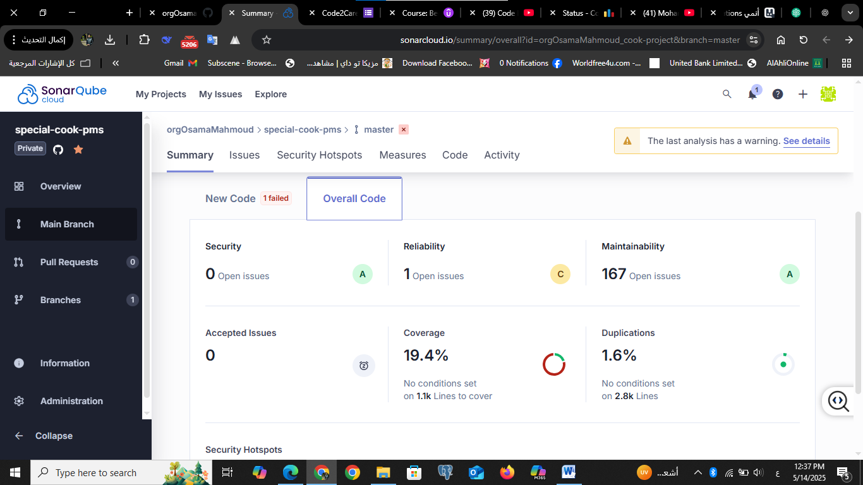

Fix issue in reliability

Bad Smell: Potential NullPointerException in App.java
Before Refactoring:
In the App.java class, the variable customer was used without checking if it was null. This could lead to a NullPointerException if the customer is not found.

After Refactoring:
A null check was added before using the customer object to ensure the program does not crash.
java
Customer customer = customerManager.getCustomer("Mahmoud Yaseen");
if (customer != null) {
System.out.println(customer.getAllergies());
} else {
System.out.println("❌ Customer not found.");
}

What software benefit did I achieve?
- Improved reliability and prevented potential runtime crashes.
- Protected the program from null reference errors.
- The warning disappeared from SonarCloud after the fix.
- Applied defensive programming best practices.
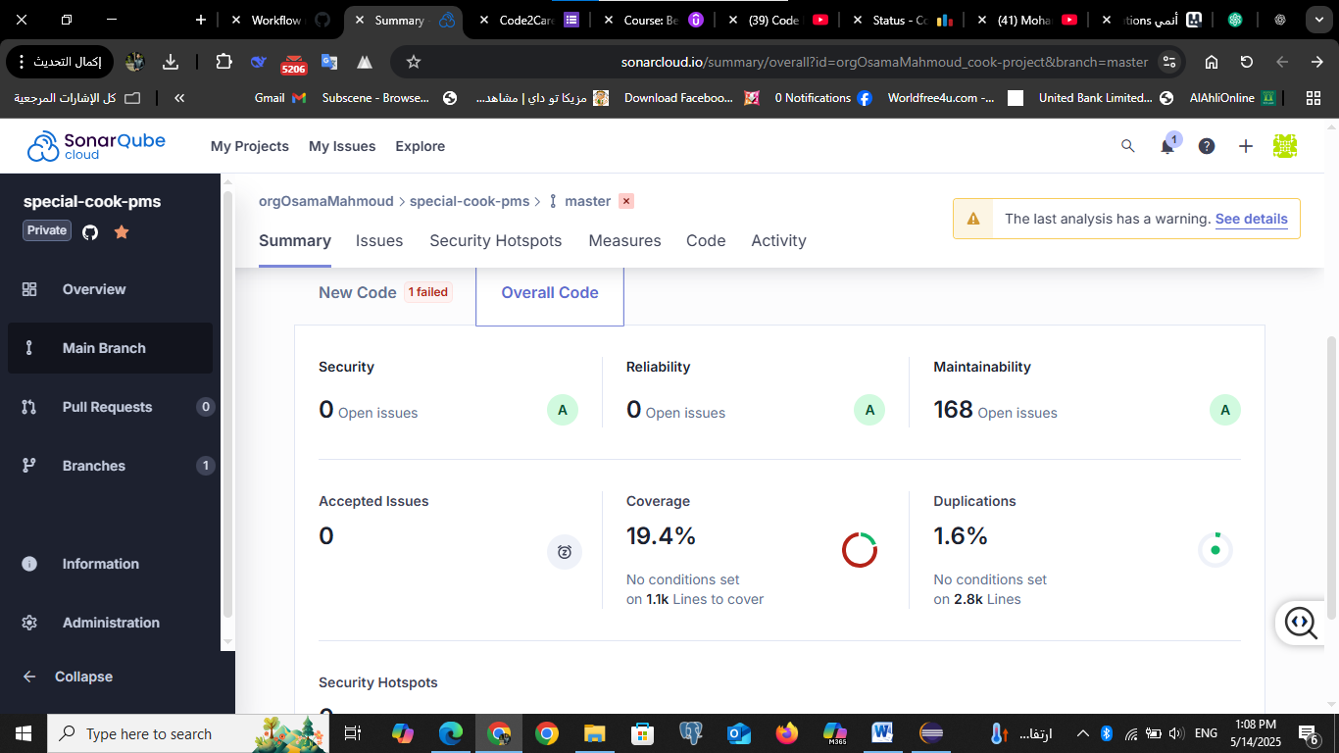

Increase the percentage of coverage for each class

Before refactor for KitchenManager.java
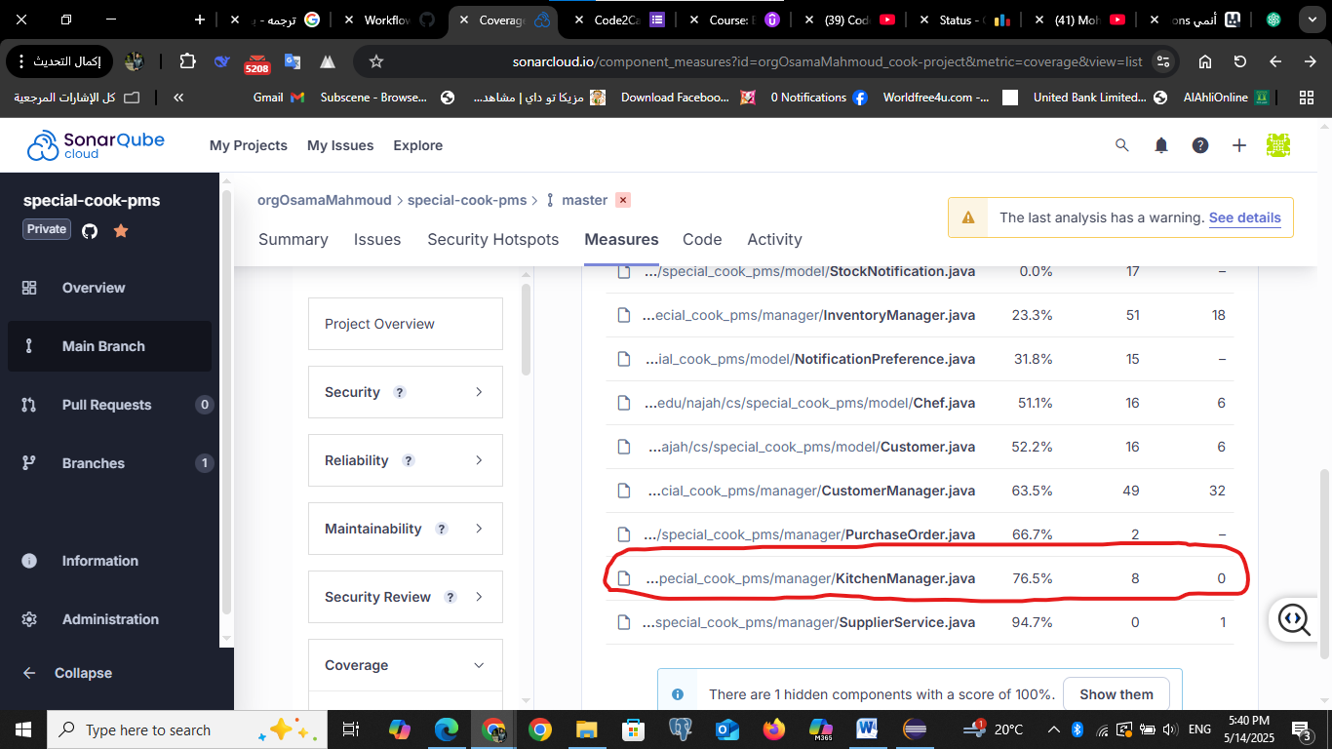

after refactor for KitchenManager.java
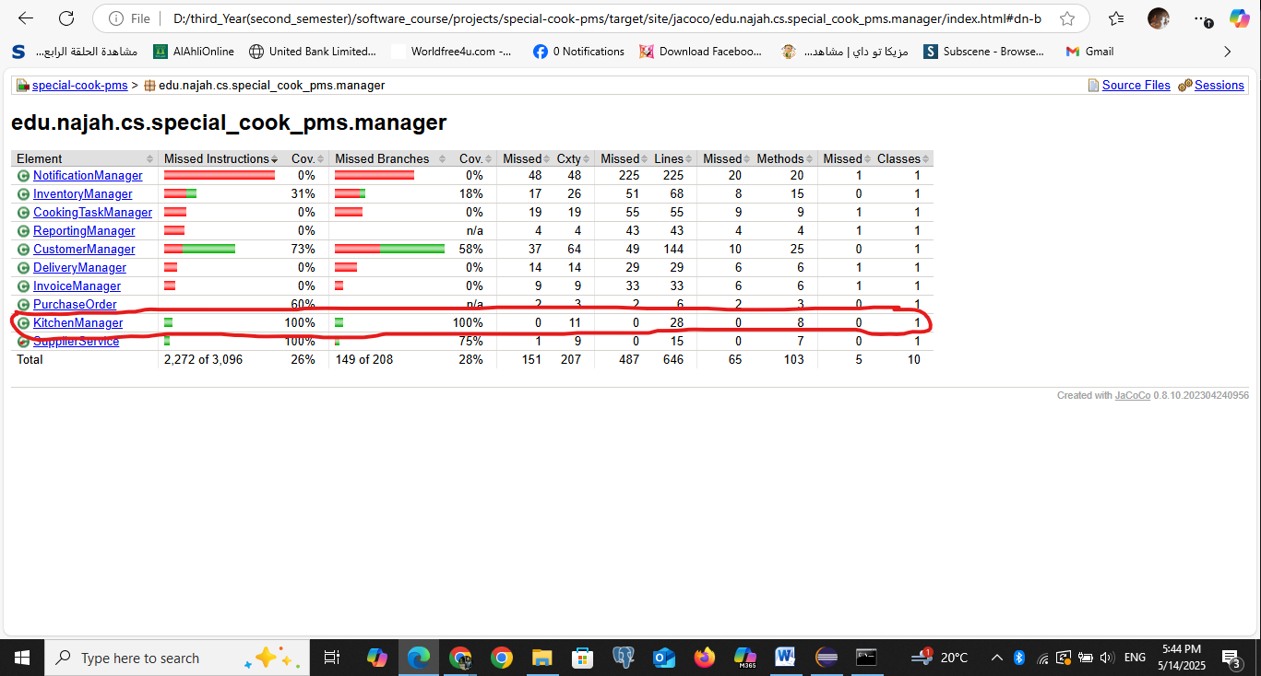
Before writing unit tests, the class KitchenManager had 0% test coverage.
We added a full test class (KitchenManagerTest) to cover all its constructors and methods, including:
- assignTask
- addChef, getChefs
- addNotification, getNotifications
- getName
After running the tests with JaCoCo, the coverage for KitchenManager reached 100%.
This improved the code reliability and made sure everything works as expected

Some classes that want to cover

Before
