Report SMA project:

Group members: Or Gamliel, Yarden Veis, Adi Koren

1. Introduction
Online social platforms provide a rich environment for examining public discourse around socially and culturally significant topics. Alcohol consumption, in particular, represents a multifaceted subject that encompasses everyday practices, social norms, cultural identity, and emotional expression. Discussions surrounding alcohol online reflect not only consumption habits but also attitudes, values, and sentiments associated with drinking across different contexts. This study focuses on understanding:
How alcohol is discussed online, how are these discussions structured into distinct communities, and what emotional sentiments characterize each type of discourse?
We use the Reddit platform as a case study. Reddit enables large-scale, user-driven discussions in which participants engage around shared interests while remaining largely anonymous, making it a suitable environment for analyzing both interaction structures and emotional dynamics.
The analysis focuses on identifying structural patterns in the interaction network, detecting communities based on interaction structure, and examining how sentiment is distributed across these communities. To this end, we combine community detection techniques with sentiment analysis in order to characterize both the structural organization of the network and the emotional tone of discussions within it.

2. Data Collection and Network Construction
Data were collected from the r/alcohol subreddit using the Reddit API (PRAW). We focused on comment-reply interactions in order to capture direct user-to-user communication. Each interaction was represented as a directed edge from the commenting user to the user being replied to, resulting in a directed interaction network. As part of the preprocessing stage, we applied a basic cleaning procedure and removed self-loops. This step ensures that all edges in the network represent meaningful social interactions between distinct users.
The dataset consists of 2,932 interactions (edges) between 1,316 unique users (nodes). After applying data cleaning procedures, we constructed a directed interaction network comprising 1,315 nodes and 2,584 edges. To ensure meaningful structural analysis, we extracted the giant weakly connected component (GWCC), which includes 1,291 nodes and 2,564 edges. Since this component contains over 98% of the network’s nodes and interactions, we focused our analysis exclusively on the GWCC in order to capture the core interaction structure and maximize the reliability and interpretability of the results, while excluding isolated or marginal users.

3. Network Structure Metrics
To characterize the structural properties of the interaction network, we computed several standard network-level metrics on the giant weakly connected component. The resulting graph exhibits a very low density (0.00258), indicating that only a small fraction of all possible user-to-user connections are realized. This reflects a sparse interaction structure, which is typical of large-scale online discussion networks where most users interact with only a limited number of others. The low density suggests that interactions are primarily content-driven and episodic rather than based on persistent social ties.
The average clustering coefficient is low (0.03424), indicating limited triadic closure and weak local connectivity in the interaction network. This implies the absence of closed friendship groups, with discussions not organized around small, cohesive clusters but rather characterized by dispersed, loosely connected interactions.
In addition, the negative degree assortativity (-0.16462) indicates a hub-oriented interaction pattern, where highly active users engage primarily with less connected participants. This structure is consistent with Reddit’s discussion dynamics, in which central users act as focal points for interaction rather than interacting mainly with each other.
Degree centrality was used to identify highly active users with many direct interactions, which served as the primary criterion for selecting community hubs.
Betweenness and closeness centrality were computed as supplementary metrics for additional structural characterization if required.

4. Community Detection and Modularity Analysis
Following the structural analysis and visualization of the network, we applied community detection techniques to identify latent groups of users based on interaction patterns. Community detection was performed on the undirected version of the giant weakly connected component using the Louvain algorithm, which optimizes network modularity by maximizing the density of intra-community connections relative to inter-community connections.
To evaluate the sensitivity of the results, we experimented with 3 different values of the resolution parameter. Based on the results, we selected resolution = 1.0 as the optimal configuration, as it achieved the highest modularity score (Q = 0.6162). This resolution resulted in the identification of 21 communities, striking a balance between avoiding over-fragmentation of the network while still producing well-defined, topic-oriented communities.
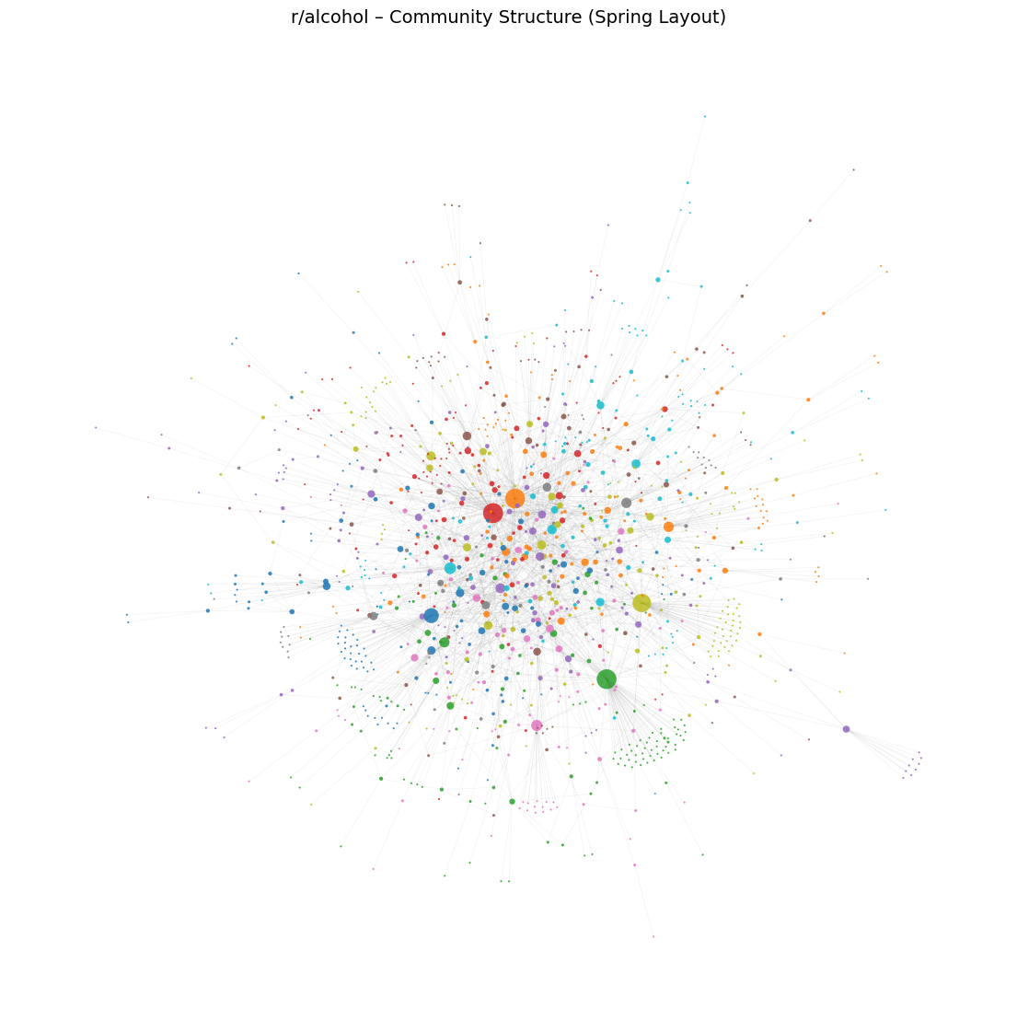
For comparison, we also experimented with the Girvan–Newman algorithm, which is based on iterative removal of edges with high betweenness centrality. However, this method produced less stable partitions and lower-quality community structures compared to Louvain, particularly given the size and sparsity of the network. Consequently, the Louvain algorithm was selected as the primary method for all subsequent community-level analyses.

5. Community-Level Text Processing and Representation
After identifying the five largest communities based on the number of unique users, we conducted a community-level content analysis to characterize the dominant topics discussed within each group. These five communities together account for a substantial portion of the network’s active users and comments, making them suitable candidates for in-depth qualitative analysis.
Prior to analysis, the text underwent a cleaning process that included lowercasing, removal of URLs, whitespace normalization, and filtering of empty or invalid entries.
For textual representation, we applied a spaCy-based NLP pipeline to extract lemmatized tokens, named entities, and noun chunks from the comments of each community. To maintain computational efficiency, an upper limit was applied to the number of processed documents per community. The extracted elements were combined using a weighted frequency scheme, where noun chunks and named entities were slightly boosted to emphasize semantically meaningful concepts. These combined frequency distributions were visualized using word clouds, providing a compact summary of the dominant topics within each community and serving as a foundation for subsequent community-level interpretation.

6. Community-Level Analysis of Dominant Topics
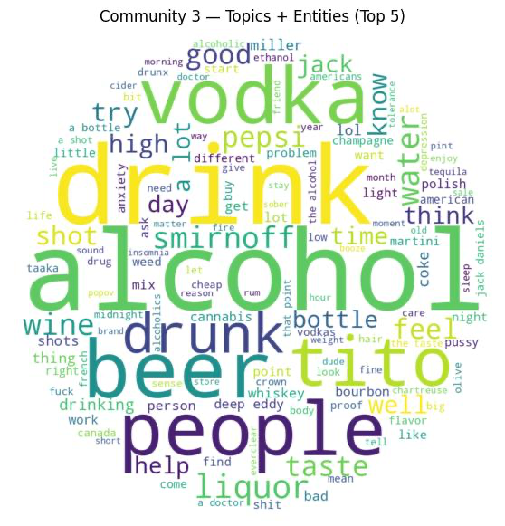
Community 3 - Everyday Drinking and Brand-Based Preferences
This community is centered around everyday alcohol consumption and informal taste evaluation. The dominant terms highlight common alcoholic beverages such as beer, vodka, and liquor, alongside frequent references to popular brands like Tito’s, Smirnoff, Jack Daniel’s, and Miller. Discussions emphasize personal experiences, mixing drinks, and subjective reactions, often comparing flavors or expressing casual preferences. Overall, the discourse reflects routine, experience-driven consumption rather than expert knowledge or structured discussions about production or craftsmanship.
Community 17 – Flavor Exploration and Cocktail-Oriented Discourse
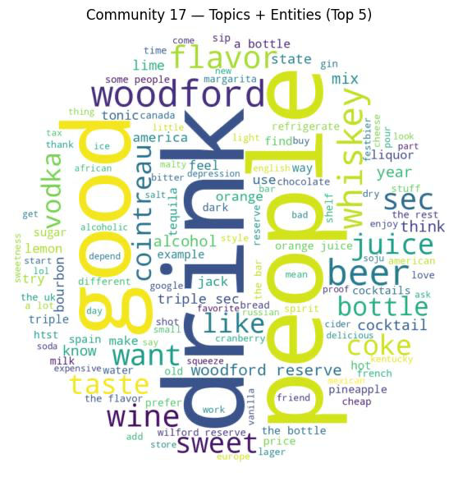
This community is characterized by discussions centered on flavor profiles, mixing practices, and a diverse range of alcoholic beverages. Prominent terms include whiskey, wine, beer, and liqueurs such as triple sec and Cointreau, alongside repeated references to brands like Woodford Reserve. Conversations frequently focus on taste, sweetness, and ingredient combinations, reflecting an exploratory and experience-driven approach to drinking. Overall, the discourse emphasizes experimentation with flavors and cocktails rather than casual consumption or social norms.
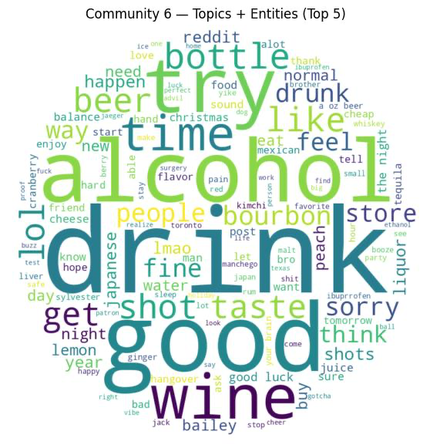
Community 6 – Casual Social Drinking and Shared Experiences
This community revolves around informal, social-oriented discussions of alcohol, with a strong emphasis on everyday experiences and shared moments. Dominant terms such as beer, wine, shots, and bourbon reflect casual drinking practices, often embedded in conversations about nights out, social interactions, and lighthearted commentary. References to expressions like “good luck” and humorous language suggest a relaxed and conversational tone. Overall, the discourse highlights alcohol as part of routine social experiences rather than focused taste exploration or technical knowledge.
Community 19 – Brand-Centered Discussions and Strong Taste Reactions
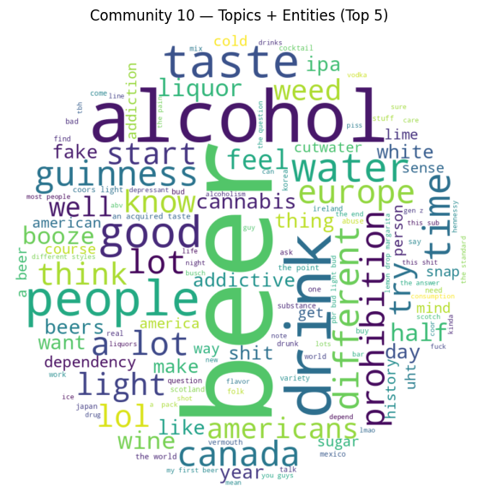
This community is characterized by discussions that strongly revolve around specific alcohol brands and pronounced taste reactions. Prominent terms include well-known spirits such as Bombay, Malört, Bacardi, and Woodford, alongside frequent mentions of beer, vodka, and whiskey. Conversations often express strong opinions, humor, or aversion related to taste, suggesting an emotionally charged and opinionated discourse. Overall, the community reflects brand-focused engagement where alcohol is discussed through distinctive flavor experiences rather than casual or purely social consumption.
Community 9 – Personal Experiences and Perceived Effects of Alcohol
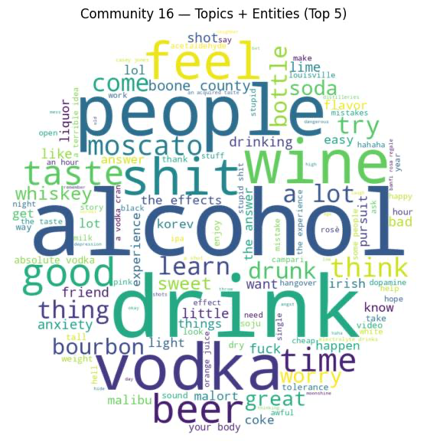
This community focuses on personal experiences and reflections on the effects of alcohol consumption. Dominant terms emphasize alcohol, wine, beer, and vodka, alongside frequent references to bodily reactions, emotions, and perceived outcomes such as feeling drunk, anxiety, or enjoyment. Discussions often blend taste-related comments with broader considerations about how alcohol affects the body and mood. Overall, the discourse highlights a reflective and experiential approach, where alcohol is discussed through its personal and physiological impact rather than brands or social conventions.

7. Community-Level Sentiment Analysis
Sentiment analysis was conducted on the five largest communities using VADER compound scores, covering 1,227 comments in total. For each community, descriptive statistics and sentiment distributions were computed to capture overall emotional tone.
While a transformer-based model (BERT) was also tested, it produced less stable and interpretable results due to the informal and sarcastic nature of Reddit discourse. Consequently, VADER was selected as the primary tool for community-level sentiment analysis.
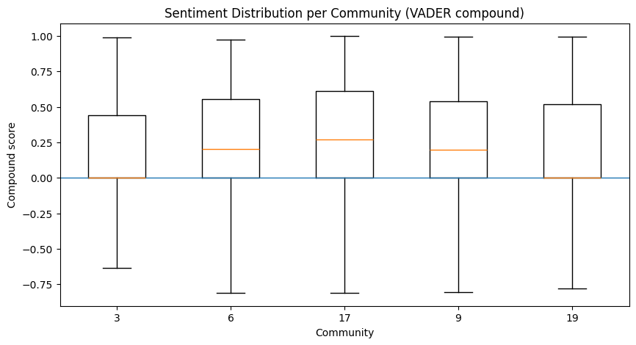
Results reveal clear variation across communities. Community 17 shows the most positive sentiment overall, followed by Communities 6 and 9. Communities 3 and 19 exhibit lower and more neutral average sentiment compared to the others. Boxplot analysis highlights substantial internal variability, indicating that emotional tone differs not only between communities but also within them.

8. Community-Level vs. Hub-Level Sentiment Analysis
Community | Main Topic Focus | Community mean sentiment | Hub mean sentiment | Hub - level alignment
Community 3 | Everyday drinking + taste/brands | 0.119361 | -0.007118 | 0.126479  Weak
Community 6 | Social drinking | 0.219281 | 0.335058 | 0.115777  Moderate
Community 17 | Cocktails + flavor mixing | 0.205258 | 0.174188 | 0.031070  Strong
Community 9 | Casual consumption | 0.258084 | 0.363794 | 0.105710  Moderate
Community 19 | Social norms | 0.160370 | 0.108949 | 0.051421  Moderate
Overall, the comparison between community-level and hub-level sentiment reveals distinct emotional dynamics across the identified communities. In Community 17 (Cocktails + flavor mixing), hub sentiment closely aligns with the overall community sentiment, suggesting that influential users reinforce a shared and relatively cohesive emotional tone. In this community, hubs appear to function as stabilizing actors that amplify the dominant discourse.
In Community 6 (Social drinking), Community 9 (Casual consumption), and Community 19 (Social norms), the alignment between hub and community sentiment is moderate. This indicates that while hubs generally follow the prevailing emotional trend, they also introduce some degree of variation, contributing to emotional diversity without substantially disrupting the overall tone.
By contrast, Community 3 (Everyday drinking + taste/brands) exhibits weak alignment between hub-level and community-level sentiment. The noticeable divergence suggests that influential users in this community express perspectives that differ from the aggregate emotional stance, potentially reflecting disagreement, mixed reactions, or more polarized evaluations within everyday alcohol-related discussions.
Taken together, these findings demonstrate that the role of hubs varies across communities: in some cases they reinforce collective sentiment, while in others they introduce heterogeneity. This highlights that community sentiment is not solely driven by network centrality, but rather emerges from the interaction between influential users and the broader community context.

9. Interpretation Summary
Overall, as initially expected, alcohol evokes a wide range of emotional responses that vary across individuals and communities, reflecting differences in personal interests, life stages, and social contexts. For some, alcohol becomes a hobby or area of interest, leading to discussions focused on production processes, types, quality, and craftsmanship. Others relate to alcohol primarily as a form of leisure and casual consumption, while for many it functions as a social convention embedded in shared activities and group interactions. In contrast, certain communities emphasize social norms, health considerations, and, in some cases, express negative emotions such as concern or fear related to alcohol consumption. These findings highlight that alcohol is perceived and integrated into everyday life in diverse ways, and consequently, the emotional responses it generates are highly heterogeneous. Contrary to our initial expectations, no single, unified emotional narrative emerged across communities. Nevertheless, it is important to acknowledge that alcohol consumption may pose health risks when practiced excessively or without moderation, underscoring the relevance of responsible and informed use.

