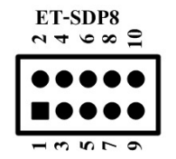

Looking at back with input connector at top,

DIN = 1 Rpi 19

Load = 2

CLK = 3 Rpi 23

5v = 10

Gnd = 8, 6