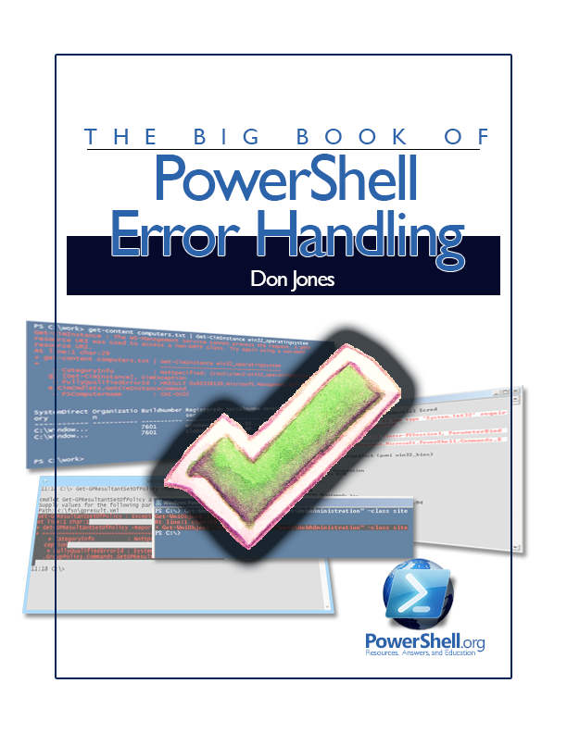

The Big

(Snarky) Book

of

Windows PowerShell

Error Handing

by Don Jones

Copyright ©2013 by Don Jones
Licensed under Creative Commons Attribution-NoDerivs 3.0 Unported

Foreword
Error handling is one of those frustrating things. Everyone runs across little tricks - usually on people’s blogs where the trick isn’t well-explained - and they take them as gospel. The result is a lot of wrong cruft. In this guide, I’m going to try to address a lot of wrong-doing that I see out there and help folks get themselves on the right error-handling track.
This is a living guide, which means I’ll update it over time. Be sure to check back for new versions.
(Oh, and as a note - I used Windows PowerShell 3.0 to write this Guide, but the principles are universal; some syntax may differ in other versions.)
And good luck.
Oh, sorry about the snarkiness. The first edition of this was written on an airplane. Makes me testy. Plus, jeez, guys, enough with SilentlyContinue already.
Don Jones
Copyright This guide is released under the Creative Commons Attribution-NoDerivs 3.0 Unported License. The authors encourage you to redistribute this file as widely as possible, but ask that you do not modify the document. However, you are encouraged to submit changes to the authors directly (http://ConcentratedTech.com/contact) so that your suggestions can be incorporated into the master document and published in a future revision.

Contents

Format Right 4

-Contains isn’t -Like 4

You Can’t Have What You Don’t Have 4

-Filter Values Diversity 4

Not Everything Produces Output 4

One HTML Page at a Time, Please 4

[Bloody] {Awful} (Punctuation) 4

Don’t+Concatenate+Strings 4

$ isn’t Part of the Variable Name 4

Use the Pipeline, not an Array 4

Backtick, Grave Accent, Escape 4

A Crowd isn’t an Individual 4

These aren’t Your Father’s Commands 4

Contacting Me 4

Handling Errors
Let’s start by discussing handling.
Handling an error means you are capturing the error and doing something about it other than displaying the default error message. It means that you have anticipated the error - a machine might be unavailable on the network, or a file or directory path might not exist - and you are performing some alternate action. You might log the unavailable computer’s name create directories, or prompt for an alternate filename.
Handling an error does not mean simply hiding the error message, except in cases where the error message is actually a success message. For example, you try to delete a file that doesn’t exist. You’ll get an error, right? But, I mean, “mission accomplished.” Either way, the file is gone, which is what you wanted. So maybe suppress that error. Except that while the error might be “file does not exist,” it also might be “access denied,” which is a very different situation. So... handle the error, see which one it was and suppress it only if the mission was, in fact, accomplished.
God as my witness, if you just suppress all errors in a script, you’ll go to Hell. Even if you don’t believe in Hell, one will be created especially for you. I hate it when people write a 100-line script in which one thing might go wrong and then suppress all errors, as if only that one thing could ever go wrong. I hate that and so does everyone else. Doing it doesn’t make you clever, it makes you sneaky at best and stupid at worst. God. Glad I got that off my chest.
Ok.

Error Actions
Windows PowerShell recognizes two kinds of errors.
A non-terminating error occurs when a command has an issue, but it knows it can continue working. Imagine Get-Service trying to connect to 10 computers, and one fails. Okay, that one isn’t going to work, but the rest of them might, so the command produces a non-terminating error (an error message) and continues trying. You can’t do anything about non-terminating errors. You can’t suppress them. You can’t take an alternate action.
A terminating error occurs when a command has an issue and just cannot possibly go on living, like your cousin Daphne ten minutes prior to the wedding reception when she realizes that dress really does make her look fat. You give Invoke-Command 10 computer names, the first two work, and the third fails - if that were a terminating error, the command would throw up its hands and go have a cocktail. Computers four through ten wouldn’t even be attempted.
PowerShell defines a global variable called $ErrorActionPreference, which, by default, has a value of Continue. Its possible values:
- Continue. Produce an error message and keep going.
- SilentlyContinue. Keep going, without complaining. This is the setting you wish your kids had.
- Inquire. Ask the user what to do. This is probably always useless.
- Stop. Turn all errors into terminating errors and stop when you encounter the first one.
The $ErrorActionPreference variable obeys all normal PowerShell scope rules. That means, if you change it in a script, you’re only changing it for that script. You’re not changing it for the global shell, nor are you changing it for other scripts. I’ve seen scripts that “capture” the contents of the session-level $ErrorActionPreference into another variable before changing it, so that they can “restore” its original value later. That’s thoughtful, but completely useless, and shows a lack of understanding of scope.
If you set $ErrorActionPreference to anything at the top of your script, you’ll go to Hell, and it’ll hurt. There’s no bloody reason to do this at all. There are times when messing with this variable is appropriate, and I’ll explain them, but you never set this globally for a script unless you’re a complete tool. If you do this, the other kids will laugh at you, and you will never get a date to the prom. Got it? No touchy $ErrorActionPreference unless you’ve got an explicit reason for it.

Trap
PowerShell 1.0 introduced the Trap construct because it was the best the product team could do in the amount of time they had.
Don’t use it.
The Trap construct is exactly like a very old woman who still wears that high-necked dress that was fashionable when she was just a “gel.” You feel bad for it, and you vow to never let your daughter do such a thing.
People who use Trap are sad, and you must pity them, but you must not be them.

Try/Catch/Finally
Introduced in Windows PowerShell 2.0, the Try/Catch/Finally construct is the right way to handle errors. You can nest these suckers, too, like this:
Try {
# Do something that might cause a terminating exception

Try {
# Do something ELSE that might cause a terminating exception
} Catch {
# Something ELSE cause a terminating exception
}

} Catch {
# Something caused a terminating exception
}

The reason you can nest these is that you should wrap a Try{} block around the smallest possible amount of code that might cause an error you’re prepared to handle. You absolutely do not do this:
Try {

Get-ChildItem *.log | Move-Item c:\Archive
Get-WmiMethod -Class Win32_NTEventLogFile |
Invoke-WmiMethod -Name ClearLog

} Catch {
Write-Warning "A problem happened"
}

You’re doing completely different things in that Try{} block. Get-ChildItem might have failed. Move-Item might have failed. Get-WmiMethod might have failed. Invoke-WmiMethod might have failed. All of them are being caught by the same Catch{} block - that’s dumb. Plus, all you’re doing is pushing out a generic, useless error. You know how upset you get when Microsoft products spew generic, useless errors? Yeah? So why are you doing it? Those commands would have produced much more useful error messages, which you are now suppressing. Bad you.
So actually, that example wouldn’t catch any errors, because all of those commands produce non-terminating errors by default, and the default $ErrorActionPreference is “Continue,” which means, “don’t catch the error.” So the right answer would be to set $ErrorActionPreference to “Stop,” right?
No. That would be the wrong answer. That was a trick question.
The right answer consists of two parts:
- Wrap the Try{} block around as few commands or lines of code as possible.
- Ensure that everything in the Try{} block produces a terminating exception if something goes wrong.
- Bonus part: Ensure that whatever’s in the Try{} block is doing only one thing - talking to one computer, moving one file, etc. We’ll get to this part, but I want it in your head right now.

ErrorAction
All PowerShell commands - and I do mean all of them, even functions you write that have a [CmdletBinding()] attribute - support the ErrorAction parameter. The ErrorAction parameter overrides $ErrorActionPreference for just that command.
ForEach ($computer in $computername) {
Try {
Get-WmiObject -Class Win32_BIOS -ComputerName $computer -ErrorAction Stop
} Catch {
$computer | Out-File failed.txt -Append
}
}

Nice. We’ve turned the normal non-terminating errors into terminating exceptions by specifying -ErrorAction Stop. We’ve used a ForEach loop to ensure that only one computer is being attempted at a time - so, if it explodes, we can handle it and pick up with the next one. We’ve included only one command in the Try{} block. We are Good People.
Note You can type -EA instead of -ErrorAction. Same thing.
(By “we,” I’m honorarily including you in my efforts - thanks for coming along on the ride.)
What if you need to run a non-command?
ForEach ($computer in $computername) {
Try {
$p = Get-Process -Name Notepad -ComputerName $computer
$ErrorActionPreference = 'Stop'
$p.Kill()
$ErrorActionPreference = 'Continue'
} Catch {
$computer | Out-File failed.txt -Append
}
}

See what we did, there? I needed to run a method of an object (the Kill() method; let’s pretend for the moment that Stop-Process, which has an -ErrorAction parameter, doesn’t exist). Methods don’t have parameters, so I set $ErrorActionPreference just for this one line of code. Everything else continues as normal.
Wait, did I put four lines of code into the Try{} block? Yes. My goal was to kill a specific process - and all four lines are needed in that process. So that’s an atomic operation. If Get-Process fails, the operation failed. If the Kill() failed, the operation failed. Either way, I need to look into it, so they’re all in the same Try{} block.
Note Yeah, I know, if Notepad isn’t running on the remote computer I’ll get an error, but it’s a “mission accomplished” situation. Don’t be a nit-picker. In a non-example I’d put some logic in place to test for the existence of the process before I tried to kill it. In fact, that’s next.

Be Proactive
It infuriates me to see this:
$p = Get-Process -Name Notepad -ComputerName SERVER1 -ErrorAction SilentlyContinue
if ($p) {
$p.Kill()
}

This may not be “wrong,” but it still ticks me off. This is relying on a set of under-the-hood actions, i.e $p contains nothing if Get-Process fails and a $p with nothing is somehow equal to $False. I hate this. It’s chancy logic, it’s ill-defined, and it shows poor manners. Your mother would slap you bald if she saw this. Don’t do it.
I’m a little better with this. It more clearly documents that I’m checking to see if $p contains anything.

$p = Get-Process -Name Notepad -ComputerName SERVER1 -ErrorAction SilentlyContinue
if ($p.Count -ge 0) {
$p.Kill()
}

I’m a good deal happier with this. I’ve stopped suppressing an error (what is it with people wanting to suppress? Let it out!), and if there are no Notepad processes running, KIll() won’t even be attempted. Mission accomplished, so the Catch{} block just does nothing. That’s fine. It has to be there - Try{} must be paired with either a Catch{}, a Finally{}, or both. I’m not ready to talk about Finally{} yet. Hang on.

Try {
$p = Get-Process -Name Notepad -ComputerName SERVER1 -ErrorAction Stop
$p.Kill()
} Catch {
# Do nothing
}

Trapping Multiple Kinds of Explosion
The next thing you need to know how to do...

Capturing Errors
You might need to know what kind of error occurred, so that you can take a different action for different errors. There are three ways to do this, and only one will not send your soul directly to perdition.
Try {
$p = Get-Process -Name Notepad -ComputerName SERVER1 -ErrorAction Stop
$p.Kill()
} Catch {
Write-Warning "$_ happened"
}

Wrong. Although $_ will contain information from the most recent command, it’s ridiculously easy to code a script wherein $_ gets “hijacked” and contains something other than the most recent error. $_ looks stupid, too, meaning it’s hard to visually parse it. Imagine that every script you write is going to be reviewed on paper by someone in Human Resources. $_ will not win you friends. Do not do this.
$error.Clear()
Try {
$p = Get-Process -Name Notepad -ComputerName SERVER1 -ErrorAction Stop
$p.Kill()
} Catch {
Write-Warning "$error happened"
}

OMG, do I walk into your house and delete everything on your DVR, just so the only program to pick from is the one I wanted to watch? No, I do not. $Error is a collection of all recent errors, not your personal storage box. Don’t mess with it. If you want to look at $error[0] for the most recent error, fine - I won’t get on your case about that. But don’t wander around wiping out the collection by running its Clear() method. Jerk.
Try {
$p = Get-Process -Name Notepad -ComputerName SERVER1 -ErrorAction Stop -ErrorVariable x
$p.Kill()
} Catch {
Write-Warning "$x happened"
}

Ahhhhh... better. You see what we did there? We captured the command error into our own, private variable, $x. The $ is not part of the variable name - the syntax above is correct; -ErrorVariable x or the shorter -EV x will capture the error into $x, giving you full access to the problem. Now, you can’t do this with a method, because they don’t have an -EV parameter, so with a method you’d have to revert back to the second example above (using $error[0] instead). But, for commands, use -ErrorVariable to capture errors.

$? is Not a Sign of Success or Failure
Brace yourself, because this one drives me nuts. Like, if someone did this on a job interview - not hired, and I’d call my colleagues and try to blacklist the person. So, like, take note.
When PowerShell runs a command, it populates a variable called $? with either $True or $False. $True if the command “completed successfully” and $False if it didn’t. I used those quotes on purpose. Frankly, I wish they’d not added this bit to PowerShell. People run across this and completely misunderstand the meaning of “success.” Which makes me wonder about their career.
$? will basically contain $True if the most recent command did not result in the heat death of the universe. That does not mean the previous command actually did what you wanted - it just means nobody died. Do not, and let me make this abundantly clear, do not use $? for error handling. Just because $? contains $True does not mean nothing went wrong. And even if it contains $False, you don’t know what went wrong. This thing is a red herring in most cases, and people use it completely inappropriately. So stop it.









Contacting Me
If you’re having problems, want to do something and can’t figure out how, found a bug and want to offer a correction, or just have feedback on this guide or the EnhancedHTML module, I’d love to hear from you. The easiest way is to post in the “PowerShell Q&A” forum on http://PowerShell.org/discuss. I keep a pretty close eye on that, and I’ll respond as soon as I’m able.
Do me a favor, if you post in the forums: Check out the Forum Tips. They’re in the site’s Site Info menu, right at the top of the page, and it’s a very short post that will help you get the most from those forums.
Do check back on http://PowerShellBooks.com from time to time, to make sure you’ve got the most recent version of this guide and its code.

