Route A — Spike-Count Energy Proxy
A Relative Workload Comparison of CPU, GPU, and Spiking Neural Network Inference on MNIST
UROP — AI Accelerators & Neuromorphic Computing · UC Berkeley EECS

Executive Summary
This phase measures how much computational work an image-classification task costs under two paradigms that reach the same accuracy: a conventional convolutional neural network (CNN) running on CPU and GPU, and a spiking neural network (SNN) whose energy is proxied by its spike count. Both models share the LeNet topology, the identical MNIST test set (10,000 images), and the same batch size, so the comparison is on equal footing.
The headline result is that the SNN matches the CNN's accuracy while emitting roughly 40× fewer per-inference events than the CNN performs multiply-accumulate operations (MACs). The CNN reaches ~98.7% accuracy at 416,520 MACs per inference; the SNN reaches ~98.5% at ~10,500 spikes per inference. Because MACs and spikes are different units, this is a workload proxy, not yet an energy measurement — converting both to joules is the goal of the next phase (Route B).
An important counterpoint: on the real CPU/GPU hardware tested here, the SNN is slower, not faster, because simulating 25 timesteps on von Neumann hardware multiplies the work. The spike-count advantage is a property of dedicated neuromorphic hardware, which this simulation does not model. The efficiency claim is therefore about potential energy on neuromorphic chips, not wall-clock speed on GPUs.

1. Introduction and Background
Modern AI inference is dominated by dense linear algebra: every layer of a conventional neural network multiplies inputs by weights and accumulates the results, and the count of these multiply-accumulate operations (MACs) is a standard proxy for compute cost. Neuromorphic computing proposes a different substrate. Instead of continuous-valued activations processed in a single pass, spiking neural networks (SNNs) communicate with sparse, binary events called spikes, distributed over simulated time. On dedicated neuromorphic hardware, energy is consumed only when a neuron fires, so the total number of spikes is a natural proxy for energy.
This phase (Route A) builds a like-for-like comparison of the two paradigms on a single task, using spike count as the neuromorphic energy proxy. It deliberately stops short of converting either metric into joules; that conversion, which requires per-MAC and per-spike energy figures for specific hardware, is deferred to Route B. The contribution here is a clean, reproducible measurement of accuracy against per-inference workload for both a conventional CNN and an equivalent SNN, on identical data.

2. Methods

2.1 Task, dataset, and scope
All experiments are inference-only on MNIST handwritten-digit classification, using a single fixed test set of 10,000 images and a fixed batch size of 128 across every run. Everything is simulation on commodity hardware; no physical neuromorphic device is involved. The software stack is Python 3.10+ with PyTorch, torchvision, and snnTorch, with GPU runs performed on Google Colab.

2.2 Conventional baseline (CNN)
The baseline is a LeNet-style convolutional network: two convolutional layers (6 and 16 feature maps, 5×5 kernels) with max-pooling, followed by three fully connected layers (120, 84, 10 units). The model has 61,706 trainable parameters. It was trained for five epochs with the Adam optimizer and evaluated for accuracy, latency per inference, throughput, and MAC count. MACs are counted analytically from the layer output shapes via forward hooks (convolution: H×W×C_out×C_in×k²; linear: in×out), which avoids an external profiling dependency and keeps the count transparent and citable. This yields 416,520 MACs per inference.

2.3 Spiking network (SNN)
The SNN mirrors the LeNet topology but replaces each layer's activation with a Leaky Integrate-and-Fire (LIF) neuron, implemented in snnTorch. Each inference runs over T = 25 simulation timesteps; the static image is presented as constant input current at every step (direct encoding), with the first convolution and LIF layer acting as a learned encoder. The network was trained from scratch with backpropagation-through-time and surrogate gradients (fast-sigmoid), which make the non-differentiable spike function trainable. Classification uses the sum of output spikes over time. The energy proxy, spikes per inference, is the total number of spike events across all LIF layers divided by the number of test samples.

2.4 Benchmarking and hardware
Both models were benchmarked on four backends: the Apple-Silicon CPU and GPU (MPS) of a MacBook Air, and the CPU and NVIDIA T4 GPU of a Google Colab instance. Timing uses a warmup phase followed by wall-clock measurement with device synchronization around each batch, so GPU asynchrony does not distort the numbers. Accuracy and per-inference workload are device-independent; latency and throughput are reported per device.

3. Results
Table 1 summarizes all runs. Both paradigms reach essentially the same accuracy — the CNN at ~98.7% and the SNN at ~98.5% — while differing by more than an order of magnitude in per-inference workload.
Table 1. CPU / GPU / SNN comparison on MNIST (LeNet topology, 10,000-image test set, batch size 128).
Approach | Device | Accuracy | Latency (ms/inf) | Throughput (inf/s) | Workload / inf
CNN | CPU (Apple M-series) | 98.73% | 0.0390 | 25,648 | 416,520 MACs
CNN | GPU (Apple MPS) | 98.73% | 0.0211 | 47,341 | 416,520 MACs
CNN | CPU (Colab vCPU) | 98.63% | 0.2655 | 3,766 | 416,520 MACs
CNN | GPU (NVIDIA T4) | 98.63% | 0.0127 | 78,835 | 416,520 MACs
SNN | CPU (Apple M-series) | 98.49% | 0.9027 | 1,108 | 10,546 spikes
SNN | GPU (Apple MPS) | 98.49% | 0.1855 | 5,392 | 10,546 spikes
SNN | CPU (Colab vCPU) | 98.50% | 2.9772 | 336 | 10,465 spikes
SNN | GPU (NVIDIA T4) | 98.50% | 0.7511 | 1,331 | 10,465 spikes

3.1 Workload per inference
The central finding is the gap in per-inference workload. The SNN emits about 10,500 spikes per inference against the CNN's 416,520 MACs — roughly a 40× difference on a logarithmic scale. The two quantities are not the same unit, so this is a proxy comparison rather than a direct energy result; the caption states this caveat explicitly.
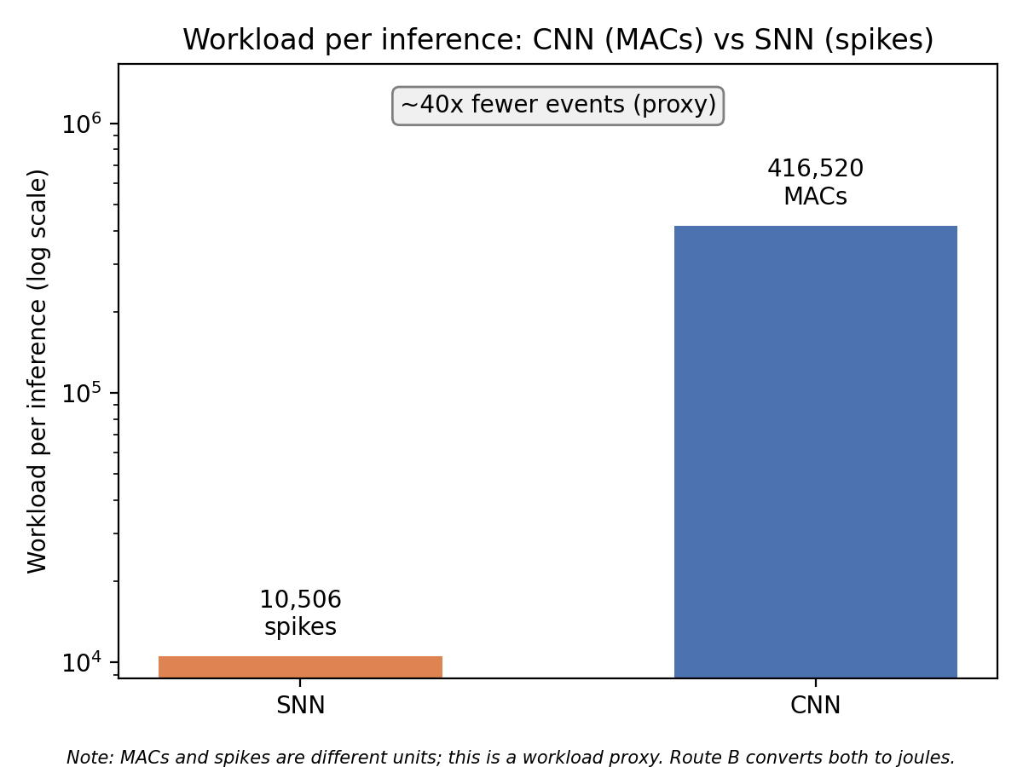
Figure 1. Per-inference workload: CNN MACs versus SNN spikes (log scale). The SNN performs ~40× fewer nominal events, the qualitative basis for the neuromorphic energy argument.

3.2 Same-task accuracy versus workload
Plotting accuracy against per-inference workload places the two approaches on one axis. The clusters sit at nearly the same height (accuracy) but are widely separated horizontally (workload): the SNN achieves comparable accuracy far to the left, i.e. at much lower nominal cost.
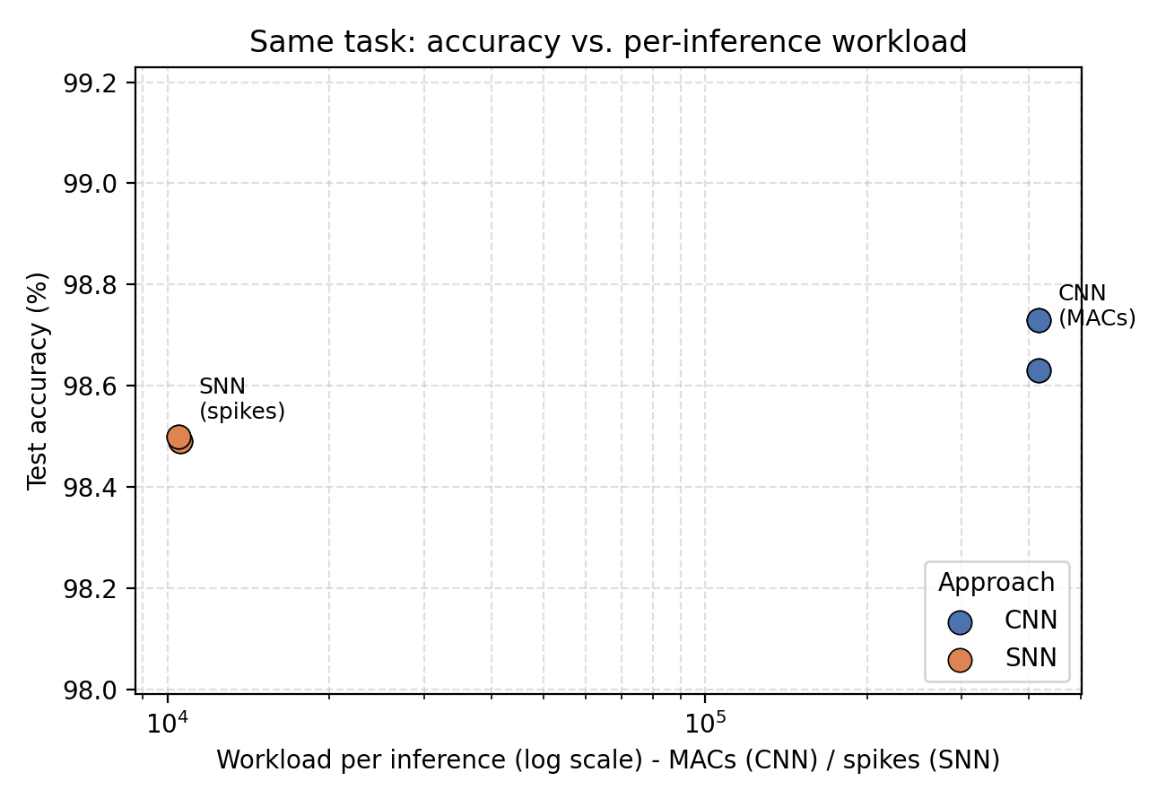
Figure 2. Accuracy versus per-inference workload (log scale). Near-equal accuracy at an order-of-magnitude lower workload for the SNN — the headline same-task result of this phase.

3.3 Latency on conventional hardware
Latency tells the opposite story and is reported for honesty. On every backend the SNN is slower than the CNN, because 25 timesteps of simulation must be executed sequentially on hardware built for dense single-pass compute. On the NVIDIA T4, for instance, the CNN completes an inference in ~0.013 ms while the SNN takes ~0.75 ms. This does not contradict the spike-count result: fewer spikes would translate into lower energy only on neuromorphic hardware that is event-driven by construction, which these CPUs and GPUs are not.
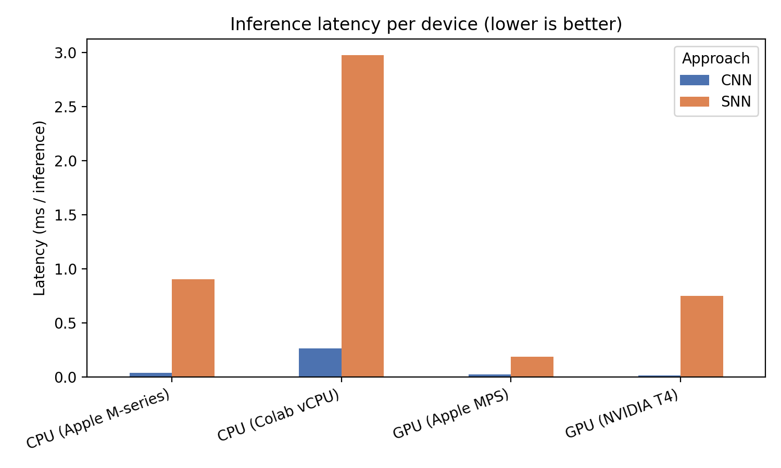
Figure 3. Inference latency per device. The SNN's timestep simulation is costly on von Neumann hardware; the spike-count advantage is not a wall-clock advantage here.

4. Discussion
Three conclusions follow. First, an SNN can match a conventional CNN's accuracy on MNIST, so the comparison is genuinely same-task and the workload difference is not bought with a large accuracy sacrifice. Second, measured by its native workload unit, the SNN is dramatically lighter — about 40× fewer events per inference — which is the quantitative core of the neuromorphic efficiency argument. Third, that advantage is latent, not realized, on the hardware tested: simulating spikes on a CPU or GPU is slower than running the CNN, so the payoff depends entirely on event-driven neuromorphic silicon.
The practical upshot for the project is that spike count is a usable, reproducible proxy that cleanly separates the two paradigms, and that any efficiency claim must be carefully scoped to hardware. The proxy answers 'how much work,' not yet 'how many joules.'

5. Limitations
The comparison is a workload proxy, not an energy measurement: MACs and spikes are not interconvertible without hardware-specific energy-per-operation figures. The task is small (MNIST), so the accuracy parity and the spike count may not transfer to harder datasets, where SNNs often need more timesteps and thus more spikes. The two trained models were fitted separately on the Mac and Colab, producing slightly different spike totals (10,546 versus 10,465), which is expected variance rather than a systematic effect. Finally, T = 25 is one point on an accuracy–energy curve; lower T reduces spikes at some accuracy cost, and the sweep is left as future work.

6. Next Steps — Route B
Route B converts both workload metrics into energy. It will multiply CNN MACs by a representative energy-per-MAC figure for the target CPU/GPU, and SNN spikes by an energy-per-spike figure for a chosen neuromorphic platform, yielding a joules-per-inference comparison rather than a unit-mismatched proxy. A timestep sweep (e.g. T = 10, 25, 50) would additionally trace the accuracy-versus-spikes tradeoff curve, turning the two-point scatter of Figure 2 into a full frontier.

Appendix — Reproducibility
The results are produced by three scripts. simulations/accelerator/cnn_baseline.py trains and benchmarks the CNN and logs MAC rows; simulations/snn/snn_baseline.py trains and benchmarks the SNN and logs spike rows to the same CSV; results/make_figures.py reads the combined CSV and regenerates Table 1 and Figures 1–3. All runs use the fixed MNIST test set, batch size 128, five training epochs, and (for the SNN) T = 25. Representative commands: python cnn_baseline.py --epochs 5 ; python snn_baseline.py --epochs 5 --timesteps 25 ; python results/make_figures.py.

