AI-Assisted Semiconductor Failure Analysis:
A Performance Comparison of General-Purpose CPUs and AI Accelerators
Undergraduate Research Opportunities Programme (UROP)
AI Accelerators (Chips) and Neuromorphic Computing
Zena Wu
Supervisor: Shubhakar
Summer 2026

Table of Contents

(In Word: right-click this table and choose 'Update Field' to populate page numbers.)

List of Figures
Figure 1. GPU speed-up over CPU across seven inference workloads.
Figure 2. Energy per inference — CNN vs spiking neural network (MNIST).
Figure 3. CPU vs GPU hardware performance for the failure-analysis classifier.

1. Introduction
Semiconductor failure analysis (FA) is essential to manufacturing and reliability engineering: engineers examine failed devices to determine root causes, correct fabrication processes, and improve long-term reliability. Interpreting FA images has traditionally been a slow, expertise-intensive manual task. As devices shrink and production volumes rise, there is growing interest in using artificial intelligence to automate defect recognition — improving inspection speed, reducing human variability, and enabling rapid screening at scale.
In an industrial setting, the computational efficiency of AI inference matters as much as its accuracy: high-throughput manufacturing demands fast, reliable processing of inspection data. Modern AI accelerators — Graphics Processing Units (GPUs), Tensor Processing Units (TPUs), and Neural Processing Units (NPUs) — are purpose-built to execute deep-learning workloads more efficiently than general-purpose Central Processing Units (CPUs). This project studies how specialized AI processors influence inference speed, computational efficiency, and the practical feasibility of deploying AI-assisted failure analysis.
Research question. How do general-purpose CPUs compare with specialized AI accelerators (GPUs) for deep-learning inference — both across a range of standard workloads and for the specific application of AI-assisted semiconductor failure-analysis image classification — and what architectural factors explain the observed performance differences?
Objectives. (1) Explain why specialized AI hardware outperforms CPUs on machine-learning workloads; (2) implement a pretrained deep-learning model to classify semiconductor failure images; (3) benchmark inference on CPUs and AI accelerators; (4) evaluate performance using latency, throughput, memory, and utilization metrics; and (5) recommend an appropriate computing platform for AI-assisted failure analysis.

2. Literature Review

2.1 Why specialized chips outperform CPUs
Machine-learning inference and training are dominated by dense linear algebra — large numbers of highly regular, parallel multiply-accumulate (MAC) operations. CPUs are latency-optimized: they spend silicon area on out-of-order execution, branch prediction, and deep caches to make single threads fast, leaving relatively little area for raw arithmetic throughput. Accelerators instead spend area on many MAC units, wide memory bandwidth, and reduced-precision arithmetic (INT8, FP16/BF16). Critically, the dominant cost in modern systems is data movement rather than computation: moving a value from off-chip DRAM can cost on the order of two hundred times more energy than the arithmetic operation itself (Horowitz, 2014). Accelerators win largely by keeping data on-chip and reusing it, minimizing this movement (Sze, Chen, Yang, & Emer, 2017).

2.2 The four processor architectures
A CPU has a few large superscalar cores backed by a deep cache hierarchy — flexible and control-friendly but with much of its area idle during regular matrix math. A GPU packs thousands of simpler cores executing in lockstep under the Single-Instruction-Multiple-Threads (SIMT) model, fed by high-bandwidth memory, making it the workhorse for training and high-throughput inference. A TPU replaces general cores with a systolic MAC array (the matrix multiply unit), streaming data through a hardwired grid so each value is reused across many operations, delivering high throughput per watt for datacenter ML (Jouppi et al., 2017). An NPU is a compact, low-power dataflow array with on-chip SRAM designed for quantized inference at the edge, trading peak throughput for energy efficiency.

2.3 Training versus inference
Training and inference are distinct workloads on the same network. Training learns the weights through repeated forward and backward passes over large batches in higher precision, storing activations, gradients, and optimizer state; it is memory-hungry and throughput-bound. Inference applies the finished weights in a single forward pass, often one sample at a time and in reduced precision, storing only weights and activations. Because inference runs continuously in deployment, it is judged mainly on latency and energy per inference. The inference pipeline moves an input through preprocessing, a one-time weight load, accelerator compute, and post-processing (softmax/argmax) to a prediction — with only the compute stage typically running on the accelerator.

2.4 Neuromorphic computing
Neuromorphic processors take a different approach, using event-driven Spiking Neural Networks (SNNs) that communicate through discrete spikes rather than dense clocked arithmetic. Because they perform work only when a neuron fires, and their synaptic operations are cheap accumulate operations, they can be extremely energy-efficient for suitable workloads (Davies et al., 2018). They represent a distinct computing paradigm beyond conventional accelerators and motivate the energy-focused analysis explored in this project.

2.5 Semiconductor failure analysis and AI defect classification
Common failure mechanisms leave characteristic signatures in microscopy images. Electromigration produces voids and hillocks in metal lines under high current density; stress migration forms stress-relaxation voids without current; time-dependent dielectric breakdown (TDDB) creates a localized conductive path through an oxide under field stress; metal delamination separates layers at an interface; and corrosion degrades metals electrochemically (JEDEC, 2016; Black, 1969; McPherson, 2013). Because each mechanism has a distinct visual signature, convolutional neural networks (CNNs) can in principle learn to classify them, enabling automated defect recognition — the application studied here.

3. Materials and Methods

3.1 Benchmarking methodology
A unified benchmarking harness was built so that every workload logs identical metrics in a consistent format. For each task a pretrained model is loaded, a fixed input is fed, and the forward pass is timed over many iterations after a warm-up, with GPU work synchronized for honest timing. Recorded metrics include latency, throughput, CPU utilization, host RAM, GPU memory, and GPU power draw. CPU runs were executed locally; GPU runs (FP32 and FP16) were executed on a cloud GPU (Google Colab).

3.2 Workloads and hardware
Seven representative inference workloads were benchmarked across CPU and GPU: dense matrix multiplication; image classification (ResNet18); object detection (YOLOv8n); speech recognition (Whisper Tiny); face detection and hand tracking (MediaPipe); and optical character recognition (Tesseract and EasyOCR). FP16 was included to expose the effect of low-precision tensor-core execution. Inputs were fixed and synthetic so that timing reflects the model and hardware rather than data content.

3.3 Neuromorphic baseline
A spiking neural network (a leaky integrate-and-fire network) was trained on MNIST using surrogate-gradient backpropagation. To compare it with a conventional CNN on a common footing, an analytical energy model converted operation counts into energy per inference using published per-operation figures (Horowitz, 2014; Davies et al., 2018): the CNN's cost is its multiply-accumulate (MAC) count times the energy per MAC, and the SNN's cost is its synaptic-operation count times the energy per accumulate, where synaptic operations are obtained from the measured per-layer spike counts and each layer's fan-out. Because the spiking network's first layer is driven by dense input current at every timestep rather than by sparse spikes, its energy was reported both excluding and including this dense encoding cost.

3.4 Failure-analysis classification and hardware evaluation
A dataset of 24 semiconductor failure-analysis images across seven classes (Bond Wire Failure, Crack Formation, Dielectric Breakdown, Electromigration, Lithography defects, Particle contamination, Stress Migration) was labelled, resized to 224x224, and split into 16 training and 8 test images. A pretrained ResNet18 was adapted by freezing its ImageNet backbone and training a new seven-class classification head. The trained model was then benchmarked on CPU and GPU using the harness of Section 3.1, additionally recording model loading time. Given the small dataset, the classification result is a proof-of-concept; the hardware comparison is the primary quantitative outcome.

4. Results and Discussion

4.1 Cross-workload benchmark
Across the seven workloads, the GPU's advantage over the CPU was not constant but ranged from roughly 112x (image classification) down to about 1.5x (speech recognition), as shown in Figure 1. The largest gains occurred for dense, parallel, batchable matrix math; the smallest for sequential, autoregressive decoding whose steps cannot be parallelized. Some efficiency-optimized models (MediaPipe face and hand tracking) already ran well above real time on the CPU alone.
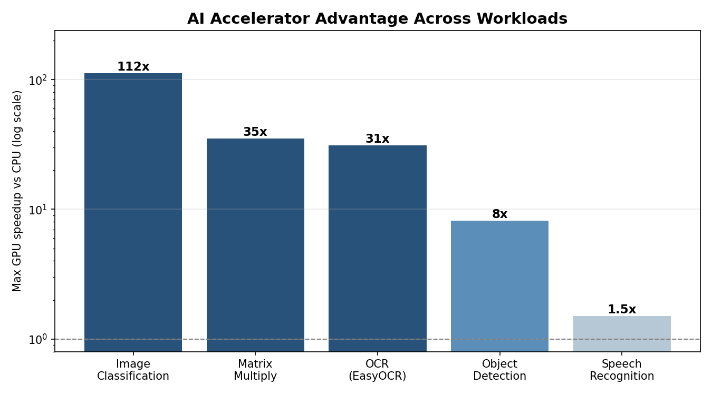
Figure 1. Maximum GPU speed-up over CPU across seven inference workloads (log scale).
The pattern is explained by parallelism. Two controlled observations confirm it: for matrix multiplication, the speed-up grew with matrix size as more independent work became available; and for image classification, increasing the batch size raised GPU throughput while lowering CPU throughput. Reduced precision compounded the effect — FP16 tensor-core execution roughly tripled the FP32 GPU gain on compute-bound models — whereas sequential speech decoding saw little benefit from either parallelism or precision.

4.2 Neuromorphic energy analysis
Beyond raw speed, energy efficiency distinguishes computing paradigms. An analytical model compared a conventional CNN with a matched spiking neural network (SNN) on MNIST at comparable accuracy (approximately 98.8% and 98.7% respectively). The CNN's dense multiply-accumulate operations cost about 1,916 nJ per inference. The SNN's event-driven core — whose energy scales only with the synaptic operations actually triggered by spikes — cost about 1,252 nJ, roughly 1.5x more efficient, confirming that sparse, event-driven computation can beat dense arithmetic. However, the SNN's input layer is driven by dense current at every one of its twenty-five timesteps; including this encoding cost (about 13,524 nJ) raised the SNN's total to roughly 14,776 nJ, about ten times worse than the CNN (Figure 2).
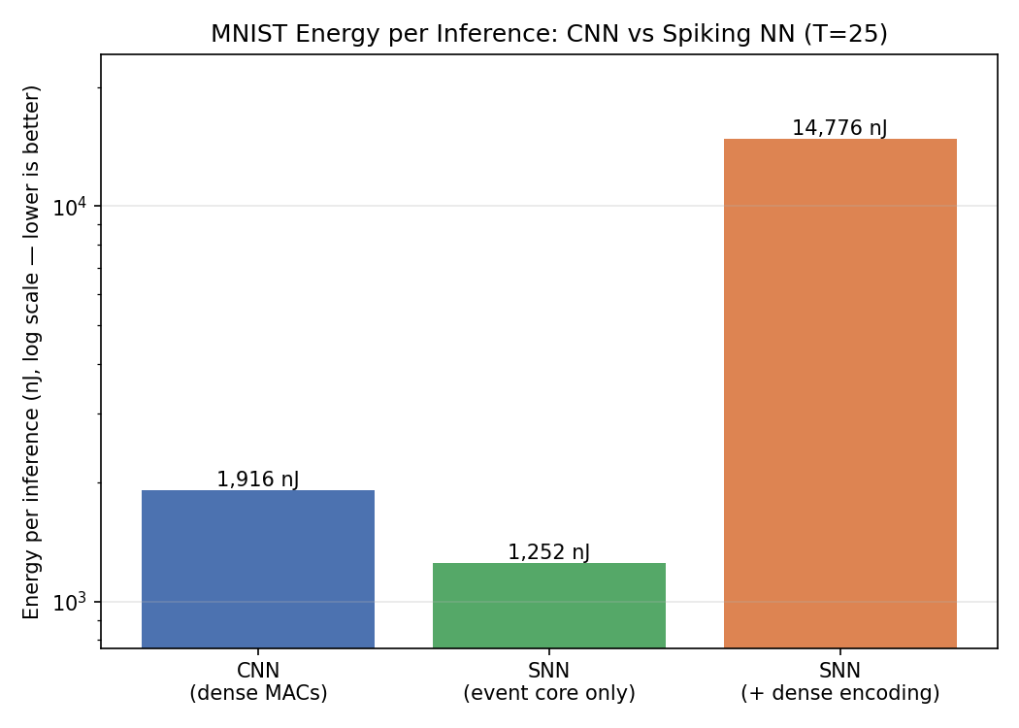
Figure 2. Energy per inference on MNIST: CNN vs spiking neural network, with and without the dense encoding-layer cost (log scale).
The finding is instructive: the event-driven portion of a spiking network is genuinely more energy-efficient than dense arithmetic, but the input-encoding scheme can dominate and erase that advantage. This identifies the encoding strategy and the number of timesteps as the decisive levers for neuromorphic energy efficiency, and reflects a known limitation of current-injection spiking networks.

4.3 Failure-analysis classification
The adapted ResNet18 classified the eight held-out failure images with 37.5% accuracy (three of eight), above the 14.3% random-chance baseline for seven classes but low, as expected for a dataset of only 24 heterogeneous images. Prediction confidences ranged from 21% to 51%. This result demonstrates that the classification-and-inference pipeline functions end to end, while confirming that a much larger, cleaner dataset would be required for a deployable classifier.

4.4 Hardware performance of the classifier
Benchmarking the identical trained model on CPU and GPU produced a clear result, summarized in Tables 1 and 2 and Figure 2. The GPU ran inference about twenty times faster than the CPU (3.4 ms versus 68.7 ms per image), raising throughput from 15 to 293 images per second.

Table 1. Inference performance
Hardware | Average Inference Time (ms) | Throughput (Images/s)
CPU | 68.69 | 14.6
GPU | 3.41 | 293.1

Table 2. Resource utilization
Hardware | Memory Usage | Processor Utilization | Classification Accuracy
CPU | 816 MB (RAM) | 99.4% | 37.5%
GPU | 1144 MB RAM + 97 MB GPU | 97.7% | 37.5%
Additional metrics: model loading time — CPU 203 ms, GPU 416 ms; GPU power draw ~59.8 W.
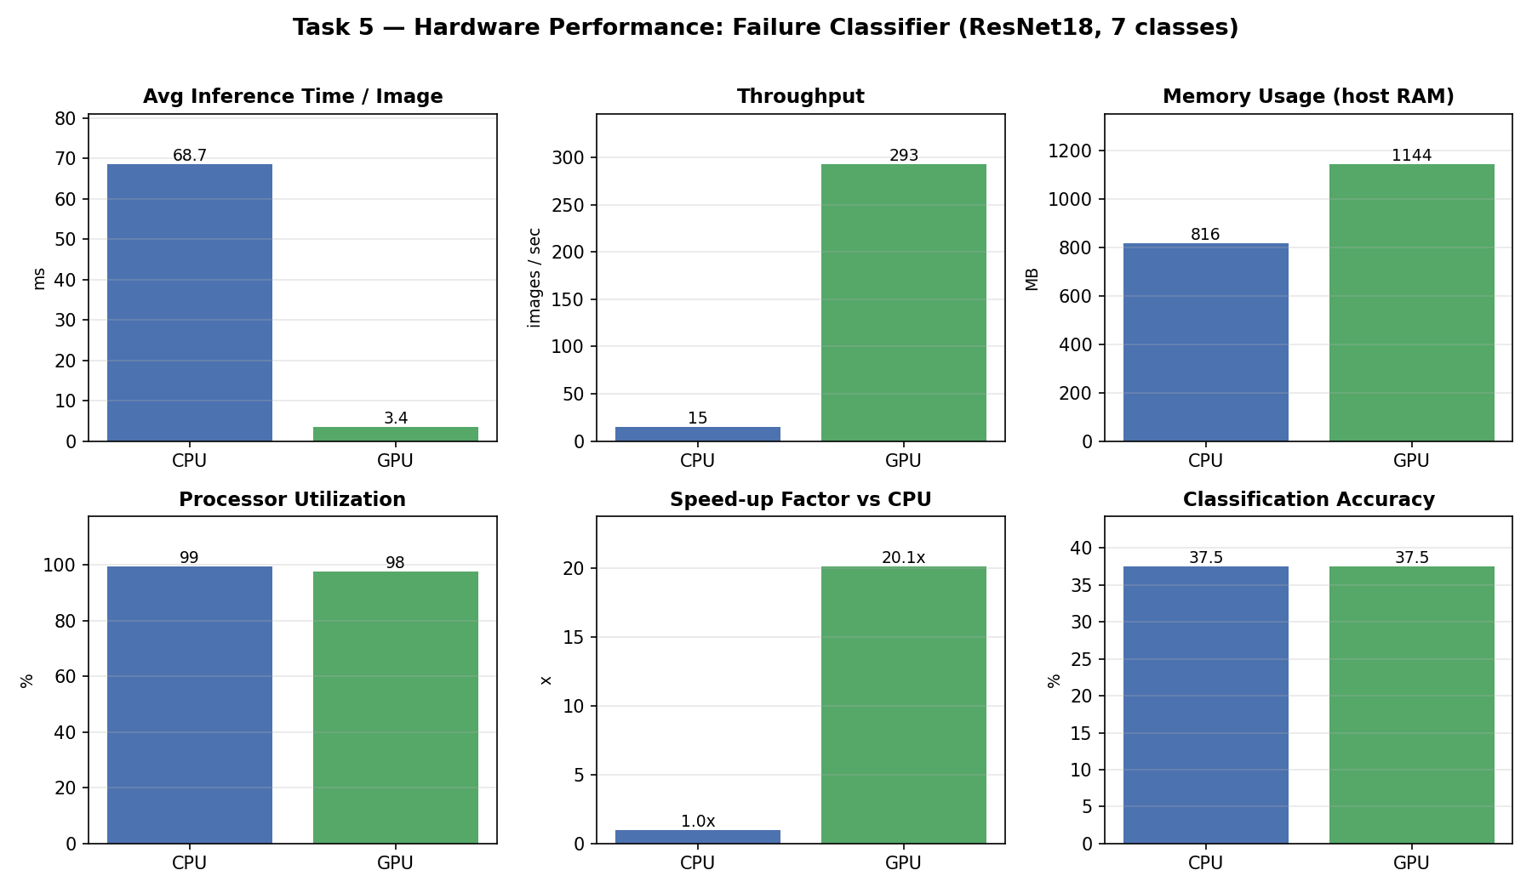
Figure 3. CPU vs GPU across inference time, throughput, memory, utilization, speed-up, and accuracy.
Three points explain the numbers. First, CNN inference is dominated by dense matrix multiplication, which maps onto the GPU's thousands of parallel cores far more efficiently than onto the CPU's few latency-optimized cores. Second, the GPU's model loading was slower (416 ms versus 203 ms) because initializing the CUDA context adds overhead — so the GPU pays off when many images are processed together, exactly the high-throughput inspection scenario, but its setup cost partly offsets its advantage for a single occasional image. Third, accuracy is identical across platforms because hardware changes speed and energy, not the model's weights; the low value reflects the tiny dataset, not the processor.

5. Conclusion
This project examined when and why specialized AI accelerators outperform general-purpose CPUs for deep-learning inference, and applied the comparison to AI-assisted semiconductor failure analysis. Across seven workloads the GPU's advantage varied from about 112x to 1.5x, determined by how parallelizable each workload is — dense matrix math gains the most, sequential decoding the least. For the failure-analysis application, a transfer-learned ResNet18 demonstrated the classification pipeline, and benchmarking showed the GPU delivering roughly twenty times the CPU's throughput at the cost of higher memory use and power.
Recommendation. For high-throughput manufacturing inspection, where large volumes of images must be screened quickly, a GPU (or a dedicated accelerator such as a TPU or NPU) is the clearly preferable platform for the inference stage, with the CPU handling orchestration and pre/post-processing. For occasional, single-image analysis or cost- and power-constrained deployments, a CPU is adequate and avoids the accelerator's loading overhead and hardware cost.
Limitations and future work. The failure-analysis dataset (24 images) was far too small for a statistically meaningful accuracy figure; a larger, cleaner, cropped dataset would enable a deployable classifier and a fair accuracy comparison across models (MobileNetV2, EfficientNet-B0). TPU and NPU platforms were out of scope and would extend the hardware comparison. The analytical energy model showed a spiking network's event-driven core to be more efficient than a CNN but its dense encoding layer to dominate; validating this against real neuromorphic hardware (e.g. Intel Loihi) and exploring event-based encodings or fewer timesteps to reduce the encoding cost are natural next steps for quantifying efficiency beyond speed alone.

References
Black, J. R. (1969). Electromigration — A brief survey and some recent results. IEEE Transactions on Electron Devices, 16(4), 338-347.
Davies, M., Srinivasa, N., Lin, T.-H., Chinya, G., Cao, Y., Choday, S. H., ... Wang, H. (2018). Loihi: A neuromorphic manycore processor with on-chip learning. IEEE Micro, 38(1), 82-99.
Deng, J., Dong, W., Socher, R., Li, L.-J., Li, K., & Fei-Fei, L. (2009). ImageNet: A large-scale hierarchical image database. IEEE Conference on Computer Vision and Pattern Recognition, 248-255.
He, K., Zhang, X., Ren, S., & Sun, J. (2016). Deep residual learning for image recognition. IEEE Conference on Computer Vision and Pattern Recognition, 770-778.
Horowitz, M. (2014). Computing's energy problem (and what we can do about it). IEEE International Solid-State Circuits Conference (ISSCC), 10-14.
JEDEC Solid State Technology Association. (2016). JEP122H: Failure mechanisms and models for semiconductor devices. JEDEC.
Jouppi, N. P., Young, C., Patil, N., Patterson, D., et al. (2017). In-datacenter performance analysis of a tensor processing unit. ACM/IEEE International Symposium on Computer Architecture (ISCA), 1-12.
McPherson, J. W. (2013). Reliability physics and engineering: Time-to-failure modeling (2nd ed.). Springer.
Sandler, M., Howard, A., Zhu, M., Zhmoginov, A., & Chen, L.-C. (2018). MobileNetV2: Inverted residuals and linear bottlenecks. IEEE Conference on Computer Vision and Pattern Recognition, 4510-4520.
Sze, V., Chen, Y.-H., Yang, T.-J., & Emer, J. S. (2017). Efficient processing of deep neural networks: A tutorial and survey. Proceedings of the IEEE, 105(12), 2295-2329.

