Consent language
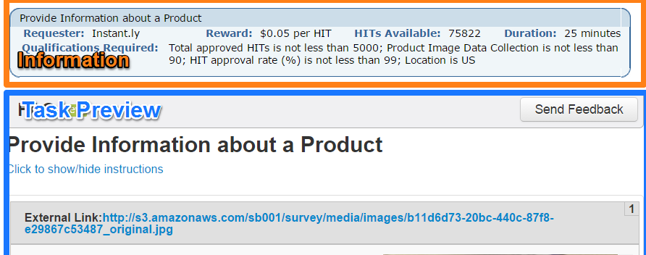
This consent language will be shown when requesters are previewing tasks in the Mechanical Interface, before deciding to perform the task. The amount of remuneration will in the task outline right above the consent language view, alongside a title other information. The inset screenshot of a random task highlights the Info Box (orange) and the Task Preview Box (blue): the consent language for this study will be in the blue area at the top of the task preview.

---
You are invited to participate in this research study on understanding task design in paid crowd settings. You will be asked to complete tasks related to online images. Your decision to participate or decline participation in this study is completely voluntary and you have the right to terminate your participation at any time.

This study will take approximately <total anticipated time, will be estimated from testing> of your time, and you will be paid for performing the tasks as noted in the details above. Your participation in this research will be confidential and data will be averaged and reported in aggregate. The data from this study may be used in academic venues, such as published papers and a student thesis. We will make no efforts to identify you. There are no risks to individuals participating in this study beyond those that exist in daily life, and the judgments you provide will help requesters on paid crowd platforms design better tasks in the future.

This study is conducted by Peter Organisciak <organis2@illinois.edu> and advised by Michael Twidale<twidale@illinois.edu, Professor, (217) 265-0510> from the University of Illinois. Please contact Mr. Organisciak or Dr. Twidale with any questions about this study. If you have any questions about your rights as a participant in this study or any concerns or complaints, please contact the University of Illinois Institutional Review Board at 217-333-2670 or irb@illinois.edu.

You may print a copy of this online consent form for your records, if you wish. By accepting and subsequently submitting any tasks, you indicate that you have read and understand the above consent information, certify that you are 18 years old or older, and indicate your willingness to voluntarily take part in the study.

