Michael B. Twidale, Peter Organisciak

# Task Design Mockups

These mockups are intended to give reviewers a sense of the tasks being pursuing. This attachment corresponds to question 10 on IRB-1. Consent language, as in the attached consent language document, will be shown at the top of the task, when it is being previewed prior to acceptance.

## Task Types

### A: Image retrieval judgments

For image retrieval relevance judgments, participants are shown a query (as in a web image search, compare to a search on Google Images), a description of what types of images are relevant to that query, and a set of 10 images. For each image in the set, participants rate whether the image is not/somewhat/very relevant to the query.

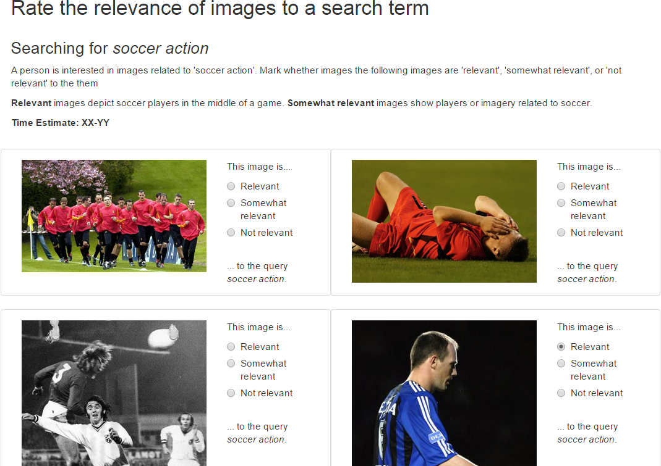

## B: Image tagging

For the image tagging task, participants are shown ten images and are asked to enter two words (‘tags’) that describe each image.

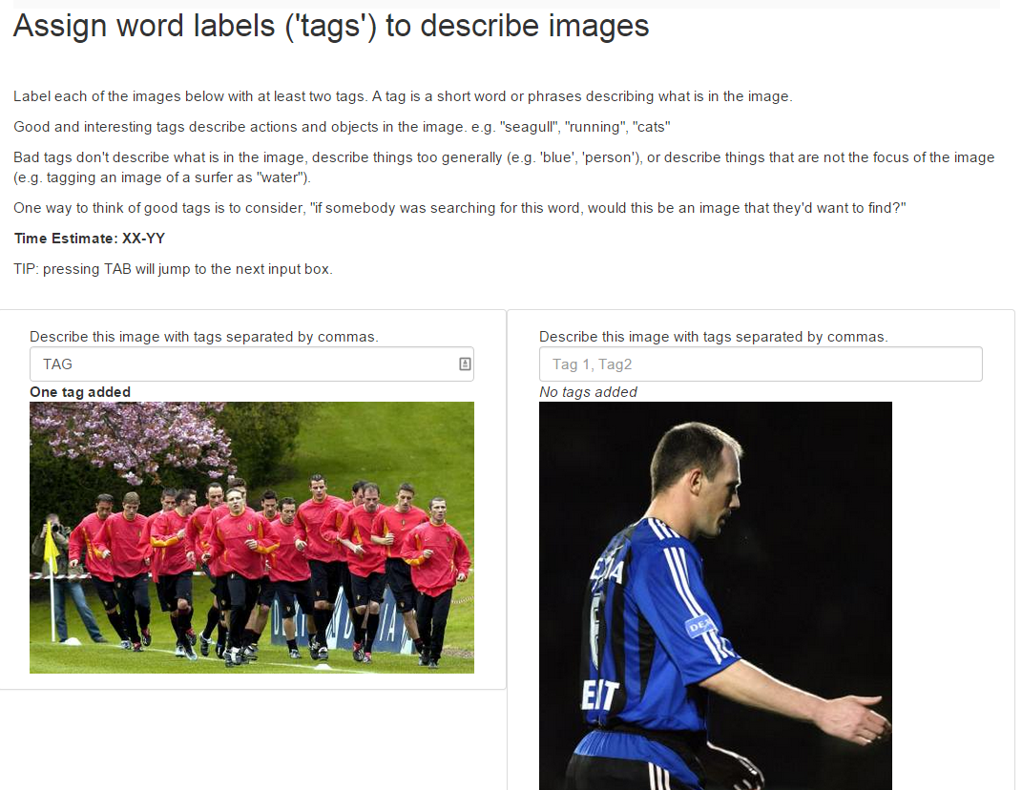

## C: Image recommendation

For the image recommendation task, subjects are shown a set of 10 images that an online user likes and a set of 25 images to perform recommendation over. Their task is to judge whether the target user (represented by the 10 “liked” items) would like or dislike each of the subsequent images.

