STROKOVNO POROČILO - - razvoj DD realno okolje
Avtor: Dejan Rožič
Datum: 07.05.2025
Projekt: PMO
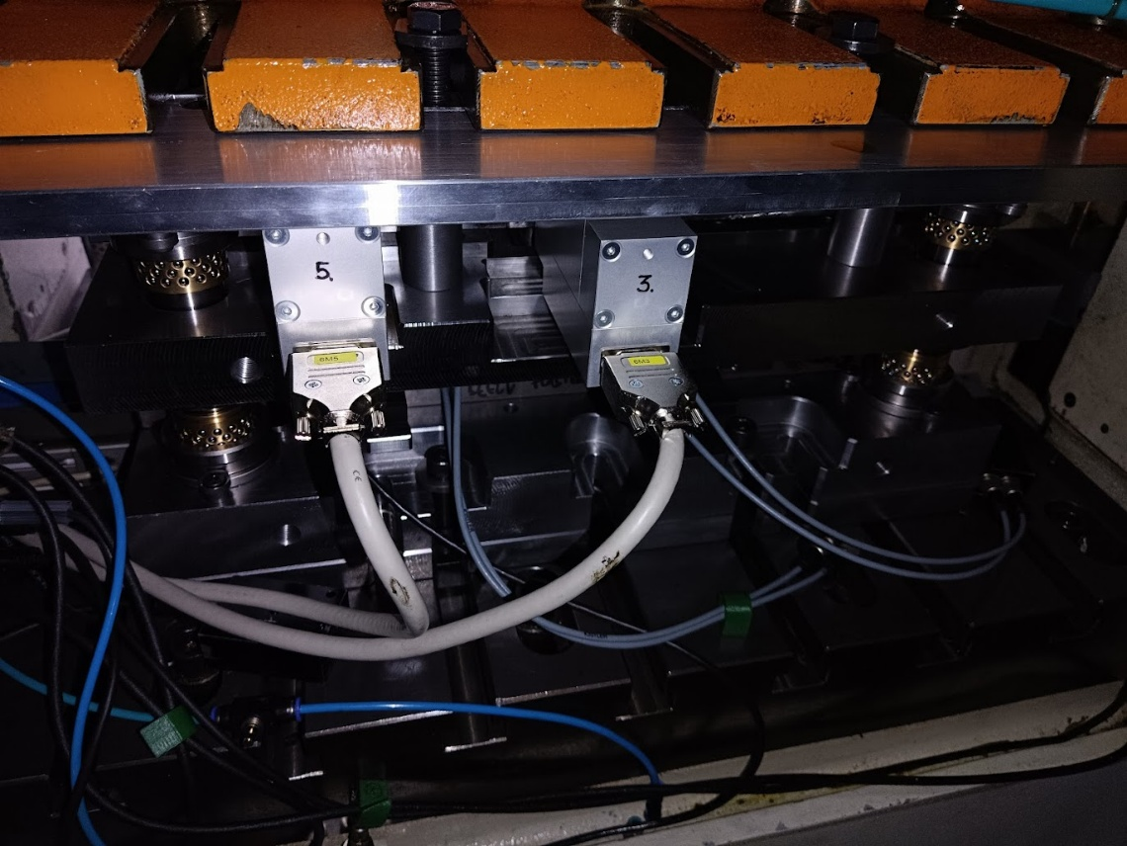
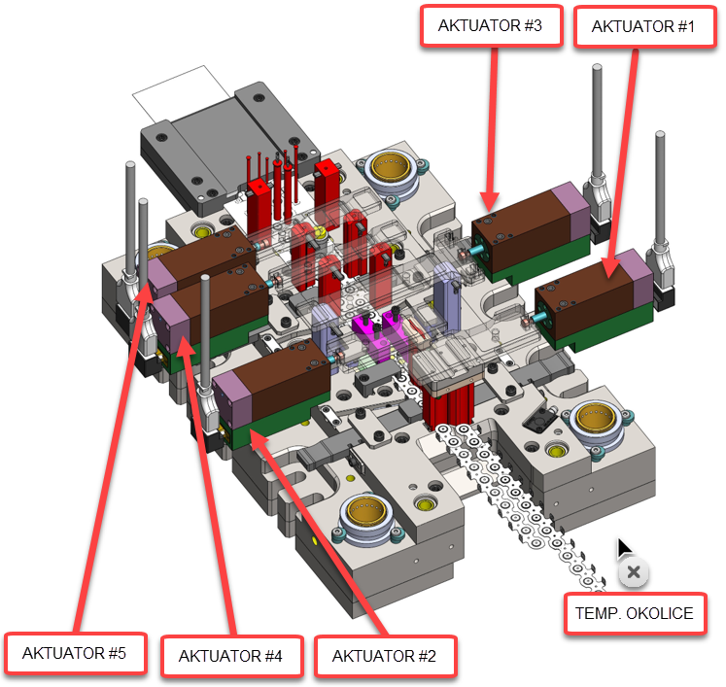

Sensors
Sensors data for digital twin:
Name : Type | # | Zone | Description
Environment sensor | 1 | 4 | Environment temperature
Actuator#1 sensors  case sensor  current sensor  Actuator#2 sensors  case sensor  current sensor  Actuator#3 sensors  case sensor  current sensor  Actuator#4 sensors  case sensor  current sensor  Actuator#5 sensors  case sensor  current sensor | 1  1  1  1  1  1  1  1  1  1 | 2  1  2  1  2  1  2  1  2  1 | Temperature - case of the actuator  Current for actuator  Temperature - case of the actuator  Current for actuator  Temperature - case of the actuator  Current for actuator  Temperature - case of the actuator  Current for actuator  Temperature - case of the actuator  Current for actuator
*Topics are send at constant interval: 2Hz [can be adjusted]

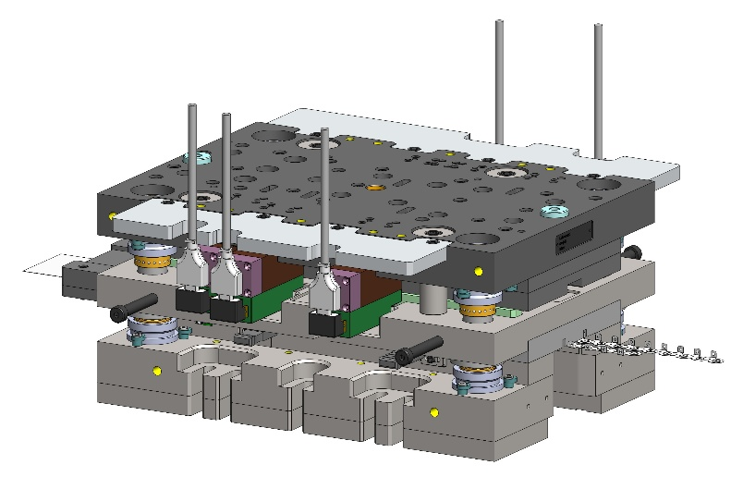 | 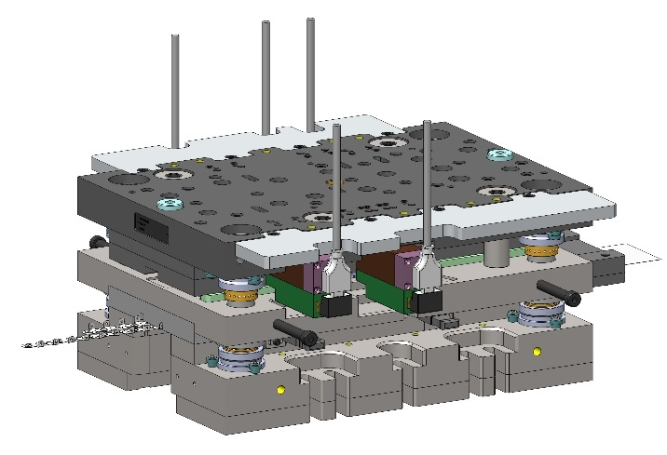
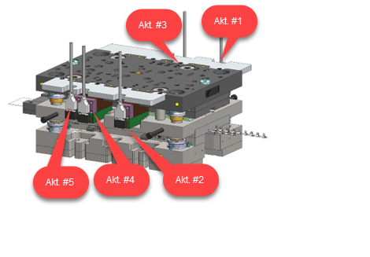

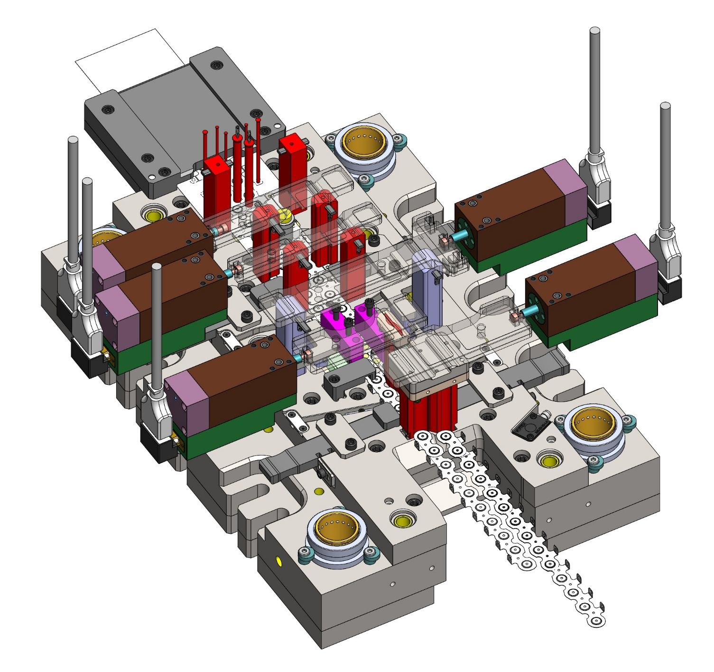



Sensor limits50N configuration - temperature range
Sensor | Measuring range | Result
Case sensor | T > 45 °C  T > 40°C AND T<=45°C  T>150°C OR T <=0 °C  T>0°C AND T<150°C | Error: overheating  Warning: temperature  Not connected  Connected range
Current sensor / Force sensor* | I > 7,10A  I > 5,39A AND I <= 7,10A  I > 1,92A AND I <=5,39A  I > 4,53A AND I <= 5,39A | Error: overrange  Warning: current  Working range  Lubrication required
Tool sensor & Environment sensor | Δt (Tool - Environment) >= 5°  5° < Δt (Tool - Environment) > 2°  -2° < Δt (Tool - Environment) <= 2°  Δt < -2°C  Δt > 2°C | Error: overheating  Warning temp.  Working condition  Warning environment  Warning environment
*Force-Linearization : F=11,71*I - 3,0 [N]

50N configuration - times to final temperature
Speed | Environment temperature | Egasi temperature | Actuator  case | Reaction time to final temperature
100RPM->150RPM | 22.4 -> 23,5 | 30 -> 35 | 22.4->23,8 | 50 min
150RPM-> 200RPM | 24.2 ->25,2 | 35 -> 35 | 24.2 ->25,8 | 65 min
200RPM->250RPM | 25.2->25.5 | 35->40 | 25.2 ->26,9 | 7 min
250RPM -> 0RPM | 27.2->27.6 | 40->30 | 29.3->28.2 | 20 min
0RPM -> 250RPM | 27.7-> 27.5 | 30->40 | 28.2->29.3 | 19 min

TOPICS SETTINGS

Topic structure

topic: /machine

Main machine status topic
- Topic: /haulick-32t
- Description: Root topic for Haulick 32T machine status
- Data Format: JSON

example for the topic:
/haulick-32t
T_env  is_in_continous_mode  is_in_error  speed  current_count | string  bool  bool  int  int | Environment temperature [°C]  Machine in continuous mode  Machine has an error  Machine speed [RPM]  Machine counter

Example payload:
{ "T_env": 23.5, "is_in_continuous_mode": true, "is_in_error": false, “speed”: 150, “current_count: 251000 }

topic : /machine/tool-nr

Toll-nr machine status topic
- Topic: /haulick-32t/32777/
- Description: Root topic for tool status
- Data Format: JSON

example for the topic:
/haulick-32t/32777/
T_tool | int | Tool temperature [°C]

Example payload:
{ "T_tool": 23.5 }

topic /machine/tool-nr/type-of-sensor_#number

Actuator/motor status topic
- Topics:
  - /haulick-32t/32777/actuator_1,
  - /haulick-32t/32777/actuator_2,
  - /haulick-32t/32777/actuator_3,
  - /haulick-32t/32777/actuator_4
- Description: Root topic for actuator/motor status
- Data Format: JSON

example for the topic:
/haulick-32t/32712/actuator_1
T  Imax  Imin  Fmax  Fmin | int  int  int  int  int | actuator temperature [°C]  actuator max. current [A]  actuator min. current [A]  actuator max. force [N]  actuator min. force [N]

Example payload:
{ "T": 23.5, “Imax”:2.5, “Imin”:-1A, “Fmax”:50N, “Fmin”:-10N }

Digital twin:
Same topic is for four other actuators (motors) example:
- /haulick-32t/32777/actuator_1 - motor #1
- /haulick-32t/32777/actuator_2 - motor #2
- /haulick-32t/32777/actuator_3 - motor #3
- /haulick-32t/32777/actuator_4 - motor #4

Response from DT (Digital Twin)

Response topics
Response status topic
- Topics:
  - /DT/response/actuator# - example /DT/response/actuator1, /DT/response/actuator2, /DT/response/actuator3, /DT/response/actuator4
- Description: Root topic from digital twin status
- Data Format: JSON

example for the topic:
/DT/response/actuator# | Data type | Comment
req_lubriration  is_current_error  is_current_warning  is_temeprature_error  is_temperature_warning  T_sensor_disconnected  I_sensor_disconnected | bool  bool  string  bool  bool  bool  bool | request lubrication for actuator  error flag  warning flag  error flag  warning flag  flag for sensor disconnected  flag for sensor disconnected

example for the topic
/DT/response/sensors/temperature
is_overheated  is_in_range  T_sensor_disconnected | bool  bool  bool | request lubrication  error flag from digital twin  error name - comment

Nodered
Node-RED je odprtokodno orodje za vizualno programiranje, namenjeno povezovanju naprav, senzorjev, PLC-jev, baz podatkov in spletnih storitev. Deluje po principu tokov (flows), kjer z grafičnimi vozlišči (nodes) definiramo zajem podatkov, njihovo obdelavo in posredovanje naprej (npr. MQTT, HTTP, InfluxDB, HMI).
Kako deluje:
- podatki vstopajo v sistem prek vhodnih vozlišč (PLC, MQTT, API),
- vmes se obdelajo (filtriranje, pretvorbe, logika),
- izhodna vozlišča podatke shranijo, prikažejo ali posredujejo drugim sistemom.
Vloga v RRI razvojnem projektu PMO – Pametno mehatronsko orodje:
Node-RED sem uporabil kot integracijsko in podatkovno plast med mehatroničnim sistemom (PLC/senzorji) in IT-okoljem. Omogoča:
- zbiranje procesnih podatkov (temperatura, napetost, tok, hitrost, stanje stroja),
- pretvorbo in pošiljanje podatkov v InfluxDB in druge storitve,
- posredovanje podatkov prek MQTT za digitalni dvojček in nadzorne aplikacije,
- hitro prilagodljiv razvoj brez poseganja v osnovno PLC logiko.
S tem Node-RED bistveno prispeva k hitremu razvoju, modularnosti in razširljivosti pametnega mehatronskega orodja v okviru RRI projekta.
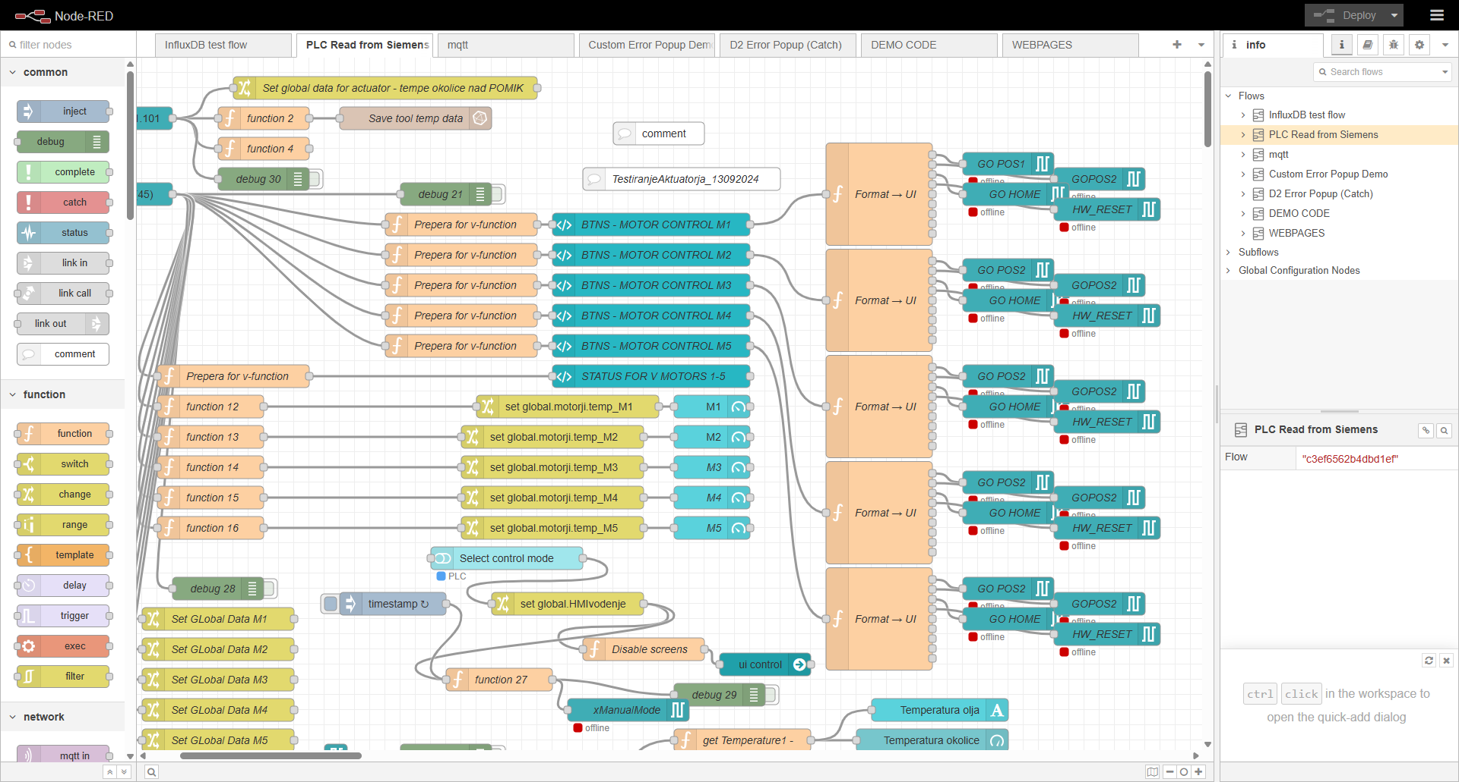

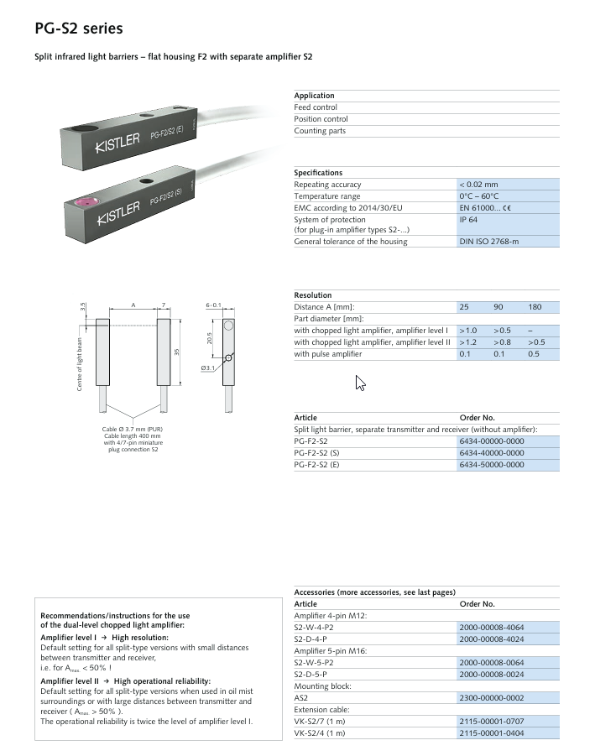

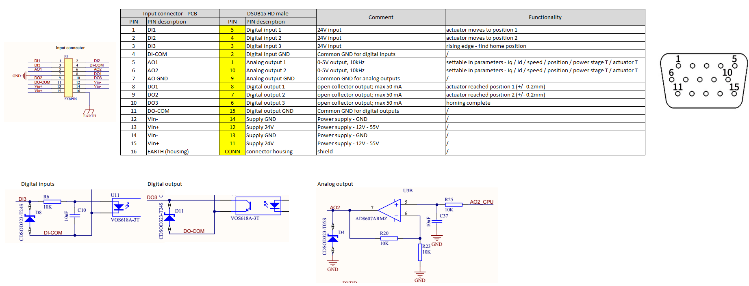

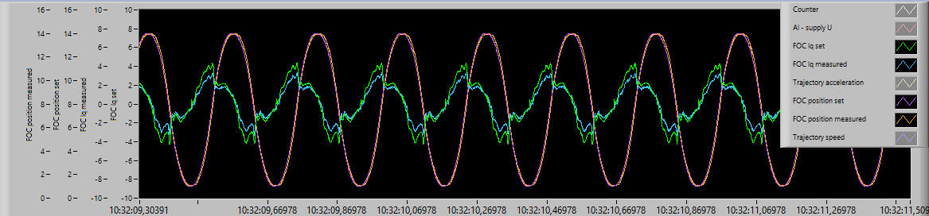

Iq vrednosti so -10A - 10A --> skalirano x0.25 + offset 2.5
Iq = -10A --> AO1 = 0V
Iq = 0A --> AO1 = 2.5V
Iq = 10A --> AO1 = 5V

Actuator T gre od -40°C - 150°C; negativnih temperatur ne bo in bom dal skaliranje 0.04, offset = 0
0°C --> AO2 = 0V
50°C --> AO2 = 2V
100°C --> AO2 = 4V

Testiranje digitalnega dvojčka
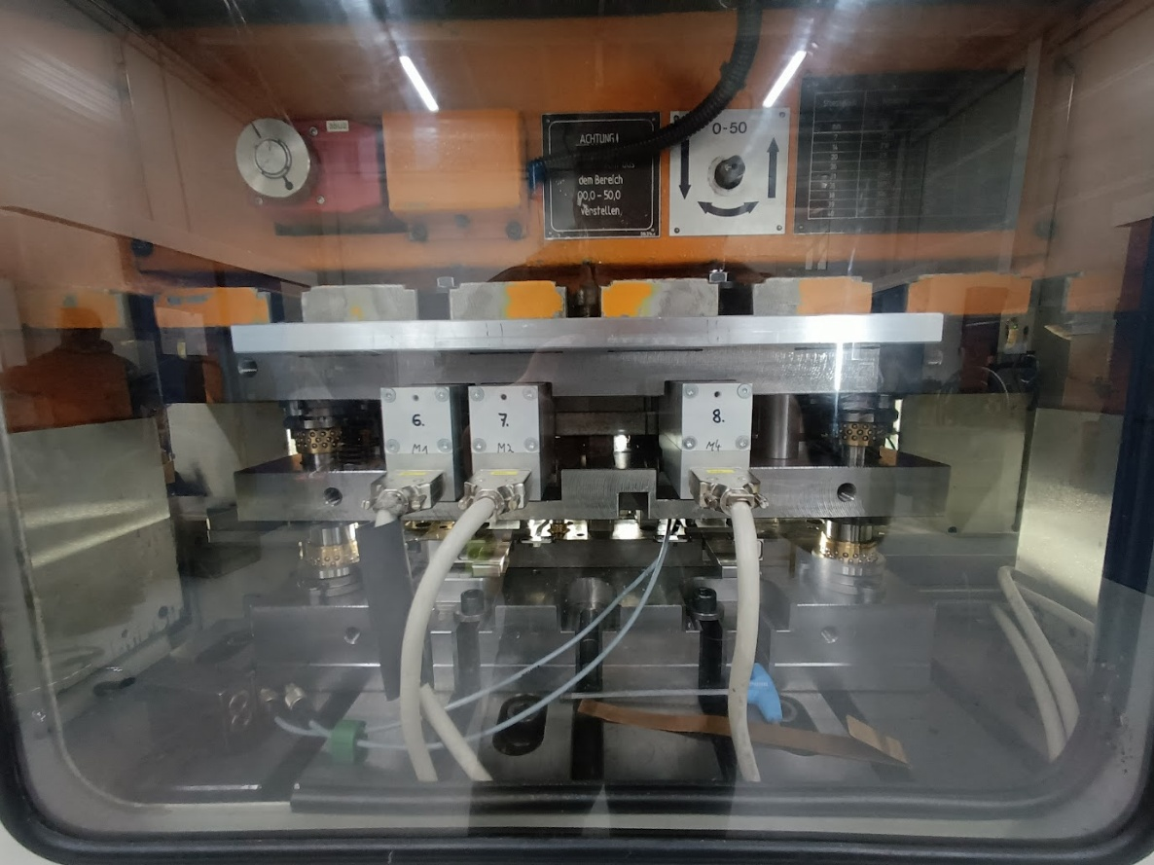

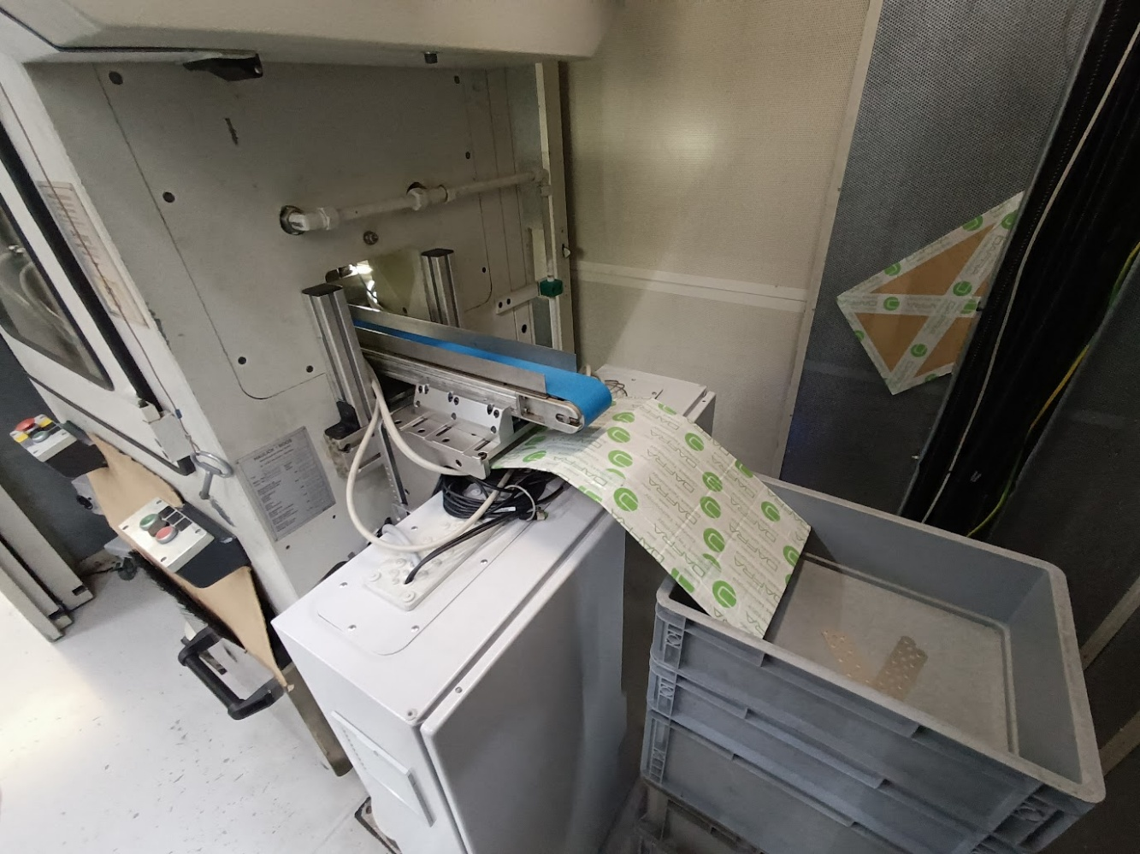

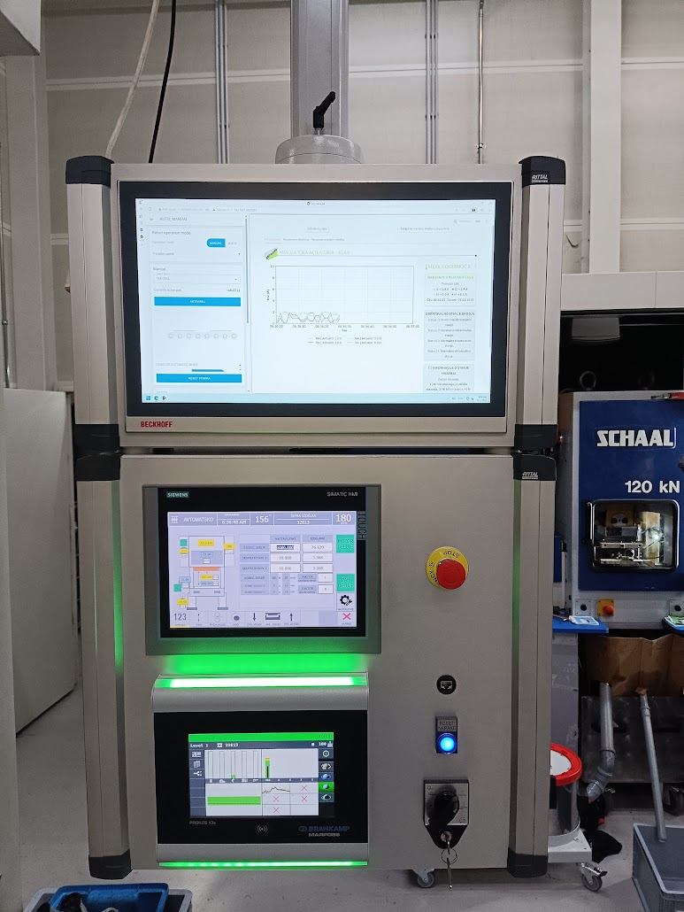

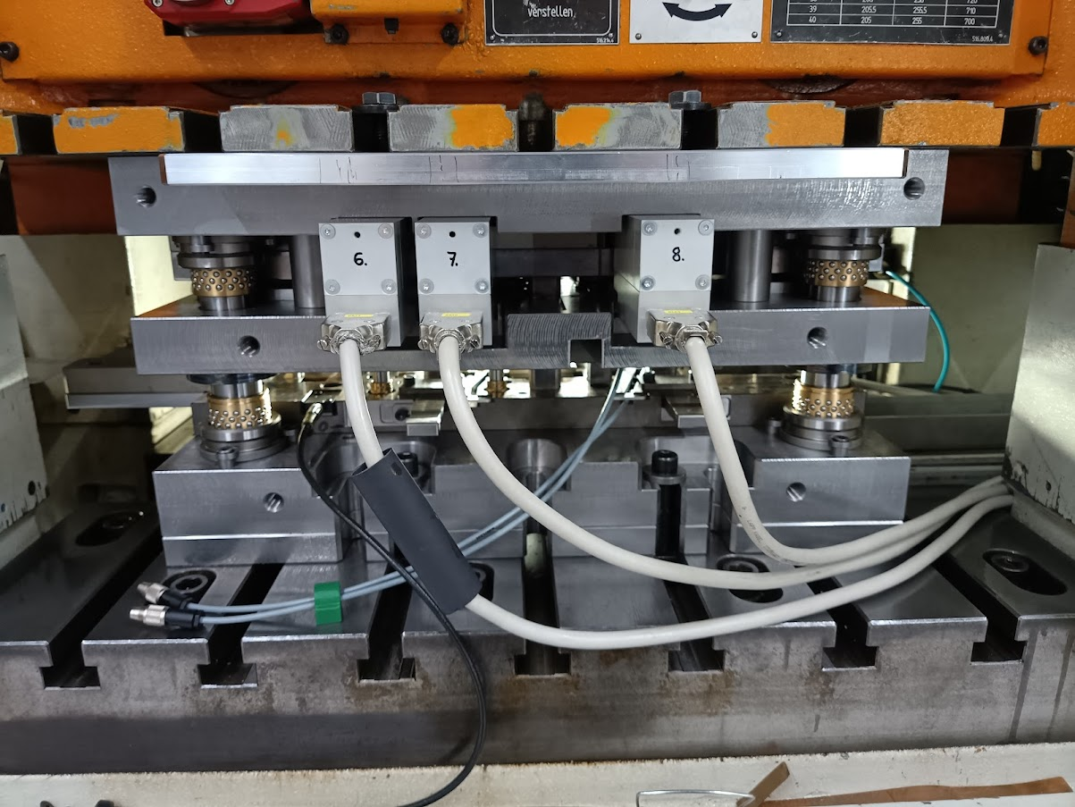

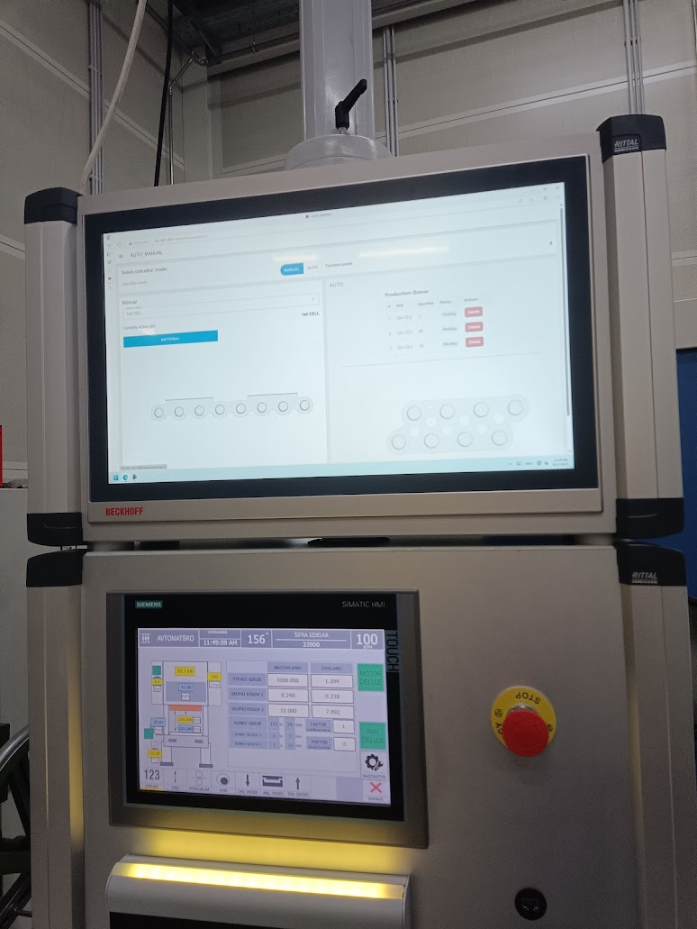

Prikaz zaslona iz aplikacije digitalnega dvojčka
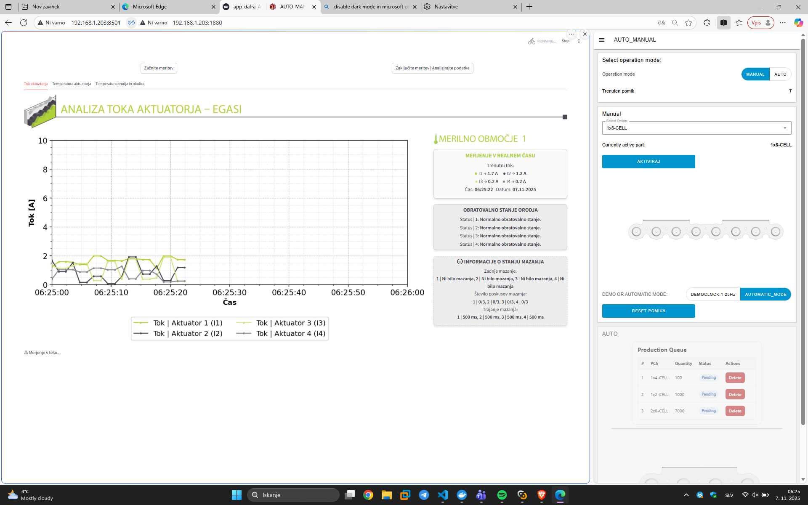
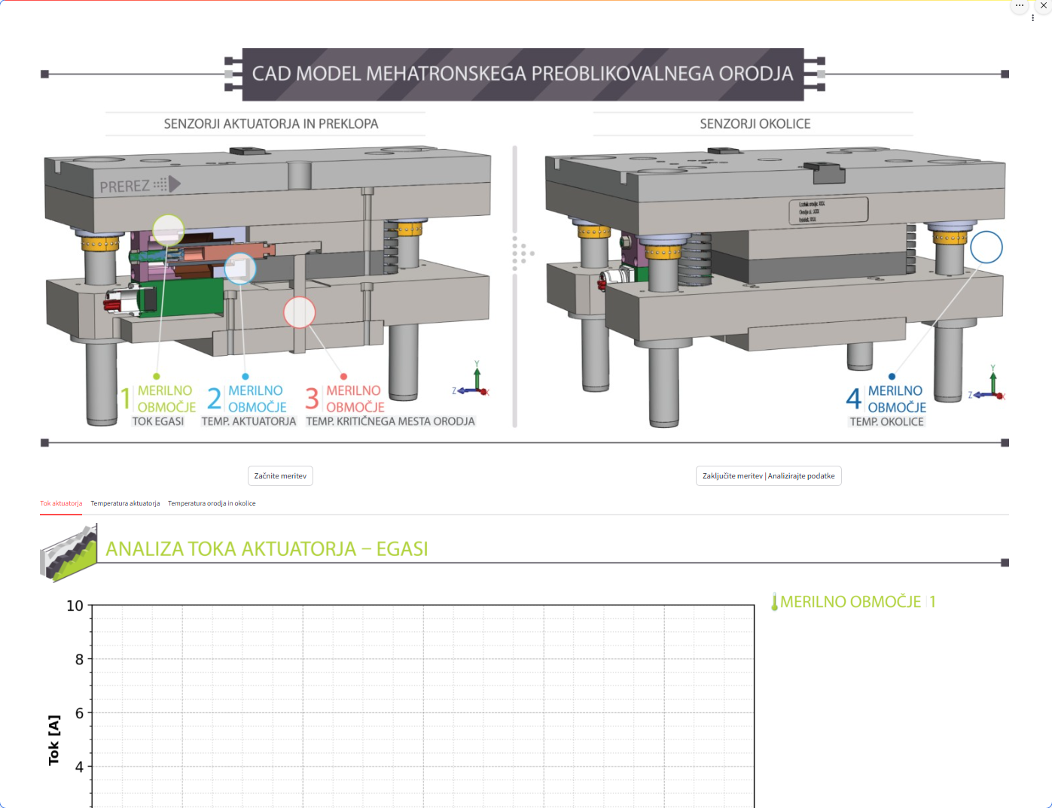

DD – algoritem po optimizaciji

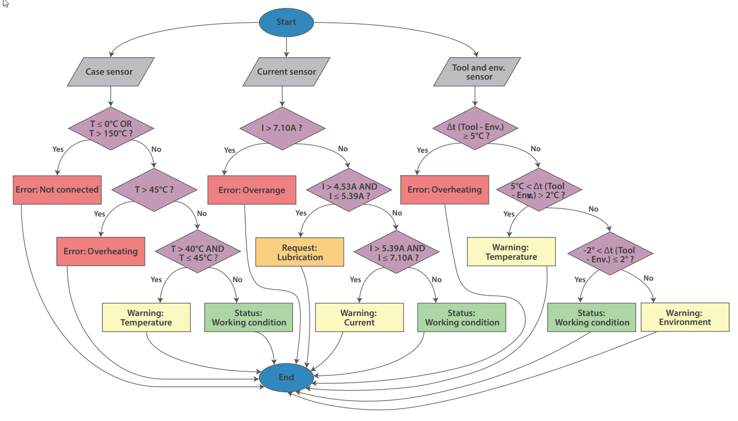

DD – Algoritem po optimizaciji
Case sensor  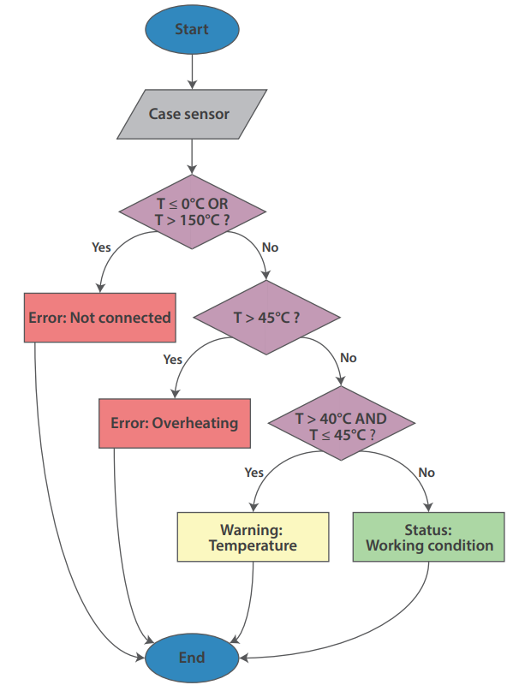 | Env. Sensor  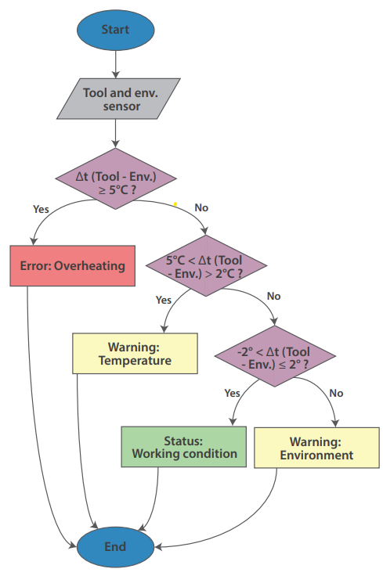 | Current sensor  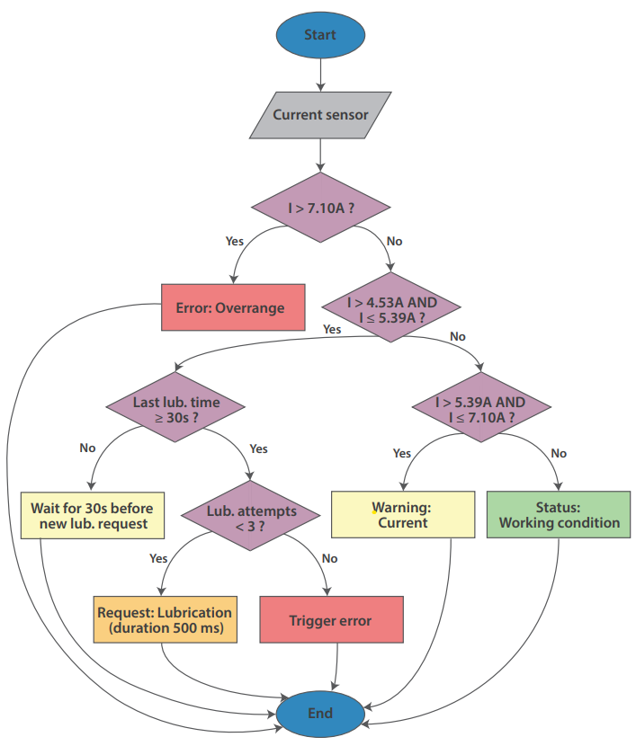

Taguchi:

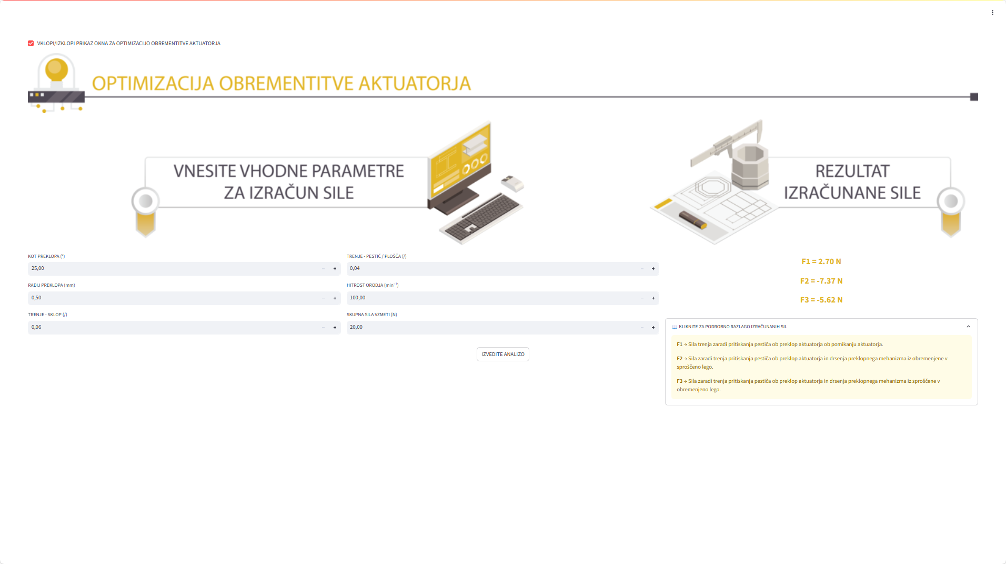

Slike iz zaslonske aplikacije  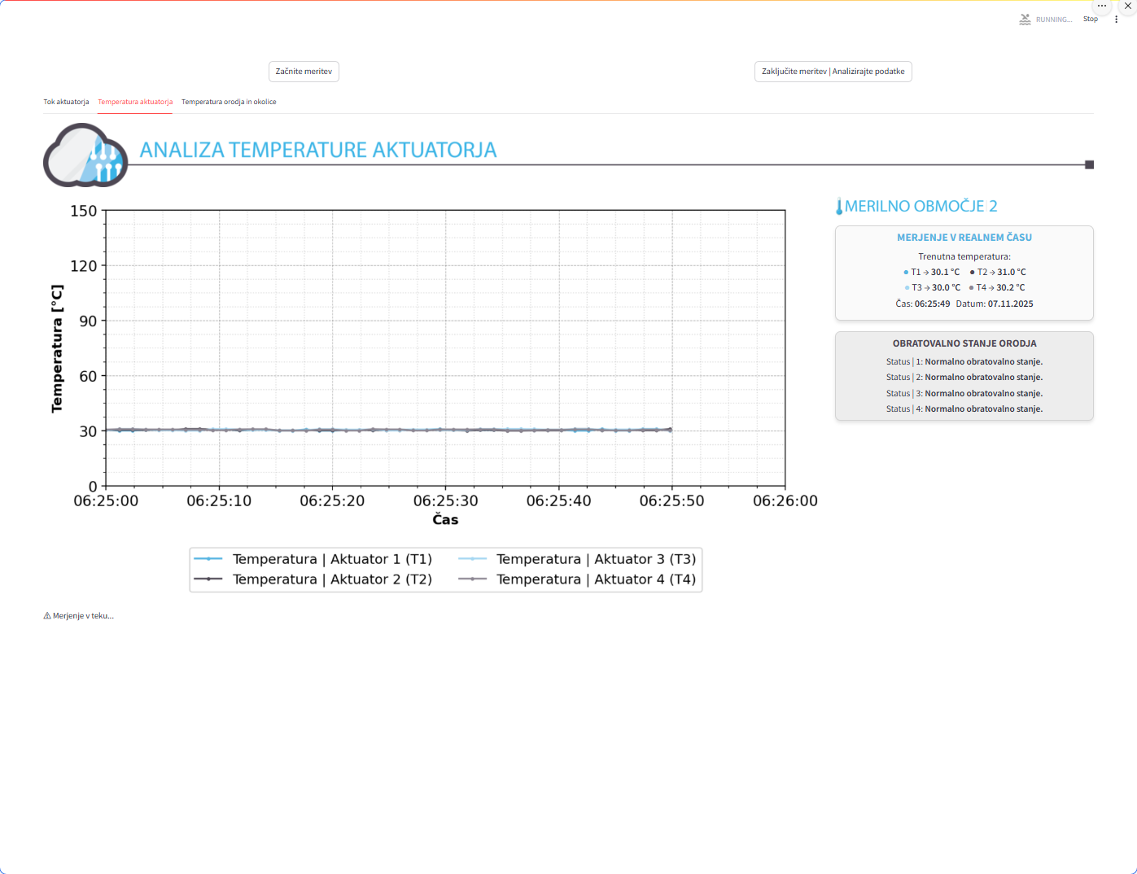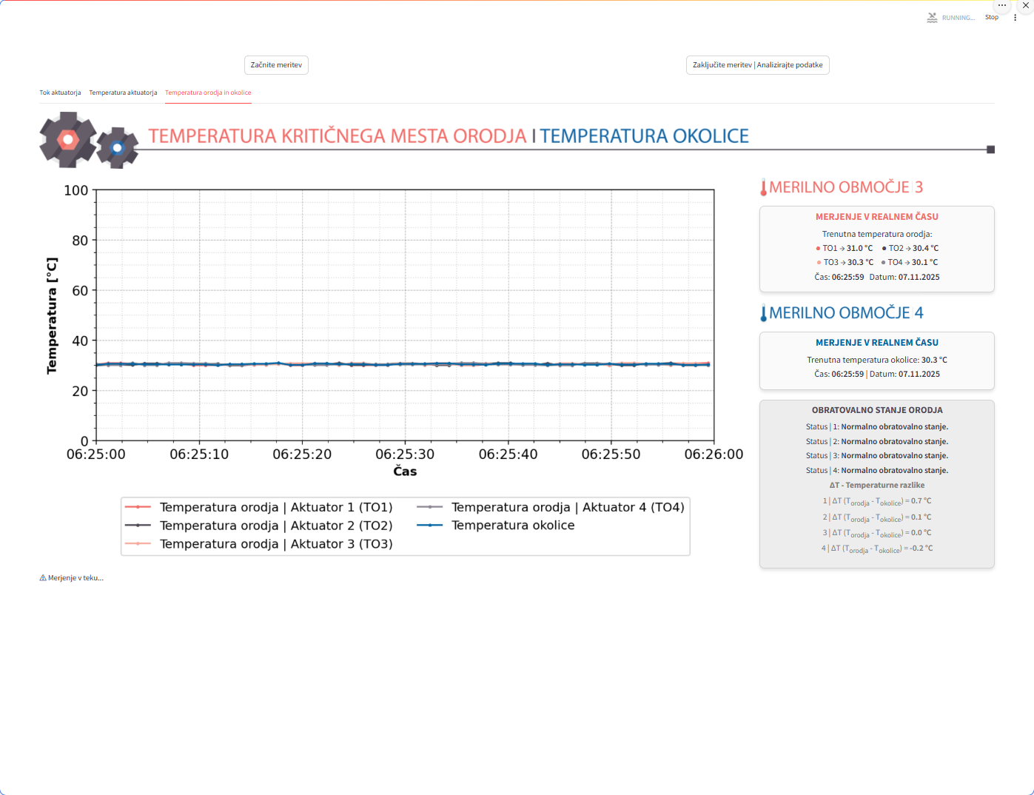 | 
