EE5134: Digital IC Design

**Standard Cell Design: Project Report**

Nitin Prasad (EE10B023), Alfred Ajay Aureate R (EE10B052), Prateek S Kolhar (EE10109), Aditya Bharadwaj (EE10B113)

**Selected Standard Cells:**

1. INVX4
2. NOR2X1
3. AOI21X1
4. DFFPOSX1

**Description of Procedure:**

1. **Criteria used to qualify a logic gate as X1, X2 etc.**

The *inverter.mag* file that has been provided was taken as a reference inverter $X1$. To qualify any logic gate to have a drive strength of $X1$, $X2$ etc. we need to choose a value of load capacitance. We have chosen a value of the capacitance to be $500$ fF, much greater than the overall diffusion capacitance present at the output, to characterize the drive strength.

The a logic circuit is said to have a drive strength of $Xn$ if it is able to drive a load of $nC$ with the same rise and fall delays as compared to a reference inverter driving a load capacitance of $C$. In case of sequential circuits, the delays that are matched to the reference inverter delay are the clock to $Q$ and the clock to $\overline{Q}$ delays.

As mentioned, the rise and fall dealys are optimized for a load capacitance of 500fF. It should be noted that for smaller values of load capacitances, the rise and the fall delays is not necessary around the same value and may not be comparable to that of the reference inverter in accordance with the definition of drive strength. This is because the associated diffusion capacitances of a logic circuit is not necessarily the same as that of the reference inverter.

1. **Rise and fall delays**

The provided reference inverter has unequal rise and fall delays. In our case, we have tried to bring down the rise and fall delays of the logic circuit to lie between the rise and fall delays of the reference inverter. Moreover, the rise and fall delays are optimized to be almost equal for a load capacitance of $500$ fF (much greater than the diffusion capacitance). For other load capacitances (comparable to the diffusion capacitances) for which the circuit needs to be characterized, the rise and fall delays may slightly be different.

1. **Process Flow**

* Based on the logic and drive strength requirement, the initial sizing of the transistors are chosen and the circuit thus obtained is simulated in *SpiceOpus*.
* Using SPICE level simulations, various parameters such as the widths of the PMOSs and NMOSs are varied so as to match the drive strength of the cell to that of the inverter.
* When an acceptable value for the drive strength is seen, the dimensions of the transistors are noted and the circuit layout is then designed in Magic.
* Once the layout is done in Magic, the spice net-list of the same is extracted and is parsed back to *SpiceOpus* and is tested for various combinations of inputs so as to verify the drive strength that has been initially obtained by simulating it in *SpiceOpus* alone.
* In case of any deviations in the drive strength, the magic layout is suitably edited to resize particular transistors. Again, the netlist is extracted and performance is verified. This kind of iteration is done until the value obtained for the drive strength is acceptable.
* Once we obtain the required design the cell is tested for various parameters such as power, rise time and fall time, by testing it for all the possible combinations of inputs. This is also done across different values of load capacitances and input rise/fall times. The values that are obtained are tabulated.

1. **Measurement of rise/fall delays**



Figure 1: Rise and fall time measurement technique

The cases where the input toggle created a corresponding output toggle was analyzed for rise/fall delays. The Vdd/2 point was considered as shown in Figure 1 to measure the rise and fall delays of the output. This is done for different values of load capacitance and input rise/fall times and the results are tabulated as rise/fall delays of the output. Here, we are considering only one input toggle at a time. A situation where more than one input toggles simultaneously has not been analyzed.

1. **Measurement of Dynamic Energy consumption**



Figure 2: Typical output current characteristic as a function of time

Dynamic power consumption arises because of two main reasons during switching of the output: charging of the output capacitance, and short circuit current. Charging of the output capacitance occurs only when the output goes from low to high. In this case, the pull-up network is ON and power is drawn out of the supply rail. In the case when output goes from high to low, the pull-down network is ON and no power is drawn out of the supply rail.

On the contrary, short-circuit current flows during both the output switching cases. This is because, both the pull-up network and the pull-down network are momentarily in the ON state during switching, causing a short between the supply rail and ground.

There are several implications that one can infer from the above nature of power dissipation:

1. During the output voltage rise, since both factors contribute to the dissipation of energy, the energy consumed for this transition is much higher than the case where the output voltage falls.
2. As the input rise/fall time is increased, the duration for which the ‘shorting’ of Vdd and GND rails happens is larger. This means that the contribution of short circuit energy dissipation increases with the increase in the input rise/fall time. Further, considering only the first order effects, the short circuit current does not have a direct proportionality relationship with the load capacitance.
3. On the contrary, the capacitor can hold a fixed amount of charge which depends on the value of its capacitance. Hence, the charging contribution to energy dissipation is independent of the rise and fall times of the input that triggers a rise in the output. But, as the value of the capacitance is increased, higher is the energy is stored in the capacitor, leading to an increase in the charging contribution to the energy dissipation.

All the above mentioned effects can be seen across all the standard cell libraries that are characterized. For measuring the switching energy that is consumed, the following procedure was adopted. Only the cases where the input toggle created a corresponding output toggle was analyzed as only there cases contribute to dynamic power. A switching frequency in such cases was considered to be 100MHz with equal ON and OFF times. The energy dissipated from the source is integrated over half the switching frequency separately for output rise and output fall. This is done for different values of load capacitance and input rise/fall times and the results are tabulated as dynamic energy consumption during switching.

Note that we are assuming that static power dissipated is extremely small when compared to the dynamic power and hence, during the dynamic power measurements, the contribution of static power is neglected.

1. **Measurement of Static Power consumption**

Due to the phenomena of sub-threshold conduction and gate leakage currents, the supply currents do not go to zero, even when there is no change in the input states. We have considered the static power consumption to be the average of quiescent power consumed under all possible input combinations. For computing the static power consumption, we need to do an operating point analysis, rather than doing a transient analysis.

**Reference Inverter:**

The Inverter of size X1 was provided with PMOS size $20λ$ and NMOS size $10λ$. For $500$ fF load, the rise delay of the reference inverter = $0.83852$ ns and the fall delay $0.8886$ ns.

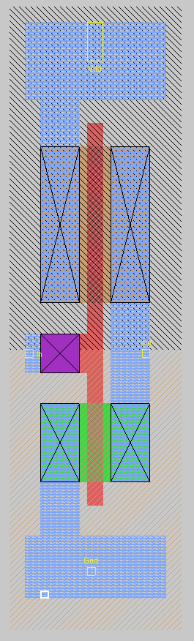

Figure 3: Layout of the inverter in MAGIC

1. **INVX4:**

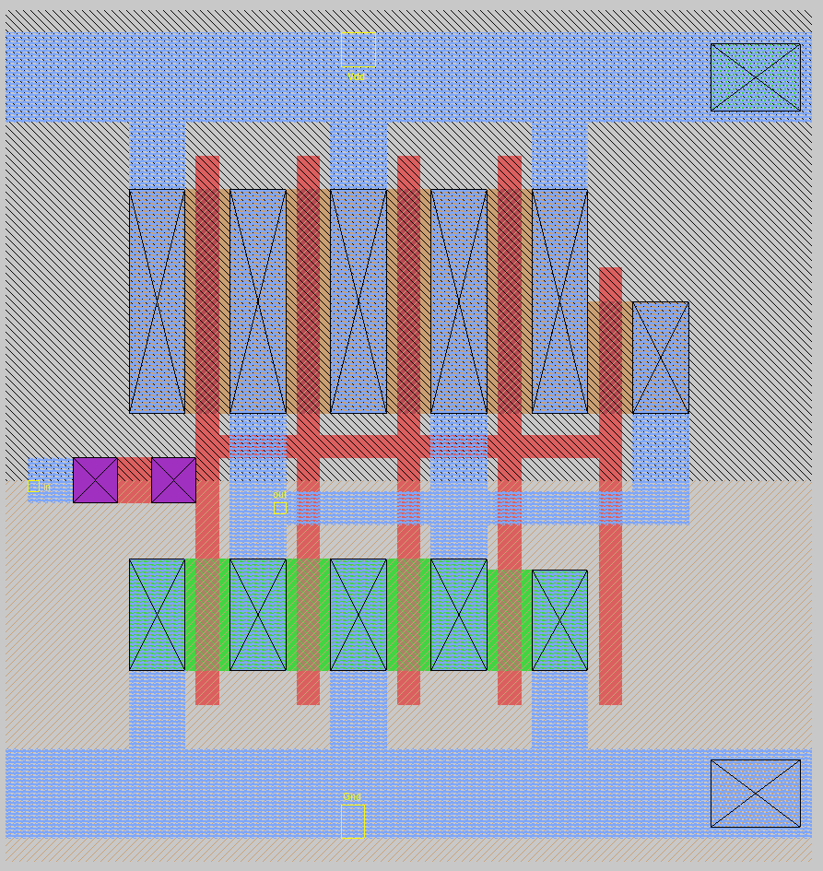 

Figure 4: Layout of the INVX4 in MAGIC(left) and its transistor level circuit diagram(right).

**Logic Expression: $Y=\overline{A}$**

**Truth Table**

|  |  |
| --- | --- |
| A | Y |
| 0 | 1 |
| 1 | 0 |

**Port Definitions**

|  |  |
| --- | --- |
| A | Input |
| Y | Output |

**Transistor sizing:** ($Wn/Ln$)

1. Initial sizing: To match the pull up and pull down resistance to that of a reference inverter.
   1. M1p: $80λ/2λ$
   2. M1n: $40λ/2λ$
2. After iteration to optimize rise/fall times:
   1. M1p: $90λ/2λ$
   2. M1n: $39λ/2λ$

**Width of the standard cell**: $66λ$

**Timing characterization (all delays are in ns)**

|  |  |  |  |  |  |  |
| --- | --- | --- | --- | --- | --- | --- |
|  | A:0 to 1 | | | A:1 to 0 | | |
| $T↓$ ${\backslash C}_{L}→$ | 0.005pF | 0.025pF | 0.15pF | 0.005pF | 0.025pF | 0.15pF |
| 0.06ns | 0.02447 | 0.03498 | 0.09134 | 0.02715 | 0.03695 | 0.09389 |
| 0.42ns | 0.03329 | 0.05493 | 0.14268 | 0.0603 | 0.08165 | 0.16785 |
| 1.2ns | 0.02782 | 0.06084 | 0.19017 | 0.1071 | 0.1405 | 0.2682 |

**Dynamic switching energy characterization (all entries are in pJ)**

|  |  |  |  |  |  |  |
| --- | --- | --- | --- | --- | --- | --- |
|  | A:0 to 1 | | | A:1 to 0 | | |
| $T↓$ ${\backslash C}_{L}→$ | 0.005pF | 0.025pF | 0.15pF | 0.005pF | 0.025pF | 0.15pF |
| 0.06ns | 0.0375 | 0.0403 | 0.0464 | 0.1058 | 0.1715 | 0.5826 |
| 0.42ns | 0.0721 | 0.0636 | 0.0381 | 0.1457 | 0.2049 | 0.5972 |
| 1.2ns | 0.1705 | 0.1600 | 0.1203 | 0.2512 | 0.3053 | 0.6756 |

**Static Power Dissipation:**

|  |  |
| --- | --- |
| **A** | **Static Power (pW)** |
| 0 | 131.352 |
| 1 | 73.848 |
| Average Power | **102.600** |

1. **NOR2X1:**

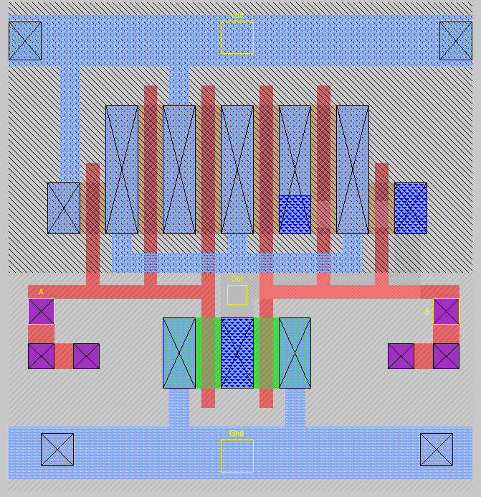 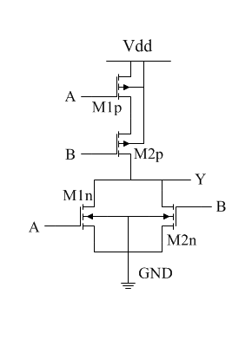

Figure 5: Layout of the NOR2X2 in MAGIC(left) and its transistor level circuit diagram(right).

**Logic Expression: $Y=\overline{A+B}$**

**Truth Table**

|  |  |  |
| --- | --- | --- |
| A | B | Y |
| 0 | 0 | 1 |
| 0 | 0 | 0 |
| 0 | 1 | 0 |
| 0 | 1 | 0 |

**Port Definitions**

|  |  |
| --- | --- |
| A | Input |
| B | Input |
| Y | Output |

**Transistor sizing:** ($Wn/Ln$)

1. Initial sizing: To match the pull up and pull down resistance to that of a reference inverter.
   1. M1p: $40λ/2λ$
   2. M1n: $10λ/2λ$
   3. M2p: $40λ/2λ$
   4. M2n: $10λ/2λ$
2. After iteration to optimize rise/fall times:
   1. M1p: $48λ/2λ$
   2. M1n: $11λ/2λ$
   3. M2p: $48λ/2λ$
   4. M2n: $11λ/2λ$

**Width of the standard cell**: $72λ$

**Timing characterization (all delays are in ps)**

|  |  |  |  |  |  |  |
| --- | --- | --- | --- | --- | --- | --- |
|  | A:0 to 1, B= 0 | | | A:1 to 0, B= 0 | | |
| $C_{L}↓\backslash T$ $→$ | .06ns | .42ns | 1.2ns | .06ns | .42ns | 1.2ns |
| 0.005pF | 43.558 | 76.025 | 274.461 | 48.270 | 82.521 | 282.526 |
| 0.025pF | 61.190 | 109.385 | 318.815 | 86.200 | 134.100 | 340.950 |
| 0.15pF | 75.700 | 148.205 | 409.245 | 130.650 | 196.850 | 470.700 |

|  |  |  |  |  |  |  |
| --- | --- | --- | --- | --- | --- | --- |
|  | B:0 to 1, A= 0 | | | B:1 to 0, A= 0 | | |
| $C_{L}↓\backslash T$ $→$ | .06ns | .42ns | 1.2ns | .06ns | .42ns | 1.2ns |
| 0.005pF | 36.143 | 69.727 | 269.665 | 36.127 | 71.092 | 272.236 |
| 0.025pF | 66.850 | 122.155 | 334.580 | 58.600 | 114.450 | 328.700 |
| 0.15pF | 104.610 | 186.575 | 476.855 | 77.150 | 159.450 | 452.750 |

**Dynamic switching energy characterization (all entries are in pJ)**

|  |  |  |  |  |  |  |
| --- | --- | --- | --- | --- | --- | --- |
|  | A:0 to 1, B= 0 | | | A:1 to 0, B= 0 | | |
| $C_{L}↓\backslash T$ $→$ | .06ns | .42ns | 1.2ns | .06ns | .42ns | 1.2ns |
| 0.005pF | 0.02107 | 0.02177 | 0.05407 | 0.08291 | 0.08878 | 0.12443 |
| 0.025pF | 0.02102 | 0.01816 | 0.04747 | 0.14874 | 0.15177 | 0.18207 |
| 0.15pF | 0.02120 | 0.01774 | 0.02835 | 0.55498 | 0.55544 | 0.57157 |

|  |  |  |  |  |  |  |
| --- | --- | --- | --- | --- | --- | --- |
|  | B:0 to 1, A= 0 | | | B:1 to 0, A= 0 | | |
| $C_{L}↓\backslash T$ $→$ | .06ns | .42ns | 1.2ns | .06ns | .42ns | 1.2ns |
| 0.005pF | 0.01994 | 0.02128 | 0.05141 | 0.05881 | 0.06962 | 0.10334 |
| 0.025pF | 0.01650 | 0.01793 | 0.04412 | 0.12452 | 0.13118 | 0.16041 |
| 0.15pF | 0.01281 | 0.01277 | 0.02634 | 0.53238 | 0.53314 | 0.54961 |

**Static Power Dissipation:**

|  |  |  |
| --- | --- | --- |
| A | B | Static Power (pW) |
| 0 | 0 | 67.8741 |
| 0 | 0 | 41.9351 |
| 0 | 1 | 54.0486 |
| 0 | 1 | 22.2120 |
| Average Power | | **46.5175** |

1. **AOI21X1**

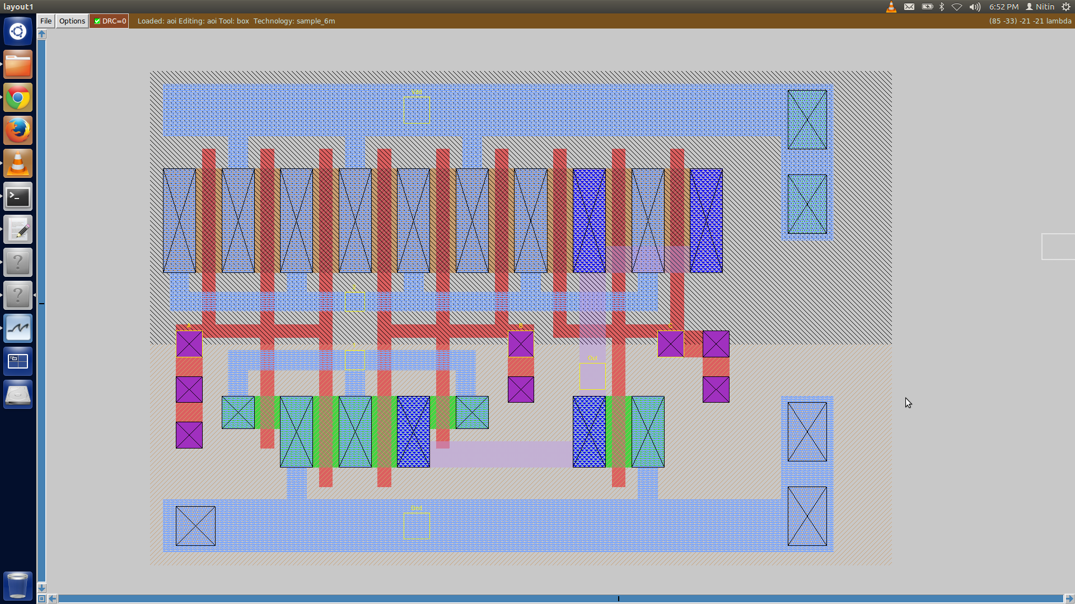 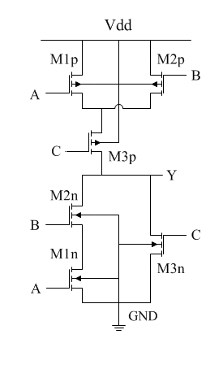

Figure 6: Layout of the AOI21X1 in MAGIC(left) and its transistor level circuit diagram(right).

**Logic Expression: $Y=\overline{AB+C}$**

**Truth Table**

|  |  |  |  |
| --- | --- | --- | --- |
| A | B | C | Y |
| 0 | 0 | 0 | 1 |
| 0 | 0 | 1 | 0 |
| 0 | 1 | 0 | 1 |
| 0 | 1 | 1 | 0 |
| 1 | 0 | 0 | 1 |
| 1 | 0 | 1 | 0 |
| 1 | 1 | 0 | 0 |
| 1 | 1 | 1 | 0 |

**Port Definitions**

|  |  |
| --- | --- |
| A | Input |
| B | Input |
| C | Input |
| Y | Output |

**Transistor sizing:** ($Wn/Ln$)

1. Initial sizing: To match the pull up and pull down resistance to that of a reference inverter.
   1. M1p: $40λ/2λ$
   2. M1n: $20λ/2λ$
   3. M2p: $40λ/2λ$
   4. M2n: $20λ/2λ$
   5. M3p: $10λ/2λ$
   6. M3n: $40λ/2λ$
2. After iteration to optimize rise/fall times:
   1. M1p: $48λ/2λ$
   2. M1n: $16λ/2λ$
   3. M2p: $48λ/2λ$
   4. M2n: $16λ/2λ$
   5. M3p: $48λ/2λ$
   6. M3n: $11λ/2λ$

**Width of the standard cell**: $102λ$

**Timing characterization (all delays are in ns)**

|  |  |  |  |  |  |  |
| --- | --- | --- | --- | --- | --- | --- |
|  | A:0 to 1, B = 1, C =0 | | | A:1 to 0, B = 1, C =0 | | |
| $T↓$ ${\backslash C}_{L}→$ | 0.005pF | 0.025pF | 0.15pF | 0.005pF | 0.025pF | 0.15pF |
| 0.06ns | 0.0607 | 0.0943 | 0.2903 | 0.0604 | 0.0933 | 0.2932 |
| 0.42ns | 0.0812 | 0.1220 | 0.3230 | 0.0909 | 0.0132 | 0.3377 |
| 1.2ns | 0.1026 | 0.1587 | 0.3973 | 0.1361 | 0.1925 | 0.4355 |

|  |  |  |  |  |  |  |
| --- | --- | --- | --- | --- | --- | --- |
|  | B:0 to 1, A = 1, C =0 | | | B:1 to 0, A = 1, C =0 | | |
| $T↓$ ${\backslash C}_{L}→$ | 0.005pF | 0.025pF | 0.15pF | 0.005pF | 0.025pF | 0.15pF |
| 0.06ns | 0.0552 | 0.0889 | 0.2850 | 0.0511 | 0.0843 | 0.2838 |
| 0.42ns | 0.0927 | 0.1375 | 0.3390 | 0.0748 | 0.1199 | 0.3283 |
| 1.2ns | 0.1343 | 0.1956 | 0.4595 | 0.1008 | 0.1672 | 0.4225 |

|  |  |  |  |  |  |  |
| --- | --- | --- | --- | --- | --- | --- |
|  | C:0 to 1, A = 0 , B = 0 | | | C:1 to 0, A = 0 , B = 0 | | |
| $T↓$ ${\backslash C}_{L}→$ | 0.005pF | 0.025pF | 0.15pF | 0.005pF | 0.025pF | 0.15pF |
| 0.06ns | 0.005 | 0.025 | 0.15 | 0.0346 | 0.0595 | 0.2094 |
| 0.42ns | 0.0400 | 0.0743 | 0.2752 | 0.0652 | 0.1111 | 0.2800 |
| 1.2ns | 0.0692 | 0.1210 | 0.3319 | 0.0962 | 0.1665 | 0.4164 |

**Dynamic switching energy characterization (all entries are in pJ)**

|  |  |  |  |  |  |  |
| --- | --- | --- | --- | --- | --- | --- |
|  | A:0 to 1, B = 1, C =0 | | | A:1 to 0, B = 1, C =0 | | |
| $T↓$ ${\backslash C}_{L}→$ | 0.005pF | 0.025pF | 0.15pF | 0.005pF | 0.025pF | 0.15pF |
| 0.06ns | 0.02175 | 0.02243 | 0.02131 | 0.11507 | 0.18051 | 0.58664 |
| 0.42ns | 0.02247 | 0.01918 | 0.01766 | 0.11979 | 0.18309 | 0.58728 |
| 1.2ns | 0.05831 | 0.05116 | 0.03127 | 0.15953 | 0.21720 | 0.60639 |

|  |  |  |  |  |  |  |
| --- | --- | --- | --- | --- | --- | --- |
|  | B:0 to 1, A = 1, C =0 | | | B:1 to 0, A = 1, C =0 | | |
|  | 0.005pF | 0.025pF | 0.15pF | 0.005pF | 0.025pF | 0.15pF |
| 0.06ns | 0.02116 | 0.02084 | 0.02322 | 0.10059 | 0.16647 | 0.57425 |
| 0.42ns | 0.02175 | 0.01836 | 0.01723 | 0.10502 | 0.16860 | 0.57390 |
| 1.2ns | 0.05308 | 0.05005 | 0.02993 | 0.14193 | 0.19962 | 0.59092 |

|  |  |  |  |  |  |  |
| --- | --- | --- | --- | --- | --- | --- |
|  | C:0 to 1, A = 0 , B = 0 | | | C:1 to 0, A = 0 , B = 0 | | |
|  | 0.005pF | 0.025pF | 0.15pF | 0.005pF | 0.025pF | 0.15pF |
| 0.06ns | 0.0204 | 0.01772 | 0.01468 | 0.06867 | 0.1341 | 0.5419 |
| 0.42ns | 0.02162 | 0.01861 | 0.01382 | 0.07959 | 0.14132 | 0.54324 |
| 1.2ns | 0.05354 | 0.04652 | 0.02872 | 0.11541 | 0.17267 | 0.56141 |

**Static Power Dissipation:**

|  |  |  |  |
| --- | --- | --- | --- |
| A | B | C | Static Power (pW) |
| 0 | 0 | 0 | 53.3228 |
| 0 | 0 | 1 | 41.5181 |
| 0 | 1 | 0 | 98.6855 |
| 0 | 1 | 1 | 41.5181 |
| 1 | 0 | 0 | 101.51 |
| 1 | 0 | 1 | 41.5181 |
| 1 | 1 | 0 | 89.6182 |
| 1 | 1 | 1 | 27.4454 |
| Average Static Power | | | **61.892025** |

1. **DFFPOSX1**

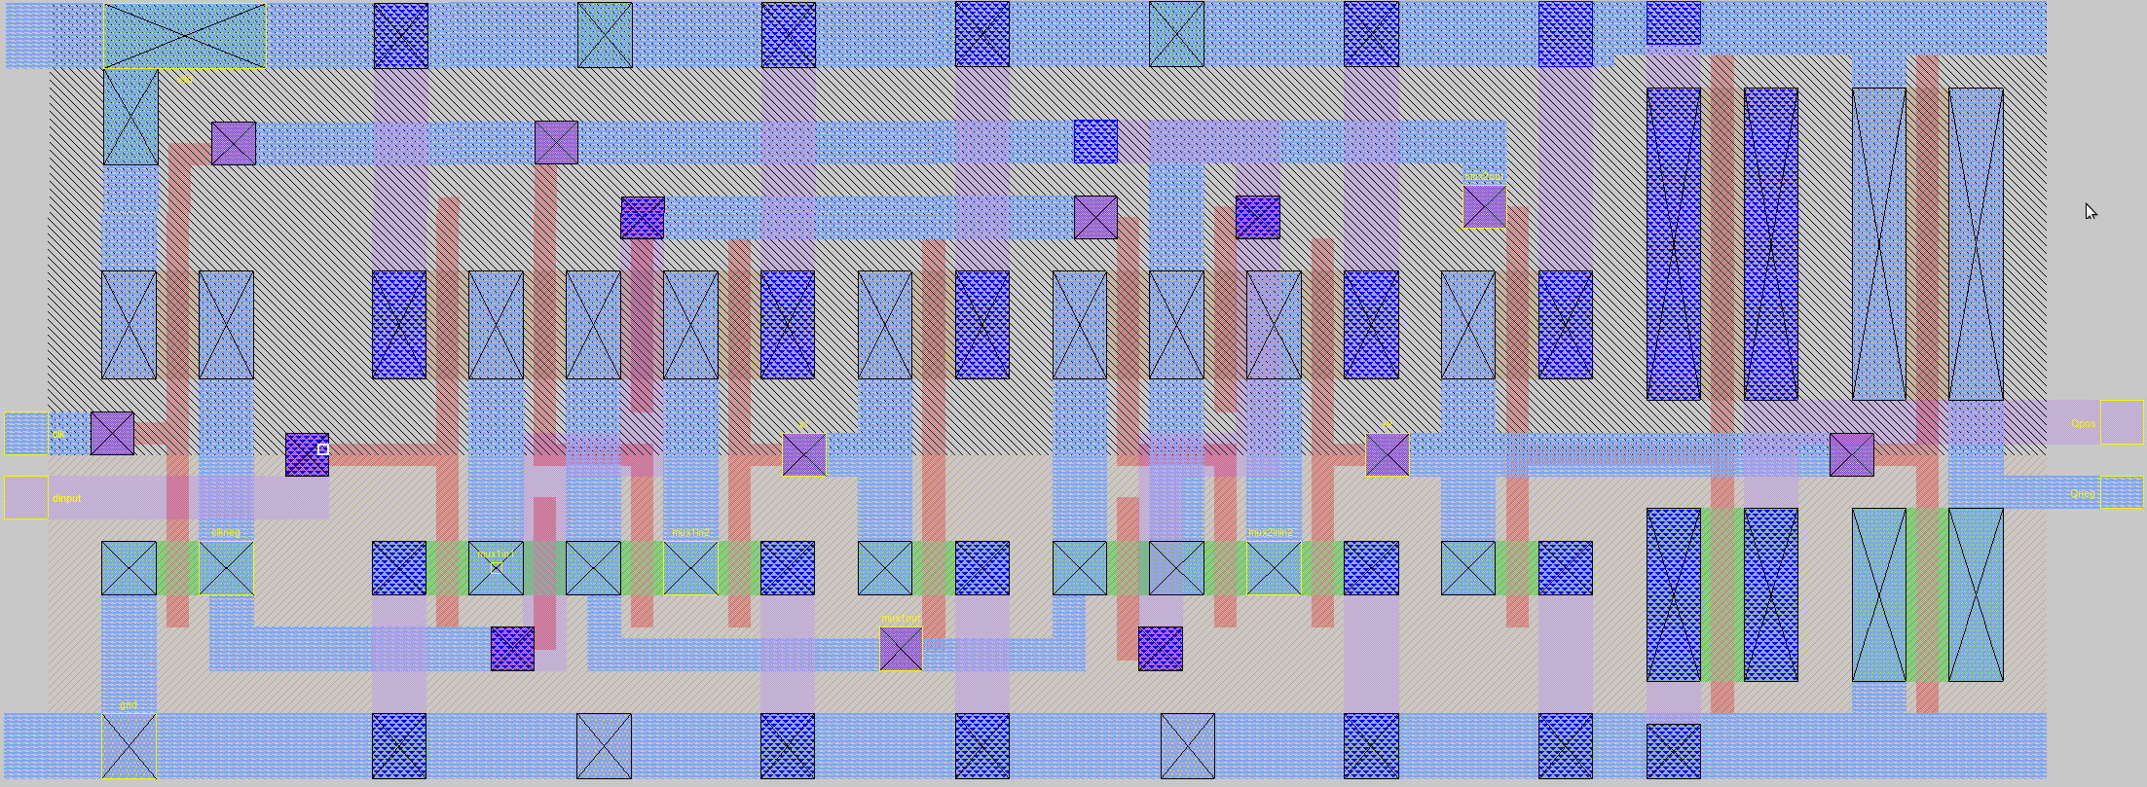

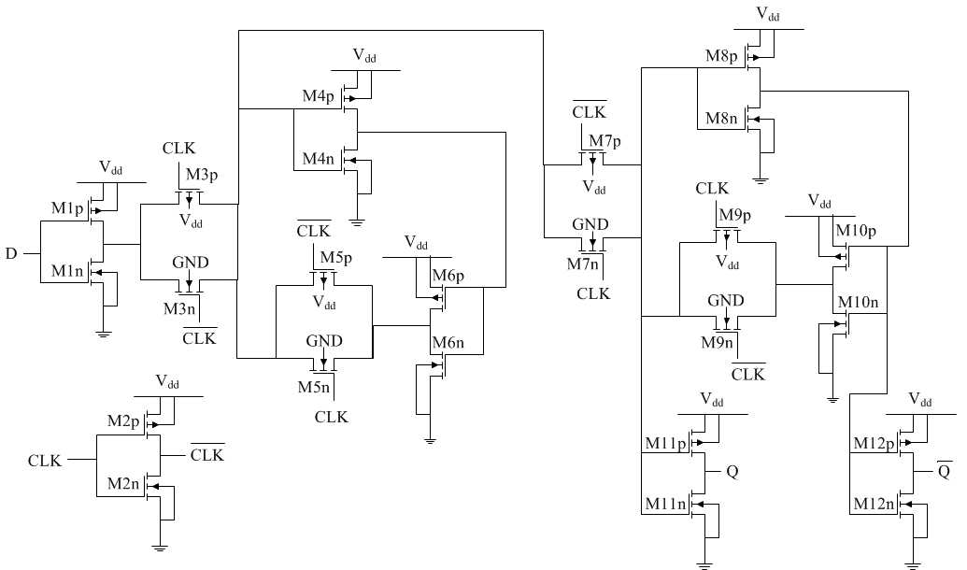

Figure 7: Layout of the DFFPOSX1 in MAGIC(top) and its transistor level circuit diagram(bottom).

**Function**

**FLIPFLOP{**

DATA=D

CLOCK=CLK

Q=DS0000

QN=P0002

}

Q=DS0000

**Static Power:**

|  |  |
| --- | --- |
| **When** | **Static Power [nW]** |
| **CLK=0; D=0** | 0.374 |
| **CLK=0; D=1** | 0.262 |
| **CLK=1; D=0** | 0.502 |
| **CLK=1; D=1** | 0.369 |
| **Average** | 0.37675 |

**Port:**

|  |  |  |  |
| --- | --- | --- | --- |
| **Pin** | **Direction** | **Signal type** | **Polarity** |
| **CLK** | INPUT | CLOCK | RISING_EDGE |
| **D** | INPUT | DATA | **-** |
| **Q** | OUTPUT | - | **-** |

|  |  |  |  |  |
| --- | --- | --- | --- | --- |
| **Name** | **Pin Capacitance [pF]** | | **Internal Power [pJ]** | |
| **Rise** | **Fall** | **Rise** | **Fall** |
| **CLK** |  |  |  |  |
| **D** |  |  |  |  |

**Output Driving Strength:**

|  |  |  |  |  |
| --- | --- | --- | --- | --- |
| **Name** | **Rise** | | **Fall** | |
| **Strength (sec/F)** | **Limit (pF)** | **Strength (sec/F)** | **Limit (pF)** |
| **Q** |  |  |  |  |

**(01CLK=>01Q)**

**DELAY [ns]**

|  |  |  |  |  |  |
| --- | --- | --- | --- | --- | --- |
| **Cl[pF] $→$** | 0.005 | 0.0125 | 0.025 | 0.075 | 0.15 |
| **ts(ns) $↓$** |
| 0.06 | 0.1490 | 0.1670 | 0.1945 | 0.2836 | 0.3987 |
| 0.24 | 0.1770 | 0.1952 | 0.2215 | 0.3108 | 0.4260 |
| 0.48 | 0.2106 | 0.2286 | 0.2555 | 0.3441 | 0.4590 |
| 0.9 | 0.2495 | 0.2468 | 0.2949 | 0.3847 | 0.5011 |
| 1.2 | 0.2704 | 0.2893 | 0.3169 | 0.4072 | 0.5237 |
| 1.8 | 0.3029 | 0.3232 | 0.3519 | 0.4440 | 0.5605 |

**ENERGY [pJ]**

|  |  |  |  |  |  |
| --- | --- | --- | --- | --- | --- |
| **Cl[pF] $→$** | 0.005 | 0.0125 | 0.025 | 0.075 | 0.15 |
| **ts(ns) $↓$** |
| 0.06 | 0.2070 | 0.2299 | 0.2686 | 0.4293 | 0.6729 |
| 0.24 | 0.2147 | 0.2375 | 0.2765 | 0.4367 | 0.6796 |
| 0.48 | 0.2355 | 0.2577 | 0.2958 | 0.4547 | 0.6969 |
| 0.9 | 0.2765 | 0.2974 | 0.3343 | 0.4910 | 0.7320 |
| 1.2 | 0.3071 | 0.3273 | 0.3634 | 0.5186 | 0.7589 |
| 1.8 | 0.3698 | 0.3887 | 0.4230 | 0.5756 | 0.8144 |

**(01CLK=>10Q)**

**DELAY [ns]**

|  |  |  |  |  |  |
| --- | --- | --- | --- | --- | --- |
| **Cl[pF] $→$** | 0.005 | 0.0125 | 0.025 | 0.075 | 0.15 |
| **ts(ns) $↓$** |
| 0.06 | 0.2173 | 0.2390 | 0.2693 | 0.3604 | 0.4699 |
| 0.24 | 0.2496 | 0.2713 | 0.3015 | 0.3929 | 0.5023 |
| 0.48 | 0.2824 | 0.3030 | 0.3321 | 0.4223 | 0.5313 |
| 0.9 | 0.3162 | 0.3349 | 0.3619 | 0.4486 | 0.5555 |
| 1.2 | 0.3202 | 0.3390 | 0.3660 | 0.4531 | 0.5598 |
| 1.8 | 0.3177 | 0.3365 | 0.3634 | 0.4503 | 0.5573 |

**ENERGY10 [pJ]**

|  |  |  |  |  |  |
| --- | --- | --- | --- | --- | --- |
| **Cl[pF] $→$** | 0.005 | 0.0125 | 0.025 | 0.075 | 0.15 |
| **ts(ns) $↓$** |
| 0.06 | 0.2382 | 0.2339 | 0.2283 | 0.2176 | 0.2154 |
| 0.24 | 0.2446 | 0.2410 | 0.2349 | 0.2257 | 0.2223 |
| 0.48 | 0.2528 | 0.2493 | 0.2435 | 0.2353 | 0.2325 |
| 0.9 | 0.2787 | 0.2748 | 0.2691 | 0.2614 | 0.2588 |
| 1.2 | 0.2991 | 0.2950 | 0.2895 | 0.2817 | 0.2790 |
| 1.8 | 0.3405 | 0.3366 | 0.3310 | 0.3234 | 0.3209 |

**Timing Constraints:**

**SETUP(01D=>01CLK)**

|  |  |  |  |  |
| --- | --- | --- | --- | --- |
| **re [ns] $→$** | **0.06** | **0.3** | **0.6** |  |
| **co [ns] $↓$** |
| 0.06 | 110 | 94 | 101 | 129 |
| 0.3 | 142 | 123 | 127 | 151 |
| 0.6 | 165 | 142 | 144 | 165 |
| 1.2 | 190 | 164 | 164 | 181 |

**SETUP(10D=>01CLK)**

|  |  |  |  |  |
| --- | --- | --- | --- | --- |
| **re [ns] $→$** | **0.06** | **0.3** | **0.6** | **1.2** |
| **co [ns] $↓$** |
| 0.06 | 149 | 198 | 241 | 312 |
| 0.3 | 200 | 249 | 290 | 361 |
| 0.6 | 252 | 302 | 342 | 412 |
| 1.2 | 333 | 386 | 426 | 497 |

**HOLD(01CLK=>01D)**

|  |  |  |  |  |
| --- | --- | --- | --- | --- |
| **re [ns] $→$** | **0.06** | **0.3** | **0.6** |  |
| **co [ns] $↓$** |
| 0.06 | -52 | -36 | -38 | -53 |
| 0.3 | -79 | -56 | -53 | -65 |
| 0.6 | -94 | -64 | -58 | -66 |
| 1.2 | -104 | -67 | -56 | -56 |

**HOLD(01CLK=>10D)**

|  |  |  |  |  |
| --- | --- | --- | --- | --- |
| **re [ns] $→$** | **0.06** | **0.3** | **0.6** | **1.2** |
| **co [ns] $↓$** |
| 0.06 | -114 | -148 | -183 | -242 |
| 0.3 | -164 | -197 | -231 | -293 |
| 0.6 | -212 | -244 | -279 | -345 |
| 1.2 | -287 | -319 | -354 | -425 |