SPORT AND PROTEST : VOCAB

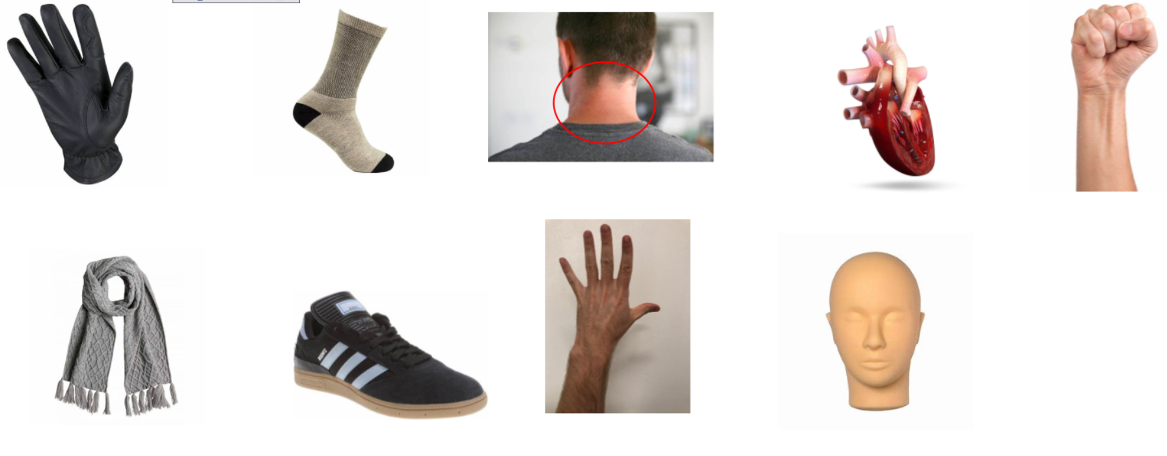

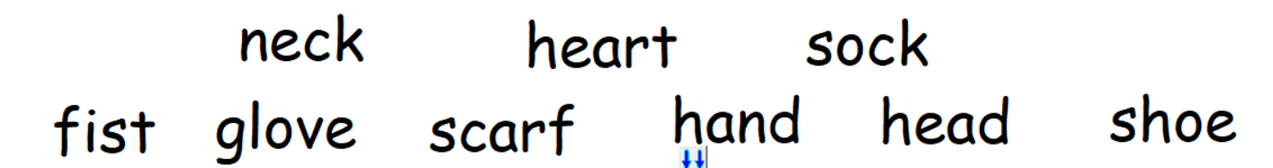
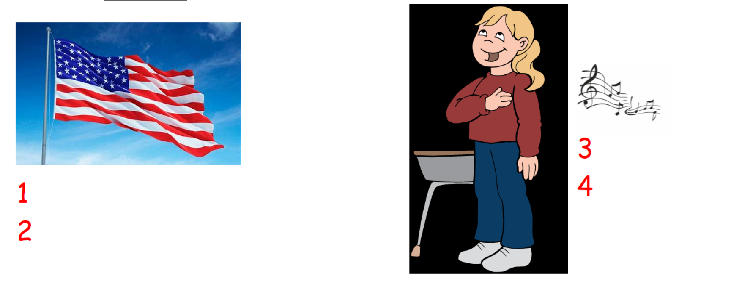
« Stars and Stripes » - the American flag – « The Star Spangled Banner » - The American anthem
MATCH THE WORDS AND THEIR TRANSLATION (as in the example)

