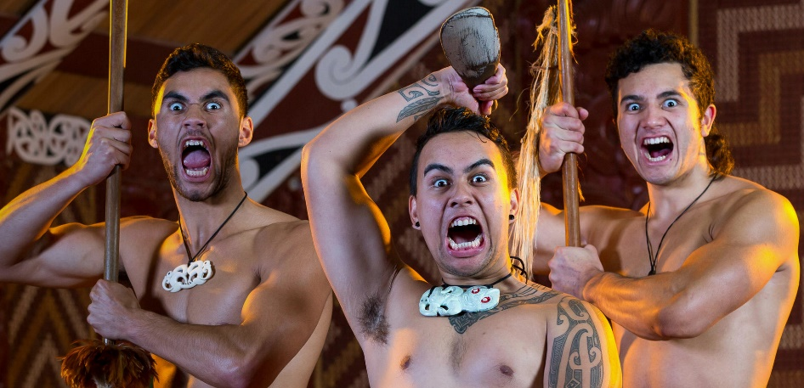
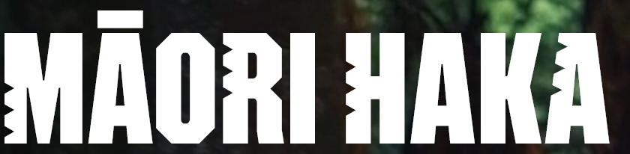
Traditionally, haka was a customary way to welcome visiting tribes, but it also served to invigorate warriors as they headed into battle. It was a show of physical prowess but also an embodiment of cultural pride, strength, and unity.
Although haka is the Māori word for dance, it is not a dance in the sense you might imagine. Usually performed in a group, it involves chanting and actions, such as stamping, hand movements, and facial gestures.
Haka varies by tribal region, with many haka telling the story of significant events in an iwi’s (tribe’s) history.
Today, haka is used as a sign of respect and is performed on important occasions, such as sporting events, weddings, funerals, and powhiri (a traditional welcome).
Ka Mate
Ka Mate is the haka often performed by the All Blacks. It begins with ‘Ka mate, ka mate, ka ora, ka ora’, which translates to ‘I die, I die, I live, I live.’ One can only imagine how Ngati Toa Chief Te Rauparaha felt when he first chanted these words 200 years ago. He had just evaded capture by a rival tribe and was given shelter by another tribe, who hid him underground in a kumara (sweet potato) pit. Ka mate tells this story, describing how Te Rauparaha shook off adversity to emerge from the darkness of the kumara pit into the light.
Te Rauparaha became a great Māori chief and warrior, helping to expand Ngāti Toa's territory across the lower North Island.
Vocabulary:
Capacité/talent |  | To head into battle
Force |  | Pride
La pénombre |  | To welcome
Un trou/une fausse |  | A tribe
Se débarasser |  | Feel/felt/felt

