CAPSTONE PROJECT WEEKLY ACCOMPLISHMENT REPORT

Team Name: ____________________ Section: ________ Date: ____________
Project Title: __________________________________________________________________

Accomplishment for the Week

Task / Activity | Description of Work Done | Output / Evidence
Revision of Concept Paper | The team revised the concept paper to align with the recommendations from the concept hearing. Machine Learning integration was added to improve the system’s analytical capabilities. | 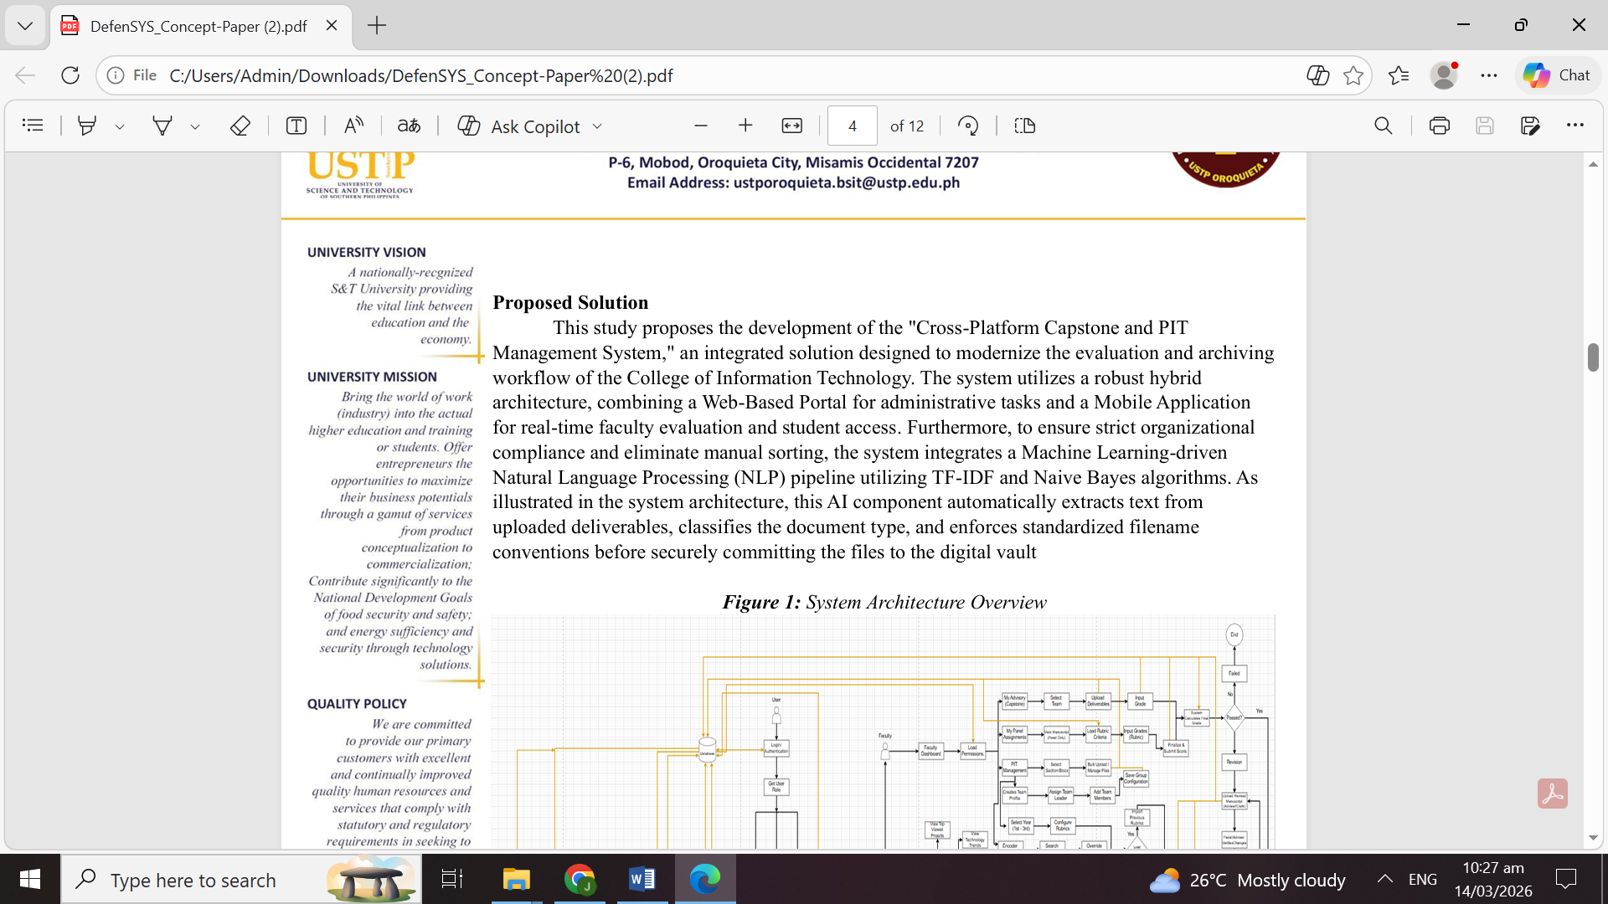
Revision of Chapter 1 | Chapter 1 of the research paper was revised to incorporate Machine Learning components such as TF-IDF and Naive Bayes algorithms for project classification and analysis. | 
ERD Enhancement | Additional tables and relationships were added to the Entity Relationship Diagram (ERD) to better represent the database structure of the repository system.
System Architecture Revision | The system architecture was altered to include the Machine Learning processing component, showing how data flows through the system and interacts with the ML module. | 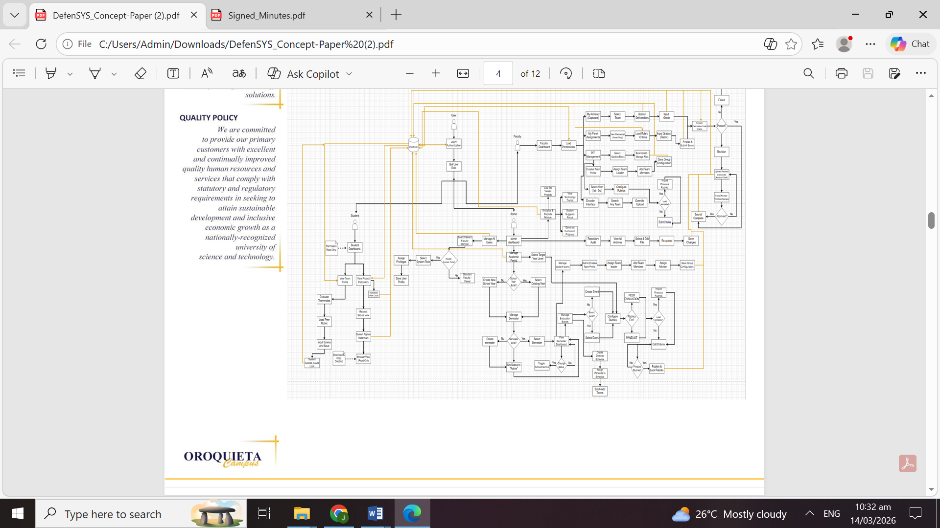
Development of Chapter 2 | The team began and completed the draft of Chapter 2 (Review of Related Literature and Studies) to support the research framework and technical background of the system. | 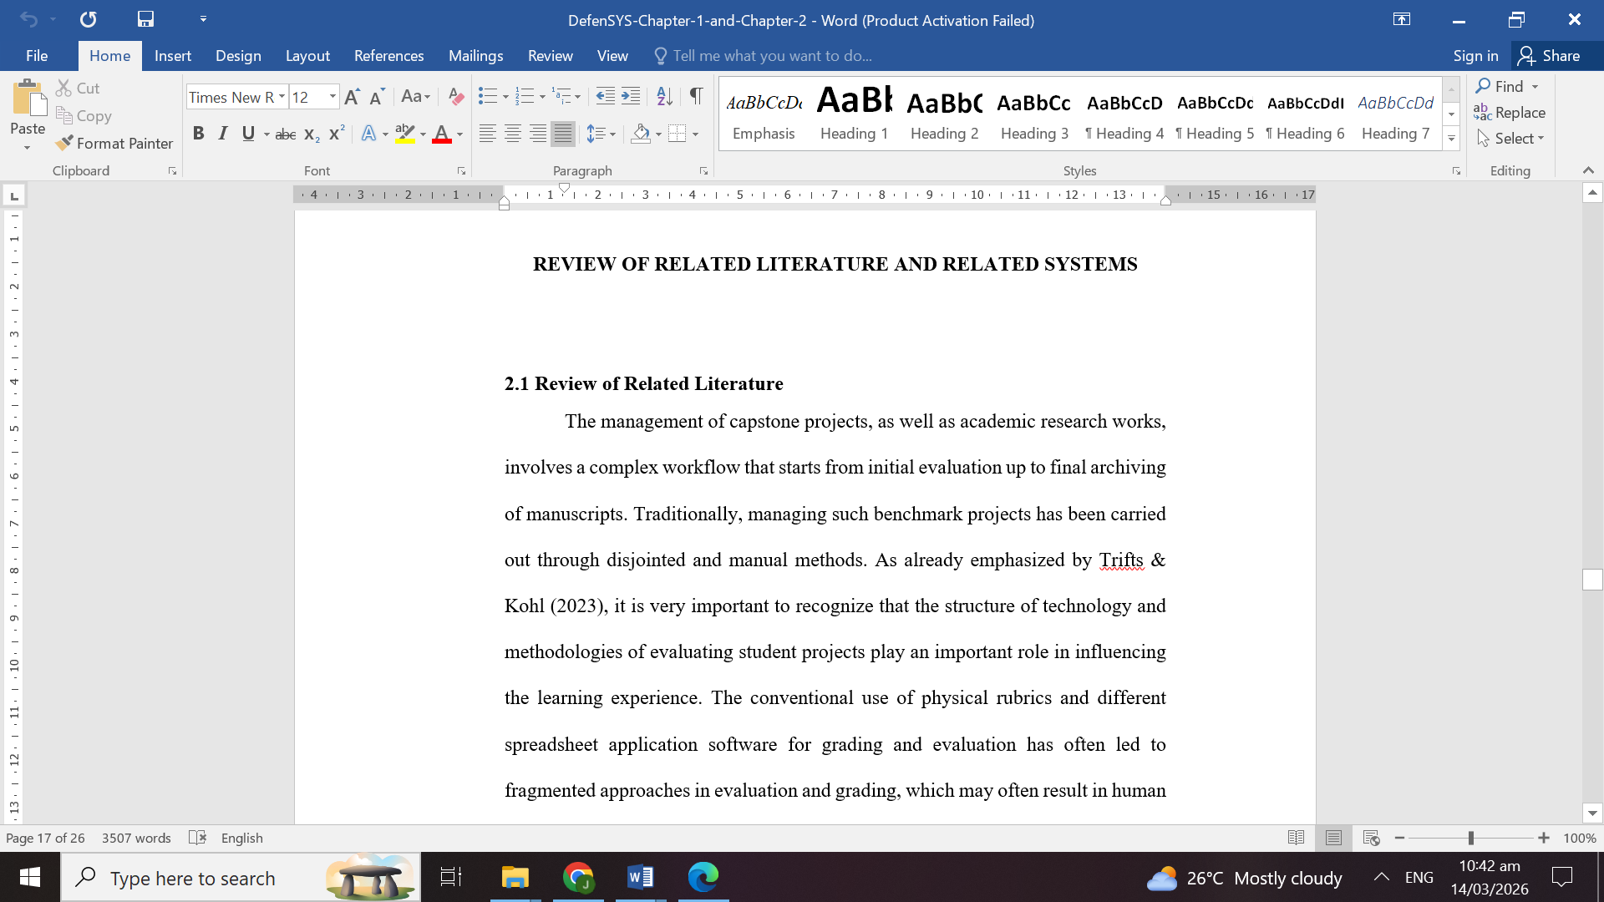
Documentation of Defense Minutes | The Minutes of Defense were prepared and documented based on the panel feedback to ensure all revisions were properly recorded. | 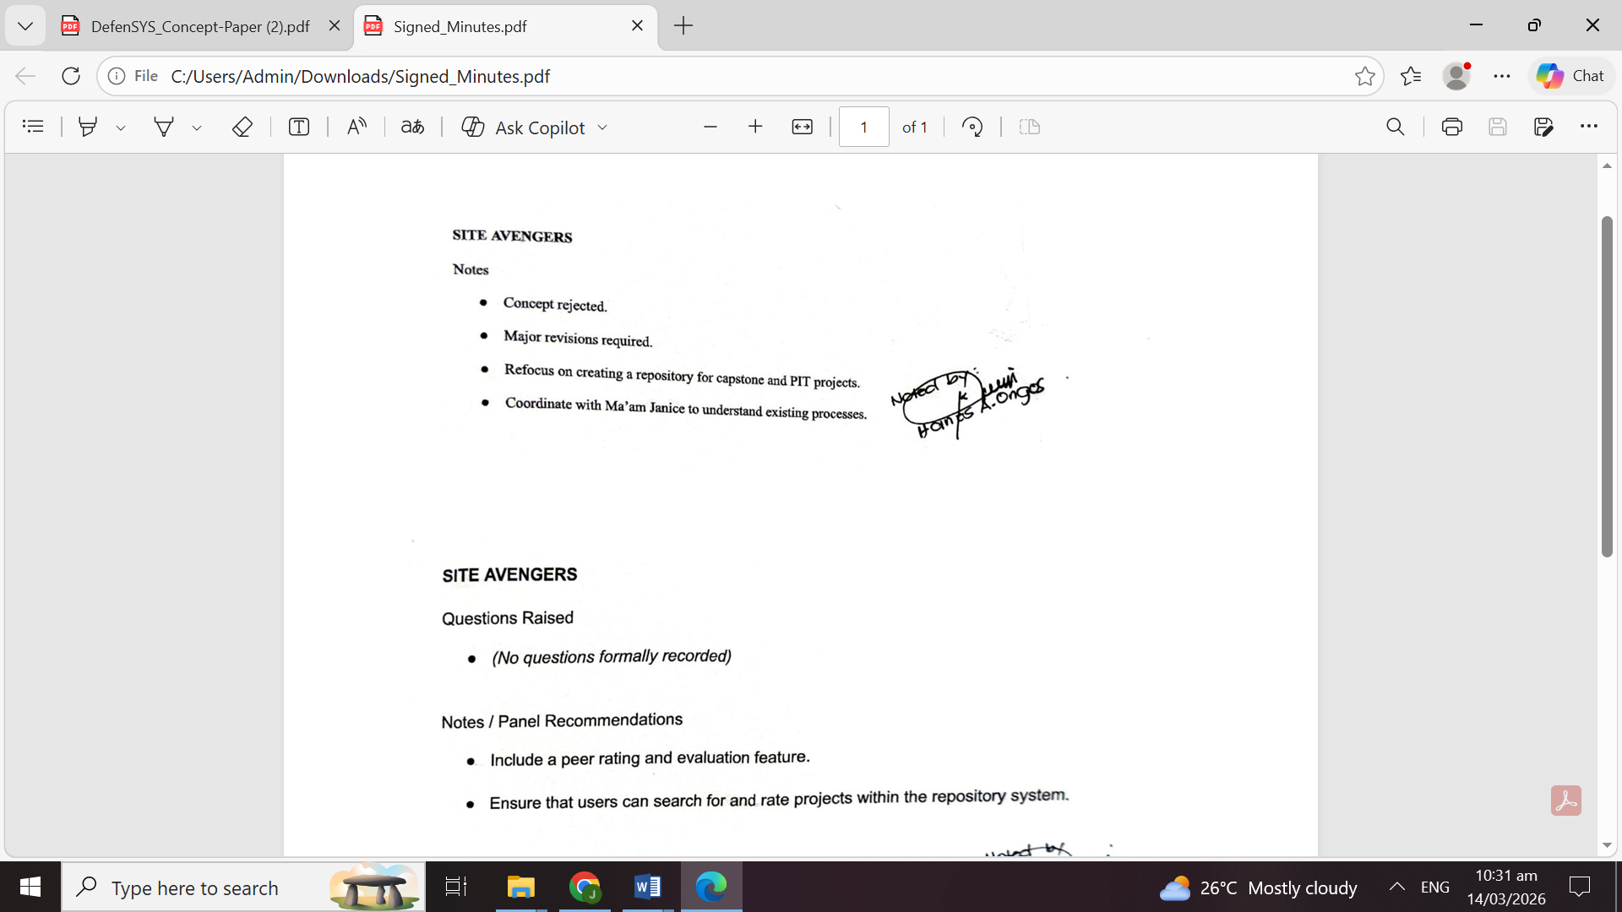

Individual Contribution

Team Member | Contribution
Jazh tene D. Orale | Revised Concept Paper and Chapter 1
Vince Rey Claveria | Implemented Machine Learning description (TF-IDF and Naive Bayes)
Alyssa Mae Rodriguez | Updated ERD and system architecture
Alwina Bacaling | Prepared Chapter 2 and documented defense minutes

Issues Encountered and Actions Taken

Issue/Concern | Action Taken / Resolution
Adjusting system design to include Machine Learning components | Revised system architecture and research chapters to properly integrate ML algorithms
Aligning research chapters with panel recommendations | Reviewed panel comments and updated relevant sections of the document

Plan for the Next Week

Planned Task | Expected Output
Continue development of Chapter 3
Refine system architecture and database design | Finalized diagrams
Start system interface prototype | 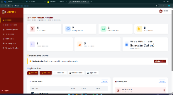

Adviser’s Remarks

Reviewed by:

Capstone Project Adviser
Date Signed:

Note:

- This report shall be submitted weekly to the Capstone Adviser.
- All members must actively contribute and be reflected in the report.
- Supporting evidence (screenshots, documents, commitments, etc.) may be attached.
- Submission of this report forms part of the progress monitoring and individual assessment of the Capstone Project.

