Gebze Technical University
Computer Engineering

CSE 222
2017 Spring

HOMEWORK 1 REPORT

ORHAN ÇELİK
151044097

Course Assistant:
1. System Requirements

MİNİMUM.

2. Use Case Diagrams

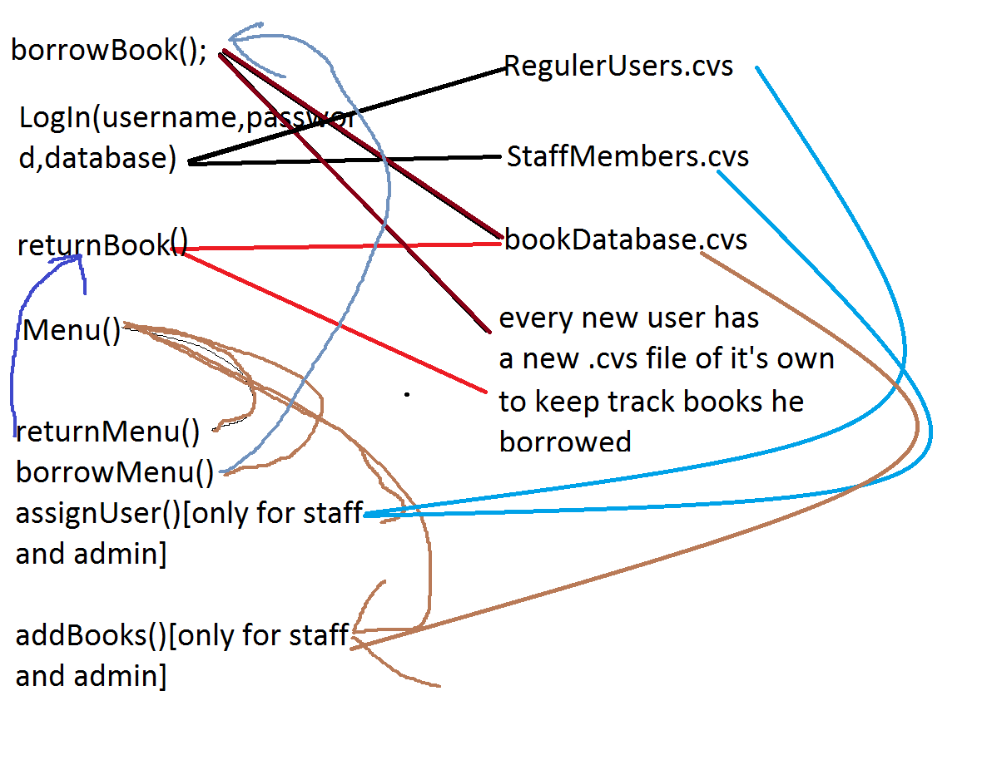

3. Class Diagrams

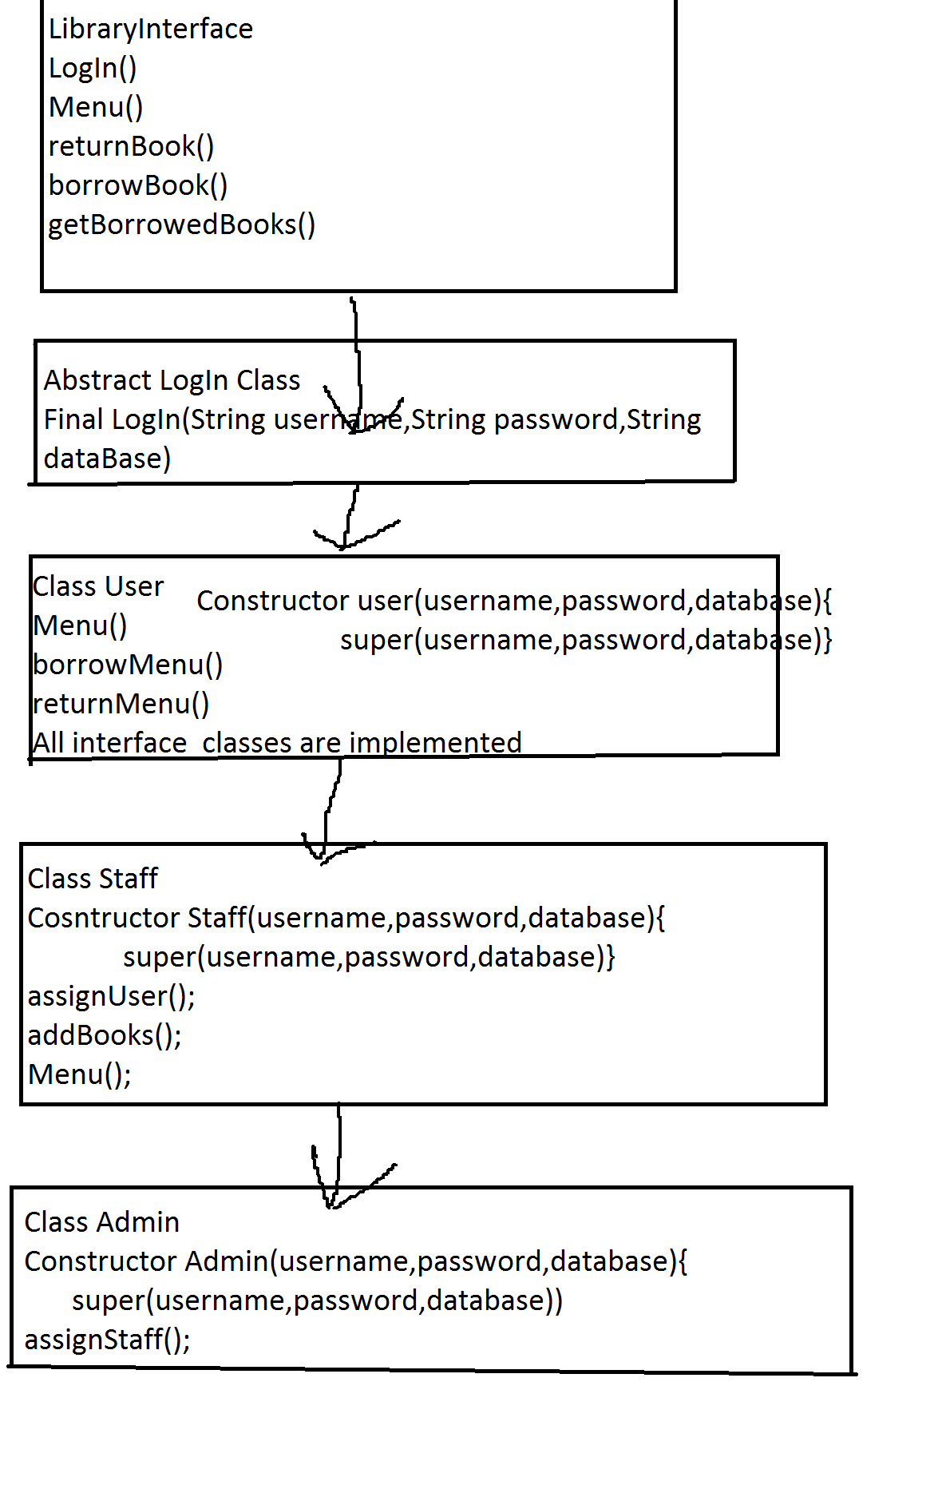

5. Problem Solutions Approach

THERE IS 3 TYPE OF USERS.REGULER,STAFF AND ADMİN.ADMİN CAN ASSİGN STAFF AND USERS,STAFF CAN ASSİGN REGULAR USER and add books,USERS ONLY BORROW BOOKS AND RETURN THEM.STAFF CAN ADD BOOKS SO DOES ADMIN.

EVERY NEW MEMBER WİLL HAVE ITS OWN CVS FILE TO KEEP TRACK OF THE BOOKS HE BORROWED.
THE IS 4 MAIN CVS DATABASE.

REGULERUSERS.CVS, STAFFMEMBERS.CVS, ADMIN.CVS, BOOKDATABASE.CVS.

6. Test Cases

THERE ARE PICTURES IN THE FILE.

7. Running and Results

THERE ARE PICTURES IN THE FILE.

