Test Case – Req Linker Guide

Authors: Orhan Ozdemir

Snapshot Version: Current

Extraction Date: February 24, 2025

Procedure for linking multiple requirements
- Enter User Name
- Enter Password
- Login
- Get project list from server
- Enter the test case number
- Get the list of of the existing requirements
- Enter list of requirements or single requirement
- Add requirements to the list of requirements to be linked
- Link the requirements
The visuals are shown in the tool.
The purpose of this tool is to create a light weight tool to speed up the linking process of the requirements to the test cases. Test case can be any type Unit, Integration or Qualification.

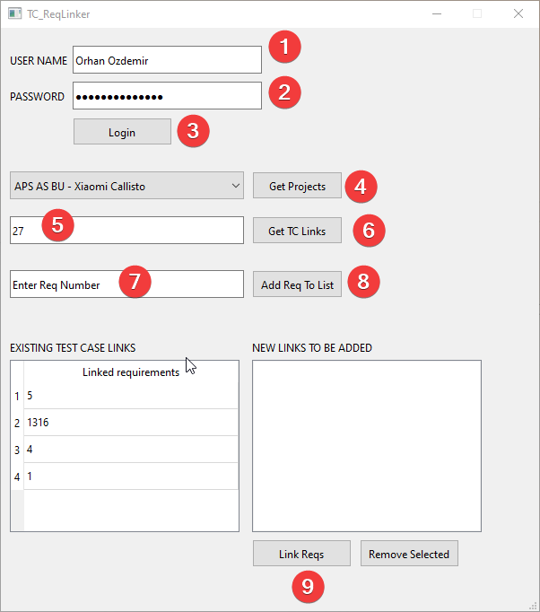

Procedure for getting linked requirements information of a test case
- Enter User Name
- Enter Password
- Login
- Get project list from server
- Select the project from the list
- Enter the test case number
- Get the list of of the existing requirements linked to test case
- Get the requirement information
- Filter requirements using tags or other keywords

