## INTRODUCTION

In this project used .Net 6.0, .Net Core Web App, N-Tier architecture, IOC container(Autofac), Unit Test (XUnit), RabbitMQ technologies.

**Configr.WebApp** MVC wep app for crud operations.

**Configr.ConfigurationReaderLibrary** class library for get and cache data by construction parameters.

**Configr.ConfigurationReaderLibrary.ConsoleApp** for using class library and get data.

**Configr.WebApp.Test** for web app unit test. Test cases were not written for all methods because there aren't any conditions in the other action methods.

In the Infrastructure folder used n-tier layer for crud operations.

RabbitMQ implementation was done. when some crud operations were done, in the class library data dynamically must be changed even if the allotted time has not expired.

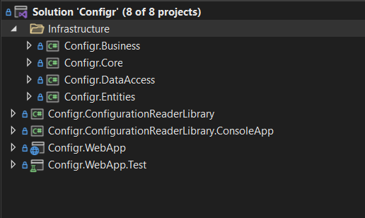

**To use the application**

1. Can be used the project by downloading the <https://github.com/orhanrecep90/Configr> github repository.
2. Run the below script for table creation.

create table ConfigurationDatas

(

ID int IDENTITY(1,1) primary key,

Name nvarchar(50) not null,

Type nvarchar(50) not null,

Value nvarchar(50) not null,

IsActive bit not null,

ApplicationName nvarchar(50) not null

)

1. Set the Configr.DataAccess class library ConfigrContext connection string by your MSSQL environment

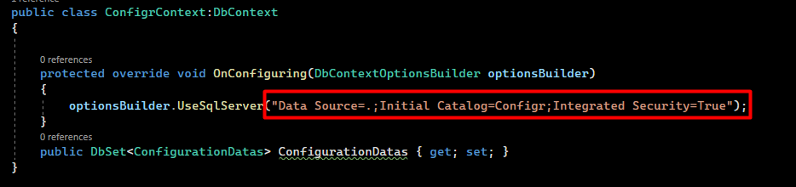

1. RabbitMQ server is active when the project is submitted. But if you want to use another server you must set the ConnectionFactory new Uri.

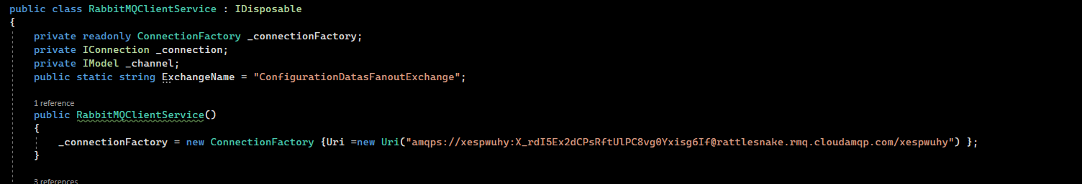

1. Configr.WepApp and Configr.ConfigurationReaderLibrary.ConsoleApp must be run as multiple projects.

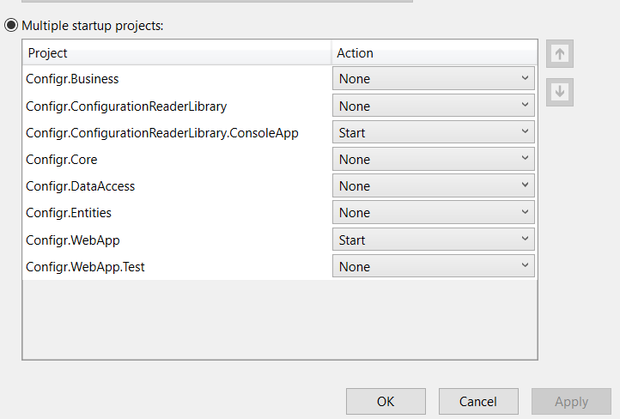

1. In the Program.cs file you can use the ConfigurationReader with own constructer parameters.



**Program Screens**

