SUPPLEMENTARY DATA
Comparative study on the pyrolysis behaviors of rice straw under different washing pretreatments of water, acid solution, and aqueous phase bio-oil by using TG-FTIR and Py-GC/MS
Dengyu Chen^{a,b,c}, Yun Wangª, Yixuan Liu^{d}, Kehui Cenª, Xiaobing Caoª, Zhongqing Ma^{b*}, Yanjun Li^{c*}
ª College of Materials Science and Engineering, Nanjing Forestry University, Nanjing, Jiangsu, 210037, China
^{b} School of Engineering, Zhejiang Provincial Collaborative Innovation Center for Bamboo Resources and High-Efficiency Utilization, Zhejiang A & F University, Hangzhou, Zhejiang 311300, China
^{c} Bamboo Engineering Research Center, Nanjing Forestry University, Nanjing, Jiangsu, 210037, China
^{d} College of Chemical Engineering, Nanjing Forestry University, Nanjing, Jiangsu, 210037, China
*Corresponding author: Zhongqing Ma; Yanjun Li
E-mail address: mazq@zafu.edu.cn; liyjnjfu@163.com

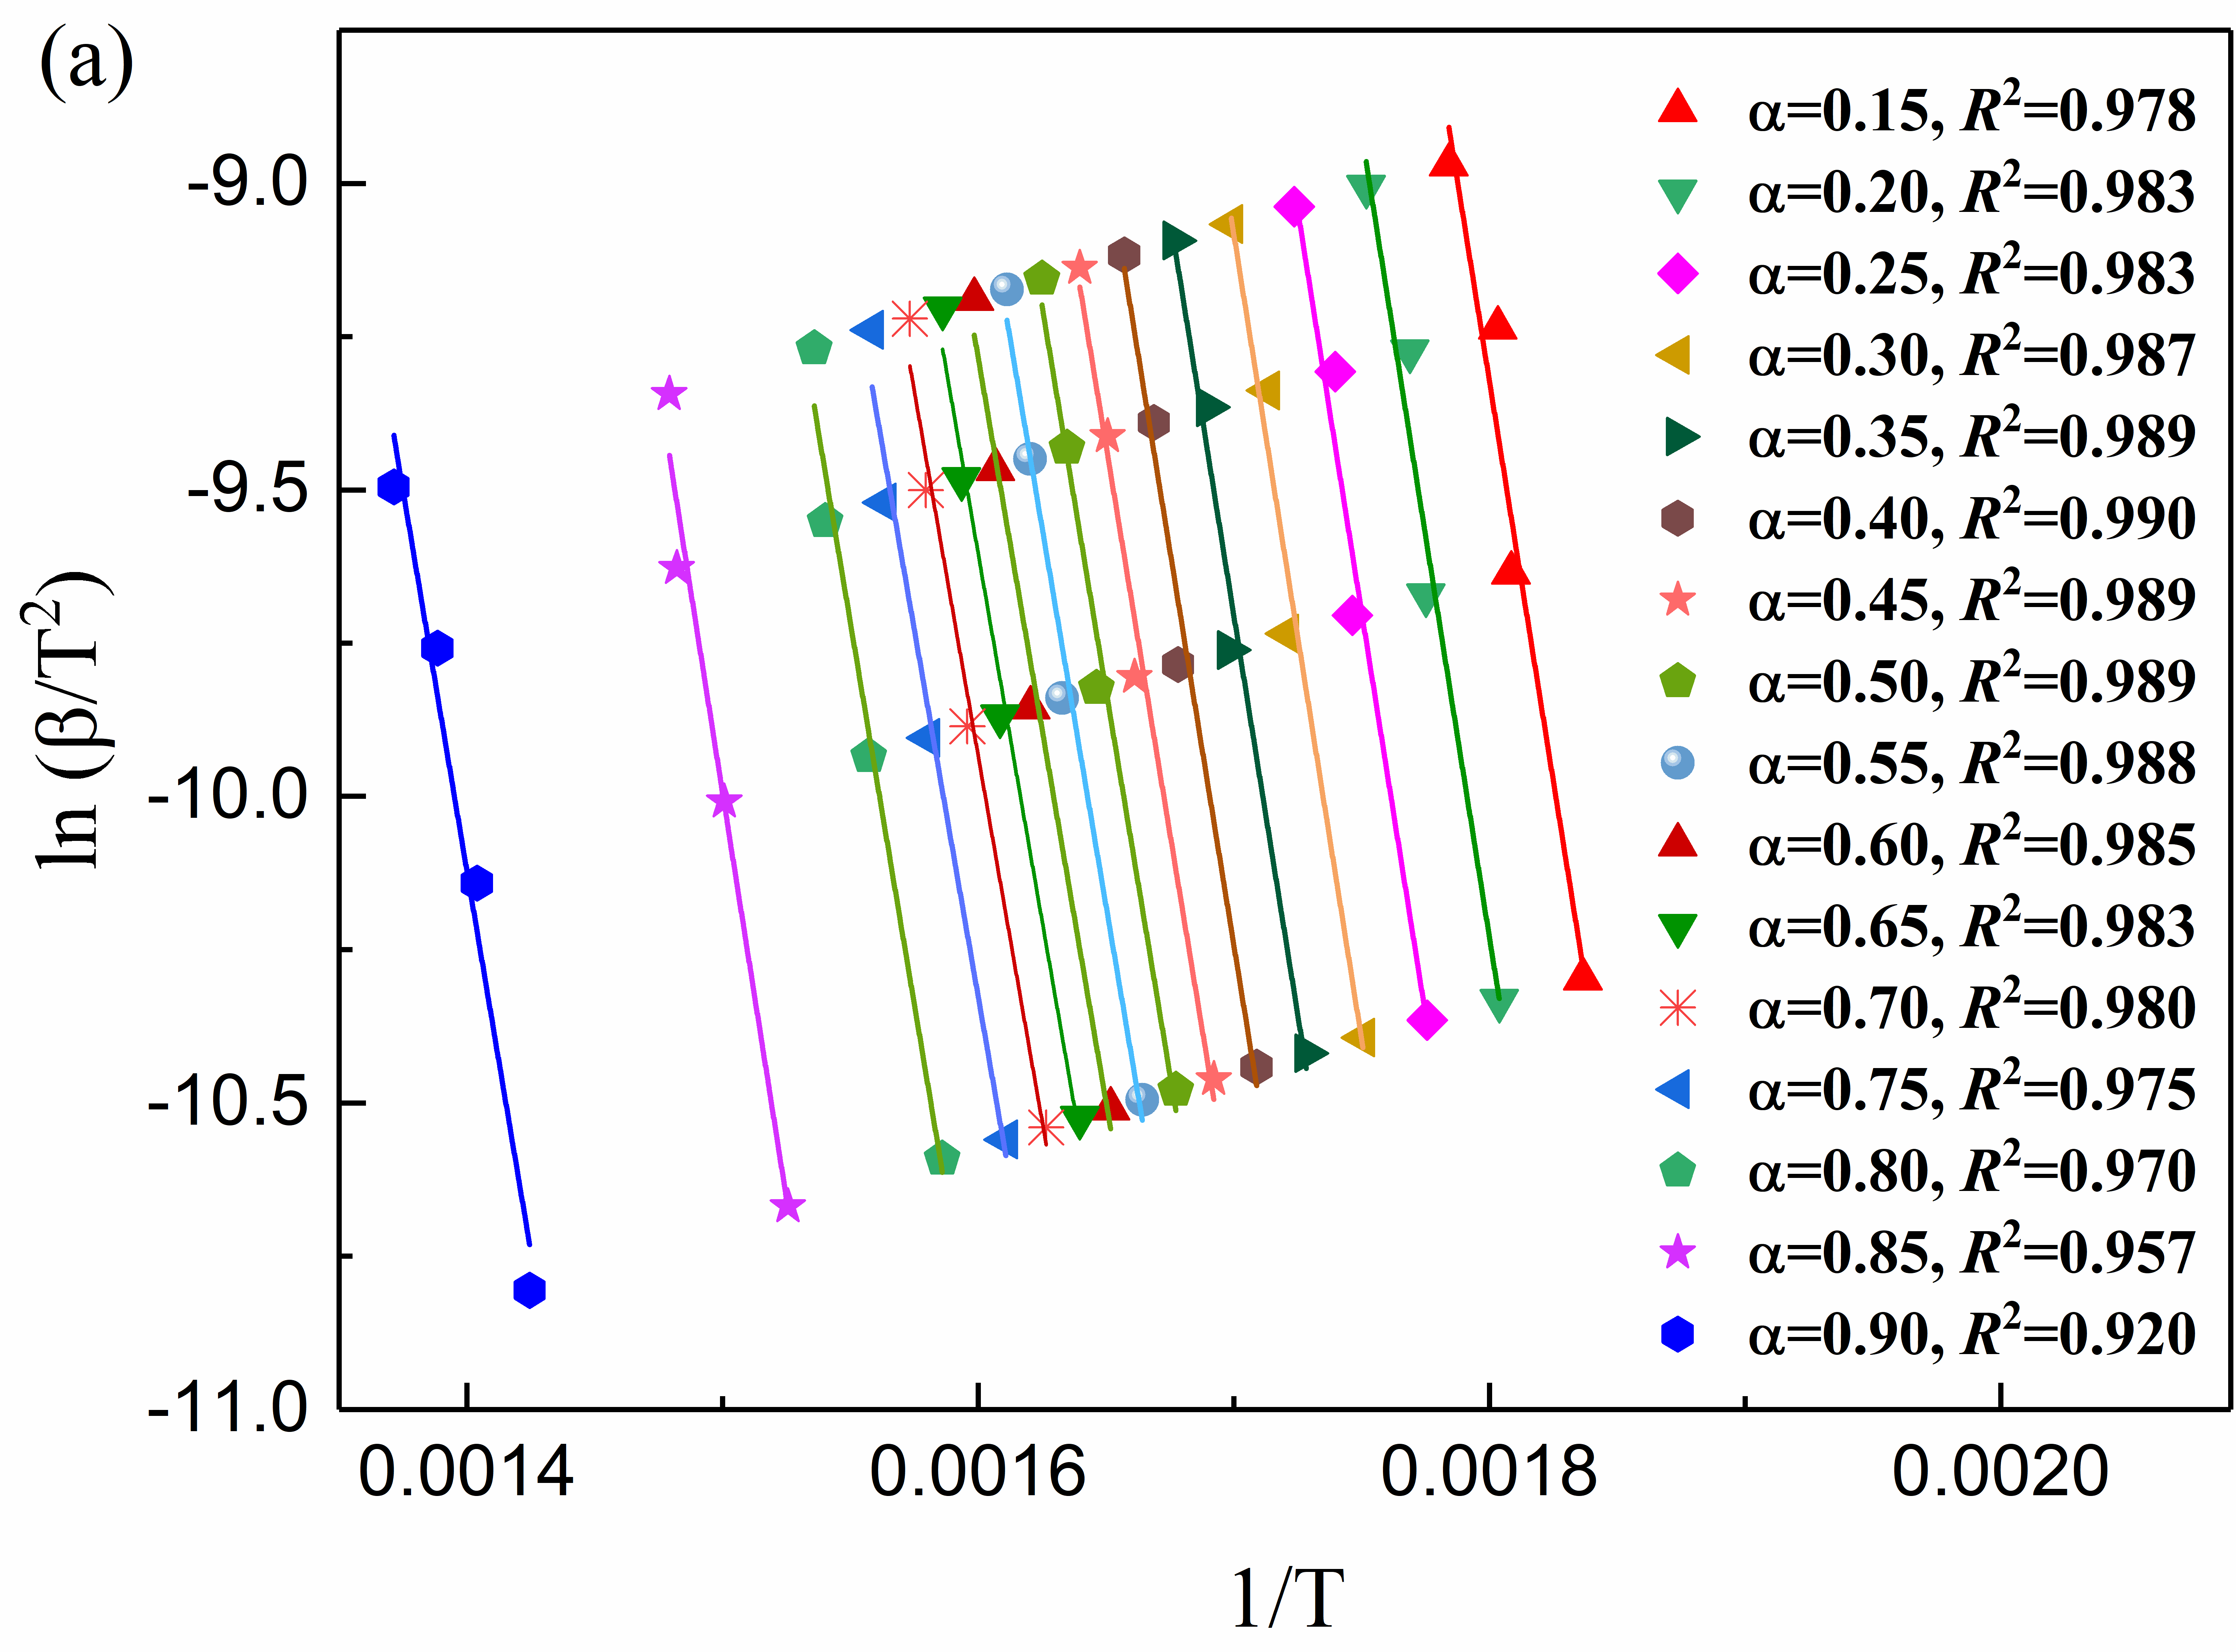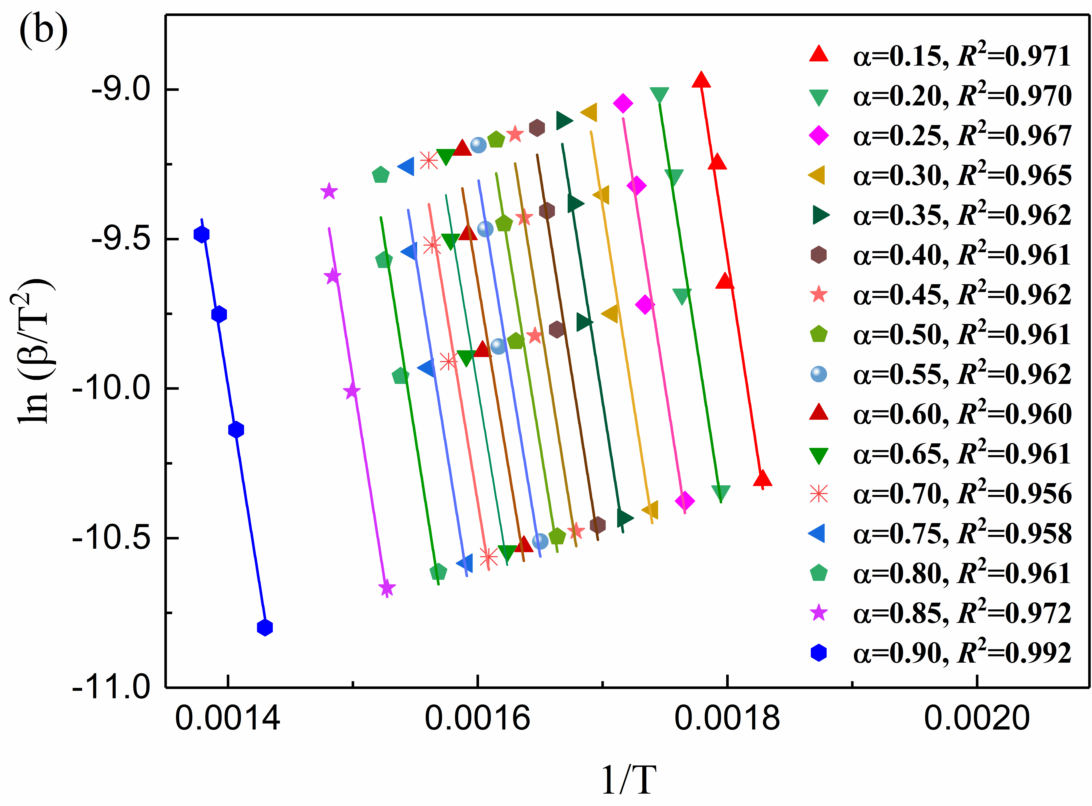
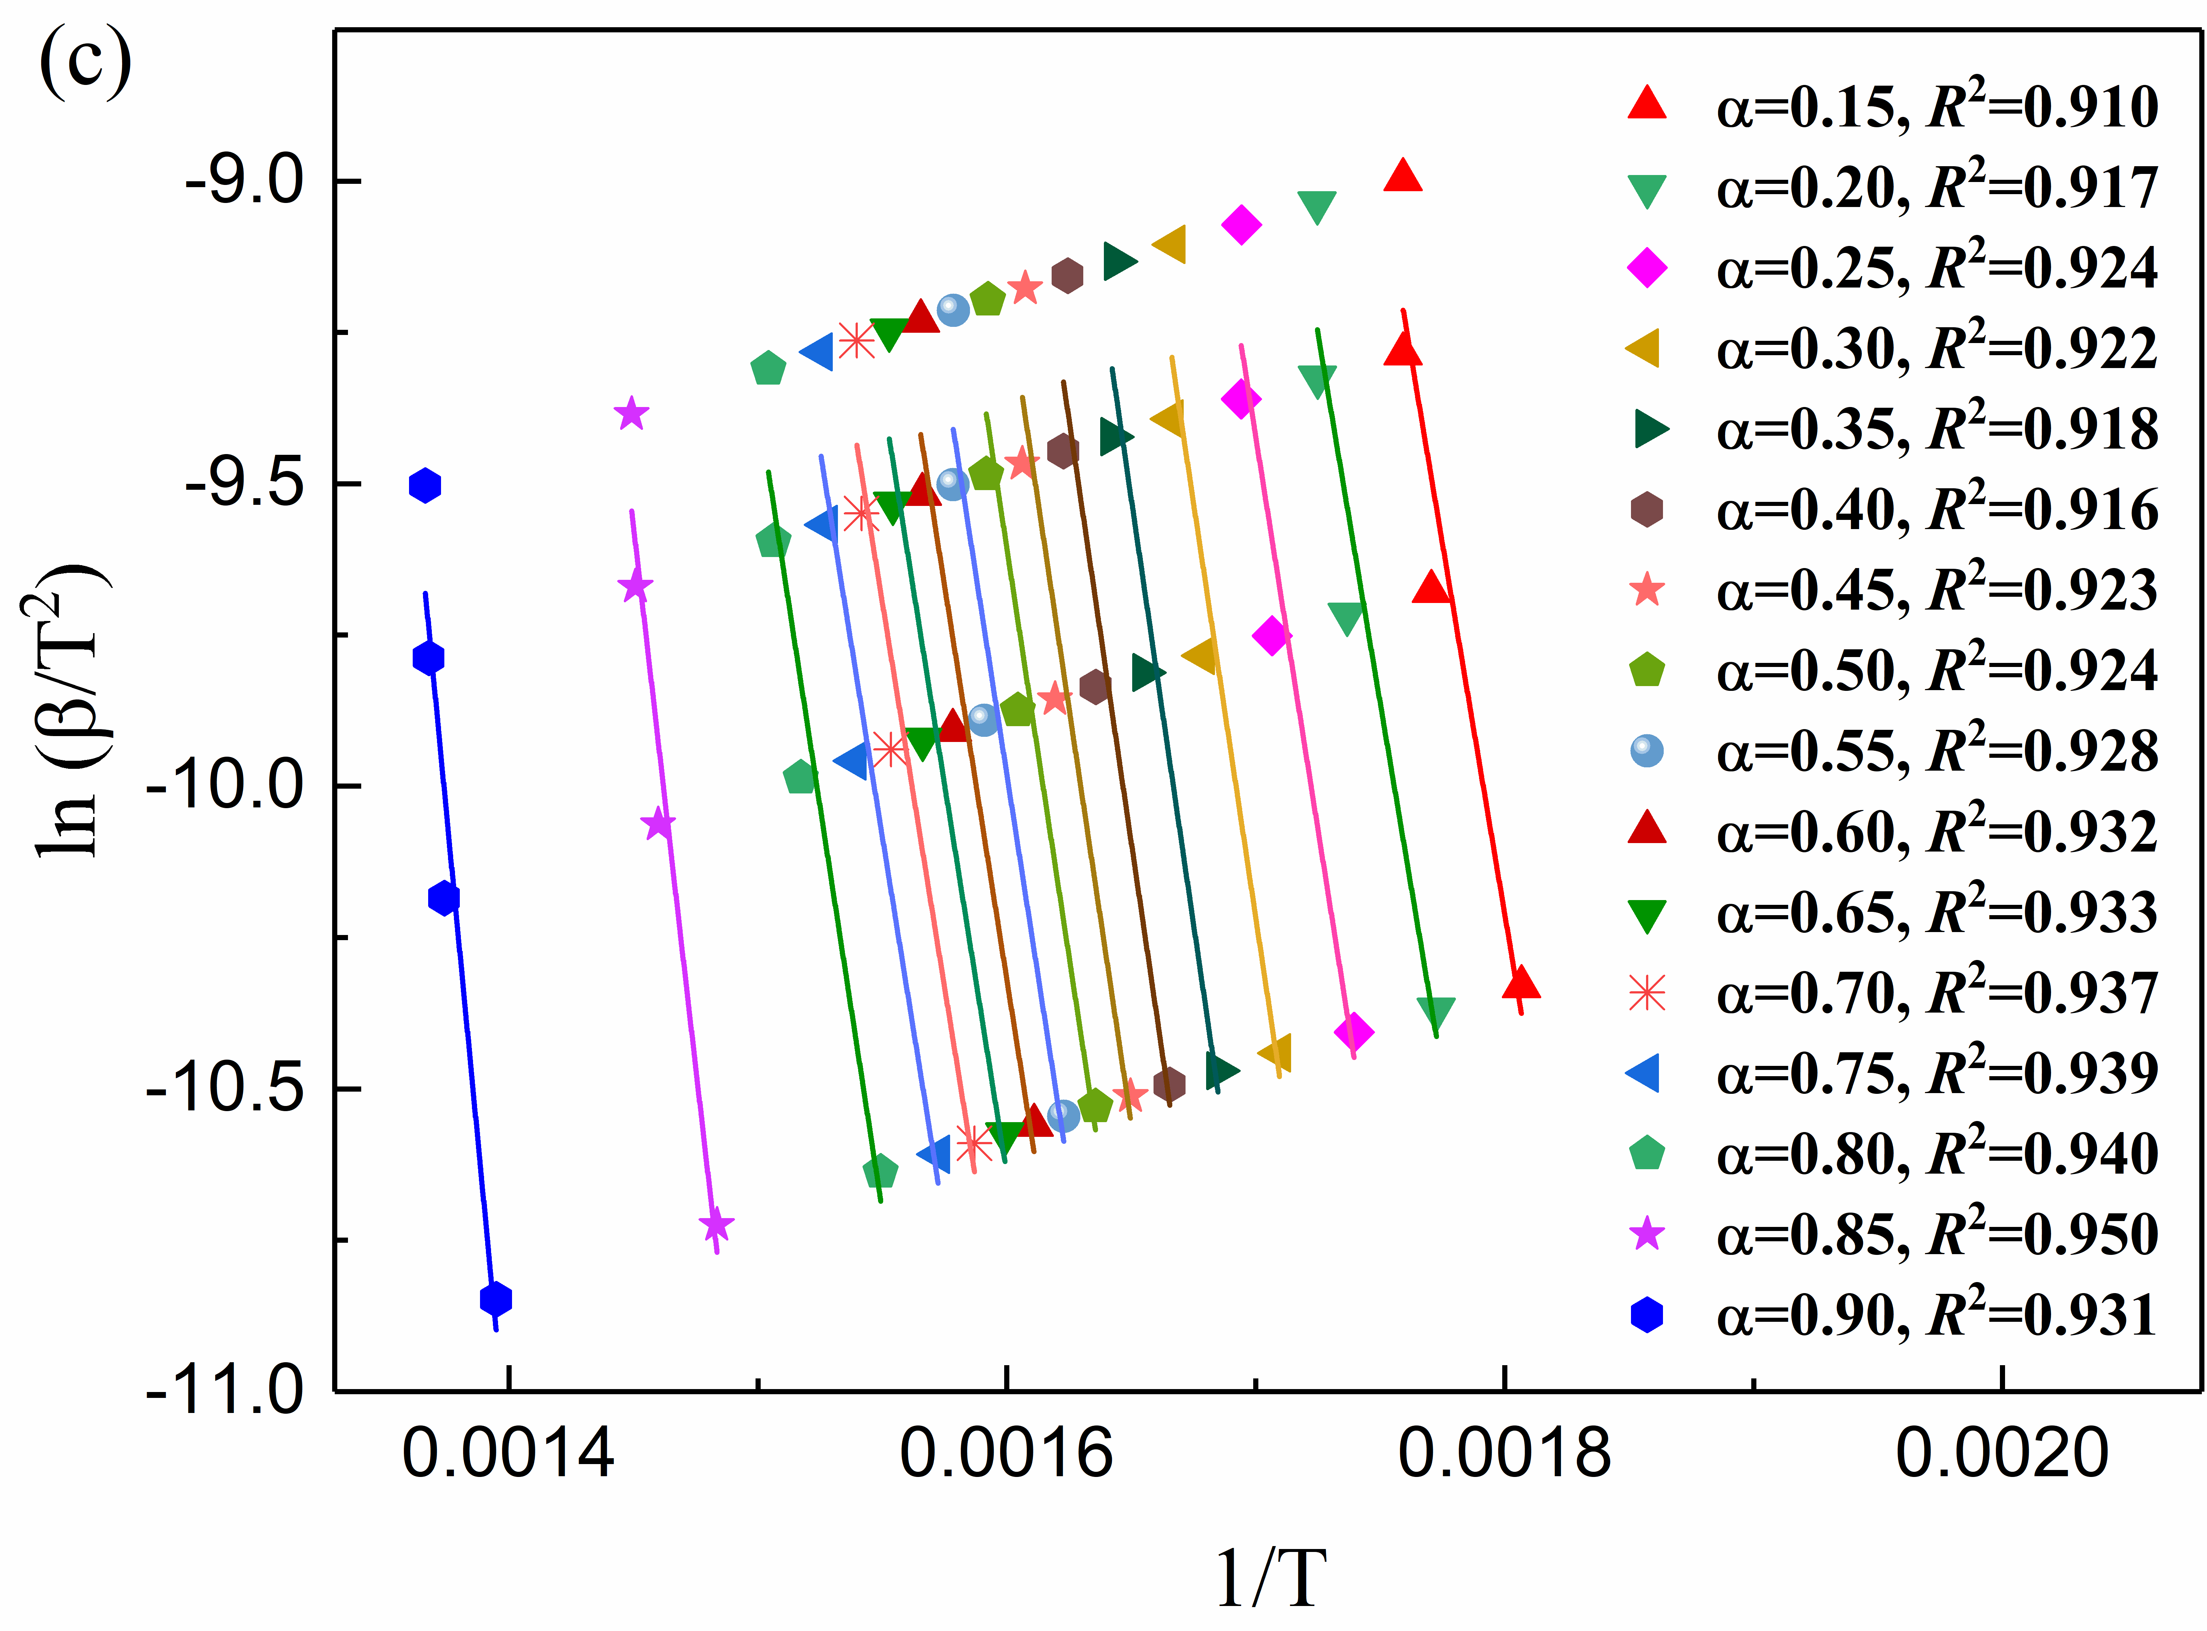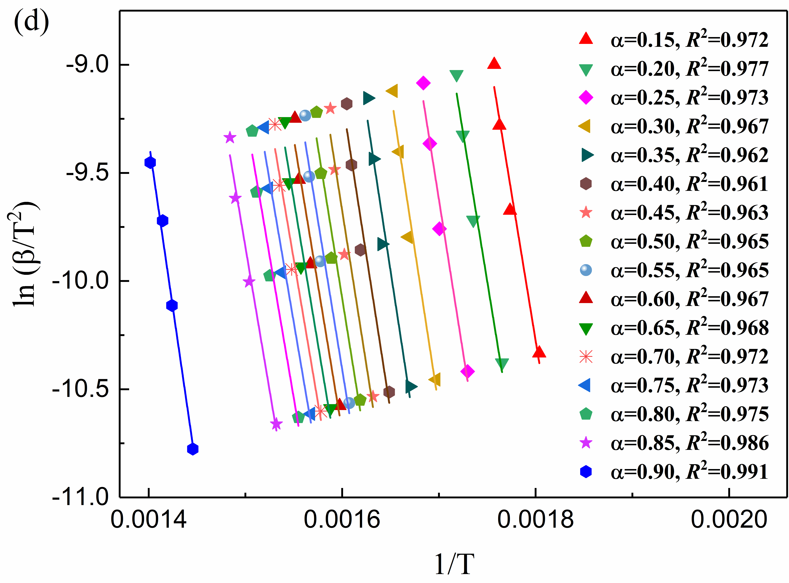
Fig. S1. Arrhenius plot of ln(β/T²) vs. 1/T at selected ɑ values for Raw-RS (a), H₂O-RS (b), HCl-RS (c), and APBO-RS (d).

Table S1 Peak area% of compounds (above 0.5% peak area cutoff) of bio-oil generated from pyrolysis of Raw-RS, H₂O-RS, HCl-RS, and APBO-RS using Py-GC/MS
Compounds | Formula | Peak area%
Compounds | Formula | Raw-RS | H₂O-RS | HCl-RS | APBO-RS
Acids
Acetic acid | C₂H₄O₂ | 9.01 | 7.35 | 4.81 | 4.29
n-Hexadecanoic acid | C₁₆H₃₂O₂ | 3.16 | 2.79 | 1.52 | 1.57
Octadecanoic acid | C₁₈H₃₆O₂ | 3.08 | 2.13 | 1.38 | 1.26
Total |  | 15.25 | 12.27 | 7.71 | 7.12
Ketones
2-Propanone, 1-hydroxy- | C₃H₆O₂ | 5.26 | 3.21 | 1.92 | 1.46
1-Hydroxy-2-butanone | C₄H₈O₂ | 1.58 | 1.17 | 1.38 | 0.69
2(5H)-Furanone | C₄H₄O₂ | 1.15 | 1.29 | 0.83 | 0.73
2-Propanone, 1-(acetyloxy)- | C₅H₈O₃ | 1.07 | 1.08 | 1.03 | 1.45
2-Cyclopenten-1-one, 3-methyl- | C₆H₈O | 1.56 | 2.65 | 2.39 | 2.53
2-Cyclopenten-1-one, 3,4-imethyl- | C₇H₁₀O | 0.63 | 0.51 | 0.58 | 0.59
2-Cyclopenten-1-one, 3-ethyl-2-hydroxy- | C₇H₁₀O₂ | 0.57 | 0.59 | 0.62 | 0.63
2-Hexanone, 6-hydroxy- | C₆H₁₂O₂ | 1.04 | 1.73 | 0.83 | 0.85
1,2-Cyclopentanedione | C₅H₆O₂ | 1.46 | 0.67 | 1.07 | 1.25
2-Cyclopenten-1-one, 2-hydroxy-3-methyl- | C₆H₈O₂ | 4.39 | 3.83 | 2.28 | 1.98
Total |  | 18.71 | 16.73 | 12.93 | 12.16
Phenols
Phenol | C₆H₆O | 0.86 | 1.07 | 0.59 | 0.81
Phenol, 2-methyl- | C₇H₈O | 0.67 | 0.58 | 0 | 0
Phenol,3-methyl- | C₇H₈O | 1.08 | 1.19 | 0.76 | 0.75
Phenol, 4-ethyl- | C₈H₁₀O | 1.25 | 1.43 | 0.62 | 0.87
Creosol | C₈H₁₀O₂ | 2.03 | 1.87 | 1.27 | 1.69
1,4-Benzenediol | C₆H₆O₂ | 0.69 | 0.52 | 0 | 0
1,2-Benzenediol, 3-methyl- | C₉H₁₂O₂ | 1.72 | 3.16 | 2.05 | 1.68
Phenol, 2,6-dimethoxy- | C₈H₁₀O₃ | 2.58 | 1.93 | 2.03 | 1.73
4-Hydroxy-2-methoxybenaldehyde | C₈H₈O₃ | 0.78 | 0.59 | 0.91 | 0.58
3, 5-dimethoxyacetophenone | C₁₀H₁₂O₃ | 0.83 | 0.57 | 0.51 | 0.53
Phenol, 4-ethenyl- | C₈H₈O | 4.31 | 4.02 | 3.58 | 2.79
Phenol, 2-methoxy- | C₇H₈O₂ | 3.43 | 3.51 | 2.19 | 2.52
Phenol, 2-methoxy-4-methyl- | C₈H₁₀O₂ | 1.27 | 1.08 | 0.58 | 0.49
Phenol, 4-ethyl-2-methoxy- | C₉H₁₂O₂ | 0.85 | 0.52 | 0.73 | 0.76
2-Methoxy-4-vinylphenol | C₉H₁₀O₂ | 3.52 | 3.65 | 2.18 | 2.08
Phenol, 2-methoxy-4-(1-propenyl)-, (E)- | C₁₀H₁₂O₂ | 0.69 | 0.62 | 0 | 0
Phenol, 2-methoxy-4-(1-propenyl)- | C₁₀H₁₂O₂ | 1.03 | 0.72 | 0.94 | 0.69
Phenol, 2,6-dimethoxy-4-(2-propenyl)- | C₁₁H₁₄O₃ | 0.64 | 0.56 | 0 | 0
Total |  | 28.23 | 27.59 | 18.94 | 17.97
Aldehydes
Glycolaldehyde | C₂H₄O₂ | 6.27 | 8.12 | 5.62 | 5.95
Pentanal, 2,3-dimethyl- | C₇H₁₄O | 3.59 | 1.93 | 1.56 | 1.56
Butanedial | C₄H₆O₂ | 1.85 | 0.86 | 1.25 | 1.58
Total |  | 11.71 | 10.91 | 8.43 | 9.09
Furans
Furfural | C₅H₄O₂ | 2.39 | 2.45 | 1.67 | 0.73
2-Furanmethanol | C₅H₆O₂ | 1.25 | 1.78 | 1.45 | 1.65
5-Hydroxymethylfurfural | C₆H₆O₃ | 1.34 | 1.26 | 1.46 | 1.58
Total |  | 4.98 | 5.49 | 4.58 | 3.96
Esters
1-Propen-2-ol, acetate | C₅H₈O₂ | 1.35 | 1.72 | 1.21 | 1.51
Propanoic acid, 2-oxo-, methyl ester | C₄H₆O₃ | 2.13 | 1.34 | 0.97 | 1.25
Total |  | 3.48 | 3.06 | 2.18 | 2.76
Nitrogen-containing compounds
Oxazolidine, 2,2-diethyl-3-methyl- | C₈H₁₇NO | 1.25 | 2.56 | 0.79 | 1.05
Total |  | 1.25 | 2.56 | 0.79 | 1.05
Anhydrosugars
Levoglucosan | C₆H₁₀O₅ | 1.78 | 6.38 | 28.83 | 30.35
Total |  | 1.78 | 6.38 | 28.83 | 30.35

