Supporting information

Towards a continuous pilot scale pyrolysis based biorefinery for
production of biooil and biochar from sawdust

Bhavin Soni, Sanjib Kumar Karmee*
¹Thermo-Chemical Conversion Division, Sardar Patel Renewable Energy Research Institute (SPRERI), Vallabh Vidyanagar - 388120, Anand, Gujarat, India

1. FT-IR analysis of bio-oil

Observed wave number in the spectrum (cm⁻¹) | Standard wave number range (cm⁻¹) | Functional group (s)
560.57 | 690-515 | C-Br stretching
617.94 | 690-515 | C-Br stretching
666.56 | 690-515 | C-Br stretching
714.60 | 730-665 | C=C bending
755.53 | 800-760 | C-H bending
790.74 | 840-790 | C=C bending
856.67 | 850-500 | C-Cl stretching
930.29 | 980-885 | C=C bending
967.63 | 980-885 | C=C bending
1035.02 | 1250-1020 | C-N stretching
1116.67 | 1250-1020 | C-N stretching
1153.00 | 1250-1020 | C-N stretching
1214.42 | 1250-1020 | C-N stretching
1234.82 | 1250-1020 | C-N stretching
1271.44 | 1342-1266 | C-N stretching
1326.23 | 1342-1266 | C-N stretching
1364.07 | 1390-1310 | O-H bending
1460.09 | 1465 | C-H bending
1515.07 | 1600-1500 | N-O stretching
1601.30 | 1600-1500 | N-O stretching
1673.53 | 1675-1665 | C=C stretching
1715.70 | 1725-1705 | C=O stretching
2876.26 | 3000-2840 | C-H stretching
2934.34 | 3000-2840 | C-H stretching
2959.76 | 3000-2840 | C-H stretching
3384.60 | 3550-3200 | O-H stretching

2. ¹H-NMR of bio-oil

Observed chemical shift in the spectra  (ppm) | Range of chemical shifts (ppm) | Type of hydrogen present in bio-oil
0.823 | 0.7-1.3 | Alkyl (Primary)
1.100 | 0.7-1.3 | Alkyl (Primary)
1.166 | 0.7-1.3 | Alkyl (Primary)
1.575 | 1.6-2.2 | Allylic
1.751 | 1.6-2.2 | Allylic
1.934 | 1.6-2.2 | Allylic
2.029 | 1.6-2.2 | Allylic
2.058 | 1.6-2.2 | Allylic
2.134 | 1.6-2.2 | Allylic
2.161 | 1.6-2.2 | Allylic
2.296 | 2.0-2.4 | Methyl ketone
2.409 | 2.0-2.4 | Methyl ketone
3.128 | 2.5-5.0 | Alcohol
3.306 | 2.5-5.0 | Alcohol
3.345 | 2.5-5.0 | Alcohol
3.480 | 2.5-5.0 | Alcohol
3.569 | 2.5-5.0 | Alcohol
3.640 | 2.5-5.0 | Alcohol
3.751 | 2.5-5.0 | Alcohol
4.144 | 2.5-5.0 | Alcohol
4.510 | 2.5-5.0 | Alcohol
4.617 | 2.5-5.0 | Alcohol
4.794 | 2.5-5.0 | Alcohol
6.609 | 6.5-8.0 | Aryl
6.760 | 6.5-8.0 | Aryl
7.286 | 6.5-8.0 | Aryl

3. ¹³C-NMR analysis of bio-oil.

Observed chemical shift in the spectra  (ppm) | Range of chemical shifts (ppm) | Type of carbon present in the bio-oil
15.75 | 16-25 | R₂CH₂
18.08 | 16-25 | R₂CH₂
20.56 | 16-25 | R₂CH₂
20.72 | 20-50 | CH₃CO-
21.76 | 20-50 | CH₃CO-
25.09 | 20-50 | CH₃CO-
26.45 | 20-50 | CH₃CO-
27.07 | 20-50 | CH₃CO-
27.23 | 20-50 | CH₃CO-
29.05 | 20-50 | CH₃CO-
29.06 | 20-50 | CH₃CO-
30.67 | 20-50 | CH₃CO-
32.04 | 20-50 | CH₃CO-
32.63 | 20-50 | CH₃CO-
49.67 | 20-50 | CH₃CO-
52.79 | 50-90 | RCH₂O-
54.50 | 50-90 | RCH₂O-
54.74 | 50-90 | RCH₂O-
55.06 | 50-90 | RCH₂O-
55.67 | 50-90 | RCH₂O-
56.06 | 50-90 | RCH₂O-
64.42 | 50-90 | RCH₂O-
68.26 | 50-90 | RCH₂O-
70.38 | 50-90 | RCH₂O-
76.94 | 50-90 | RCH₂O-
77.26 | 50-90 | RCH₂O-
77.59 | 50-90 | RCH₂O-
90.19 | 50-90 | RCH₂O-
97.51 | 100-150 | C=C
102.79 | 100-150 | C=C
104.57 | 100-150 | C=C
105.09 | 100-150 | C=C
105.38 | 100-150 | C=C
105.78 | 100-150 | C=C
106.03 | 100-150 | C=C
108.44 | 100-150 | C=C
110.20 | 100-150 | C=C
111.03 | 100-150 | C=C
111.27 | 100-150 | C=C
112.19 | 100-150 | C=C
112.68 | 100-150 | C=C
114.62 | 115-140 | C=C (in alkenes)
114.84 | 115-140 | C=C (in alkenes)
114.98 | 115-140 | C=C (in alkenes)
115.22 | 115-140 | C=C (in alkenes)
115.43 | 115-140 | C=C (in alkenes)
115.92 | 115-140 | C=C (in alkenes)
119.05 | 115-140 | C=C (in alkenes)
120.01 | 115-140 | C=C (in alkenes)
120.23 | 115-140 | C=C (in alkenes)
121.27 | 115-140 | C=C (in alkenes)
123.04 | 115-140 | C=C (in alkenes)
126.99 | 115-140 | C=C (in alkenes)
127.34 | 115-140 | C=C (in alkenes)
129.35 | 115-140 | C=C (in alkenes)
130.64 | 115-140 | C=C (in alkenes)
130.84 | 115-140 | C=C (in alkenes)
134.01 | 115-140 | C=C (in alkenes)
134.10 | 115-140 | C=C (in alkenes)
134.97 | 115-140 | C=C (in alkenes)
143.31 | 125-150 | C in aromatic rings
144.52 | 125-150 | C in aromatic rings
144.86 | 125-150 | C in aromatic rings
145.73 | 125-150 | C in aromatic rings
147.11 | 125-150 | C in aromatic rings
174.47 | 160 – 185 | C=O (in acids and esters)

4. GC-MS analysis of bio-oil.

Compound class name | Specific compound name
Phenols | - 2-Methoxy-5-Methylphenol
Phenols | - 2-Methoxy-6-Methylphenol
Phenols | - 3-Allyl-6-Methoxyphenol
Phenols | - Allyl-6-Methoxyphenol
Phenols | - Phenol, 2-Methoxy
Phenols | - Phenol, 2-Methoxy-, Acetate
Phenols | - Phenol, 2-Methoxy-3-(2-Propenyl)
Phenols | - Phenol, 2-Methoxy-3 Methyl-
Phenols | - Phenol, 2-Methoxy-4-(1-Propenyl)
Phenols | - Phenol, 2-Methoxy-4-(1-Propenyl)-, (Z)-
Phenols | - Phenol, 2-Methoxy-4-(2-Propenyl)-. Acetate
Phenols | - Phenol, 2-Methoxy-5-(1-Propenyl)-, (E)-
Phenols | - Phenol, 2-Methoxy-6-(1-Propenyl)-
Phenols | - Phenol, 2-Methoxy-6-(2-Propenyl)
Phenols | - Phenol, 4-Ethyl-2-Methoxy
Phenols | - Phenol, 4-Methoxy-3-Methyl
Phenols | - Phenol, 2-Methoxy-3-(2-Propenyl)-
Phenols | - 1-Phenanthrenol
Phenols | - 3-Allyl-6-Methoxyphenol
Phenols | - 4-(1-Hydpoxyallyl)-2-Methoxyphenol
Phenols | - 9-Phenanthrenol
Phenols | - Creosol
Phenols | - Eugenol
Phenols | - Mequinol
Phenols | - Phenol, 2-Methoxy-4-(1-Propenyl)
Phenols | - Trans-Isoeugenol
Ketones | - Ethanone, 1-(2-Methyl-1-Cyclopenten-1-Yl)
Ketones | - Ethanone, 1-(1-Cyclohexen-1-Yl)
Ketones | - 1(2h)-Naphthalenone, 3,4-Dihydro-4-Phenyl
Ketones | - 2-5 Utanone, 4-(4-Hydroxyphenyl)
Ketones | - 2h-1-Benzopyran-2-One, 3-Phenyl
Ketones | - 2h-1-Benzopyran-2-One, 4-Phenyl
Ketones | - 5h-Dibenzo[A,D]Cycloheptane-10,11-Dione
Ketones | - 6-Methyl-3,5-Heptadiene-2-One
Ketones | - 9,10-Anthracenedione, 2-Methyl
Ketones | - 9h-Fluoren-9-One. Hydrazone
Ketones | - Anthrone
Ketones | - Tert-Butyl-P-Benzoquinone
Alcohols | - O-Methoxyalpha. -Methylbenzyl Alcohol
Alcohols | - 1, 3-Benzenediol, 4-Propyl
Alcohols | - 1,3-Benzenediol, 4-Ethyl
Alcohols | - 1,4-Benzenediol, 2-Methyl
Alcohols | - Benzenepropanol, 4-Hydroxy-3-Methoxy
Alcohols | - 4-Methoxyphenyl Methyl Carbinol
Alcohols | - 7-Benzofuranol, 2,3-Dlhydro-2,2-Dimethyl
Alcohols | - Benzenemethanol, .Alpha.-Ethyl-4-Methoxy
Nitrogen containing compounds | - 1-Cycloheptenecarboxamide, N-Phenyl-
Nitrogen containing compounds | - 1h-Imidazo[1,2-B]Pyrazole, 2,3-Dihydro-
Nitrogen containing compounds | - 1H-Lndene-1,2-DIONE, 3-PHENYL-2,3-DIHYDRO
Nitrogen containing compounds | - 3- Pyridinol, 6-Methyl-
Nitrogen containing compounds | - 3-(3-Hydroxy-4-Methoxyphenyl)-L-Alanine
Nitrogen containing compounds | - Benzo[C]Cinnol|Ne, 4-Methyl
Nitrogen containing compounds | - Bicyclo[4.1.0]Heptane-7-Carbohydrazide, N2-(3-Allyl-2-Hydroxybenzylid
Cyclic ethers | - Furane-2-Carboxaldehyde,5-(4-Nitrophenoxymethyl)-
Cyclic ethers | - 2-Acetyl-5-Methylfuran
Cyclic ethers | - Furane-2-Carboxaldehyde,5-(2,4,6-Trichlorophenoxymethyl)-
Cyclic ethers | - FURAN,2-(1 ,1-Dlmethylethyl)-4-METHYL-
Aromatics | - 2,3-Dimethoxytoluene
Aromatics | - 3, 4-Dimethoxytoluene
Aromatics | - BENZENE, 1,2-Dimethoxy-
Aromatics | - BENZENE, 1,4-Dlmethoxy-2-METHYL
Acids | - Formic Acid, 2 Methoxyphenyl Ester
Acids | - Benzeneacetic Acid, .Alpha. -Hydroxy-2methoxy
Halides | - Diphenylacetyl Chloride
Halides | - 9-Ethylfluorene
Aldehydes | - 1-CYCLOHEXENE-1-CARBOXALDEHYDE, 2,6,6-Trlmethyl
Aldehydes | - 2-Fluorenecarboxaldehyde
Hydrocarbon | - 4-Acetyl-1-Methylcyclohexene
Hydrocarbon | - Cyclohexene, 3-Methyl-6-(1-Methylethyl)-
Furan | - 2,9b-Dihydrofurano[4,3,2-Jk]Fluorene
Ester | - Bicyclo[4.1.0]Heptane-7-Carboxylic Acid, 4-Acetylphenyl Ester

6. FT-IR analysis of bio-char.

Observed wave number in the spectrum (cm⁻¹) | Standard wave number range (cm⁻¹) | Functional group
552.48 | 500-600 | C-I stretching
748.00 | 750±20 | C-H bending
874.28 | 880±20 | C-H bending
1118.25 | 1085-1150 | C-O stretching
1629.45 | 1600-1650 | C=C stretching
2852.55 | 2840-3000 | C-H stretching
2922.13 | 2840-3000 | C-H stretching
3444.99 | 3200-3550 | O-H stretching

7. FT-IR spectrum for sawdust.

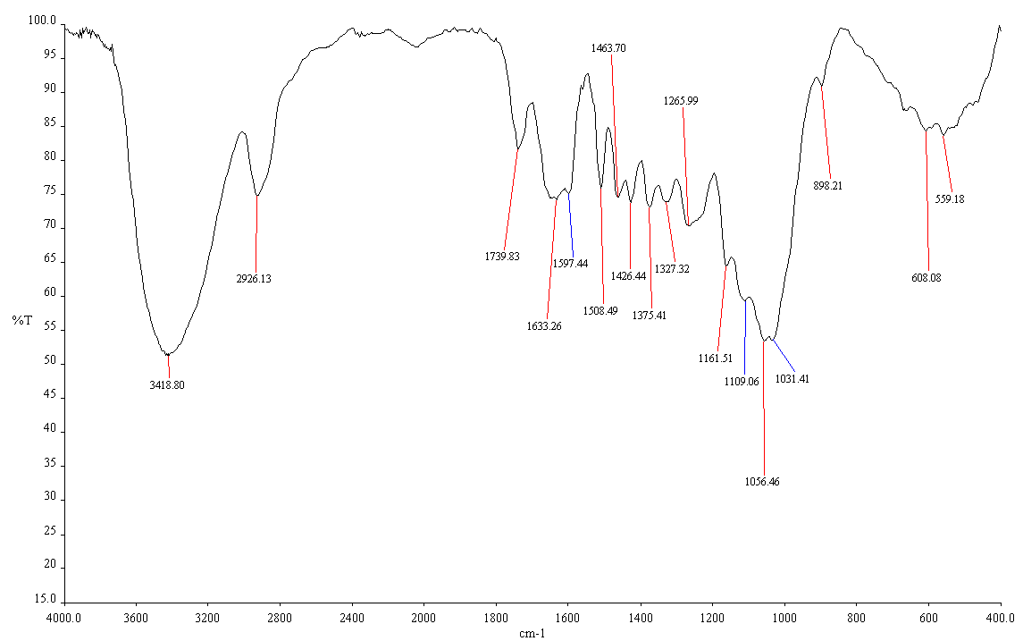

8. Comparison of TGA thermograms of sawdust and its char

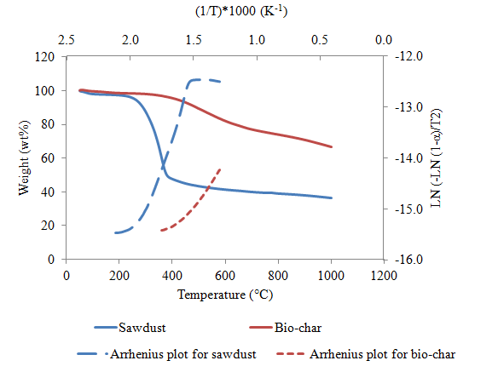
Where, T: Temperature in Kelvin; α- Fraction of mass loss. E_{a} of sawdust and bio-char were found to be 108.44 kJ/mol and 41.38 kJ/mol respectively.

Corresponding author: E-mail: thermo@spreri.org; sanjibkarmee@gmail.com

