Supplementary material
Fast pyrolysis of potassium impregnated poplar wood and characterization of its influence on the formation as well as properties of pyrolytic products

Hyewon Hwang, Shinyoung Oh, Tae-Su Cho, in-Gyu Choi, Joon Weon Choi

ª Department of Forest Sciences and Research Institute for Agriculture and Life Science, Seoul National University, 599 Gwanak-ro, Gwanak-gu, Seoul, 151-921, Korea

^{b} Department of Forest Resources Utilization, Korea Forest Research Institute, 57 Hoegi-ro, Dongdaemun-gu, Seoul 130-712, Korea

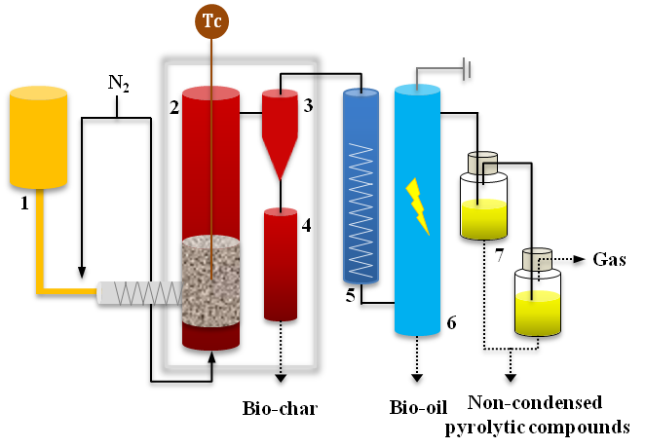
Fig. A. Fluidized bed fast pyrolysis system with two acetone filters (1: feeder, 2: reactor, 3: cyclone, 4: char collector, 5: cooler, 6: electrostatic precipitator, 7: extractors filled with acetone).

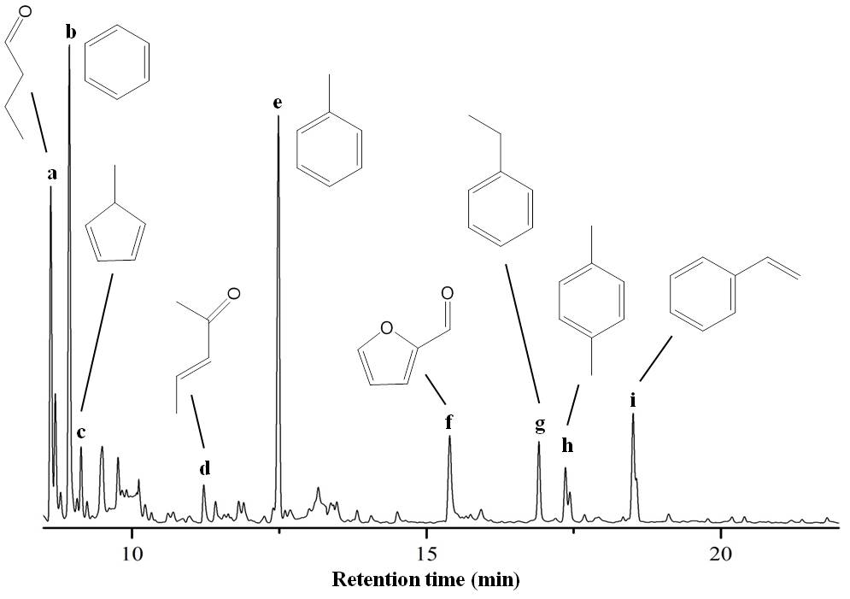

Fig. B. GC/MS chromatogram for non-condensed pyrolytic compounds trapped in acetone. Major peaks are identified by mass spectra as follows: (a) 2-Butenal; (b) Benzene; (c) 5-Methyl-1,3-cyclopentadiene; (d) 3-Penten-2-one; (e) Toluene; (f) Furfural; (g) Ethylbenzene (h) p-Xylene (i) Styrene.

