Influence of Inherent Hierarchical Porous Char with AAEMs on Lignin Pyrolysis

Shaoqing Wang, Zhihe Li, Xueyuan Bai*, Weiming Yi, Peng Fu

(School of Agricultural Engineering and Food Science, Shandong Research Center of Engineering and Technology for Clean Energy, Shandong University of Technology, Zibo 255000, China. )

* Corresponding author. Tel.: +86-13953386393
E-mail address: baixy@sdut.edu.cn (X. Bai)

Supplementary Figures
Fig. S1. FTIR spectra of different char samples.
Fig. S2. XRD diffraction patterns of different prepared AAEMs-loaded char samples.
Fig. S3. SEM micrographs of different char samples at 1000× and 5000× for (a) lignin-char, (b-e,corresponds to Na, K, Ca, and Mg, respectively) AAEMs-loaded char,( f-i,corresponds to Na, K, Ca, and Mg, respectively) AAEMs-loaded char after interaction.
Fig. S4. Elemental chemical mapping obtained by energy dispersive spectroscopy: AAEMs-loaded char( a-d, corresponds to Na, K, Ca and Mg, respectively); AAEMs-loaded char after interaction (e-h, corresponds to Na, K, Ca and Mg, respectively).

Supplementary Tables
Table S1：Characteristic temperature and maximum weight loss rates of samples.
Table S2：Surface elemental composition of different char samples.

Fig. S1. FTIR spectra of different char samples.

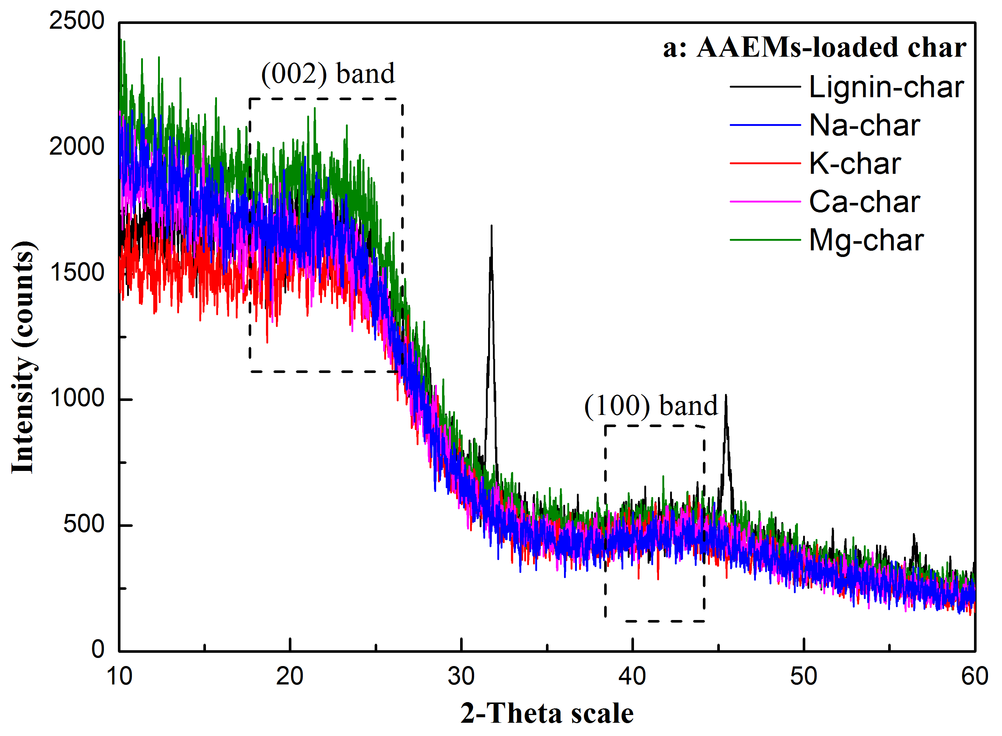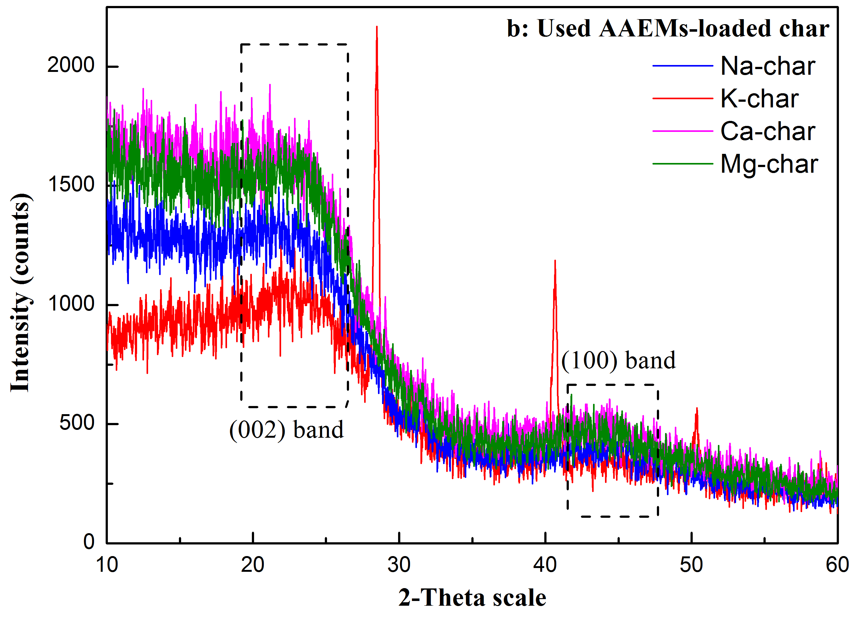
Fig. S2. XRD diffraction patterns of different prepared AAEMs-loaded char samples.

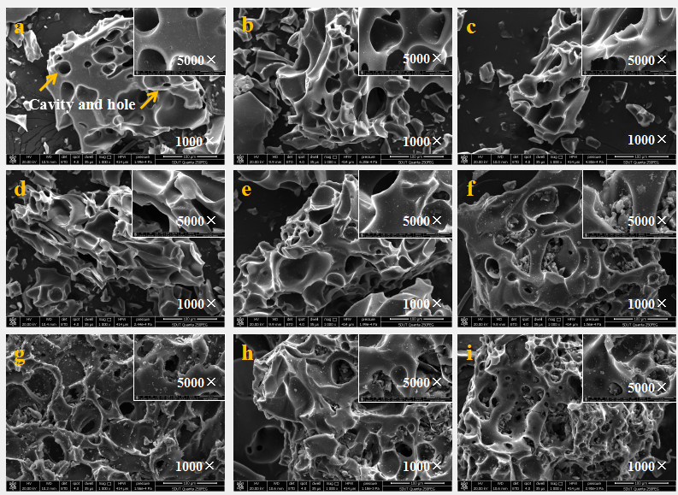
Fig. S3. SEM micrographs of different char samples at 1000× and 5000× for (a) lignin-char, (b-e,corresponds to Na, K, Ca, and Mg, respectively) AAEMs-loaded char,( f-i,corresponds to Na, K, Ca, and Mg, respectively) AAEMs-loaded char after interaction.

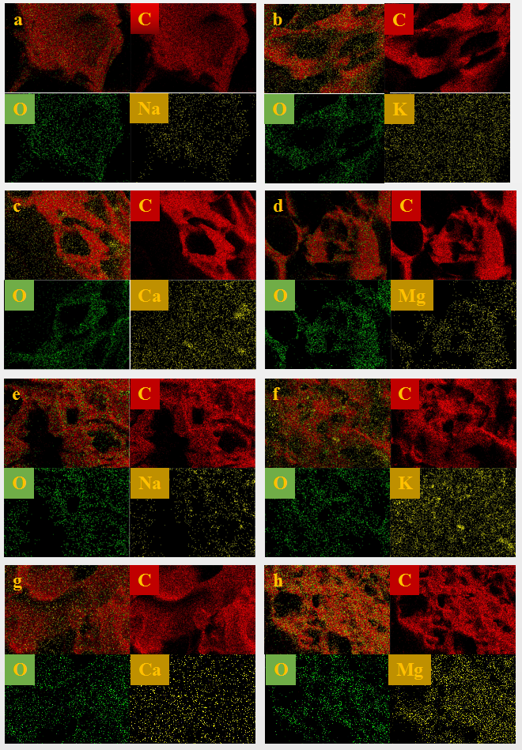
Fig. S4. Elemental chemical mapping obtained by energy dispersive spectroscopy: AAEMs-loaded char( a-d, corresponds to Na, K, Ca and Mg, respectively); AAEMs-loaded char after interaction (e-h, corresponds to Na, K, Ca and Mg, respectively).

Table S1
Characteristic temperature and maximum weight loss rates of samples.
Sample | Peak temperatures (℃) | (dW_{i}/dt)_{max}(%/min) | Residue (wt.%)
Lignin | 344.5 | 2.91 | 44.02
Na-lignin | 350.9 | 2.85 | 43.12
K-lignin | 335.0 | 2.63 | 43.69
Ca-lignin | 360.5 | 2.89 | 39.79
Mg-lignin | 364.5 | 2.97 | 39.62

Table S2
Surface elemental composition of different char samples.
Sample | Element composition (wt%) |  |  | C/O
Sample | C | O | AAEMsª | C/O
Na-lignin | 85.00 | 14.61 | 0.39 | 5.82
K-lignin | 80.83 | 17.16 | 2.01 | 4.71
Ca-lignin | 85.47 | 12.93 | 1.60 | 6.61
Mg-lignin | 87.42 | 12.52 | 0.06 | 6.98
Na-char | 85.88 | 13.26 | 0.86 | 6.48
K-char | 82.22 | 13.16 | 4.62 | 6.25
Ca-char | 87.08 | 12.18 | 0.74 | 7.14
Mg-char | 86.69 | 11.24 | 2.07 | 7.71
ª The AAEMs contents represent only the loaded metal content.

