A Reverse Deep Learning Approach for Estimating Bio-Oil Composition from Syngas Characteristics in Steam Reforming Processes
Abstract
Real-time estimation of bio-oil composition can support feed-quality monitoring and process control in steam-reforming plants. This study develops an inverse machine-learning methodology for constructing a soft sensor that predicts six bio-oil composition classes from reformer operating conditions and outlet syngas composition. Because sufficient plant-scale paired bio-oil-syngas measurements were unavailable, Cantera was used only as a synthetic data-generation tool to establish and evaluate the methodology. Literature-derived bio-oil compositions were represented by surrogate compounds for aromatics, acids, alcohols, furans, phenols, and aldehydes/ketones. Steam-reforming simulations generated paired bio-oil and syngas data over structured temperature, pressure, and steam-to-carbon ratio grids. After completeness filtering, 1,350 samples representing 30 bio-oil compositions were used to train and compare linear regression, random forest, XGBoost, standard and composition-constrained multilayer perceptrons, and ensemble models. The standard multilayer perceptron achieved the best row-wise test performance, with mean R² = 0.863, root mean squared error = 5.87 wt.%, and mean absolute error = 4.03 wt. %. Component-level R² values ranged from 0.762 for phenols to 0.942 for aromatics. The results demonstrate the feasibility of learning the inverse relationship between reformer syngas and bio-oil composition. For industrial implementation, the proposed workflow should be retrained and validated using paired measurements collected from the target plant; Cantera-generated data are not intended to replace actual plant data in the deployed soft sensor.
Keywords
Bio-oil; steam reforming; soft sensor; inverse modeling; deep learning; process monitoring
1. Introduction
Fast and slow pyrolysis convert biomass into gas, char, and a liquid fraction generally referred to as bio-oil. The liquid product is a potential intermediate for renewable fuels, chemicals, materials, and hydrogen production, but its composition varies strongly with biomass origin, pretreatment, reactor configuration, temperature, heating rate, residence time, and condensation strategy (Bridgwater, 2012; Sharifzadeh and Sadeqzadeh, 2019; Zhang et al., 2022). This variability affects acidity, stability, heating value, coke tendency, catalyst performance, and the composition of products obtained during upgrading or reforming.
Steam reforming is a promising route for converting the oxygenated fraction of bio-oil into hydrogen-rich synthesis gas. The process is nevertheless sensitive to feed composition and operating conditions, while the molecular complexity of bio-oil complicates mechanistic reactor modeling (Vagia and Lemonidou, 2007; Pafili et al., 2021; Singh and Jaswal, 2024). Detailed liquid characterization typically relies on offline methods such as gas chromatography-mass spectrometry, Fourier-transform infrared spectroscopy, elemental analysis, and wet-chemical procedures (Oasmaa and Peacocke, 2010). Reformer outlet gas composition, in contrast, is more compatible with frequent or online measurement. This difference creates an opportunity for a soft sensor that infers feed composition from measured syngas and known operating conditions.
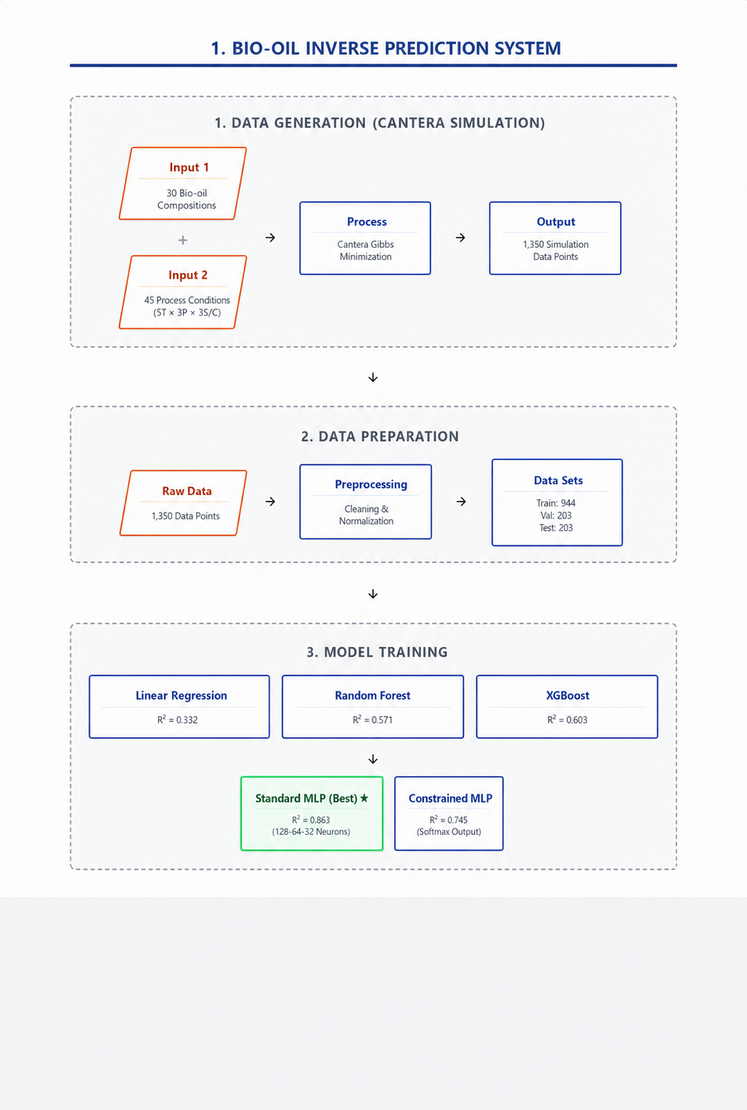
Figure 1. Development and implementation workflow for the inverse soft sensor.
Machine learning has been increasingly applied to biomass conversion for forward prediction of yields, product distributions, and fuel properties (Leng et al., 2021). The present problem is different: it seeks the inverse relation from reformer outputs to feed composition. Such inverse mappings may be ill posed because distinct feed mixtures can approach similar equilibrium gas states. A useful model must therefore capture nonlinear interactions while being interpreted within the composition and operating domain represented during training.
This study proposes an inverse machine-learning framework for developing a soft sensor that estimates bio-oil composition from reformer outlet syngas and operating conditions. The soft sensor is defined by the learned inverse relationship between paired bio-oil and syngas observations. Because a sufficiently large set of paired plant measurements was not available at the present stage, Cantera was used solely to generate a synthetic development dataset and evaluate whether this inverse relationship could be learned. The contributions of this study are: (i) the organization of literature-derived bio-oil compositions into six chemically interpretable classes; (ii) the generation of paired bio-oil-syngas data over a structured operating-condition grid; (iii) the comparison of linear, tree-based, deep-learning, constrained-output, and ensemble inverse models; and (iv) the definition of a plant implementation workflow in which the selected model is retrained and validated using measurements from the target facility. The reported model is therefore a simulation-based proof of concept for the soft-sensor methodology, rather than a plant-ready sensor trained on Cantera data.
2. Materials and methods
2.1. Literature-derived bio-oil composition data
Experimental bio-oil composition data were collected from published pyrolysis and bio-oil characterization studies and organized in a SQL Server relational database linking bibliographic metadata, biomass identity, pyrolysis conditions, product distribution, and class-level bio-oil composition. The complete curated database contained 70 class-level bio-oil records from 14 literature sources, covering 43 biomass names and pyrolysis temperatures between 300 and 850 °C.
Hu et al. (2023) provided the largest primary dataset, reporting bamboo and wet-torrefied bamboo samples converted by catalytic fast pyrolysis; these records supplied biomass properties, pretreatment conditions, catalyst-related parameters, pyrolysis temperature, product yields, and bio-oil chemical-class information. Zhang et al. (2017) contributed rice husk and wet-torrefied rice husk experiments, including pretreatment temperature effects and pyrolysis product properties. Hwang et al. (2013) reported potassium-impregnated yellow poplar wood pyrolysis, from which treated biomass identities and bio-oil composition classes were extracted. Chen et al. (2016) supplied pine nut shell pyrolysis records at different temperatures, including product quality and bio-oil composition information. Chen et al. (2017) contributed cotton-stalk samples subjected to aqueous washing and torrefaction pretreatments, with linked pyrolysis-product quality and bio-oil data. Wang et al. (2018) provided lignin pyrolysis data for corn-cob lignin, including composition classes relevant to aromatic and phenolic bio-oil fractions. Cao et al. (2021) contributed catalytic macroalgae conversion data for Enteromorpha clathrata, including catalyst-dependent bio-oil class distributions.
Additional records were incorporated to broaden the biomass and bio-oil composition domain. Modak et al. (2023) supplied slow-pyrolysis bio-oil data from cooked food waste at different temperatures. Bordoloi et al. (2016) contributed algal bio-oil and sub-fraction characterization data from Scenedesmus dimorphus. Azri Sukiran et al. (2009) and Khor et al. (2009) provided oil palm empty fruit bunch bio-oil characterization records. Mullen et al. (2010) supplied fast-pyrolysis bio-oil data from three barley biomass/by-product streams: DDGS, hulls, and straw. Chukwuneke et al. (2019) contributed physicochemical bio-oil characterization data from Swietenia macrophylla wood waste. Sampaio et al. (2025) provided review-derived class-level composition records for several biomass sources, including palm shell, rice straw, corn stover, eucalyptus chips, pine sawdust, sisal residue, banana leaves, bamboo, sugarcane bagasse, corn cob, coconut shell, and mahua seed.
Because literature studies did not report all chemical groups consistently, the database was screened for completeness before simulation. The inverse-model workflow retained records containing the six target groups required for surrogate representation: aromatics, acids, alcohols, furans, phenols, and aldehydes/ketones. These retained fractions were normalized to a common 100 wt.% basis before Cantera simulation, so the model target represents a normalized class-level surrogate composition rather than the complete molecular composition of raw bio-oil. After this filtering, 30 unique bio-oil compositions were used as simulation-ready feed definitions; each composition was later expanded over 45 reforming operating-condition combinations, producing 1,350 complete machine-learning samples.
2.2. Surrogate representation
Each chemical class was represented by one model compound: toluene for aromatics, acetic acid for acids, ethanol for alcohols, furan for furans, phenol for phenols, and acetone for aldehydes/ketones. Model compounds are commonly used to reduce the complexity of thermodynamic and catalytic studies of bio-oil reforming (Vagia and Lemonidou, 2007). The surrogate set was selected to preserve differences in carbon, hydrogen, and oxygen balance among the six classes while remaining compatible with the thermodynamic mechanism used in Cantera. Table 1 summarizes the class representation.
Table 1 Bio-oil classes and surrogate compounds used in the simulation
Target class | Surrogate compound | Formula
Aromatics | Toluene | C₇H8
Acids | Acetic acid | C2H4O2
Alcohols | Ethanol | C2H6O
Furans | Furan | C4H4O
Phenols | Phenol | C6H6O
Aldehydes/ketones | Acetone | C3H6O

2.3. Cantera equilibrium model
Steam-reforming data were generated with Cantera 3.2.0, an open-source framework for thermodynamics, chemical kinetics, and transport calculations (Goodwin et al., 2025). The model represents the reformer at thermodynamic equilibrium. At specified temperature and pressure, the equilibrium state minimizes total Gibbs free energy subject to elemental conservation and non-negative species amounts (Smith and Missen, 1982):
$$Minimize: G = Σ(nᵢ × μᵢ)$$ | Equation 1
$$μᵢ = μᵢ° + RT ln(aᵢ)$$ | Equation 2
where nᵢ is the amount of species i, μᵢ is its chemical potential, R is the universal gas constant, T is temperature, and aᵢ is activity. Elemental carbon, hydrogen, and oxygen balances were checked for each converged case.
The reformer-only boundary was selected because the inlet bio-oil composition has its most direct effect on this unit. Downstream water-gas shift, carbon-dioxide removal, and pressure-swing adsorption are relevant to hydrogen purification but were excluded from the inverse-model boundary. Accordingly, the model estimates feed composition from reformer outlet gas rather than from final purified hydrogen.
Cantera was used as a synthetic data-generation environment for developing and testing the inverse machine-learning methodology. It is not a component of the intended industrial soft sensor. In the proposed plant implementation, paired measurements of actual bio-oil composition, reformer operating conditions, and outlet syngas composition would replace the synthetic dataset used in this study. The deployed inverse model would then be trained or recalibrated using plant-specific data.

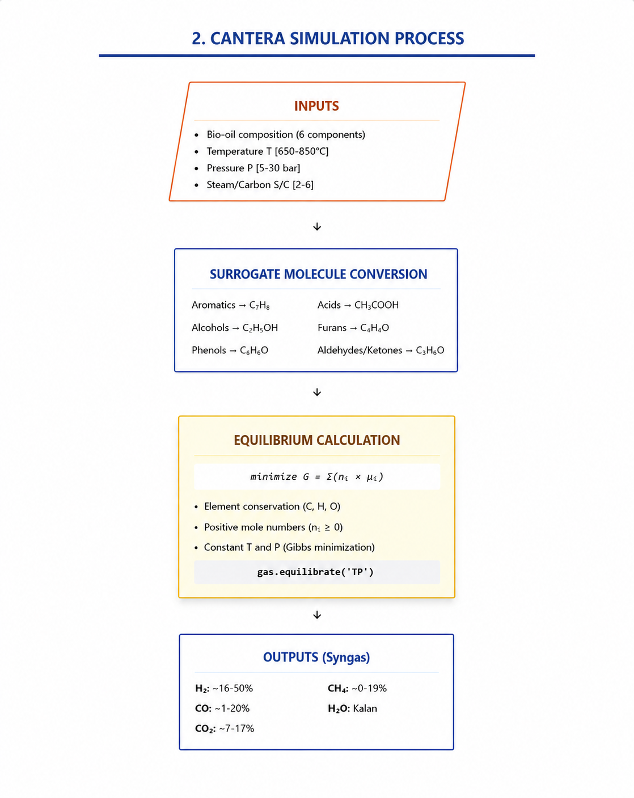
Figure 2. Cantera data-generation workflow, including surrogate-feed construction, operating-condition assignment, equilibrium calculation, validation, and database storage.
2.4. Operating grid and generated dataset
For each literature-derived bio-oil composition, simulations were conducted over five temperatures (650, 700, 750, 800, and 850 °C), three pressures (5, 15, and 30 bar), and three steam-to-carbon ratios (2.0, 4.0, and 6.0). The full factorial grid contains 45 operating points per composition. Across the original 70 records, 3,150 cases were generated. Removal of records without complete six-class targets left 30 compositions and 1,350 complete cases for machine learning.
The final inverse-model input vector comprised eight variables: reformer temperature, pressure, steam-to-carbon ratio, and outlet mole percentages of H2, CO, CO2, CH4, and H2O. The output vector comprised the normalized weight percentages of the six bio-oil classes. Table 2 defines the modeling dataset.
Table 2. Inverse-model dataset and row-wise split used in this study
Item | Value
Original Cantera cases | 3,150
Complete model-ready cases | 1,350
Unique model-ready bio-oil compositions | 30
Input variables | 8
Output variables | 6
Training samples | 944
Validation samples | 203
Test samples | 203

The primary comparison used a random row-wise split of approximately 70% training, 15% validation, and 15% testing. Because each bio-oil composition contributes multiple operating-condition rows, this protocol measures interpolation within the simulation-expanded data domain. It does not by itself establish transfer to a completely unseen bio-oil identity.
The resulting dataset represents a controlled methodological benchmark rather than an industrial training dataset. Its purpose is to determine whether the inverse bio-oil-to-syngas relationship contains sufficient information for machine-learning-based estimation and to compare candidate model structures under consistent conditions. The numerical performance reported in this study therefore applies to the synthetic simulation domain and should not be interpreted as expected accuracy on unmeasured plant data.
2.5. Machine-learning models
Linear regression was used as a lower-bound baseline. Random forest and XGBoost represented nonlinear tree-based learners. The principal deep-learning model was a multilayer perceptron (MLP) with eight inputs, hidden layers of 128, 64, and 32 neurons, and six linear outputs. Batch normalization followed the hidden layers, while dropout rates of 0.30, 0.20, and 0.10 were used from the first to the third hidden layer. Training used the Adam optimizer, a batch size of 32, a maximum of 200 epochs, early stopping with a patience of 30 epochs, and learning-rate reduction with a patience of 15 epochs.
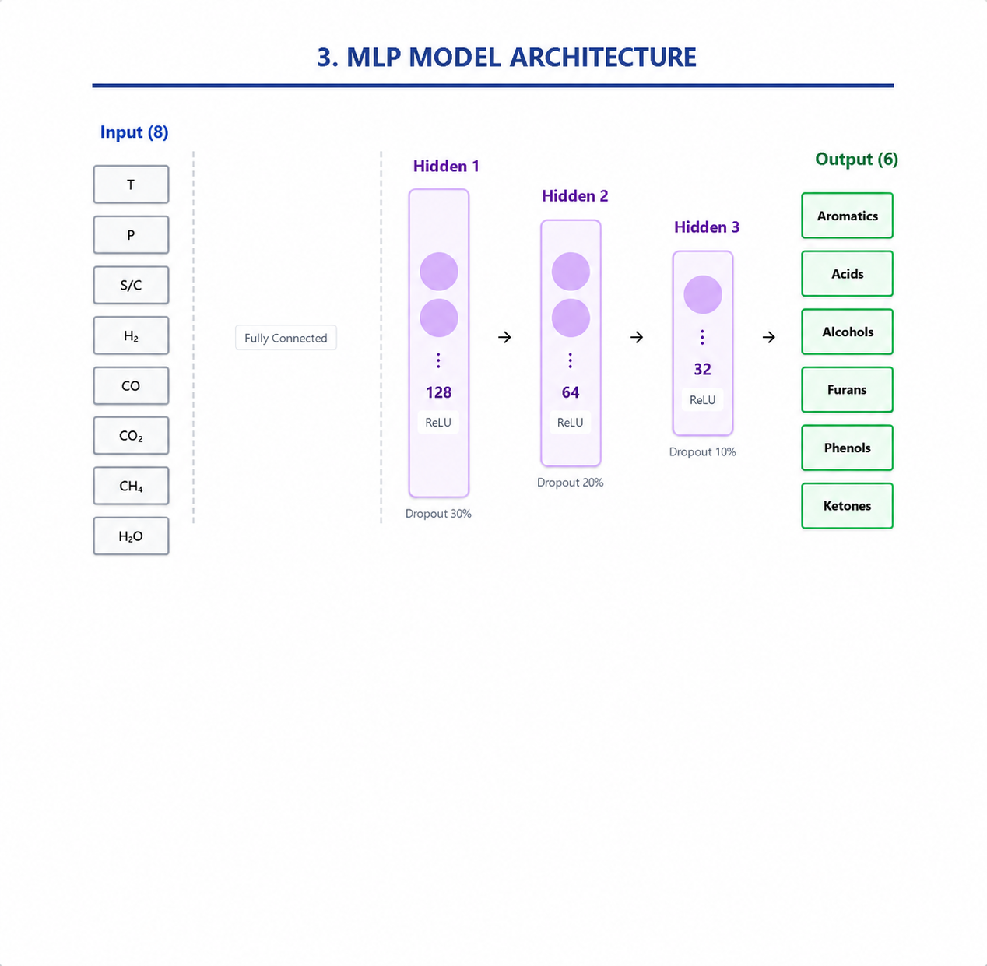
Figure 3. Standard MLP architecture with eight inputs, three hidden layers, and six bio-oil composition outputs.
A second MLP used a softmax-style output to impose exact closure of the six predicted fractions to 100%. This constrained model was evaluated to quantify the trade-off between compositional consistency and prediction error. Three ensembles were also tested: an equal average of random forest, XGBoost, and standard MLP; a weighted average assigning weights of 0.25, 0.25, and 0.50, respectively; and a stacking model with ridge regression as the meta-learner.
The model-development environment used Python 3.11, TensorFlow/Keras 2.12.0, scikit-learn 1.2.2, and XGBoost 1.7.5. Data splitting and the tree-based models used a fixed random state of 42.
2.6. Performance measures
Model performance was evaluated separately for each predicted bio-oil composition class. Three standard regression metrics were used: the coefficient of determination, root mean squared error, and mean absolute error.
The coefficient of determination, reported as R², was used to measure how well the model explained the variation in the actual composition values. An R² value close to 1 indicates strong predictive performance, whereas lower values indicate that the model explains less of the observed variation.
RMSE was used to quantify the typical prediction error while giving greater weight to larger deviations. This metric is useful for identifying whether a model occasionally produces large composition errors.
MAE was used to measure the average absolute difference between predicted and actual composition values. Because the target variables are bio-oil composition fractions expressed on a wt.% basis, RMSE and MAE are reported in wt.% units.
All metrics were calculated separately for aromatics, acids, alcohols, furans, phenols, and aldehydes/ketones. The reported mean values were obtained by taking the arithmetic average across these six output classes. This component-wise evaluation was used because the inverse prediction task is multi-output and the prediction difficulty differs among bio-oil composition groups.
3. Results and discussion
3.1. Comparison of inverse models
Table 3 reports the test-set results. Linear regression explained only 33.2% of the target variance on average, indicating that the inverse mapping cannot be represented adequately by one linear relation. Random forest and XGBoost improved the mean R² to 0.571 and 0.603, respectively. The standard MLP was the strongest model, with mean R² = 0.863, RMSE = 5.87 wt.%, and MAE = 4.03 wt.%.
Table 3. Test-set comparison of inverse modeling strategies.
Model | Mean R² | Mean RMSE (wt.%) | Mean MAE (wt.%)
Linear regression | 0.332 | 13.38 | 9.92
Random forest | 0.571 | 9.83 | 6.25
XGBoost | 0.603 | 9.50 | 6.10
Standard MLP * | 0.863 | 5.87 | 4.03
Constrained MLP | 0.745 | 15.06 | 11.54
Simple-average ensemble | 0.746 | 7.69 | 5.16
Weighted-average ensemble | 0.797 | 6.94 | 4.75
Stacking ensemble | 0.562 | 9.95 | 6.34
* The best performed model is represented by an asterix
The standard MLP improved mean R² by 0.292 absolute points relative to random forest, corresponding to a 51.1% relative increase when random forest is used as the baseline. The comparison supports the use of a multilayer nonlinear representation for this inverse equilibrium mapping. It does not imply that neural networks will universally outperform tree models outside the present data and tuning protocol.
Within the synthetic development dataset, the standard MLP provided the strongest representation of the inverse relationship. This result identifies the MLP as the preferred candidate architecture for subsequent training and validation with plant-specific paired measurements; it does not establish the reported numerical accuracy for an industrial reformer.
3.2. Component-level MLP performance
The standard MLP produced R² values above 0.84 for five of the six classes (Table 4). Aromatics had the highest R² (0.942), whereas phenols had the lowest (0.762). Furans had the smallest absolute errors because their range and abundance in the normalized target space were lower. Reporting all three metrics is important because R² is scale dependent and may appear low for a target with limited variance even when its absolute error is small.
Table 4. Component-level standard MLP performance on the test set.
Bio-oil class | R² | RMSE (wt.%) | MAE (wt.%)
Aromatics | 0.942 | 8.70 | 6.35
Acids | 0.877 | 6.46 | 4.80
Alcohols | 0.853 | 4.82 | 3.41
Furans | 0.897 | 1.50 | 1.05
Phenols | 0.762 | 8.42 | 5.28
Aldehydes/ketones | 0.849 | 5.30 | 3.29
Arithmetic mean | 0.863 | 5.87 | 4.03

The similar mean R² values on validation and test partitions (both 0.863) indicate stable performance across these two row-wise subsets. This observation should not be interpreted as proof of generalization to bio-oil compositions outside the dataset, because operating-condition rows derived from the same underlying compositions can occur in different partitions.
3.3. Composition closure
The standard MLP uses independent linear outputs and therefore does not enforce exact summation to 100%. Its predicted total was 99.85 ± 7.4 wt.% in the reported evaluation. The constrained MLP enforced 100.00 ± 0.00 wt.% closure but reduced mean test R² from 0.863 to 0.745 and increased MAE from 4.03 to 11.54 wt.%. For the present dataset, a hard output constraint introduced a larger predictive penalty than the closure benefit justified.
A practical deployment can handle this trade-off in three ways: retain the unconstrained model and report the total as a diagnostic; apply post-prediction normalization only after checking its effect on class errors; or train a compositional model with an objective designed specifically for simplex-valued outputs. The first option preserves the reported test performance and is therefore the reference implementation in this study.
3.4. Ensemble behavior
None of the ensemble strategies outperformed the standard MLP. The weighted average was the strongest ensemble with mean R² = 0.797, followed by simple averaging at 0.746. Stacking reached only 0.562. Combining models is beneficial when component learners have comparable skill and sufficiently diverse errors. Here, the two tree models were substantially weaker than the MLP, so averaging diluted the strongest predictions. The ensemble results are retained because they establish that additional model complexity did not automatically improve this inverse problem.
3.5. Feature interpretation
Random-forest feature importance was used as a model-specific interpretation of the inputs. Methane mole fraction had the largest importance (27.1%), followed by CO2 (26.0%), H2O (20.5%), H2 (11.9%), CO (9.9%), temperature (3.1%), pressure (1.0%), and steam-to-carbon ratio (0.6%). These values indicate that outlet gas composition carries most of the inverse signal once the operating state is supplied to the model.
The ranking is consistent with elemental-balance reasoning. Changes in the carbon, hydrogen, and oxygen content of the surrogate feed alter the equilibrium distribution among CH4, CO, CO2, H2, and H2O. Feature importance does not demonstrate causality, however, and correlated gas variables can share or redistribute importance. The result should therefore be treated as a consistency check rather than a mechanistic proof.
4. Proposed plant implementation of the soft sensor
The proposed soft sensor is an inverse machine-learning model trained on paired observations of bio-oil composition, reformer operating conditions, and outlet syngas composition. In an industrial implementation, the plant would first collect synchronized datasets containing laboratory measurements of the incoming bio-oil, routinely measured process conditions, and online or near-online syngas measurements. These plant data would be used to train, calibrate, and independently validate the inverse model.
Once validated, the model would receive reformer temperature, pressure, steam-to-carbon ratio, and outlet H2, CO, CO2, CH4, and H2O measurements during operation. It would then estimate the six bio-oil composition classes without requiring continuous detailed liquid analysis. Periodic laboratory measurements would remain necessary for model verification, drift detection, and recalibration.
Cantera is not required during this operational stage. Its role in the present study is limited to generating synthetic paired data for testing the feasibility of the inverse-learning approach and
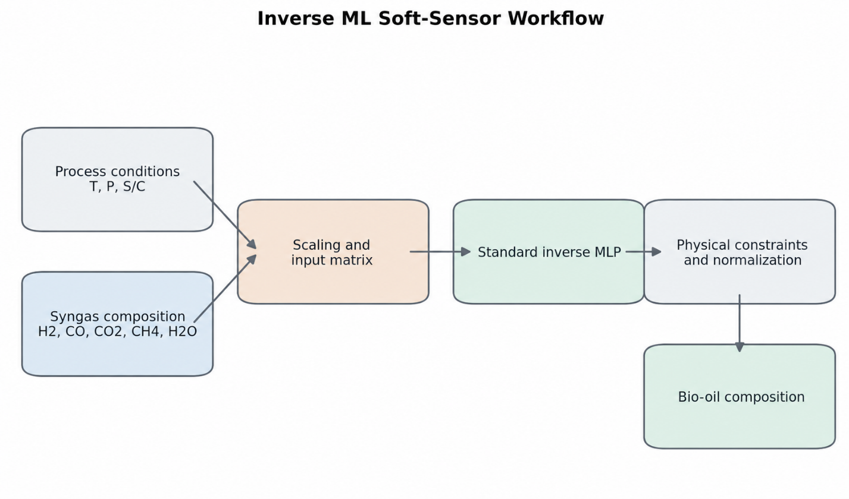
Figure 6. Proposed industrial workflow in which plant-specific paired bio-oil and syngas measurements are used to train, validate, deploy, and periodically recalibrate the inverse soft sensor.
5. Limitations and future work
The dataset is generated from thermodynamic equilibrium simulations. It does not represent finite-rate kinetics, catalyst deactivation, carbon deposition, reactor hydrodynamics, heat- and mass-transfer limitations, sensor noise, or downstream separation dynamics. The surrogate approach also compresses a chemically complex liquid into six representative compounds. Consequently, the numerical accuracy reported here applies to the simulated surrogate domain.
The row-wise split is another important limitation. Multiple rows originate from the same bio-oil composition under different operating conditions, so the test set primarily evaluates interpolation over represented feed identities and process states. A composition-grouped external validation is required before claiming performance for unseen bio-oils. The current mean R² of 0.863 must therefore be cited together with the row-wise split protocol.
Future work should include experimental reformer measurements, grouped validation by bio-oil identity and biomass source, uncertainty quantification, robustness tests with realistic sensor error, and comparison with compositional-learning approaches. The validated inverse estimator can then be coupled to a forward surrogate and assessed in closed-loop MPC simulations.
A central limitation is that the current inverse models were trained and tested using Cantera-generated data rather than paired measurements from an operating reformer. Synthetic equilibrium data cannot fully reproduce catalyst behavior, measurement noise, process disturbances, feed-handling effects, sensor dynamics, or plant-specific correlations. Consequently, the reported R², RMSE, and MAE values demonstrate methodological feasibility only within the generated dataset. They should not be presented as the expected performance of a deployed industrial soft sensor.
6. Conclusions
This study proposed an inverse machine-learning methodology for developing a soft sensor that estimates six bio-oil composition classes from steam-reforming syngas and operating conditions. Cantera was used solely to generate a synthetic development dataset because sufficient paired plant measurements were not available. The resulting 1,350 complete samples were used to compare linear regression, random forest, XGBoost, standard and composition-constrained MLPs, and three ensemble strategies.
Within the synthetic row-wise test setting, the standard 128-64-32 MLP achieved the best performance, with mean R² = 0.863, RMSE = 5.87 wt.%, and MAE = 4.03 wt.%. These results demonstrate that the inverse relationship contains learnable information under the represented simulation conditions and identify the standard MLP as the preferred candidate architecture. They do not establish plant-scale prediction accuracy.
Industrial implementation requires the model to be trained, calibrated, and independently validated using paired measurements collected from the target reformer. Cantera-generated data are not intended to replace these measurements or to serve as the permanent training data of the deployed soft sensor. The principal outcome of this study is therefore a validated methodological workflow and candidate model architecture for subsequent plant-specific soft-sensor development.
Declaration of competing interest
The authors declare that they have no known competing financial interests or personal relationships that could have appeared to influence the work reported in this paper.
Funding
This research did not receive any specific grant from funding agencies in the public, commercial, or not-for-profit sectors.
CRediT authorship contribution statement
Orhun Uzdiyem: Conceptualization, methodology, software, validation, Formal analysis, Data curation, Writing - original draft, Visualization.
Özben Kutlu: Conceptualization, Methodology, Supervision, Writing - review & editing, Project administration.
Data availability
The used data, generated data, simulation scripts, model-training scripts, and model-performance files is deposited in a public repository: {link}
Declaration of generative AI and AI-assisted technologies in the manuscript preparation process
During the preparation of this work, the authors used OpenAI Codex to organize source material and assist with language and manuscript structure. After using this tool, the authors reviewed and edited the content as needed and take full responsibility for the content of the published article.
References
Bordoloi, N., Narzari, R., Sut, D., Saikia, R., Chutia, R.S., Kataki, R., 2016. Characterization of bio-oil and its sub-fractions from pyrolysis of *Scenedesmus dimorphus*. Renewable Energy 98, 245-253. https://doi.org/10.1016/j.renene.2016.03.081.

Bridgwater, A.V., 2012. Review of fast pyrolysis of biomass and product upgrading. Biomass and Bioenergy 38, 68-94.

Chen, D., Cen, K., Jing, X., Gao, J., Li, C., Ma, Z., 2017. An approach for upgrading biomass and pyrolysis product quality using a combination of aqueous phase bio-oil washing and torrefaction pretreatment. Bioresource Technology 233, 150-158. https://doi.org/10.1016/j.biortech.2017.02.120.

Goodwin, D.G., Moffat, H.K., Schoegl, I., Speth, R.L., Weber, B.W., 2025. Cantera: An object-oriented software toolkit for chemical kinetics, thermodynamics, and transport processes. Version 3.2.0. https://doi.org/10.5281/zenodo.17620923.

Leng, E., He, B., Chen, J., Liao, G., Ma, Y., Zhang, F., Liu, S., E, J., 2021. Prediction of three-phase product distribution and bio-oil heating value of biomass fast pyrolysis based on machine learning. Energy 236, 121401. https://doi.org/10.1016/j.energy.2021.121401.

Modak, S., Katiyar, P., Yadav, S., Jain, S., Gole, B., Talukdar, D., 2023. Generation and characterization of bio-oil obtained from the slow pyrolysis of cooked food waste at various temperatures. Waste Management 158, 23-36. https://doi.org/10.1016/j.wasman.2023.01.002.

Mullen, C.A., Boateng, A.A., Hicks, K.B., Goldberg, N.M., Moreau, R.A., 2010. Analysis and comparison of bio-oil produced by fast pyrolysis from three barley biomass/byproduct streams. Energy & Fuels 24, 699-706. https://doi.org/10.1021/ef900912s.

Oasmaa, A., Peacocke, C., 2010. A guide to physical property characterisation of biomass-derived fast pyrolysis liquids. VTT Publications.

Pafili, A., Charisiou, N.D., Douvartzides, S.L., Siakavelas, G.I., Wang, W., Liu, G., Papadakis, V.G., Goula, M.A., 2021. Recent progress in the steam reforming of bio-oil for hydrogen production: A review of operating parameters, catalytic systems and technological innovations. Catalysts 11, 1526. https://doi.org/10.3390/catal11121526.

Sharifzadeh, M., Sadeqzadeh, M., 2019. The multi-scale challenges of biomass fast pyrolysis and bio-oil upgrading: Review of the state of art and future research directions. Progress in Energy and Combustion Science 71, 1-80.

Singh, P.P., Jaswal, A., Singh, R., Mondal, T., Pant, K.K., 2024. Green hydrogen production from biomass: A thermodynamic assessment of the potential of conventional and advanced bio-oil steam reforming processes. International Journal of Hydrogen Energy 50, 627-639. https://doi.org/10.1016/j.ijhydene.2023.10.099.

Smith, W.R., Missen, R.W., 1982. Chemical Reaction Equilibrium Analysis: Theory and Algorithms. Research Studies Press.

Vagia, E.C., Lemonidou, A.A., 2007. Thermodynamic analysis of hydrogen production by steam reforming of bio-oil components. International Journal of Hydrogen Energy 32, 212-223.

Zhang, S., Chen, T., Xiong, Y., Dong, Q., 2022. A comprehensive review of bio-oil, bio-binder and bio-asphalt materials: Their source, composition, preparation and performance. Journal of Traffic and Transportation Engineering (English Edition) 9, 151-166.
Azri Sukiran, M., Palm Oil Board, M., Institusi, P., Baru Bangi, B., Mee Chin, C., & Kartini Abu Bakar, N., 2009. Bio-oils from Pyrolysis of Oil Palm Empty Fruit Bunches. American Journal of Applied Sciences
6(5), 869-875.

Bordoloi, N., Narzari, R., Sut, D., Saikia, R., Chutia, R.S., Kataki, R., 2016. Characterization of bio-oil and its sub-fractions from pyrolysis of Scenedesmus dimorphus. Renewable Energy 98, 245-253.
https://doi.org/10.1016/j.renene.2016.03.081

Cao, B., Yuan, J., Jiang, D., Wang, S., Barati, B., Hu, Y., Yuan, C., Gong, X., Wang, Q., 2021. Seaweed-derived biochar with multiple active sites as a heterogeneous catalyst for converting macroalgae into
acid-free biooil containing abundant ester and sugar substances. Fuel 285. https://doi.org/10.1016/j.fuel.2020.119164

Chen, D., Chen, X., Sun, J., Zheng, Z., Fu, K., 2016. Pyrolysis polygeneration of pine nut shell: Quality of pyrolysis products and study on the preparation of activated carbon from biochar. Bioresource
Technology 216, 629-636. https://doi.org/10.1016/j.biortech.2016.05.107

Chen, D., Cen, K., Jing, X., Gao, J., Li, C., Ma, Z., 2017. An approach for upgrading biomass and pyrolysis product quality using a combination of aqueous phase bio-oil washing and torrefaction pretreatment.
Bioresource Technology 233, 150-158. https://doi.org/10.1016/j.biortech.2017.02.120

Chukwuneke, J.L., Ewulonu, M.C., Chukwujike, I.C., Okolie, P.C., 2019. Physico-chemical analysis of pyrolyzed bio-oil from Swietenia macrophylla (mahogany) wood. Heliyon 5(6), e01790.
https://doi.org/10.1016/j.heliyon.2019.e01790

Hu, Z., Zhu, L., Cai, H., Huang, M., Li, J., Cai, B., Chen, D., Zhu, L., Yang, Y., Ma, Z., 2023. Enhancement of the production of bio-aromatics from bamboo pyrolysis: Wet torrefaction pretreatment coupled
with catalytic fast pyrolysis. Journal of Analytical and Applied Pyrolysis 169, 105818.

Hwang, H., Oh, S., Cho, T., Choi, I., Choi, J.W., 2013. Fast pyrolysis of potassium impregnated poplar wood and characterization of its influence on the formation as well as properties of pyrolytic products.
Bioresource Technology 150, 359-366.

Khor, K.H., Lim, K.O., Zainal, Z.A., 2009. Characterization of Bio-Oil: A By-Product from Slow Pyrolysis of Oil Palm Empty Fruit Bunches. American Journal of Applied Sciences 6(9), 1647-1652.

Modak, S., Katiyar, P., Yadav, S., Jain, S., Gole, B., Talukdar, D., 2023. Generation and characterization of bio-oil obtained from the slow pyrolysis of cooked food waste at various temperatures. Waste
Management 158, 23-36. https://doi.org/10.1016/j.wasman.2023.01.002

Mullen, C.A., Boateng, A.A., Hicks, K.B., Goldberg, N.M., Moreau, R.A., 2010. Analysis and comparison of bio-oil produced by fast pyrolysis from three barley biomass/byproduct streams. Energy & Fuels 24(1),
699-706. https://doi.org/10.1021/ef900912s

Sampaio, T.Q.S., Lima, S.B., Pires, C.A.M., 2025. Influence of extractives on the composition of bio-oil from biomass pyrolysis - A review. Journal of Analytical and Applied Pyrolysis 186, 106919.
https://doi.org/10.1016/j.jaap.2024.106919

Wang, S., Li, Z., Bai, X., Yi, W., Fu, P., 2018. Influence of inherent hierarchical porous char with alkali and alkaline earth metallic species on lignin pyrolysis. Bioresource Technology 268, 323-331.
https://doi.org/10.1016/j.biortech.2018.07.117

Zhang, S., Chen, T., Xiong, Y., Dong, Q., 2017. Effects of wet torrefaction on the physicochemical properties and pyrolysis product properties of rice husk. Energy Conversion and Management 141, 403-409.

