Cloudy Vision Output

Cloudy Vision is a tool to help compare computer vision API vendors. [See this blog post](https://goberoi.com/comparing-the-top-five-computer-vision-apis-98e3e3d7c647) and the [Github page](https://github.com/goberoi/cloudy_vision) for details.

Results Summary

**On Mar 07, 2018, 10 images were processed across 1 vendors**: rekognition.

A thumbnail of each image is displayed (click to see it fullsize) along with results from each computer vision API vendor.   
Statistics on response times and more are at the bottom of the page.

image_accordion.jpg

desired_tags: accordion

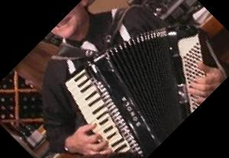

|  |  |
| --- | --- |
| **rekognition** | View raw json (1.48s) |
| **rekognition_tags** | Accordion (.98) , Leisure Activities (.98) , Music (.98) , Musical Instrument (.98) , Console (.88) , Electronics (.88) |
| **rekognition_matching_tags** | Accordion (.98) |

image_airplanes.jpg

desired_tags: airplanes

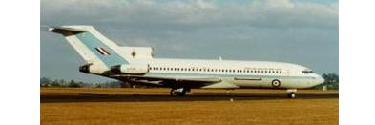

|  |  |
| --- | --- |
| **rekognition** | View raw json (.60s) |
| **rekognition_tags** | Aircraft (.85) , Airliner (.85) , Airplane (.85) , Transportation (.85) ,Jet (.77) , Takeoff (.72) |
| **rekognition_matching_tags** |  |

image_anchor.jpg

desired_tags: anchor

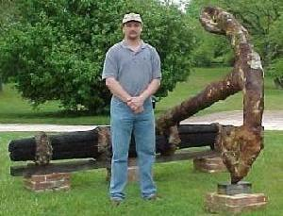

|  |  |
| --- | --- |
| **rekognition** | View raw json (1.22s) |
| **rekognition_tags** | Human (.99) , People (.99) , Person (.99) , Clothing (.72) , Denim(.72) , Jeans (.72) , Pants (.72) , Flora (.63) , Grass (.63) , Plant(.63) , Hat (.55) , Backyard (.53) , Outdoors (.53) , Yard (.53) , Cap(.51) , Park (.51) |
| **rekognition_matching_tags** |  |

image_ant.jpg

desired_tags: ant

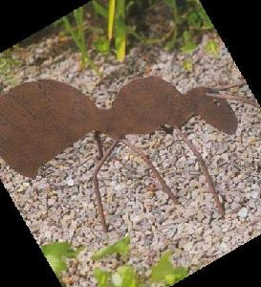

|  |  |
| --- | --- |
| **rekognition** | View raw json (.90s) |
| **rekognition_tags** | Animal (.98) , Butterfly (.98) , Insect (.98) , Invertebrate (.98) ,Moth (.98) , Pebble (.96) , Rock (.65) , Cobblestone (.60) , Path(.60) , Pavement (.60) , Sidewalk (.60) , Walkway (.60) ,Mountain (.52) , Nature (.52) , Outdoors (.52) , Flora (.51) , Moss(.51) , Plant (.51) |
| **rekognition_matching_tags** | Plant (.51) |

image_barrel.jpg

desired_tags: barrel

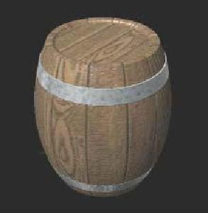

|  |  |
| --- | --- |
| **rekognition** | View raw json (.90s) |
| **rekognition_tags** | Barrel (.74) |
| **rekognition_matching_tags** | Barrel (.74) |

image_bass.jpg

desired_tags: bass

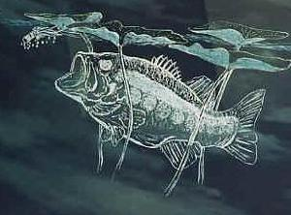

|  |  |
| --- | --- |
| **rekognition** | View raw json (.84s) |
| **rekognition_tags** | Animal (.81) , Sea Life (.81) |
| **rekognition_matching_tags** |  |

image_beaver.jpg

desired_tags: beaver

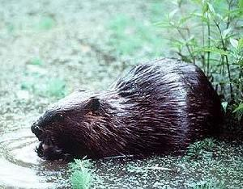

|  |  |
| --- | --- |
| **rekognition** | View raw json (1.13s) |
| **rekognition_tags** | Animal (.96) , Mammal (.96) , Porcupine (.96) , Rodent (.96) |
| **rekognition_matching_tags** |  |

image_binocular.jpg

desired_tags: binocular

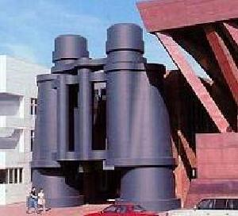

|  |  |
| --- | --- |
| **rekognition** | View raw json (1.06s) |
| **rekognition_tags** | Binoculars (.81) , Architecture (.54) , Building (.54) , City (.51) ,Town (.51) , Urban (.51) , Downtown (.51) |
| **rekognition_matching_tags** | Binoculars (.81) |

image_bonsai.jpg

desired_tags: bonsai

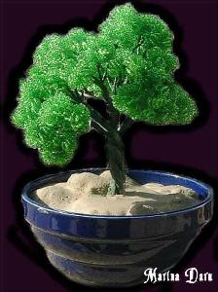

|  |  |
| --- | --- |
| **rekognition** | View raw json (.99s) |
| **rekognition_tags** | Bonsai (.99) , Flora (.99) , Jar (.99) , Plant (.99) , Potted Plant(.99) , Pottery (.99) , Tree (.99) , Vase (.99) , Bowl (.76) , Weed(.58) , Furniture (.51) , Tabletop (.51) , Moss (.51) |
| **rekognition_matching_tags** | Bonsai (.99) |

image_brain.jpg

desired_tags: brain

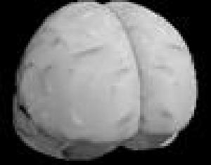

|  |  |
| --- | --- |
| **rekognition** | View raw json (.82s) |
| **rekognition_tags** | Ct Scan (.56) , X-Ray (.56) |
| **rekognition_matching_tags** |  |

Stats

On time taken, and number of tags returned. Note that Cloudsight returns captions, not a list of tags, so those counts appear as zero.

|  |  |  |  |  |  |  |  |  |
| --- | --- | --- | --- | --- | --- | --- | --- | --- |
| **Vendor** | **mean_response_time** | **stdev_response_time** | **mean_tags_count** | **stdev_tags_count** | **mean_matching_tags_count** | **stdev_matching_tags_count** | **mean_matching_confidence** | **stdev_matching_confidence** |
| **rekognition** | 0.99 | 0.23 | 7.50 | 5.77 | 0.50 | 0.50 | 0.40 | 0.42 |