***Attention students:***

***In order to demonstrate successful completion of all components in the project, please use screenshot(s) to show each completed action step as specified on the instructions page.***

**Identity and Access Management**

1. Proof of Assigned roles and AD assignments
   1. Andrew

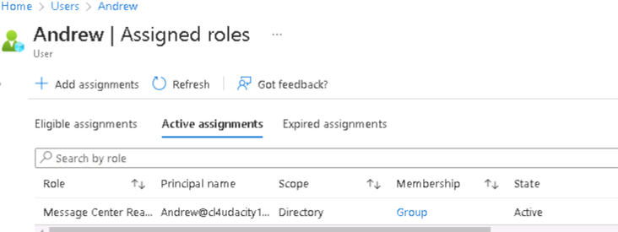

* 1. Chris

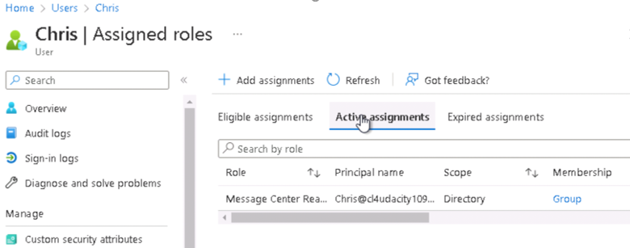

* 1. Karl

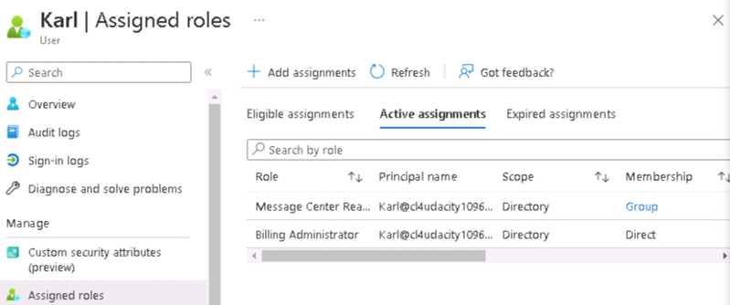

* 1. Lora

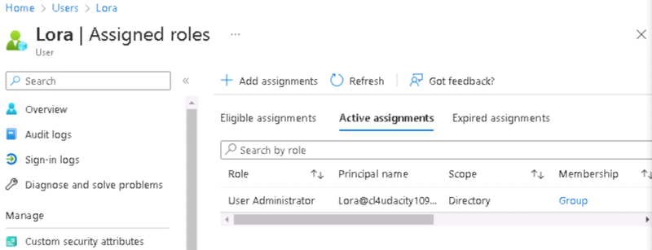

* 1. Neelima

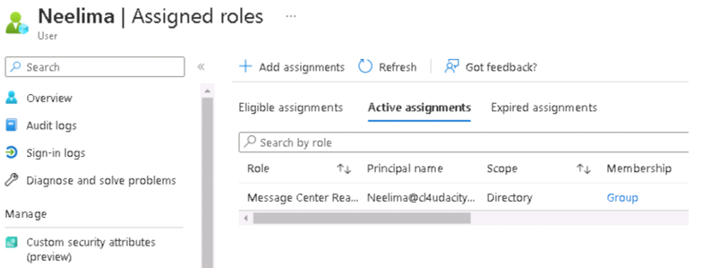

* 1. Neha

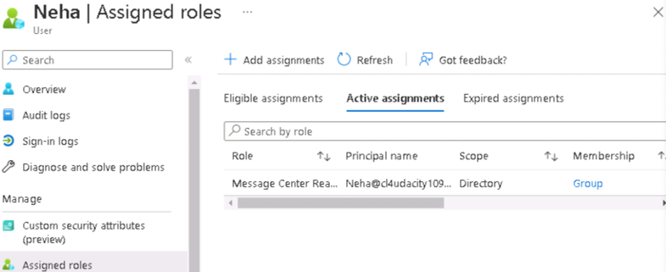

* 1. Seth  
     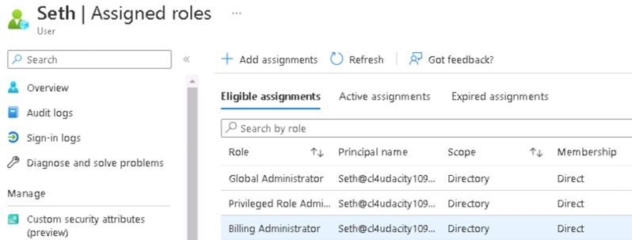
  2. Srinadh

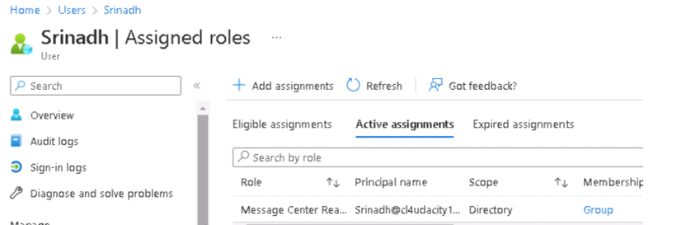

* 1. Tom  
     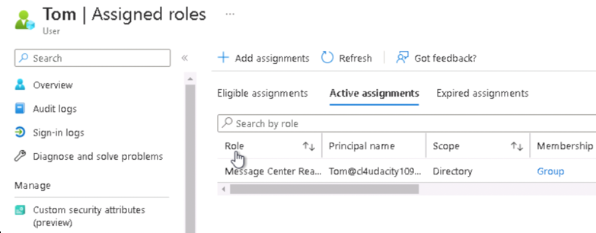
  2. Winifred  
     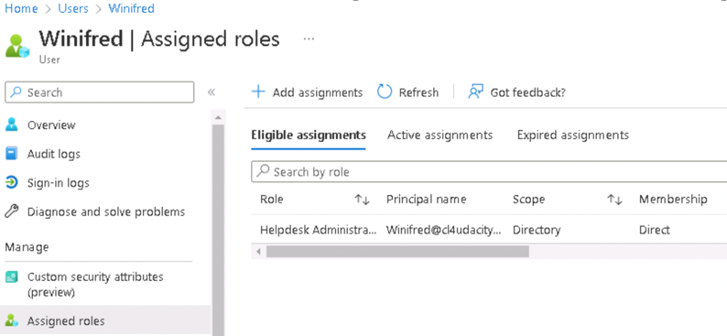

1. Proof of Global Administrator setting with duration, eligibility, expiration  
   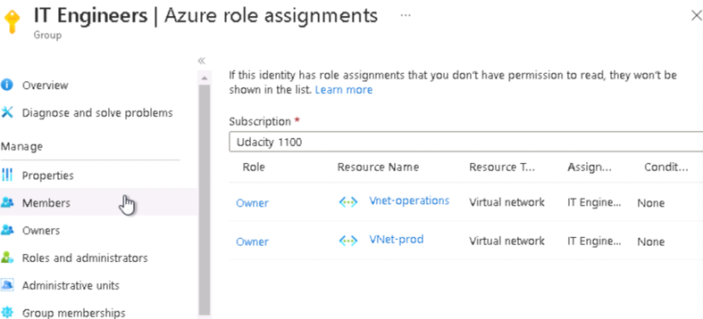  
   IT Engineerings member  
   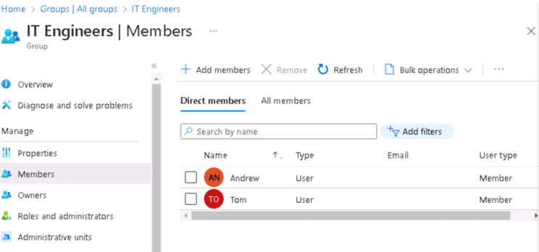
2. Proof of Conditional Access policy all users  
   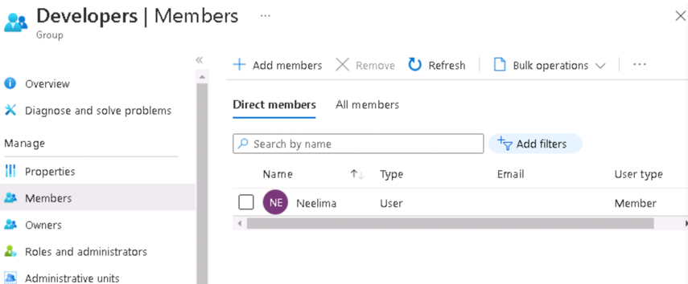  
   Developers role  
   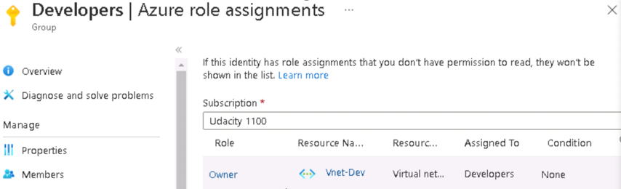
3. Proof of Multi-factor authentication(14 days, Charlotte office info)

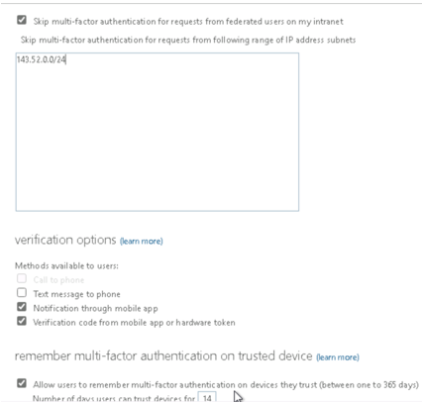

**Network Security**

1. Bastion overview   
   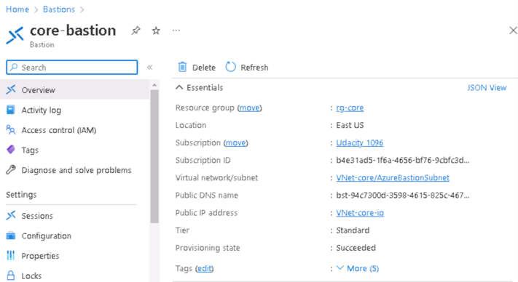
2. Proof of public IP addresses removed  
   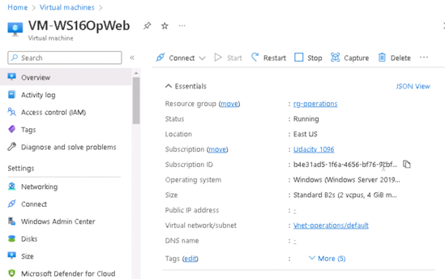

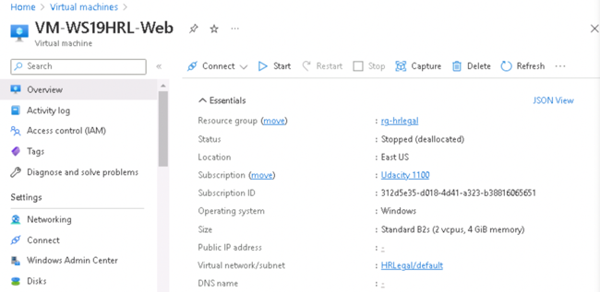

**Data and Encryption**

1. Proof of Encryption types for VM ( devapp,OpWeb,HRL-App,OPApp, HRL-Web)

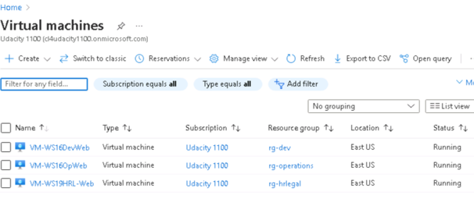

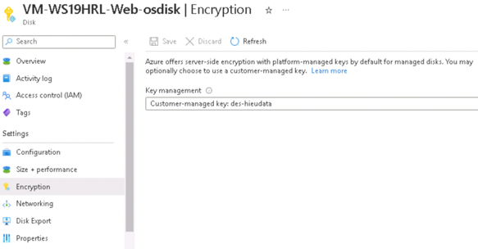

1. Firewalls and virtual networks page
   1. Proof of no public access and TLS for SQL servers(prod, dev)  
      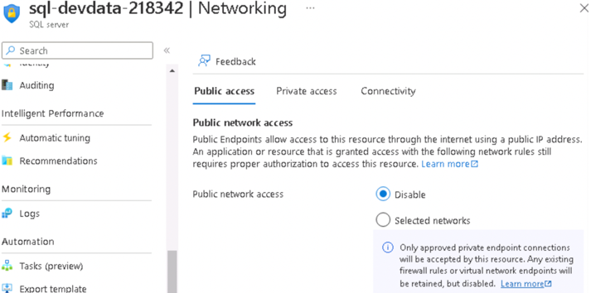

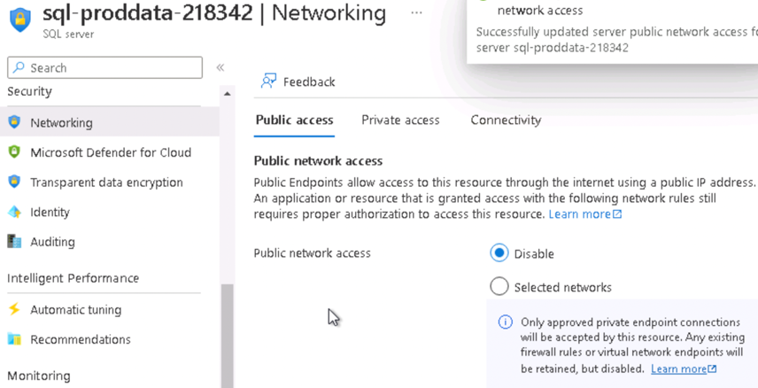

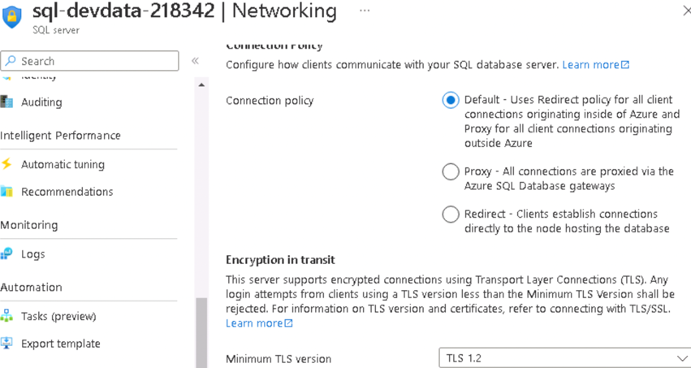

1. Proof of Azure Defender SQL server enabled(prod, dev)

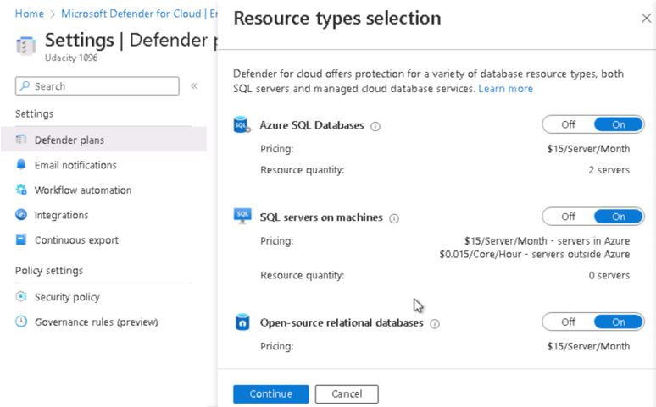

1. Proof of Azure AD authentication for SQL enabled(prod, dev)  
   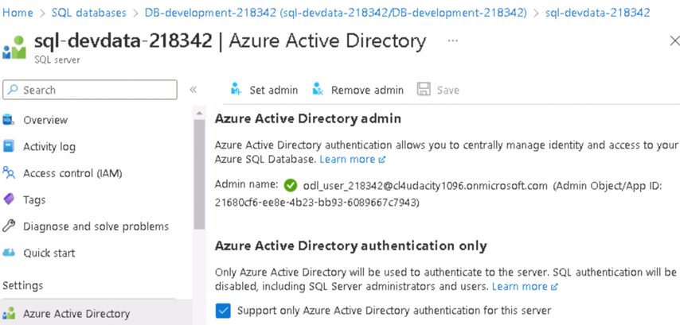

**Cloud Protection**

1. Proof of IaaSAntimalware enabled ( devapp,OpApp,HRL-Web, HRL-App,OpWeb)

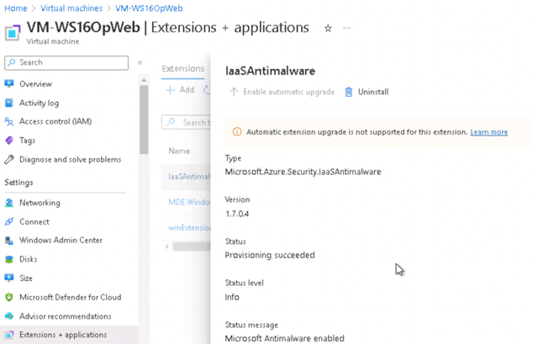

1. Recommendations

* MFA should be enabled for all subscription accounts.   
  =) We need to enable MFA to enhance security.
* There should be more than one owner assigned to subscriptions.   
  =) We need to add more owners to ensure redundancy in administrative access.
* Accounts with owner permissions should have MFA enabled.   
  =) To safeguard owner accounts, we need to do that. We can enable MFA by defaults or enable it on a per-user basis.

**Monitoring**

1. Proof of Azure SQL auditing with Log analytics (devdata,proddata)  
   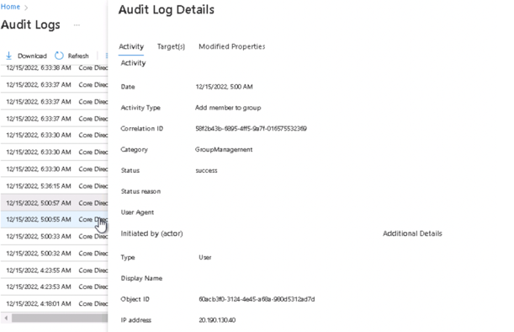

This is the audit log entry for the activity type "Add member to group." It occurred when a new user was added to a group. We can see who added this user to the group and what changes were made.

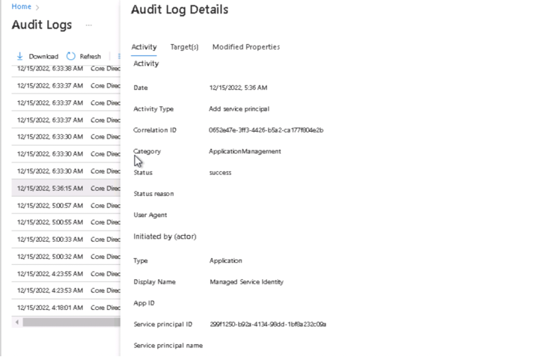

This log records whenever a new service principal is added to the system. We can review when it was created and what was created.

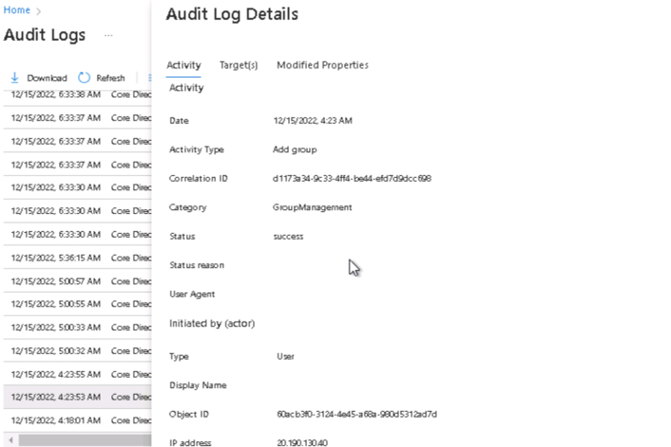

This is the audit log entry for the activity type "Add new group." It occurred when a new group was added. We can see who added this group and what changes were made.

1. Proof of Sentinel connectors (2+)  
   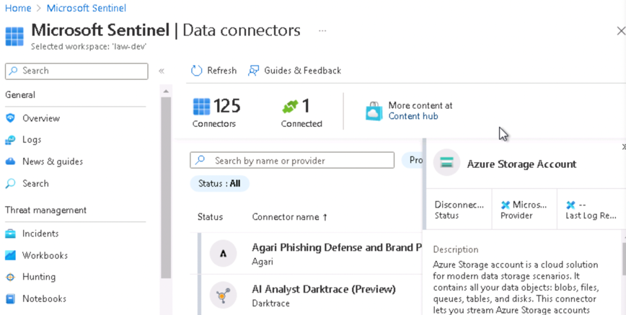

**Compliance**

1. Proof of NIST SP 800-53 rev4 policy added  
   