Final Project Description

Specification

Your final project is to create a web page that matches the example given here. Your page must match mine exactly other than the title and any parts that have been highlighted in yellow. (If you would like to open this image in a separate window you can find it [here](http://www.intro-webdesign.com/HTML5/HTML5project.png). If you need help with this content due to difficulties accessing the text, you can find a textual description of the image below at <http://intro-webdesign.com/projectdescription.html>.)

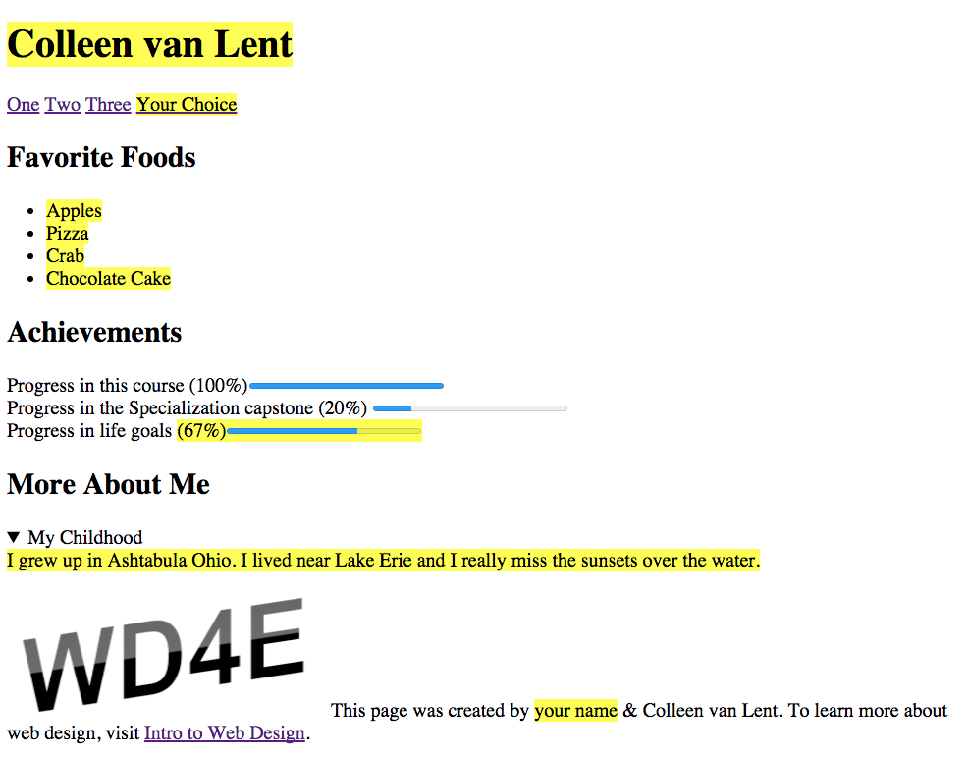

## Grading Checklist

1. **doctype**
2. **head**
3. **body**

* **nav -- add four links, they can go to anywhere you like or nowhere at all**
* **section - Favorite Foods**
* **section - Achievements**
* **section - More About Me**

1. **footer - The image from the footer can be found at my website:**<http://www.intro-webdesign.com/images/newlogo.png>

## Peer Grading

For this assignment you will be grading the submission of your peers and they will be be grading your work as well.

Please note that you must get this COMPLETELY correct to receive credit. You will get frustrated. You will put in silly mistakes. But hang in there. And don't forget to reach out for help if you need it.