###### 1 OVERVIEW

1.1 **Business Goals**

It is required to streamline grade calculation process throughout university sections so as to save on professors’ and student time. It is required that the system will relief university staff from the hectic job of gathering grades by email from professors and then going through the data calculations by hand to calculate students GPAs.

The system allows calculating and managing Student GPA. The system will generate user login and transaction tracking module for the auditing purpose. System must be able to generate reports (Here create to generate grade card, Student Details, and Course VS Student report) for all the levels of users.

1.2 **Business Process Overview**

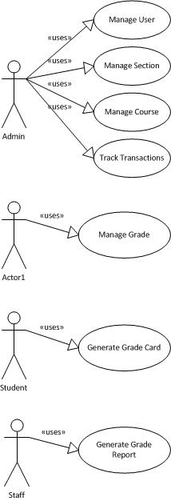

1.3 **Objectives of System**

The main business processes required to achieve this functionality are: Manage Users, Manage Grades, Manage Courses, Manage Sections, Generate Grade Card, Generate Grade Report and Track Transactions.

**2 BUSINESS PROCESS**

2.1 **Process map**

#### Generate Grade Report Process

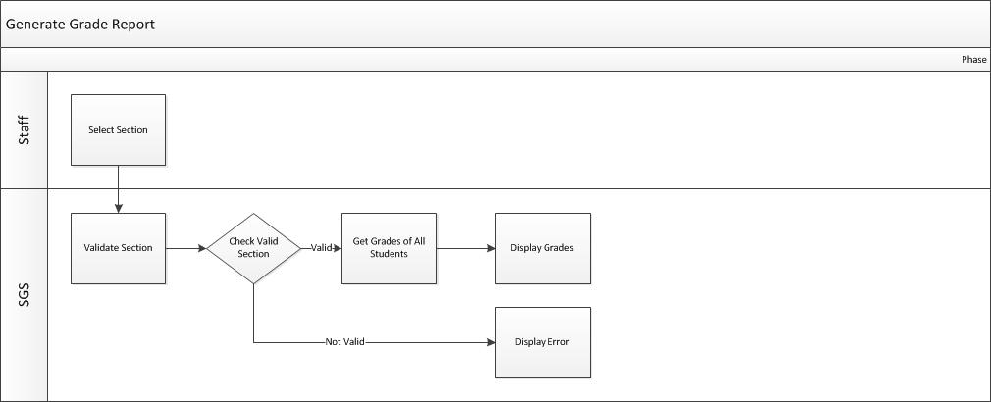

2.2 **Business Functions**

* Select Section
* Section Validation
* Get All Grades for Section
* Display All Grades for Section
* Display Error

3 BUSINESS FUNCTIONS

3.1 **Functional Overview**

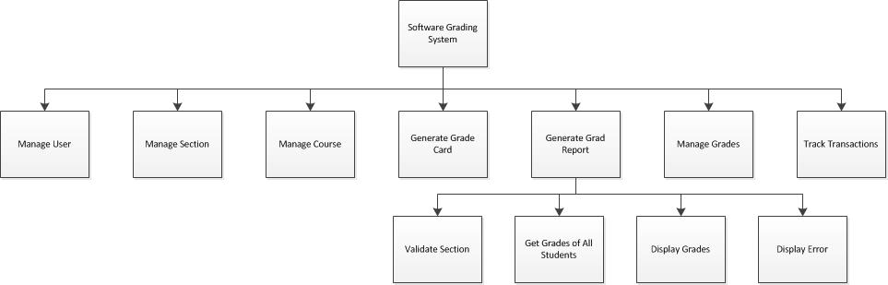

3.2 **Functional Requirements**

**3.2.1 Validate Selection**

Description of the function

Validates the user selection of the section.

Roles

Staff member

Input

Section Selection

Output

If section selected was a valid section or not

Flow of Events

|  |  |  |
| --- | --- | --- |
| **Sequence No.** | Role’s Action | System Response |
| 1 | Staff enter his/her selection of the section number | Validated the entered section number returns valid or invalid |

Business Processing Rules

* Selected section ID must exist in database before selection happens

Transaction Volume

10 transactions per month

**3.2.2 Get Grades for All Students**

Description of the function

Retrieves grades for all students in section.

Roles

SGS

Input

A valid Section ID

Output

A list of Student IDs and their respective grades for the input section

Flow of Events

|  |  |  |
| --- | --- | --- |
| **Sequence No.** | Role’s Action | System Response |
| 1 | SGS pass section ID to proper query | The query retrieves the required output from the database |

Business Processing Rules

* Selected section ID must exist in database before selection happens
* A professor must have entered the grades early on to the system for that specific section

Transaction Volume

10 transactions per month

**3.2.3 Display Grades**

Description of the function

Display grades for all students in section.

Roles

SGS

Input

StudentID/Grades List

Output

Displays a table representing the list to the screen

Flow of Events

|  |  |  |
| --- | --- | --- |
| **Sequence No.** | Role’s Action | System Response |
| 1 | SGS pass Grade List to display handler | Display handler display the list as a table on the screen |

Business Processing Rules

* None

Transaction Volume

10 transactions per month

**3.2.4 Display Error**

Description of the function

Display Error.

Roles

SGS

Input

Error message

Output

Displays an error message to the screen

Flow of Events

|  |  |  |
| --- | --- | --- |
| **Sequence No.** | Role’s Action | System Response |
| 1 | SGS pass Error message to display handler | Display handler displays the error message to the screen. |

Business Processing Rules

* None

Transaction Volume

10 transactions per month

The Following Sections were not filled as we understood the three first sections are required for this assignment.

**4 OTHER REQUIREMENTS**

Document the details of other requirements pertaining to:

* Technical requirements
* Generic requirements that support across functions

The typical requirements are documented as follows:

1. SYSTEM PERFORMANCE

State the required system performance, if applicable. Specify the following:

- System response and turnaround time (include definition of the response time and turnaround time)

- System availability (e.g. operational hours for normal working days, weekends and public holidays)

1. SECURITY REQUIREMENTS

- Specify user groups that can have access to the application and the various functions and data within the application; List any other security requirements (e.g. user authentication and mechanism, encryption and key management control, audit control)

- Specify security classification of the application and data

1. EXTERNAL INTERFACES

For each external interface, describe the data transfer requirements and the characteristics of communication media/systems used for the transfer. For example:

- Data Format, mode and frequency of the exchange of the data transfer

- Security considerations for transfer

- Media of interfacing (e.g. tape, network, diskette, etc.)

- Timing and/or dependencies of the transmitted and received data

- Future needs of interface systems (if any) which may have impact on the proposed system

1. ARCHIVAL REQUIREMENTS

State the following :

- Retention period for each type of information

- Actions to be taken after the retention period (eg. to transfer to off-line media, or to delete them)

- If transfer to off-line media, state the period to be stored and the types of storage media (e.g., tapes, diskettes, reports etc.)

- Reasons for the proposed archival policy (if necessary)

1. CONTINGENCY REQUIREMENTS

For critical business functions, specify :

- Tolerable downtime

- Types of records, frequency (daily, weekly etc.) and retention period of the backup

- Fallback mechanism to continue operations during downtime (eg. switch to another alternative computerised system, rely on localised processing, resort to manual procedures, etc.)

1. CONVERSION REQUIREMENTS

State existing manual or computerised files (eg. text or graphics) to be converted. If required, document the following information :

- Conversion approach (eg. one time or in stages, impact on the existing operation routine)

- Types of records and data to be converted

- Conversion rules (eg. old code no. to new code no.)

- Cut-off date of how far back the data should be converted

- Types and no. of conversion reports required assumptions (eg. exclusion of some fields or records for conversion, storing the unconverted records on the specific media)

1. STATUTORY REQUIREMENTS

Highlight statutory/regulatory requirements and constraints such as laws or critical policies or procedures.

# 5 SYSTEM/OPERATING ENVIRONMENT

Define the system environment and network infrastructure. Illustrate with diagram (if needed) to describe user location with respect to the host system/server and input/output equipment and document the following :

a) Communications Overview

Specify the method of communication that will support the system (e.g. network layout and features)

b) Hardware Requirements/Configuration

Specify the hardware requirements/configuration, which include number of workstations, peripherals and customer location for installation of hardware.

c) System Software

List the system software required (eg. operating system, utilities) and indicate version/release number and other pertinent details.

6 ASSUMPTIONS AND LIMITATIONS

State and explain any assumptions or limitations that will have impact on the scope, design and implementation of the proposed system.

7 USER INTERFACE DESIGN CONCEPT

Document the user interface design concept/standard for the system. For Web Applications, document the design theme for the web page and describe the design concept for the following :

* Background
* Screen layout (provide sample, if necessary)
* User interactions
* Text font / style
* Icons
* Buttons
* Frames
* Header / Footer / Terms and Conditions

###### 8 SCENARIO FLOW / USER INTERFACE DEMO

Describe the typical scenario of an end-to-end user experience by putting yourself in the user’s shoes. For each role, focus on a targeted set of users who are ready to perform a transaction. Think through the likely/commonly occurred scenarios these users will need to perform. Depict the flow in terms of inter-linked screens/web pages that allow the user to complete a transaction from end-to-end as shown below:

