Drone Control and Simulation

Final Report - Extra

August 22, 2019

Prepared by:
Eric Zhang

Introduction
Advances in quadrotor technology have skyrocketed, allowing their potential to continue to grow the past few years. The clear next step is automation.

Problem Statement
Programming a set of controls to fly a quadrotor is difficult, even if it’s meant for use with an external controller. This report aims to clarify the process of designing such a controller for a quadrotor.

Sensors
Ultrasound sensor (US) – measures altitude by pinging sound and measuring Δt before its echo.
Bottom camera – uses optical flow (tracking how objects move) to calculate horizontal speed.
Barometer – used to measure altitude when US is out of range; low pressure→high altitude
Inertial Measurement Unit – measures acceleration and angular velocity
Front camera – for the user.

Rotor Design
Rotors are placed in an “X”, with opposite rotors spinning in the same direction. This allows for the independent control of thrust, roll, pitch, and yaw.
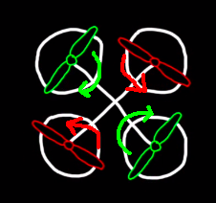

Figure 1. Opposing rotors spin in the same direction.

The Control Problem
How to control the 4 rotors, given the sensors available?

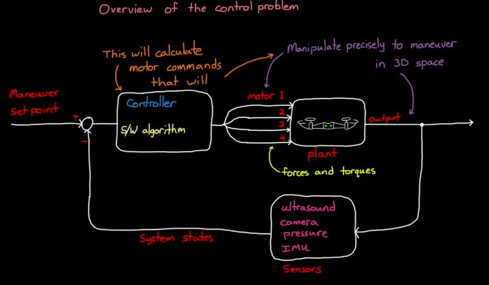

Figure 2. Diagram of the basic idea behind controlling a drone.

Error Bounds
In the case of a hovering drone, it is a good idea to set error bounds – whenever the drone’s sensors receive data that ends up outside the bounds, it would correct itself. The most simple example would be hovering at a fixed altitude at x meters. If the drone’s ultrsound sensor detects outside 0.98*x and 1.02*x, for example, the drone would apply more or less thrust to fall back inside the range. There is a lot more to fine-tune on this topic, but recognizing and responding to error bounds are the most basic yet important part of drone autonomy.

Simulation
It is not feasible (or cost-effective) to test a drone by physically flying it. Simulation is a good way to get a rough idea of how well a drone flies in certain environments. By creating a simple model (in software like Simulink, for example), one can slowly work to develop a controller for the drone and build upwards, taking time to focus on important aspects rather than trying to avoid crashes. Additionally, because thrust, roll, pitch, and yaw are independent of each other, it is easy to develop each controller separately, which is helpful. This, combined with the quickness of feedback (from simulation), greatly speeds up development time.

Conclusion
Quadrotor control is a complicated topic. With the help of simulation tools and good hardware design, it becomes fairly straightforward to build and test a set of controls for a quadrotor.

