Drone Control and SiMuLaTiOn

Final Report

August 22, 2019

Prepared by:
Clark Harrison Dy
Eric Zhang

Introduction
Advances in quadrotor technology have skyrocketed, allowing their potential to continue to grow the past few years. The clear next step is automation.
Problem Statement
Programming a set of controls to fly a quadrotor is difficult, even if it’s meant for use with an external controller. This report aims to clarify the process of designing such a controller for a quadrotor.

Sensors
Ultrasound sensor (US) – measures altitude by pinging sound and measuring Δt before its echo.
Bottom camera – uses optical flow (tracking how objects move) to calculate horizontal speed.
Barometer – used to measure altitude when US is out of range; low pressure→high altitude
Inertial Measurement Unit – measures acceleration and angular velocity
Front camera

Rotor Design
Rotors are placed in an “X”, with opposite rotors spinning in the same direction. This allows for the independent control of thrust, roll, pitch, and yaw.
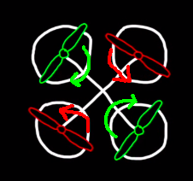

The Control Problem
How to control the 4 rotors, given the sensors available?

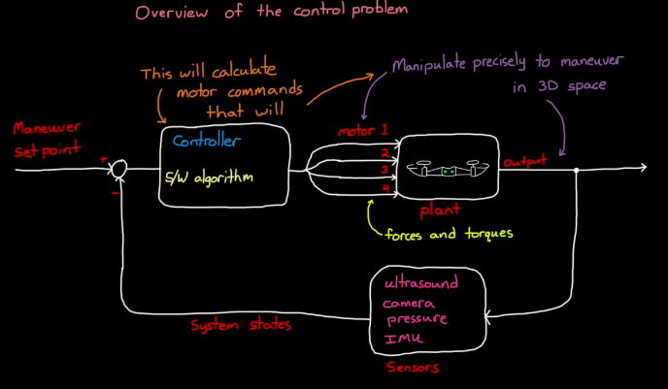

Error Bounds
In the case of a hovering drone, it is a good idea to set error bounds – whenever the drone’s sensors receive data that ends up outside the bounds, it would correct itself. The most simple example would be hovering at a fixed altitude at x meters. If the drone’s ultrsound sensor detects outside 0.98*x and 1.02*x, for example, the drone would apply more or less thrust to fall back inside the range. There is a lot more to fine-tune on this topic, but recognizing and responding to error bounds are the most basic yet important part of drone autonomy.

Simulation
It is not feasible (or cost-effective) to test a drone by physically flying it. Simulation is a good way to get a rough idea of how well a drone flies in certain environments. By creating a simple model (in software like Simulink, for example), one can slowly work to develop a controller for the drone and build upwards, taking time to focus on important aspects rather than trying to avoid crashes. Additionally, because thrust, roll, pitch, and yaw are independent of each other, it is easy to develop each controller separately, which is helpful. This, combined with the quickness of feedback (from simulation), greatly speeds up development time.

Conclusion
Quadrotor control is a complicated topic. With the help of simulation tools and good hardware design, it becomes fairly straightforward to build and test a set of controls for a quadrotor.

Problem Statement
Our goal is to be able to use Computer Vision (with the OpenCV library) in order to control the AR.Drone 2.0 (the drone) autonomously. The drone had limited battery capacity, and so we only had limited testing time per recharge. Additionally, during the testing phase, we need to be connected to the drone via wifi in order to send the drone instructions, and since we intend on testing the drone’s functions while it is flying, we are unable to conduct testing inside the computer lab.

Drone Control
In order to control the drone, or robots in general, is with a collection of libraries bundled together into the Robot Operating System (ROS). Data is published and received through “topics,” a hub for information to be received from and given to by “publishers” and “subscribers” respectively. For example, information is published from the drone’s camera and read by an external program, which would send instructions to the drone via wifi (Figure 1).

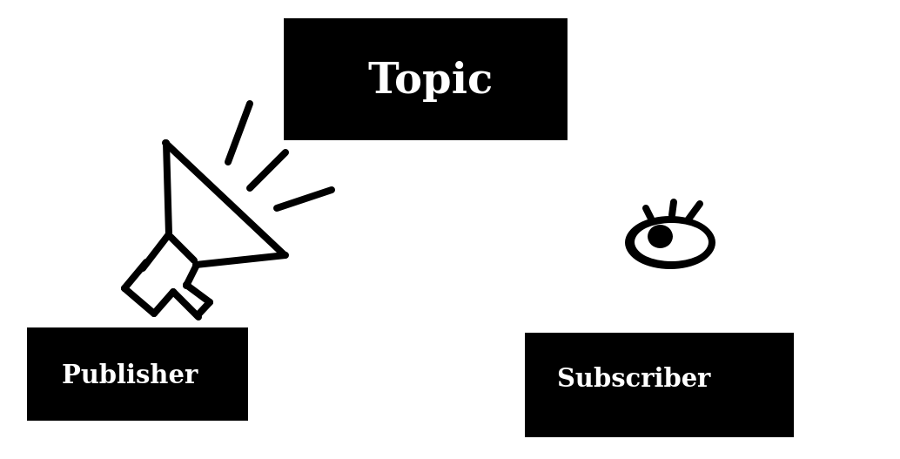
Figure 1: Publisher-Subscriber Relationship via Topic

Testing Process
Previously, we have mentioned that we were unable to pilot the drone inside the computer lab since it would be dangerous for the drone and the people within the lab. In order to partially remedy this problem, we installed a virtual machine running Ubuntu 16.04 on a laptop. This allowed us to pilot the drone in a relatively open space outside. The drone was flown in different environments, such as a grass field or a spacious indoor room within the Electrical Engineering building. However, many issues came with using a virtual machine. It was excessively difficult to transfer files to the virtual machine, using a shared folder that required the commands:

/media$ sudo cp sf_shared/file ~/drone_ws
/media$ cd ~/drone_ws
~/drone_ws$ sudo chmod 666 file
~/drone_ws$ sudo chown eric file
for every file, where “eric” is the user name. Essentially, the folder was read-only and all ownership rights had to be transferred as well as permissions granted. Otherwise, make (for c++, the language we used) would fail (since vm user eric has no read or write permission). Additionally, the virtual machine took a heavy toll on the laptop’s resources, resulting in it being slow and unresponsive. This was especially apparent in later test programs that would read and display images from the drone's camera and run an object tracking algorithm. However, virtual machine was the only real solution apart from lugging a desktop setup to another room. Our primary goal was to read data from the drone. This led to the creation of a status updater program (Figure 2a) and a camera feed program (Figure 2b). After connection was established, we needed that commands could be given to the drone. This led to the basic key-input program that allowed for drone control (Figure 2c).

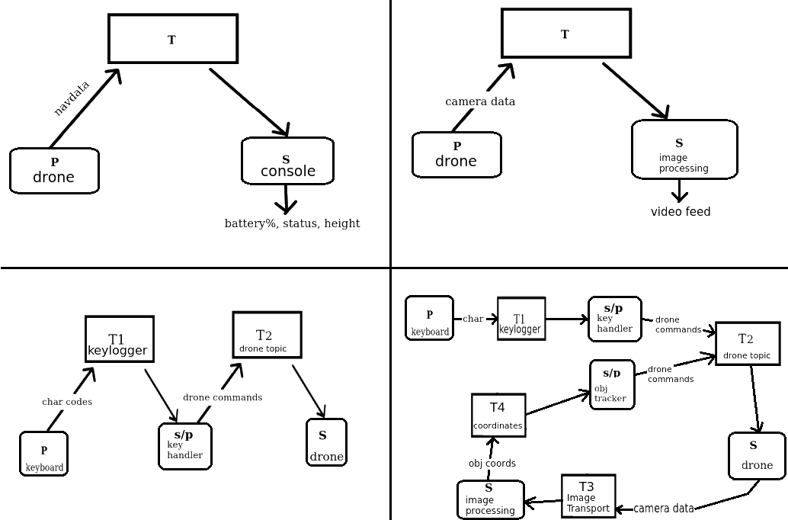
Figure 2 (Left to Right, Top to Bottom): a) Read Navdata from drone. b) Read Camera data from the drone. c) Keyboard Controller. d) Use feedback from drone’s camera

We were unable to implement an object tracking program, as outlined in (Figure 2d), combining the keyboard controller, with an option to enter “Follow Mode” that uses the drone’s camera to track an object and control the drone as a response to the image processing algorithm. This was mainly due to an unforeseen technical issues with the drone’s camera, which suddenly stopped working.

Conclusion
By the end of the program, we were able to successfully send instructions and receive information from the drone. As such, we were able to build a keyboard controller in order to fly the drone from a computer via wifi, as well as view a video feed from the drone’s front and bottom camera. Additionally, we were able to make significant progress in computer vision, having the drone autonomously track an object using an image processing algorithm built with OpenCV. Unfortunately, we were unable to test the final program, which included the “Follow Mode” feature, due to unforeseen technical issues with the drone. However, the initial tests showed lots of promise, and we are certain that our program would allow a drone to hover over an object.

