**Developer Challenge - Marvel**

1. After cloning the repository
   1. Open Terminal (Command Prompt) - Not as administrator

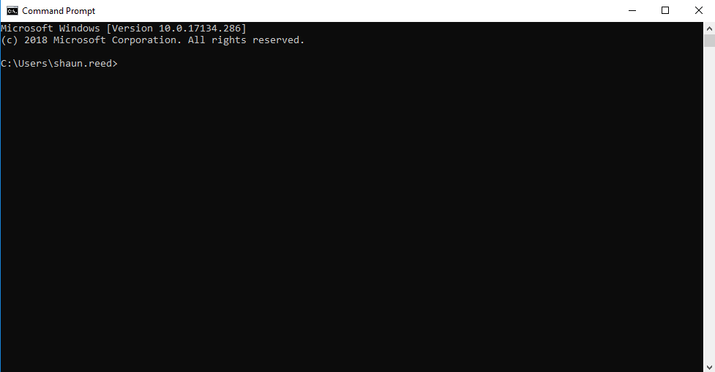

* 1. Within the terminal, access the location or path of the repository.
     + - * An example here below

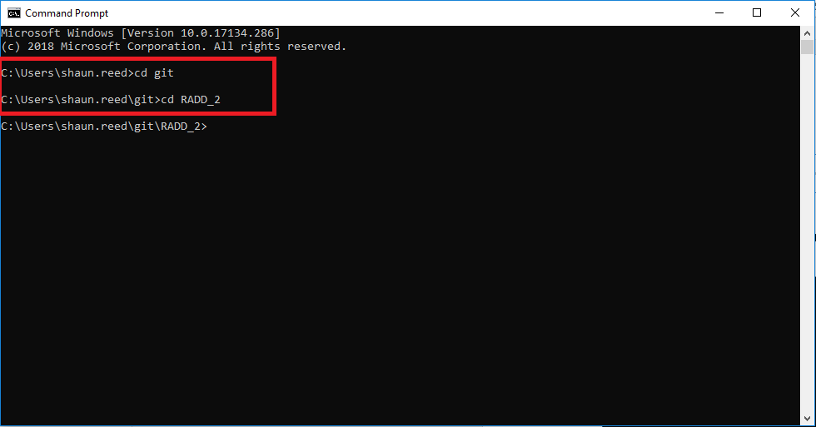

* 1. Within the terminal, access the location or path of the project.
     + - * An example here below

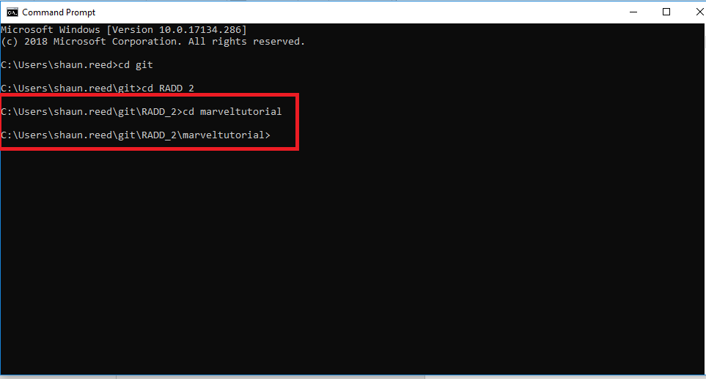

* 1. Within the terminal, run the **marvel_index.js** file. The **default port** for the application is 8080, but if the port is in use or if the port is closed, the port will change. The port number will show in the terminal.
     + - * An example of starting up the application through the server:

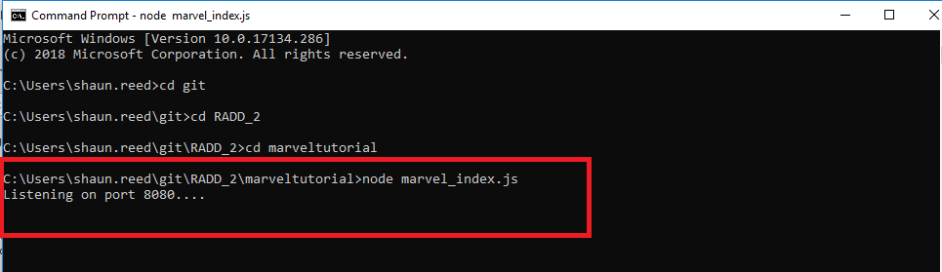

* 1. Open a browser (IE/Chrome/Firefox), clear the address bar if it has text or address in it and type in **localhost:8080.**
* An example of how it will look in address bar (Chrome browser used in this example).



* 1. After pressing Enter on the keyboard, the application will look like this:

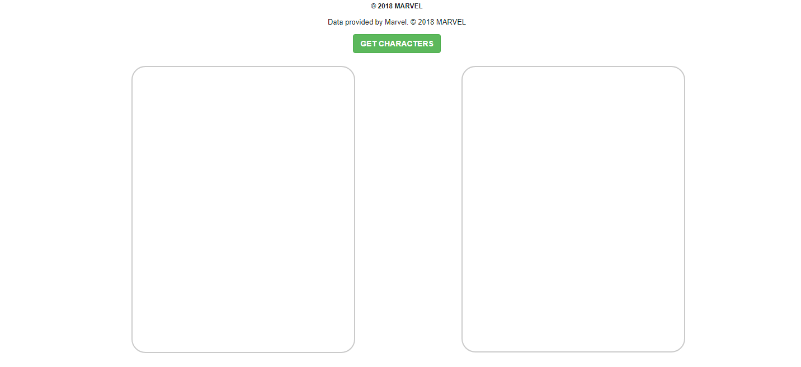

* 1. After clicking on the **GET CHARACTERS BUTTON**, the application will look like this:

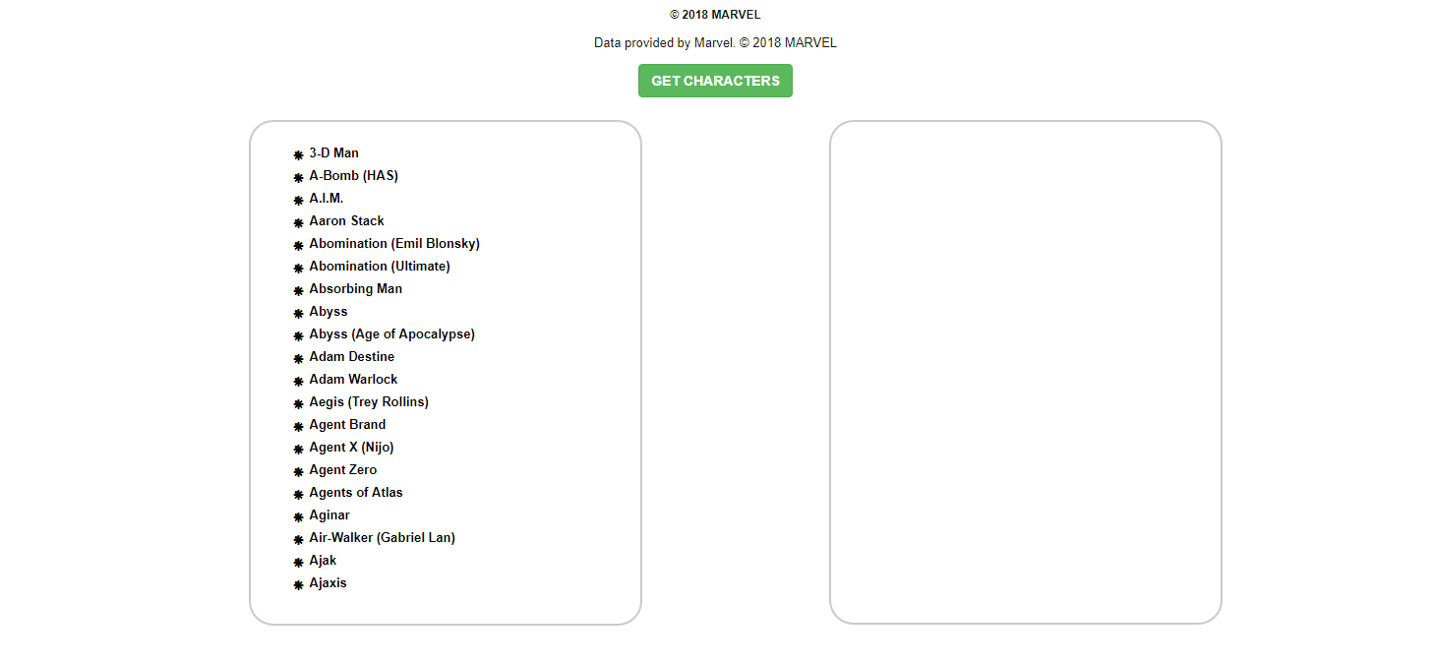

* 1. After clicking on of one of the characters in the box on the left, the application will look like this:

