Pacemakers:
A Life Changing Evolution
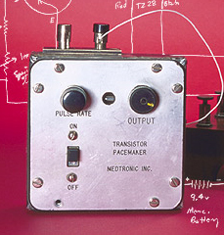

Maynard W. Solliday

Fort Hays State University
December 5, 2010
Technology in Society - IDS 390
Instructor - Joseph Chretien
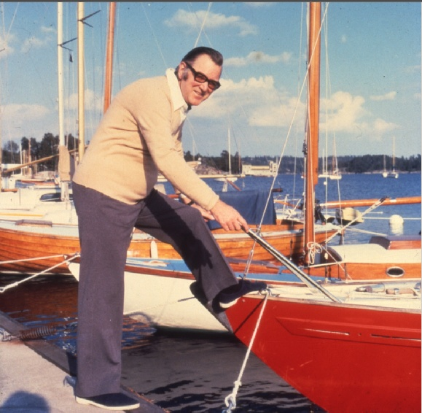
In 1958, Dr Jorge Reynolds performed a life-changing surgery on Arne Larsson (Wickstead). Arne Larsson was the first person to receive an implantable pacemaker at the age of 43, however it failed three hours later. The following day they implanted a similar pacemaker, which also failed shortly after implantation. Suffering from heart blockage due to Stokes Arne luckily did not suffer an attack for the following three years when another pacemaker was implanted. When Arne passed away, due to an unrelated issue, in 2001, he had undergone twenty-four pacemaker surgeries (Ryden, Schuller, and Larsson; Mohee). This was the beginning of a technology advancement that has aided thousands of people throughout the world in leading normal and fulfilling lives.
It is highly debatable who created the first pacemaker. Some believe it was Dr. Albert Hyman while others feel it was Mark Lidwell and Major Edgar Booth (UNC). Regardless of who created the first pacemaker, this technology has gone through very extensive advancements over the centuries. There is documentation as far back as 1778 of The Humane Society of London performing the first resuscitation of a child that fell from a window via electroshock (Biotele LLC.)
In 1929 Mark C. Lidwill told an audience that in 1926 he used a primitive model of a electrical heart stimulating machine to revive one of several stillborn infants. Despite the success and his notoriety, there was no interest or further pursuit of his discovery (Mohee).
In 1930 the first “artificial pacemaker” was developed and patented by Albert S. Hyman and his brother, Charles (Biotele; "Albert Hyman"). The device was not accepted by the medical community and was only used in the New York area, despite press coverage.
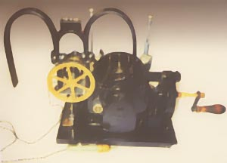
The Hyman brothers' pacemaker was a hand crank device that turned a magneto to create electricity. In 1932 Albert created a more refined machine that was portable, and had a battery. It was used forty-three times in less than a month with fourteen successful treatments (Biotele).
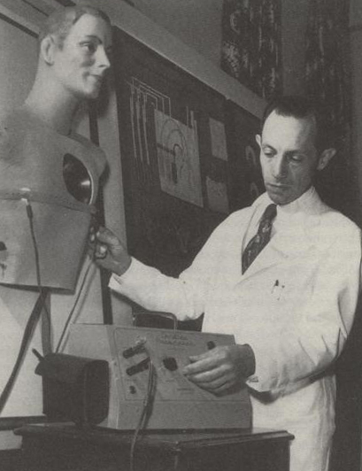
In 1952, Dr Paul M. Zoll, proved to the medical community and the public that with electrodes on the bare chest running a burst of electricity of 100-150 volts every 2 milliseconds can stimulate a systolic heartbeat. With this knowledge fundamentally understood, the technology of pacemakers began its expedient transition into the technology we know today (Mohee).
Nearly ten years later, on the 19th of May, 1959, a 67 year old man with a complete heart block underwent surgery to insert a transvenous lead via cephalic vein cut down, which means they inserted a cable into his heart through a vein in order to use a pacemaker. He was released from the hospital June 23rd of the same year as an outpatient and lived for another three years.
In 1957 a power outage in Minneapolis caused a hospital to lose power and since hospitals were without power backups at the time, they were unable to use the typical pacemakers on patients. This brought Dr W. Lillehei, to request Earl Bakken and Medtronic to develop a pacemaker that could run off a battery backup to ensure that power failure could not cause patients harm. Bakken, over the course of several weeks, developed and produced a pacemaker that was self contained and was roughly the size of a pack of cigarettes (Mohee).
The pacemaker had the technology to sense rapid cardiac activity and could also vary its output and evaluate lack of electrical transfer. There was also a connector for an audio cable and the pacemaker had to be carried around by the patient. There was no internal infection, but there was superficial infection that needed treatment commonly.
These treatments lead to the research that was used to develop some of the technology that created the first practical pacemaker which was used in 1958 for Arne Larsson (Mohee).
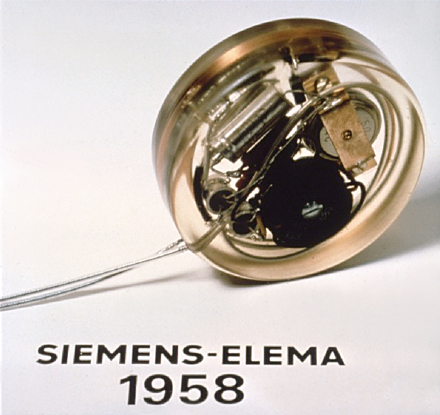
In 1960, on the 3rd of February, a woman was told her only chance at surviving a complete heart block and recurring Adams-Stokes episodes was to try an experimental operation involving an implantable pacemaker (Biotele).
The pacemaker was 52.5mm in diameter and 17.5mm thick and weighed 64.3 grams. This made it roughly the size of a hockey puck, resulting in the pace maker being implanted in the abdomen (Arndt; Biotele).
The woman was without any Stokes episodes but nine and a half months later, the cut in her abdomen became infected and she died of Sepsis (Biotele).
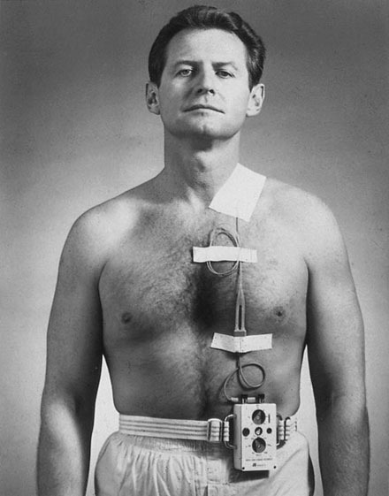
The pacemaker was made fully implantable, then the newly developed radio frequency stimulator, allowed the patient to receive the benefits of the pacemaker without suffering the potential infections and the need to carry the pacemaker themselves. The RF stimulator recharged and altered programing for the pacemaker through the skin.
After a few years, lithium-Ion batteries were developed for the pacemakers, which extended battery life from several days to nearly ten years.
The technology used for the RF stimulator actually was expanded to meet other medical needs such as diaphragm pacing, contract paralyzed urinary bladder and muscle sphincters, and enhance hearing with cochlear implants (Biotele).
In 1962 pacemakers were implantable without a thoracotomy, meaning it was no longer necessary to cut open the chest to implant the leads in the heart. This allowed more focus on perfecting the pacemaker itself.
From 1973 to 1980 the pacemaker made leaps and bounds in its usefulness. The battery was changed multiple times from Nickel-cadmium to zinc-mercury oxide then to the lithium battery which became the acceptable standard due to its longevity and the ability to seal the pulse generators which aided in a more reliable pacemaker.
Nuclear powered pacemakers were also experimented with, however a survey of 132 patients that had used this specific type recommended against it due to radiation exposure and potential leaks.
With all the developments that the pacemaker was receiving, some were not so much innovative as re-inventing what was already in use. Programmability had been in existence since 1931 when the General Electric Company had a pacemaker that could be adjusted between 70 beats per minute for rest to 100 beats per minute for activity with a magnet; however, in 1972, Medtronic developed a pacemaker with a gear train and magnets that adjusted the pulse generator.
Shortly after, in 1973, Medtronic created a new interface that could be adjusted through radio frequency signals, this lead to a standard for all manufacturers to create programmable pacemakers. They were able to use hybrid circuitry which allowed the pulse generators to be downsized and the overall power consumption could be reduced with no negative impacts on the patients.
The fact that pacemakers were becoming a more common response to heart related complications caused the creation of the antibradycardia pacing systems code. This set standards for where leads were placed in the heart and how the procedures were performed.
By the 1980s pacemakers were nearly all powered by lithium batteries and used hybrid circuitry and could manage a heartbeat for at least eight years without replacement as a result. Pacemakers began to slowly transition towards being dual-chambered, since testing had shown it alleviates excessive pacing of the right chamber. The doctors were slow to adopt this form of pacemaker simply because the features, stimulus rate, amplitude, and duration where more complex than the doctors were prepared for. By the end of the 80s the majority were still single-chamber.
Pacing for AV Block, caused by a new technique called catheter ablation, caused some rise in pacemaker implantations, but mostly the percentage just went up do to acceptance in the medical community by the end of the 90s (Mohee). Catheter ablation is a minimally intrusive surgery where a tube enters the body through a blood vein in the arm, groin, or neck ("What is Catheter Ablation?").
Over the last ten years pacemakers have been adapted to be multi-chamber devices, they are rate responsive, and even support defibrillation (Mohee).
Newer pacemakers are able to sense electrical pulses that exceed a healthy rate and actually can slow the heart rate by using a small electrical pulse to cause the heart to beat more regular. They can also switch to just the lower chamber to assist in higher heart rates to keep from impeding normal rates. Some pacemakers have been adapted to monitor atrial fibrillation and heart arrhythmia and will adjust its pulses to correct the irregular heart beat.
For those who have abrupt lowering of the heart rate, pacemakers can now detect this occurrence and will kick in with a fast pulses to up the heart rate to around 100 beats per minute to keep them from fainting then will ease back down to a regular rate.
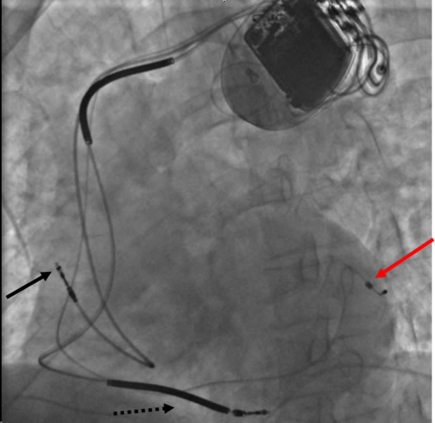
The bi-ventricular pacemaker can actually aid hearts with damage to the nerves or muscle to beat regularly. It needs an extra lead that attaches to the left lower chamber but provides the synchronization that the muscle and nerve damage typically requires to beat normally (Parks).
Modern day pacemakers are close to four centimeters tall, seven millimeters thick, and five centimeters long (Parks).
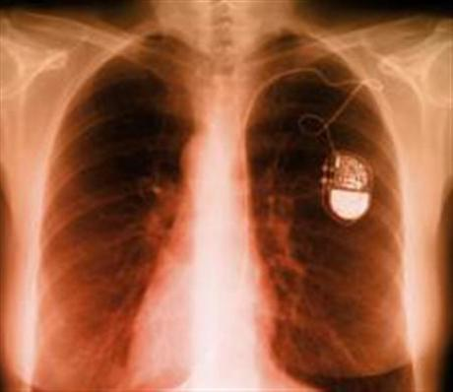
The future for patients that require pacemakers is looking very promising. In Britain, a team managed to create a small generator with two bladders that is attached to one of the leads on the pacemaker. The bladders will compress during a heartbeat and generate power to recharge the battery in the pacemaker.
Their experiment showed approximately twenty percent harvest of electrical power, but they plan to continue developing the generator to use different materials, potentially increasing its yield significantly. This will allow pacemakers to need replaced less often, and could one day lead to a pacemaker that is fully powered off the heartbeat itself, eliminating the need of a battery for typical pacing (Kahn).
The pacemaker has provided a new potential solution to many other illnesses for patients. There has already been a volunteer by the name of Reed S. Kohn as the first man to have a “pacemaker-like” device placed in his brain to attempt to control his epileptic seizures. Within five months he was experiencing an average of ten to fifteen seizures a month which was significantly down from the fifty to seventy that he had before the operation (Arndt).
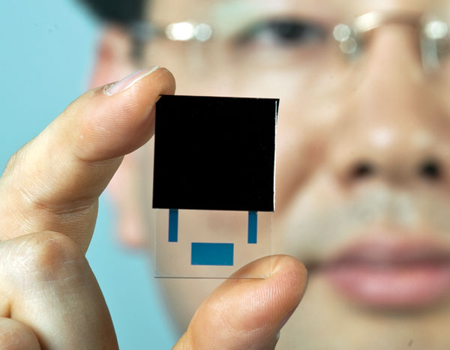
The best innovations are under way and currently being refined. Jae Won Kwon, a professor from the University of Missouri, has developed and been perfecting a new form of nuclear battery. This battery will allow pacemaker sizes to become minuscule and they will no longer be the large bulges that patients must deal with, and they will never need replaced. There will also be no risk of radiation reaching the patient due to the nature of the battery. The nuclear isotopes will be encased in the semiconductor so that the radiation will always strike the semiconductor and not escape the battery. This technology is just waiting for the patents to go through before a manufacturer will be allowed to use it for production ("Master of the Minuscule").
The pacemaker is making leaps and bounds since its basic functionality has reached a stable base point. The technologies that it boasts are nothing less than amazing. The fact that in barely more than fifty years pacemakers have gone from large boxes that made patients nearly immobile and were not always reliable to being able to be implanted in the chest and need replaced once every six to ten years is purely amazing.
This technology is already growing the ability to aid other muscles, nerves, and organs that are either failing or malfunctioning. In the next ten years we will possibly see pacemakers the size of a grain of rice, and one day pacemakers will be as common as corrective laser eye surgery.

"History of Pacemakers." University of North California. 28 Nov 2001. University of North California. 5 Dec 2010 <http://www.unc.edu/~ashesh/physics24/page3.html>.
Ryden, Lars, Hans Schuller, Berit Larsson. "Biography of Arne Larsson"Notable Figures. 17 Jun 2009. Heart Rhythm Society. <http://www.hrsonline.org/news/ep-history/notable- figures/arnelarsson.cfm>
"History of Pacemakers" Biotele LLC. 28 Nov. 2008. Biotele LLC. <http://www.biotele.com/pacemakers.htm>
"Albert Hyman" Wikipedia. 20 Nov. 2010. Wikipedia. <http://en.wikipedia.org/wiki/Albert_Hyman>
Arndt, Michael "Big and Awkward" Special Report. 6 Mar 2006. Business Week <http://images.businessweek.com/ss/06/03/hearthealth/source/2.htm>
Mohee, Kevin. "Cardiac Pacing: A Brief History in the Developement of Pacemakers". Tomorrow's Cardiothoracic Surgeons. Society for Cardiothoracic Surgery. <http://sscts.org/HistoryPacemakers.aspx>
Wickstead, Mark. "Humpback Whales Help Pioneer New Heart Treatment". 4th July 2008. CNN <http://www.cnn.com/2008/TECH/science/07/03/medicine.biomimic/index.html?iref=allsearch>
"What is Catheter Ablation?". Feb 2010. Diseases and Conditions Index. National Heart Lung and Blood Institute. <http://www.nhlbi.nih.gov/health/dci/Diseases/ablation/ablation_whatis.html>
Parks, Robin. "What are some recent advances in pacemaker technology?". 18 Jun. 2009. Health & Wellness. Blue Shield Association. <https://www.blueshieldca.com/hw/articles/hw_article.jsp?articleId=HWTE7163ABC&fromCategoryId=-1&_requestid=242444>
Kahn, Michael. "Hearbeats May Power Future Pacemakers." Rueters. 10 Nov. 2008. <http://www.reuters.com/article/idUSTRE4A94I220081110>
Arndt, Michael "Rewiring the Body". 7 Mar 2007. Business Week. <http://www.businessweek.com/magazine/content/05_10/b3923001_mz001.htm>
"Master of the Minuscule". Spring 2010. Illumination. <http://illumination.missouri.edu/s10/minuscule>

