Features
- User can register with e-mail, password
- Receives mail to confirm account
- Login with mail, password
- When user comes back, his login will be remembered via Token
- Token should expire after e.g. 1 week

Technologies
- Frontend: VueJS
- Backend: Mock Service Worker (temporary), Python Django

Requirements
- Strict separation between FE and BE
- Modular architecture, based on MVC
  - Separation between data & functions
  - Model: Users with Name, e-mail, city
  - Views:
    - Login screen
    - Rergister screen
    - Private member area, where some private information is displayed (e.g. city)
  - Controllers:
    - Auth Service that handles login, logout, register/ Check if user is logged in etc.
    - DB service that handles creation, deletion, modification of user data

Views

Login
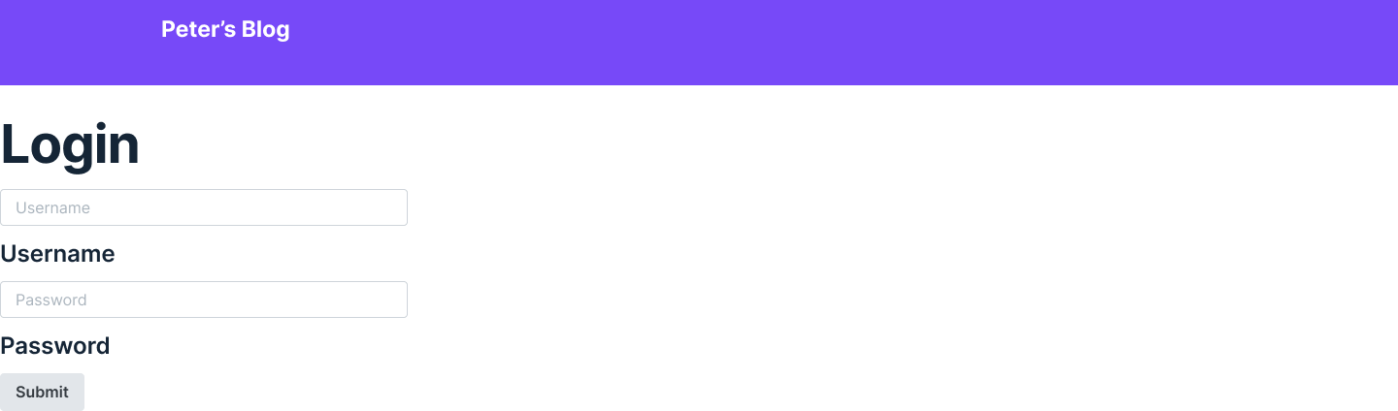

Register

Member Area
Display city of user

