Machine learning for early prediction of subsequent stage 2-3 acute kidney injury in critically ill adults: hospital-disjoint internal-external validation
Cagdas YILMAZ¹ · Ali AKDAGLI¹*
¹ Mersin University, Faculty of Engineering, Department of Electrical and Electronics Engineering, Mersin, Türkiye
ORCID: Cagdas YILMAZ, 0000-0001-6373-2768; Ali AKDAGLI, 0000-0003-3312-992X
* Corresponding author: Ali AKDAGLI, akdagli@mersin.edu.tr
Article type: Article
Article section: General Nephrology
Running title: Early prediction of subsequent stage 2-3 AKI

Abstract
Purpose: To develop and evaluate machine-learning models for subsequent serum-creatinine-defined KDIGO stage 2-3 acute kidney injury (AKI) after a fixed 12-hour landmark in critically ill adults.
Methods: We performed a retrospective study using eICU-CRD. Adults observable at 12 hours without prior stage 2-3 AKI or acute renal replacement therapy were included. The outcome was incident or progressive stage 2-3 AKI from >12 to 72 hours. We evaluated 159 predictors using five-fold hospital-disjoint internal-external cross-validation, fold-specific Platt calibration, and secondary robustness analyses.
Results: Among 58,491 patients from 198 hospitals, 3,032 (5.18%) developed the outcome. Calibrated XGBoost achieved an area under the receiver operating characteristic curve (AUROC) of 0.876 (95% confidence interval 0.868-0.883), an area under the precision-recall curve (AUPRC) of 0.399 (0.375-0.423), and a Brier score of 0.038. Calibration intercept and slope were 0.002 and 1.005. Compared with the strongest parsimonious renal-status comparator, XGBoost improved AUROC from 0.834 to 0.876 and AUPRC from 0.288 to 0.399. At approximately matched alert burden, XGBoost identified 2,247 events versus 2,069 with the creatinine-trajectory comparator specified before its performance was reviewed. With minimum 12- and 24-hour warning intervals, AUROC was 0.842 and 0.795, respectively; pooled calibration was good, but calibration-in-the-large varied across adequately sized hospitals.
Conclusion: Models using routine data available by 12 hours showed strong discrimination and good pooled calibration for subsequent stage 2-3 AKI across held-out hospitals and provided predictive information beyond parsimonious renal status and creatinine trajectory. Independent external and prospective evaluation are required before clinical deployment.
Keywords: Acute kidney injury; Critical illness; Machine learning; Clinical prediction; Internal-external validation; Decision curve analysis

Introduction
Acute kidney injury (AKI) is a frequent and heterogeneous complication of critical illness. In the multinational AKI-EPI study, 1,032 of 1,802 patients admitted to 97 intensive care units (ICUs) in 33 countries developed AKI during the first ICU week when complete Kidney Disease: Improving Global Outcomes (KDIGO) serum-creatinine and urine-output criteria were applied. Increasing AKI severity was associated with progressively worse short-term outcomes. Yet serum creatinine and urine output are delayed, imperfect functional markers influenced by nonrenal factors, and patients with mild early abnormalities may follow very different courses [1-3].
Electronic health record data create an opportunity to identify patients at risk before subsequent stage 2-3 AKI, but the AKI prediction literature remains methodologically heterogeneous. Reviews of adult ICU studies report frequent risk of bias, inconsistent calibration reporting, limited external validation, and reliance on a few reusable databases. Across ICU prediction research more broadly, performance often decreases when models are transferred to new settings. For rare or moderately imbalanced outcomes, AUROC alone can obscure alert burden and positive predictive value, making AUPRC a useful complementary measure [4-8].
Prior AKI models address distinct clinical tasks, including incident AKI, prediction of KDIGO stage 2-3, persistent severe AKI, transient-versus-persistent phenotypes, and progression among patients already meeting AKI criteria. Some studies have reported independent external or prospective evaluation, but prediction landmarks, horizons, baseline definitions, and outcome components differ substantially. Direct performance ranking across these tasks is therefore not warranted. A fixed-landmark design using only pre-prediction information and evaluating performance across held-out hospitals may allow a more direct assessment of early risk of subsequent stage 2-3 AKI [9-15].
We therefore developed and evaluated models to estimate the probability of subsequent serum-creatinine-defined KDIGO stage 2-3 AKI after a 12-hour ICU landmark and through 72 hours. The analysis framework used nested hospital-disjoint internal-external cross-validation, training-only preprocessing, fold-specific calibration, hospital-cluster bootstrap uncertainty, and decision-curve analysis across a predefined threshold range. Secondary analyses examined selection, missingness robustness, incremental value beyond parsimonious renal information, alarm burden, hospital heterogeneity, and exploratory subgroup performance.

Methods

Study design and data source
This retrospective multivariable prediction-model study used version 2.0 of the eICU Collaborative Research Database (eICU-CRD), a deidentified multicenter database of United States ICU admissions collected during 2014-2015. The database was accessed through PhysioNet under credentialing and data-use requirements [16-17]. We designed and reported the study with reference to TRIPOD+AI and TRIPOD-Cluster because the data were clustered across multiple hospitals [18-19].

Participants and analytical landmark
Adult ICU stays lasting at least 12 hours were considered. To avoid correlated repeated observations, a single deterministic eligible ICU stay per patient was retained. The prediction landmark was fixed at 12 hours after ICU admission. Patients were excluded from the primary cohort when a qualifying early reference creatinine was unavailable, chronic dialysis or end-stage kidney disease was identified, KDIGO stage 2-3 or acute renal replacement therapy had occurred by the landmark, or outcome status could not be determined because of early death, inadequate follow-up, or absent post-landmark creatinine measurements. The target population was therefore adults who remained eligible and observable at 12 hours without prior stage 2-3 AKI or acute renal replacement therapy. No formal prospective sample-size calculation was performed because this retrospective study used all 58,491 patients with 3,032 events from 198 hospitals who met the eligibility and outcome-observability criteria; nested hospital-disjoint folds preserved cluster separation.

Reference creatinine and outcome
An operational reference creatinine was defined as the earliest available creatinine between the later of hospital admission or 24 hours before ICU admission and 6 hours after ICU admission and was used for KDIGO comparison. No reference value occurred after the 12-hour landmark. The primary outcome was incident or progressive serum-creatinine-defined KDIGO stage 2 or 3 occurring >12-72 hours after ICU admission. Acute renal replacement therapy (RRT) at or before the 12-hour landmark was an exclusion. RRT initiated after the landmark was not itself a primary outcome component; creatinine measurements were not censored at post-landmark RRT initiation and could contribute to creatinine-based stage ascertainment. Urine-output criteria were not used because sufficiently reliable hourly data were unavailable [3, 20-21].

Predictors and data preparation
The model used 159 source predictors selected before outer-test evaluation from routinely recorded variables considered relevant to subsequent stage 2-3 AKI and available no later than the landmark, including demographics, admission context, previous history, laboratory measurements, vital-sign summaries, respiratory support, medication or infusion indicators, and early renal state. Data cleaning, feature construction, and temporal eligibility rules were specified before outer-test evaluation. Numeric imputation values and missingness indicators were learned within each training partition; categorical variables used an explicit missing category and one-hot encoding. Scaling was applied only for algorithms that required it. Preprocessing objects learned from training hospitals were applied unchanged to the corresponding held-out hospitals. Exact technical locators are `sql/06_feature_static.sql` through `sql/10_feature_matrix_and_model_view.sql`, `sql/14_modeling_view.sql`, `code/05_AKI_V2_MODEL_DEVELOPMENT_SOURCE.ipynb`, locked protocols in `protocols/`, `docs/SOFTWARE_ENVIRONMENT.md`, and `checklists/REPRODUCIBILITY_CHECKLIST.md`.

Model development and hospital-disjoint validation
Five outer folds were defined at the hospital level so that no hospital contributed patients to both development and evaluation in the same fold. Within each outer-training set, five additional hospital-disjoint inner folds were used for candidate selection. Candidate models were ranked by pooled inner out-of-fold AUPRC, with AUROC and Brier score as predefined tie-breakers. The outer-test fold was used only once for diagnostic evaluation and never for tuning. Elastic-net logistic regression and XGBoost comprised the original model set; random forest and CatBoost were additional post-hoc benchmarks, and a parsimonious clinical logistic model was an exploratory clinical comparator.

Calibration and performance measures
For each model family and outer fold, Platt calibration was fitted only to the selected candidate’s pooled inner out-of-fold prediction scores and then applied to that model’s untouched outer-test predictions. The five-model comparison therefore used fold-specific Platt-calibrated held-out probabilities for each model family. Performance was summarized from the pooled outer-test predictions using AUROC, AUPRC, Brier score, log loss, calibration intercept, calibration slope, and calibration by risk decile. AUPRC was interpreted relative to the observed event prevalence. Uncertainty was estimated using 2,000 hospital-cluster bootstrap replicates. Model comparisons used paired hospital resampling and are described as nominal exploratory comparisons when they were not specified before performance review [8].

Clinical utility and operating points
Decision-curve analysis compared the calibrated XGBoost model with the parsimonious clinical comparator, treat-all, and treat-none strategies. The primary threshold range of 1-10% in 0.5-percentage-point increments and the sensitivity range of 0.5-15% were specified before the decision-curve results were examined. No threshold was selected because it maximized observed net benefit. Scenario thresholds of 1%, 2%, 3%, 5%, 7.5%, and 10% were used to quantify sensitivity, specificity, predictive values, F1 score, and alerts per 100 patients [22].

Explainability, sensitivity, and secondary analyses
Native XGBoost TreeSHAP values were calculated for held-out patients, aggregated to source-predictor level, and interpreted as non-causal raw-margin attribution. Secondary strengthening analyses evaluated alternative reference-creatinine rules, landmark selection, and hospital heterogeneity. Robustness analyses repeated the locked hospital-disjoint workflow after removing source predictors with at least 50% missingness within each outer-training partition and, separately, after omitting explicit numeric missingness indicators; indicator attribution was also quantified from held-out TreeSHAP values. Renal comparators included the strongest parsimonious renal-status comparator (Comparator 1) and a creatinine-trajectory logistic comparator specified before performance review (Comparator 2), with complete Comparator 0-3 definitions in Online Resource 1. The exploratory parsimonious clinical comparator reported in Table 3 was a separate model from this Comparator 0-3 renal set. Incremental performance, decision curves, and matched alert burden were evaluated. Exploratory subgroup performance across sex, age, and recorded race/ethnicity used the original held-out probabilities without subgroup refitting or recalibration. Paired uncertainty used 2,000 hospital-cluster bootstrap replicates where applicable. Actionable lead-time sensitivity progressively excluded events occurring within 6, 12, or 24 hours after the landmark, without relabeling them as non-events; alternative outcome windows assessed horizon dependence. Hospital-specific performance used untouched calibrated outer-test predictions, with a descriptive tier requiring at least 20 events and 20 non-events and no hospital-specific fitting, recalibration, or threshold optimization.

Ethics and software
The source database was deidentified to meet the HIPAA Safe Harbor provision and was accessed through PhysioNet by a credentialed investigator after completion of the required human-subjects research training and acceptance of the applicable PhysioNet Data Use Agreement [16-17]. The investigators analyzed only the deidentified eICU-CRD, had no access to direct patient identifiers, had no contact with participants, and did not intervene in care. Analyses were performed in Google Colab with Python 3.12.13, pandas 2.2.2, NumPy 2.0.2, scikit-learn 1.6.1, XGBoost 3.3.0, imbalanced-learn 0.14.2, SHAP 0.52.0, google-cloud-bigquery 3.42.2, and google-cloud-bigquery-storage 2.39.0.
OpenAI ChatGPT was used during manuscript preparation for code review, literature organization, language editing, and drafting assistance. The authors independently verified all analytical decisions, database queries, model outputs, numerical results, citations, and final manuscript text and take full responsibility for the work. No identifiable patient-level information was provided to the tool.

Results

Cohort and outcome
Among 172,392 adult ICU stays lasting at least 12 hours, application of repeated-stay, reference-creatinine, pre-existing renal-state, landmark, and outcome-observability criteria yielded 58,491 patients from 198 hospitals (Fig. 1). The outcome occurred in 3,032 patients (5.18%). Baseline characteristics by outcome group are summarized in Table 1, and cohort construction and the final analytical population are summarized in Table 2. Descriptively, patients who developed the outcome had higher body mass index, reference and last pre-landmark creatinine, blood urea nitrogen, heart rate, respiratory rate, and prevalence of KDIGO stage 1 at the landmark, together with lower systolic blood pressure. The five outer folds contained 39-40 hospitals each and had nearly identical event prevalence. Additional mutually exclusive landmark inclusion and exclusion details are reported in Online Resource 1.
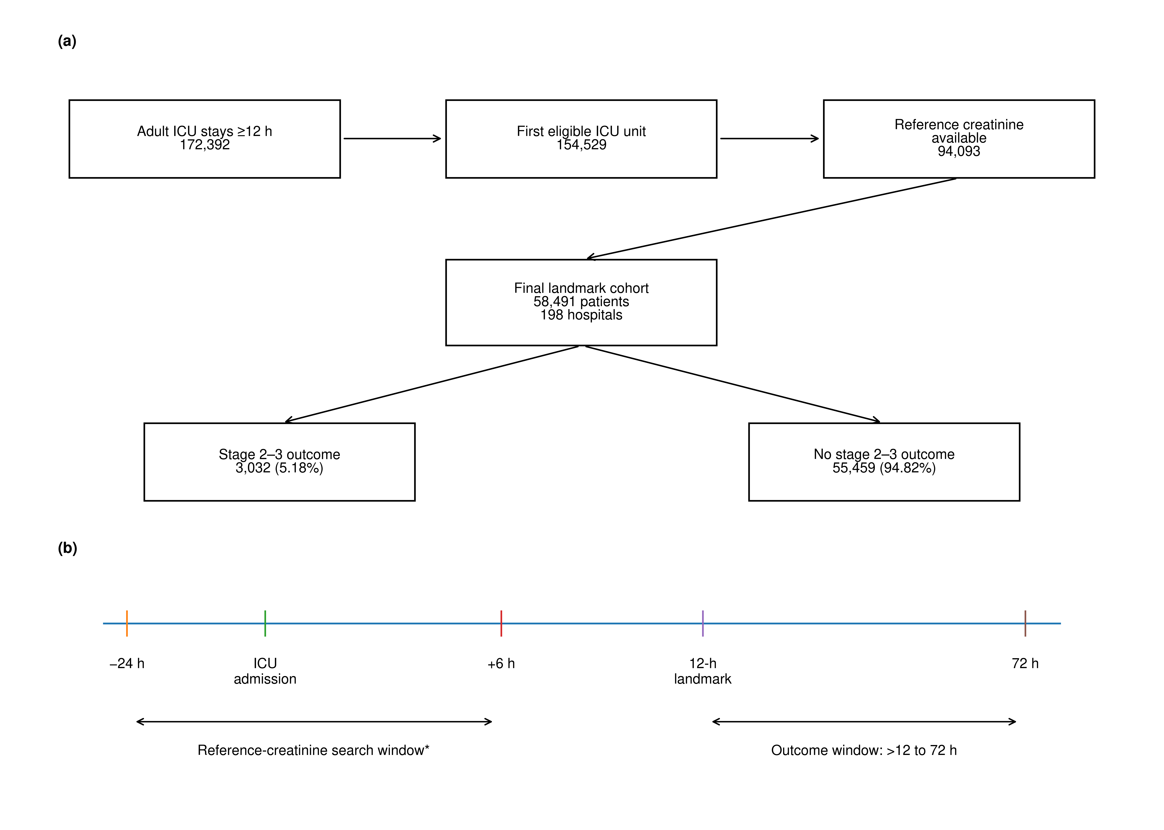
Fig. 1 Cohort flow and temporal design. (a) Cohort flow from eligible adult ICU stays to the final landmark cohort and outcome groups. (b) Fixed temporal design showing the reference-creatinine search window, 12-h prediction landmark, and >12- to 72-h outcome window. *Reference creatinine was defined as the earliest available value between the later of hospital admission or 24 hours before ICU admission and 6 hours after ICU admission

Discrimination, calibration, and model comparison
All five model-comparison estimates in Table 3 and Fig. 2a,b were computed from fold-specific Platt-calibrated held-out probabilities. XGBoost achieved a pooled AUROC of 0.876 (95% confidence interval (CI) 0.868-0.883), an AUPRC of 0.399 (0.375-0.423), a Brier score of 0.038 (0.036-0.040), and log loss of 0.142. The calibration intercept was 0.002 and the calibration slope was 1.005. Across outer folds, AUROC ranged from 0.862 to 0.884 and AUPRC from 0.340 to 0.429. Logistic regression achieved AUROC 0.848 and AUPRC 0.315. Random forest (AUROC 0.868; AUPRC 0.389) and CatBoost (AUROC 0.871; AUPRC 0.393) formed a broadly comparable nonlinear performance cluster with XGBoost, which was numerically strongest (Table 3; Fig. 2). The exploratory parsimonious clinical comparator achieved AUROC 0.815 and AUPRC 0.262. Relative to that comparator, XGBoost improved AUROC by 0.061 (nominal 95% CI 0.054-0.069) and AUPRC by 0.136 (0.120-0.155).
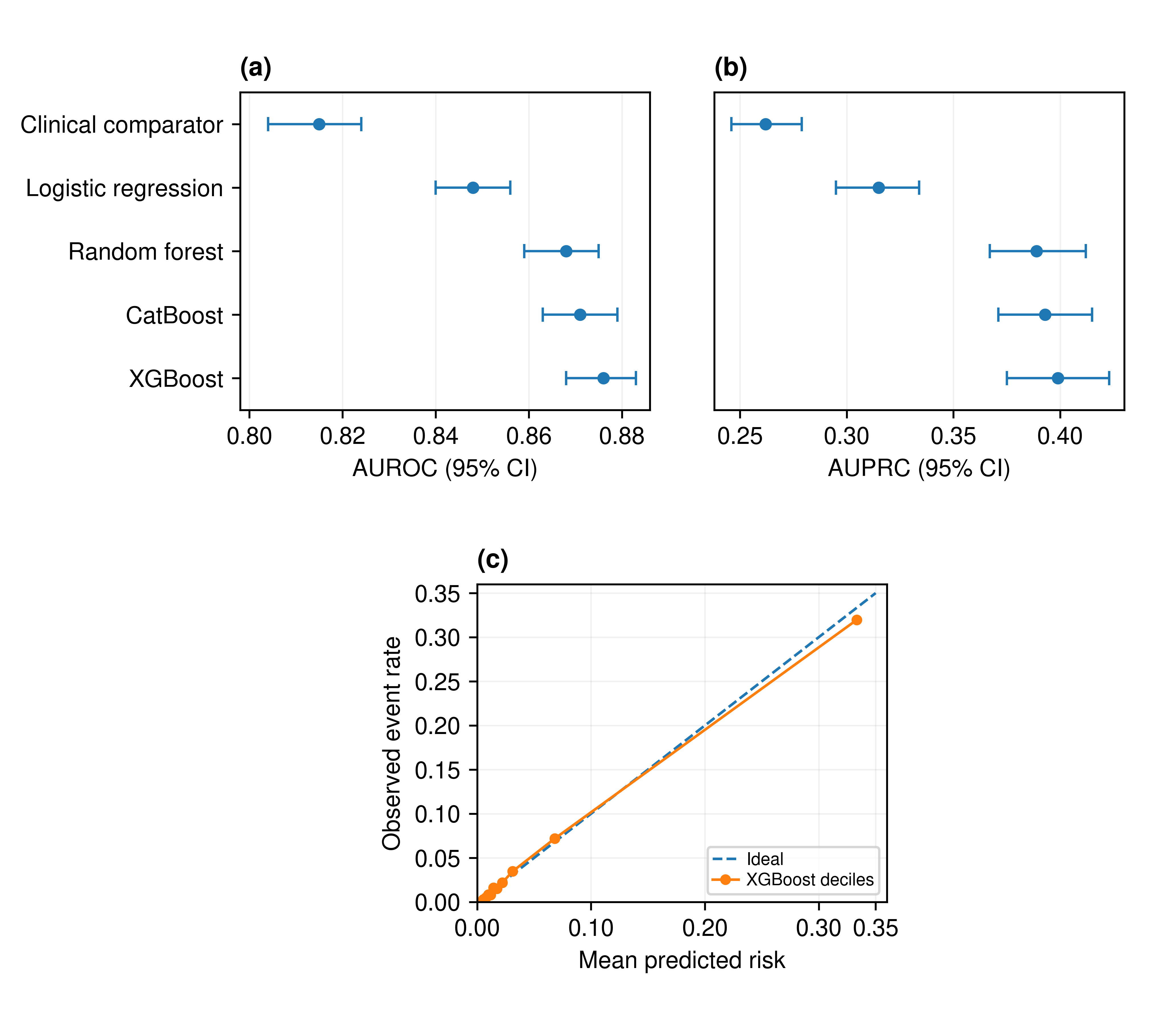
Fig. 2 Discrimination and calibration. (a) Pooled held-out AUROC with 95% percentile confidence intervals from 2,000 hospital-cluster bootstrap samples across the clinical comparator and four model families. (b) Corresponding pooled held-out AUPRC with 95% percentile confidence intervals. (c) Pooled held-out calibration for fold-specific Platt-calibrated XGBoost predictions, showing observed event rate versus mean predicted risk across prediction deciles; the dashed diagonal denotes ideal calibration. Fold- and hospital-level calibration heterogeneity are reported in Online Resource 1

Clinical utility and feature attribution
XGBoost had positive estimated net benefit at all 19 thresholds from 1% to 10% and exceeded the clinical comparator at all 19 thresholds (Fig. 3a). At 5%, 7.5%, and 10% thresholds, sensitivities were 74.1%, 69.5%, and 66.4%; positive predictive values were 22.9%, 27.0%, and 30.1%; and the model generated 16.8, 13.3, and 11.4 alerts per 100 patients, respectively (Table 4). These operating points represent scenarios rather than an optimized deployment threshold. The leading source predictors by pooled mean absolute grouped TreeSHAP were early reference creatinine, the last pre-landmark creatinine, and KDIGO stage 1 status at the landmark, followed by oxygenation and vital-sign summaries, admission source, blood urea nitrogen, body mass index, and blood-pressure measures (Fig. 3b). Pairwise Spearman correlations of source-predictor ranks across outer folds ranged from 0.819 to 0.890, indicating broadly stable global attribution patterns across held-out hospital groups.
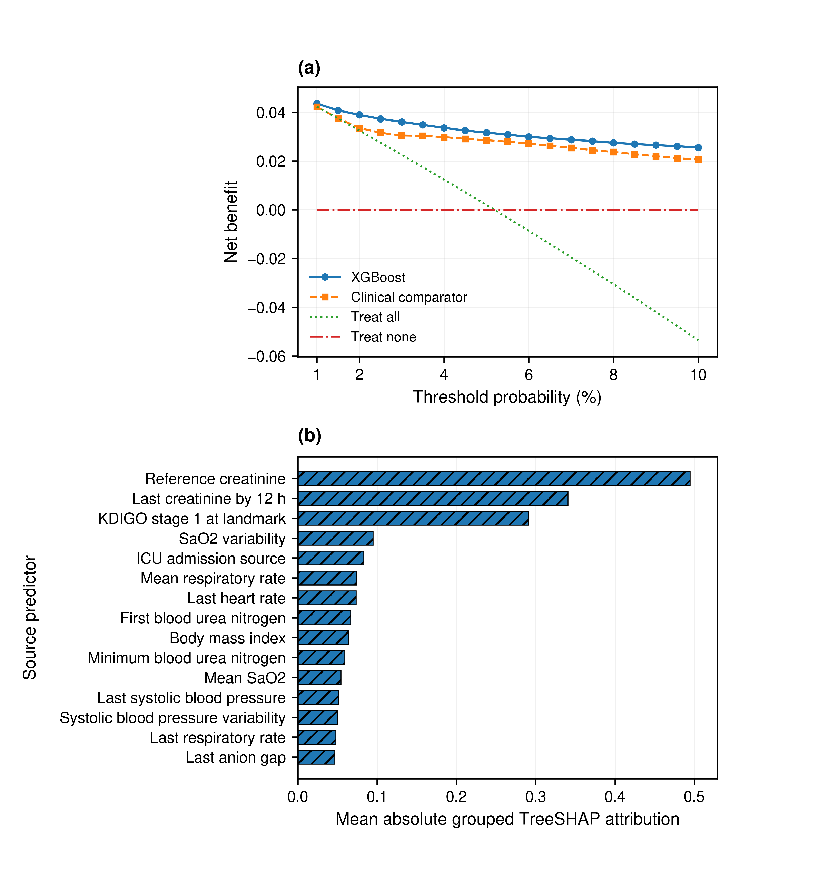
Fig. 3 Clinical utility and feature attribution. (a) Decision-curve analysis across the 1-10% threshold range for calibrated XGBoost, the parsimonious clinical comparator, treat-all, and treat-none strategies. (b) Top 15 source predictors ranked by pooled mean absolute grouped TreeSHAP attribution. SHAP values are non-causal model attributions

Sensitivity, comparator, and subgroup analyses
After removal of eight predefined renal-state predictors, calibrated XGBoost retained AUROC 0.786 and AUPRC 0.209. In direct renal comparisons, full XGBoost achieved AUROC 0.876 and AUPRC 0.399 versus 0.834 and 0.288 for Comparator 1, the strongest parsimonious renal-status comparator. Comparator 2, which incorporated creatinine trajectory and was specified before its performance was reviewed, achieved AUROC 0.784 and AUPRC 0.251 and performed worse than Comparator 1; creatinine slope was unavailable in 71.8% of patients. At 16.78 alerts per 100 admissions, XGBoost identified 2,247 events versus 2,069 with Comparator 2, identifying 178 additional patients with subsequent stage 2-3 AKI at approximately the same alert burden. XGBoost also had greater estimated net benefit than Comparator 2 at every evaluated threshold from 1% to 10%.
Performance was robust after removing predictors with at least 50% missingness in each outer-training partition (AUROC/AUPRC 0.876/0.399 versus 0.876/0.399 for the full model). The 153 explicit numeric missingness indicators accounted for 1.89% of total absolute held-out TreeSHAP attribution, and their removal did not materially reduce performance (AUROC 0.877; AUPRC 0.401). Selection characterization showed observable differences between included and excluded groups in early support, monitoring, and admission context, together with between-hospital variation in reference-creatinine availability. Exploratory subgroup performance showed lower discrimination among patients aged at least 80 years (AUROC 0.830), although calibration remained close to ideal; recorded African American patients had observed risk 8.34% versus mean predicted risk 7.34%, consistent with modest underprediction despite preserved discrimination (AUROC 0.889). These were the most notable signals from systematic sex, age, and recorded race/ethnicity summaries; complete subgroup estimates, group sizes, and uncertainty are provided in Online Resource 1, Tables S5-S14 and Figs. S6-S10.

The median interval from the landmark to the first qualifying stage 2-3 event was 18.3 hours. Predictive discrimination attenuated with increasing minimum warning intervals but remained informative: after requiring at least 12 and 24 hours of warning, AUROC/AUPRC were 0.842/0.252 and 0.795/0.134. For the >12-48-hour outcome window, AUROC/AUPRC were 0.897/0.382 (Online Resource 1, Tables S15-S16; Fig. S11).

Among 51 held-out hospitals with at least 20 events and 20 non-events, median AUROC was 0.878 (IQR 0.856-0.899; P10 0.827; minimum 0.730); 47/51 had AUROC >=0.80 and none had AUROC <0.70. Calibration intercept varied more (median 0.073, IQR -0.145 to 0.319; 28/51 with absolute intercept >0.25), whereas calibration slope was 1.012 (IQR 0.952-1.097). In the stricter 29-hospital subset, median/minimum AUROC were 0.883/0.823; removing the 10 highest-AUROC hospitals changed pooled AUROC from 0.876 to 0.870 (Online Resource 1, Tables S17-S18; Fig. S12).

Discussion
By 12 hours after ICU admission, routinely collected data yielded strong discrimination and good pooled calibration for subsequent serum-creatinine-defined KDIGO stage 2-3 AKI through 72 hours. Each patient was evaluated by a model trained without data from that hospital. Discrimination was consistent across outer folds; calibration-in-the-large varied more across adequately sized hospitals. These findings apply to held-out hospitals within eICU, not to independent external or prospective validation.
The study addresses a more specific question than general incident-AKI prediction: which patients who remain eligible at a fixed 12-hour landmark will subsequently develop stage 2-3 creatinine-defined AKI during the following 60 hours? Existing progression and severe-AKI studies use heterogeneous index times, populations, prediction horizons, and outcome definitions. Wei and colleagues modeled progression after early AKI in MIMIC-III, whereas You and colleagues recently evaluated sepsis-associated progression to stage 3 across several datasets. Persistent severe-AKI and continuous incident-AKI models have also undergone external or prospective evaluation. These studies demonstrate the field's progress but do not provide directly comparable performance benchmarks because their tasks and temporal alignment differ [9-11, 13, 23].
Hospital-disjoint internal-external validation was a major strength. Discrimination held across adequately sized held-out hospitals and was not driven by a small subset of high-performing centers; calibration-in-the-large showed greater between-center heterogeneity. All hospitals arose from the same eICU data ecosystem; these results do not constitute independent external validation or universal transportability and support local calibration evaluation before deployment [7, 15, 19, 24].
Clinical usefulness depends on the action associated with a risk estimate. Performance declined as the required warning interval lengthened (AUROC 0.842 with at least 12 hours of warning and 0.795 with at least 24 hours), indicating greater usefulness for near-term than long-horizon risk. Decision curves showed positive estimated net benefit across the predefined 1-10% range, but threshold selection depends on intervention burden and workflow. High risk could prompt clinician-led review of renal-function and urine-output surveillance, nephrotoxic or renally cleared medications, hemodynamics, and volume status, with nephrology consultation when otherwise appropriate. This study did not test an intervention protocol or show that model-guided care improves outcomes [22, 25-26].
Renal-state variables dominated global attribution, which is clinically plausible because the outcome was defined by subsequent creatinine-defined AKI. The renal-marker ablation confirmed that legitimate pre-landmark renal state carried much of the prognostic information. Direct comparisons nevertheless showed added predictive value beyond parsimonious renal information: Comparator 1, the strongest renal-status comparator, outperformed Comparator 2, the creatinine-trajectory comparator, but both remained below the full model. Creatinine slope was unavailable in 71.8% of patients, which limits the completeness of trajectory-only baselines in this dataset. Matched-alert and decision-curve analyses favored the full model under the evaluated thresholds but did not establish clinical superiority or patient-outcome benefit.
Hospital separation was maintained during model selection and evaluation, and preprocessing and calibration were learned only from development data. AUPRC, hospital-cluster bootstrap uncertainty, and source-level TreeSHAP were reported; post-hoc and exploratory analyses were labeled accordingly. This design limits common sources of optimism, including temporal leakage and test-set tuning.
Important limitations include retrospective use of one United States multicenter database from 2014-2015, reliance on serum creatinine without urine-output criteria, and an early-admission operational reference that may not represent stable premorbid renal function. Because RRT timing and indication were documentation-dependent and post-RRT creatinine values were not censored, the creatinine-defined phenotype should not be interpreted as a complete KDIGO stage 3 phenotype incorporating RRT. Selection and measurement-process limitations persist despite the robustness analyses, and the exploratory subgroup findings, which were not a formal fairness assessment, would need confirmatory evaluation. Independent contemporary validation and prospective impact studies, together with local calibration assessment, are still needed before implementation.
Future work should test a refitted and locked model in independent contemporary cohorts, evaluate complete creatinine-plus-urine-output phenotypes where reliable data exist, and prospectively assess workflow and patient impact.

Conclusion
Using a fixed 12-hour landmark and hospital-disjoint internal-external validation, we found that routinely available ICU data can support strong discrimination with good pooled calibration for early prediction of subsequent serum-creatinine-defined KDIGO stage 2-3 AKI. The model added information beyond parsimonious renal-status and creatinine-trajectory comparators, but independent external, subgroup-confirmatory, and prospective impact evaluations remain necessary before implementation.

Statements and Declarations

Ethics approval
This study was a secondary analysis of the deidentified eICU Collaborative Research Database (eICU-CRD). The database was deidentified to meet the HIPAA Safe Harbor provision before release [16-17]. Access was granted through PhysioNet after researcher credentialing, completion of the required human-subjects research training, and acceptance of the applicable PhysioNet Data Use Agreement [17]. The investigators analyzed only the deidentified database, had no access to direct patient identifiers, did not recruit or contact participants, and did not intervene in care.

Consent to participate
Not applicable to the authors’ secondary analysis; the investigators did not recruit or contact participants and analyzed only the deidentified eICU-CRD available under PhysioNet credentialed access.

Consent for publication
Not applicable.

Funding
This research received no specific grant from any funding agency in the public, commercial, or not-for-profit sectors.

Competing interests
The authors have no relevant financial or non-financial interests to disclose.

Author contributions
Cagdas YILMAZ: Conceptualization (supporting), Data curation (lead), Formal analysis (lead), Investigation (lead), Methodology (supporting), Software (lead), Validation (lead), Visualization (lead), Literature and evidence synthesis (lead), Writing – original draft (lead), and Writing – review and editing (equal). Ali AKDAGLI: Conceptualization (lead), Methodology (lead), Supervision (lead), Project administration (lead), Resources (lead), Validation (supporting), and Writing – review and editing (equal). Both authors approved the final manuscript and agree to be accountable for the integrity and accuracy of the work.

Data availability
The eICU Collaborative Research Database (version 2.0) is available through PhysioNet at https://doi.org/10.13026/C2WM1R to credentialed users who complete the required human-subjects research training and accept the applicable Data Use Agreement [17, 28-29]. No patient-level derivative dataset is publicly redistributed by the authors.

Code availability
Source-only reproducibility materials are publicly available at https://github.com/originalprojects-code/aki-progression-hospital-iec/tree/v1.1.1-submission and are archived in Zenodo as version 1.1.1-submission at https://doi.org/10.5281/zenodo.21966107. The archive includes code, parameterized SQL query templates, predefined model specifications, aggregate outputs, software-environment files, and reproduction instructions. No patient-level data or Data Use Agreement-restricted derivatives are redistributed. No single production-ready final model was trained or released; reported performance came from held-out predictions within the hospital-disjoint validation framework. Clinical implementation would require refitting and locking a final model, followed by independent and prospective evaluation.

Supplementary information
Online Resource 1 contains Supplementary Methods and Results, Tables S1-S18, and Figs. S1-S12 covering operating points, reference-creatinine sensitivity, landmark selection, missingness robustness, renal comparators, exploratory subgroups, actionable lead time, outcome-window sensitivity, and hospital-level discrimination and calibration heterogeneity.

Registration
This retrospective secondary analysis was not prospectively registered.

Patient and public involvement
Patients and members of the public were not involved in the design, conduct, reporting, or dissemination planning of this retrospective secondary analysis.

References
1. Hoste EAJ, Bagshaw SM, Bellomo R, Cely CM, Colman R, Cruz DN, Edipidis K, Forni LG, Gomersall CD, Govil D, Honoré PM, Joannes-Boyau O, Joannidis M, Korhonen A-M, Lavrentieva A, Mehta RL, Palevsky P, Roessler E, Ronco C, Uchino S, Vazquez JA, Vidal Andrade E, Webb S, Kellum JA (2015) Epidemiology of acute kidney injury in critically ill patients: the multinational AKI-EPI study. Intensive Care Med 41:1411-1423. https://doi.org/10.1007/s00134-015-3934-7
2. Pickkers P, Darmon M, Hoste E, Joannidis M, Legrand M, Ostermann M, Prowle JR, Schneider A, Schetz M (2021) Acute kidney injury in the critically ill: an updated review on pathophysiology and management. Intensive Care Med 47:835-850. https://doi.org/10.1007/s00134-021-06454-7
3. Kellum JA, Sileanu FE, Murugan R, Lucko N, Shaw AD, Clermont G (2015) Classifying AKI by urine output versus serum creatinine level. J Am Soc Nephrol 26:2231-2238. https://doi.org/10.1681/ASN.2014070724
4. Shi T, Lin Y, Zhao H, Kong G (2025) Artificial intelligence models for predicting acute kidney injury in the intensive care unit: a systematic review of modeling methods, data utilization, and clinical applicability. JAMIA Open 8:ooaf065. https://doi.org/10.1093/jamiaopen/ooaf065
5. Vagliano I, Chesnaye NC, Leopold JH, Jager KJ, Abu-Hanna A, Schut MC (2022) Machine learning models for predicting acute kidney injury: a systematic review and critical appraisal. Clin Kidney J 15:2266-2280. https://doi.org/10.1093/ckj/sfac181
6. Feng Y, Wang AY, Jun M, Pu L, Weisbord SD, Bellomo R, Hong D, Gallagher M (2023) Characterization of risk prediction models for acute kidney injury: a systematic review and meta-analysis. JAMA Netw Open 6:e2313359. https://doi.org/10.1001/jamanetworkopen.2023.13359
7. Rockenschaub P, Akay EM, Carlisle BG, Hilbert A, Wendland J, Meyer-Eschenbach F, Näher A-F, Frey D, Madai VI (2025) External validation of AI-based scoring systems in the ICU: a systematic review and meta-analysis. BMC Med Inform Decis Mak 25:5. https://doi.org/10.1186/s12911-024-02830-7
8. Saito T, Rehmsmeier M (2015) The precision-recall plot is more informative than the ROC plot when evaluating binary classifiers on imbalanced datasets. PLoS ONE 10:e0118432. https://doi.org/10.1371/journal.pone.0118432
9. Wei C, Zhang L, Feng Y, Ma A, Kang Y (2022) Machine learning model for predicting acute kidney injury progression in critically ill patients. BMC Med Inform Decis Mak 22:17. https://doi.org/10.1186/s12911-021-01740-2
10. You X, Chen Y, Chen J, Mao X, Wang Y, Zhang Z, Zhou Z, Li W, Mei Y, Zhu Y, Huang P, Chen X (2026) Early identification of acute kidney injury progression in critically ill patients with sepsis: interpretable machine learning approach. Clin Kidney J:sfag216. https://doi.org/10.1093/ckj/sfag216
11. Zappalà S, Alfieri F, Ancona A, Taccone FS, Maviglia R, Cauda V, Finazzi S, Dell’Anna AM (2024) Development and external validation of a machine learning model for the prediction of persistent acute kidney injury stage 3 in multi-centric, multi-national intensive care cohorts. Crit Care 28:189. https://doi.org/10.1186/s13054-024-04954-8
12. Jiang W, Zhang Y, Weng J, Song L, Liu S, Li X, Xu S, Shi K, Li L, Zhang C, Wang J, Yuan Q, Zhang Y, Shao J, Yu J, Zheng R (2025) Explainable machine learning model for predicting persistent sepsis-associated acute kidney injury: development and validation study. J Med Internet Res 27:e62932. https://doi.org/10.2196/62932
13. Alfieri F, Zappalà S, Bacci A, Cauda V, Basso M, Musso G, Cochelli L, Votta CD, Mariconti L, Maderna L, Russo G, Gomez J, Esteban-Reboll F, Gilavert Cuevas MC, Bodì M, Finazzi S, Kashani K, Ancona A (2026) Prospective and external evaluation of an AI model for continuous and early prediction of moderate and severe AKI in critically ill patients. Intensive Care Med Exp 14:71. https://doi.org/10.1186/s40635-026-00928-y
14. Jonkers J, Rouzé A, Verhaeghe J, Van Biesen W, De Waele J, Duchateau L, Van Wallendael G, Hoste E, Van Hoecke S (2026) Beyond binary AKI classification: development and external validation of a distributional model predicting serum creatinine and urine output trajectories in ICU patients. Crit Care 30:249. https://doi.org/10.1186/s13054-026-06017-6
15. Hourani AZ, Jakubowska Z, Malyszko J (2026) Forecasting ICU acute kidney injury with actionable lead time using interpretable machine learning: development and multi-center validation. J Clin Med 15(3):1191. https://doi.org/10.3390/jcm15031191
16. Pollard TJ, Johnson AEW, Raffa JD, Celi LA, Mark RG, Badawi O (2018) The eICU Collaborative Research Database, a freely available multi-center database for critical care research. Sci Data 5:180178. https://doi.org/10.1038/sdata.2018.178
17. Pollard T, Johnson A, Raffa J, Celi LA, Badawi O, Mark R (2019) eICU Collaborative Research Database (version 2.0). PhysioNet. https://doi.org/10.13026/C2WM1R
18. Collins GS, Moons KGM, Dhiman P, Riley RD, Beam AL, Van Calster B, Ghassemi M, Liu X, Reitsma JB, van Smeden M, Boulesteix A-L, Camaradou JC, Celi LA, Denaxas S, Denniston AK, Glocker B, Golub RM, Harvey H, Heinze G, Hoffman MM, Kengne AP, Lam E, Lee N, Loder EW, Maier-Hein L, Mateen BA, McCradden MD, Oakden-Rayner L, Ordish J, Parnell R, Rose S, Singh K, Wynants L, Logullo P (2024) TRIPOD+AI statement: updated guidance for reporting clinical prediction models that use regression or machine learning methods. BMJ 385:e078378. https://doi.org/10.1136/bmj-2023-078378
19. Debray TPA, Collins GS, Riley RD, Snell KIE, Van Calster B, Reitsma JB, Moons KGM (2023) Transparent reporting of multivariable prediction models developed or validated using clustered data: TRIPOD-Cluster checklist. BMJ 380:e071018. https://doi.org/10.1136/bmj-2022-071018
20. Siew ED, Matheny ME, Ikizler TA, Lewis JB, Miller RA, Waitman LR, Go AS, Parikh CR, Peterson JF (2010) Commonly used surrogates for baseline renal function affect the classification and prognosis of acute kidney injury. Kidney Int 77:536-542. https://doi.org/10.1038/ki.2009.479
21. Rahimi AK, Ghadimi M, van der Vegt AH, Canfell OJ, Pole JD, Sullivan C, Shrapnel S (2023) Machine learning clinical prediction models for acute kidney injury: the impact of baseline creatinine on prediction efficacy. BMC Med Inform Decis Mak 23:207. https://doi.org/10.1186/s12911-023-02306-0
22. Vickers AJ, Holland F (2021) Decision curve analysis to evaluate the clinical benefit of prediction models. Spine J 21:1643-1648. https://doi.org/10.1016/j.spinee.2021.02.024
23. Zappala S, Alfieri F, Ancona A, Dell Anna AM, Kashani KB (2025) External validation of persistent severe acute kidney injury prediction with machine learning model. Mayo Clin Proc Digit Health 3(2):100200. https://doi.org/10.1016/j.mcpdig.2025.100200
24. Sun H, Depraetere K, Meesseman L, Cabanillas Silva P, Szymanowsky R, Fliegenschmidt J, Hulde N, von Dossow V, Vanbiervliet M, De Baerdemaeker J, Roccaro-Waldmeyer DM, Stieg J, Domínguez Hidalgo M, Dahlweid FM (2022) Machine learning-based prediction models for different clinical risks in different hospitals: evaluation of live performance. J Med Internet Res 24:e34295. https://doi.org/10.2196/34295
25. Flechet M, Falini S, Bonetti C, Güiza F, Schetz M, Van den Berghe G, Meyfroidt G (2019) Machine learning versus physicians’ prediction of acute kidney injury in critically ill adults: a prospective evaluation of the AKIpredictor. Crit Care 23:282. https://doi.org/10.1186/s13054-019-2563-x
26. Kashani KB, Awdishu L, Bagshaw SM, Barreto EF, Claure-Del Granado R, Evans BJ, Forni LG, Ghosh E, Goldstein SL, Kane-Gill SL, Koola J, Koyner JL, Liu M, Murugan R, Nadkarni GN, Neyra JA, Ninan J, Ostermann M, Pannu N, Rashidi P, Ronco C, Rosner MH, Selby NM, Shickel B, Singh K, Soranno DE, Sutherland SM, Bihorac A, Mehta RL (2023) Digital health and acute kidney injury: consensus report of the 27th Acute Disease Quality Initiative workgroup. Nat Rev Nephrol 19:807-818. https://doi.org/10.1038/s41581-023-00744-7
27. Lin W-L, Fang S-S, Chen S-H (2026) From black box to glass box: explainable artificial intelligence for acute kidney injury prediction-a scoping review and the GLASS-AKI translational framework proposal. Int Urol Nephrol. Online ahead of print. https://doi.org/10.1007/s11255-026-05241-x
28. Pollard T, Moody BE, Lehman L-WH, Gow BJ, Fernandes C, Xie C, Johnson A, Mark RG, Heldt T (2026) PhysioNet as a global platform for biomedical research. Nature Health 1(8):792-795. https://doi.org/10.1038/s44360-026-00096-z
29. Goldberger AL, Amaral LAN, Glass L, Hausdorff JM, Ivanov PC, Mark RG, Mietus JE, Moody GB, Peng C-K, Stanley HE (2000) PhysioBank, PhysioToolkit, and PhysioNet: components of a new research resource for complex physiologic signals. Circulation 101:e215-e220. https://doi.org/10.1161/01.CIR.101.23.e215

Tables
Table 1 Baseline characteristics by outcome group
Characteristic | Overall (n=58,491) | No stage 2–3 outcome (n=55,459) | Stage 2–3 outcome (n=3,032) | Missing overall, n (%)
Age, years | 65.0 (53.0–76.0) | 65.0 (53.0–77.0) | 65.0 (54.0–75.0) | 0 (0.0%)
Body mass index, kg/m² | 27.6 (23.6–32.9) | 27.5 (23.6–32.8) | 28.9 (24.4–34.6) | 1,393 (2.4%)
Reference creatinine, mg/dL | 1.0 (0.8–1.5) | 1.0 (0.8–1.5) | 2.1 (1.0–4.5) | 0 (0.0%)
Last creatinine by 12 h, mg/dL | 1.0 (0.8–1.5) | 1.0 (0.7–1.5) | 2.5 (1.3–4.1) | 12,777 (21.8%)
Last blood urea nitrogen by 12 h, mg/dL | 19.0 (13.0–32.0) | 19.0 (12.0–31.0) | 32.0 (20.0–53.0) | 13,018 (22.3%)
Last heart rate by 12 h, beats/min | 84.0 (72.0–97.0) | 83.0 (72.0–96.0) | 89.0 (75.0–104.0) | 898 (1.5%)
Last systolic blood pressure by 12 h, mmHg | 116.0 (103.0–133.0) | 116.0 (103.0–133.0) | 112.0 (98.0–129.0) | 3,377 (5.8%)
Last respiratory rate by 12 h, breaths/min | 18.0 (15.0–22.0) | 18.0 (15.0–22.0) | 20.0 (16.0–25.0) | 5,185 (8.9%)
Last temperature by 12 h, °C | 37.2 (36.7–37.7) | 37.2 (36.8–37.7) | 37.0 (36.2–37.7) | 51,414 (87.9%)
Female sex | 26,304 (45.0%) | 25,054 (45.2%) | 1,250 (41.2%) | —
Male sex | 32,179 (55.0%) | 30,397 (54.8%) | 1,782 (58.8%) | —
Other/missing sex | 8 (0.0%) | 8 (0.0%) | 0 (0.0%) | —
KDIGO stage 1 at the 12-h landmark | 2,949 (5.0%) | 2,168 (3.9%) | 781 (25.8%) | 0 (0.0%)
Values are median (interquartile range) for continuous variables and n (%) for categorical variables. Descriptive summaries for variables with missing data are based on observed values; no between-group hypothesis tests were performed. Temperature was available for 7,077 of 58,491 patients (12.1%) and should therefore be interpreted cautiously. KDIGO, Kidney Disease: Improving Global Outcomes.
Table 2 Cohort construction and analytical population
Cohort step | Number
Adult ICU stays lasting ≥12 h | 172,392
First eligible ICU unit per hospital stay | 154,529
Reference creatinine available | 94,093
Final primary cohort | 58,491
Stage 2-3 events >12–72 h | 3,032 (5.18%)
Non-events | 55,459
Additional mutually exclusive landmark selection and exclusion groups are provided in Online Resource 1. Counts in the supplementary landmark groups are defined within the landmark candidate set and should not be interpreted as a single subtraction sequence from the initial ICU-stay count.
Table 3 Pooled held-out performance after fold-specific Platt calibration
Model | Role | AUROC (95% CI) | AUPRC (95% CI) | Brier (95% CI) | Calibration slope
XGBoost | Original primary nonlinear | 0.876 (0.868-0.883) | 0.399 (0.375-0.423) | 0.038 (0.036-0.040) | 1.005
CatBoost | Additional post-hoc benchmark | 0.871 (0.863-0.879) | 0.393 (0.371-0.415) | 0.038 (0.036-0.040) | 0.994
Random forest | Additional post-hoc benchmark | 0.868 (0.859-0.875) | 0.389 (0.367-0.412) | 0.038 (0.036-0.040) | 0.998
Logistic regression | Original linear | 0.848 (0.840-0.856) | 0.315 (0.295-0.334) | 0.042 (0.040-0.044) | 1.010
Clinical comparator | Exploratory post-hoc comparator | 0.815 (0.804-0.824) | 0.262 (0.246-0.279) | 0.044 (0.042-0.046) | 1.000
All estimates use fold-specific Platt-calibrated outer-test predictions. Confidence intervals are percentile intervals from 2,000 hospital-cluster bootstrap samples. XGBoost and logistic regression were original candidate families; random forest and CatBoost were additional post-hoc benchmarks; the parsimonious clinical logistic model was an exploratory post-hoc comparator.
Table 4 Selected operating-point scenarios for calibrated XGBoost
Threshold | Sensitivity | Specificity | PPV | NPV | F1 | Alerts/100
5% | 74.1% | 86.4% | 22.9% | 98.4% | 0.350 | 16.8
7.5% | 69.5% | 89.7% | 27.0% | 98.2% | 0.389 | 13.3
10% | 66.4% | 91.6% | 30.1% | 98.0% | 0.414 | 11.4
Thresholds were scenario values fixed before decision-curve results were examined and were not selected to maximize observed performance. PPV, positive predictive value; NPV, negative predictive value; F1, harmonic mean of precision and recall.

